Aurora’s Degree & PG College 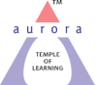
(ACCREDITED BY NAAC WITH 'B++' GRADE)
Chikkadpally, Hyderabad 500020

NAME OF THE EVENT : | Ramakrishna Paramahamsa Jayanthi
TYPE OF EVENT | Class Event
FACULTY INCHARGE | S. Sailaja
DEPARTMENT | Languages
DATE | 18th February 2019
VENUE | Aurora’s Degree &PG College
TARGET AUDIENCE | B.com I B,D,E Students

Objective:

B.COM -1B, ID and IE section students have spoken about Ramakrishna Paramahamsa Jayanthi at class room level.

Brief about the event :-
B.COM -1B, ID and IE section students have organized Ramakrishna Paramahamsa Jayanthi at class room level. T. Bindu from B.COM- 1E and U. Nikhil gave a presentation about Ramakrishna Paramahamsa where they spoke about the biography and works of Ramakrishna Paramahamsa.

Students from B.Com IB Soundarya and Manisha, have spoken about his childhood and married life after he married Sarada.

Aditya from B.Com ID and Anagha from B.Com IE gave information and speech on the importance of Ramakrishna Paramahamsa, about his works and association with Vivekananda who was his prime disciple who established the Ramakrishna Math.

Faculty briefly explained about the life history of Ramakrishna Paramahamsa, his works and the importance of teacher disciple relation in the class.

OUTCOME:
Students have known about Ramakrishna Paramahamsa and his works learnt about the principles of life to achieve better results in life. They knew the Importance of the teacher – disciple relationship.

Objective:

B.COM -1B, ID and IE section students have spoken about Ramakrishna Paramahamsa Jayanthi at class room level.

Brief about the event :-
B.COM -1B, ID and IE section students have organized Ramakrishna Paramahamsa Jayanthi at class room level. T. Bindu from B.COM- 1E and U. Nikhil gave a presentation about Ramakrishna Paramahamsa where they spoke about the biography and works of Ramakrishna Paramahamsa.

Students from B.Com IB Soundarya and Manisha, have spoken about his childhood and married life after he married Sarada.

Aditya from B.Com ID and Anagha from B.Com IE gave information and speech on the importance of Ramakrishna Paramahamsa, about his works and association with Vivekananda who was his prime disciple who established the Ramakrishna Math.

Faculty briefly explained about the life history of Ramakrishna Paramahamsa, his works and the importance of teacher disciple relation in the class.

OUTCOME:
Students have known about Ramakrishna Paramahamsa and his works learnt about the principles of life to achieve better results in life. They knew the Importance of the teacher – disciple relationship.

Photographs
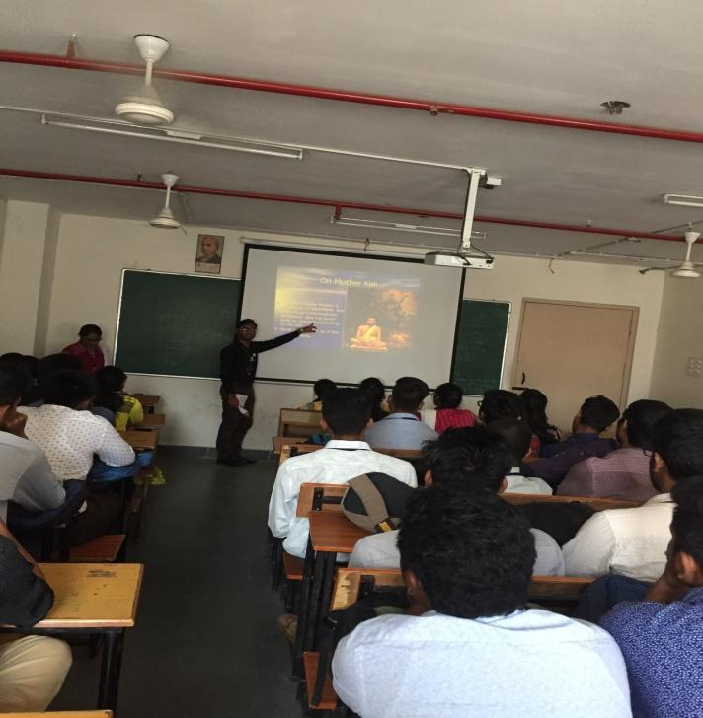 | 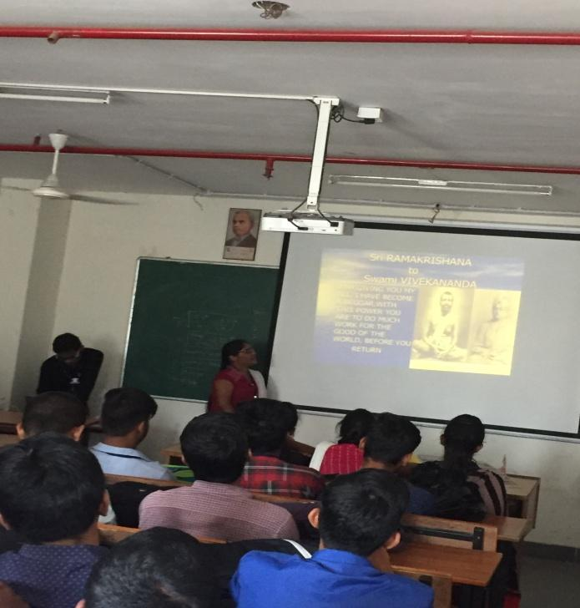
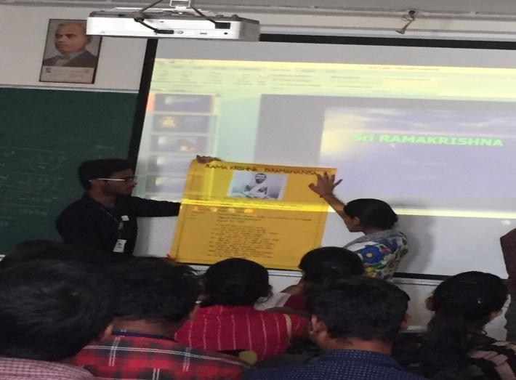 | 