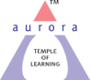
Aurora’s Degree & PG College
(ACCREDITED BY NAAC WITH 'B++' GRADE)
Chikkadpally, Hyderabad 500020

NAME OF THE EVENT | World Forest Day and World Water Day
TYPE OF EVENT | Class Event
FACULTY INCHARGE | Tejaswini G and Unnamalai.C
DEPARTMENT | Management
DATE | 21st and 22nd March 2019
VENUE | Aurora Degree and PG College RTC X Roads Block VI
TARGET AUDIENCE | Students from all Streams

OBJECTIVE: To celebrate forest day and water day and inculcate responsibility among the students towards the environment. To also create awareness about how it’s about time to save what is left of our nature and to take better care of it.

BRIEF ABOUT THE EVENT: On the occasion of World Forest Day and World Water Day, students from BBA 1A and 1B came together to organize an event. On 20th of March various competitions were conducted for the students of all the streams in the college. The competitions were:
- Debate competition- It was a team event. Five teams registered for the event. The topic was Ruining Nature VS Developing the country.
- Collage Making- The students were asked to make collages on the theme of Nature. There were three participants who participated in the event.
- Creative Writing- The students were asked to write their best creative piece of writing on nature. Students wrote poems in Hindi and English, Essays and Stories about nature.

OUTCOME: The students for two days celebrated nature in the college campus where not only the students were involved but also teaching and non-teaching staff of the college. Students of BBA first year distributed lovely saplings to the entire faculty and the non- teaching staff of the college including the attender’s and ayyamas. The winners of the above three competitions were also given a saplind as a prize. The event not only encouraged the students to create awareness about nature but also brought out the organizing and management skills in the students.

PHOTOGRAPH:
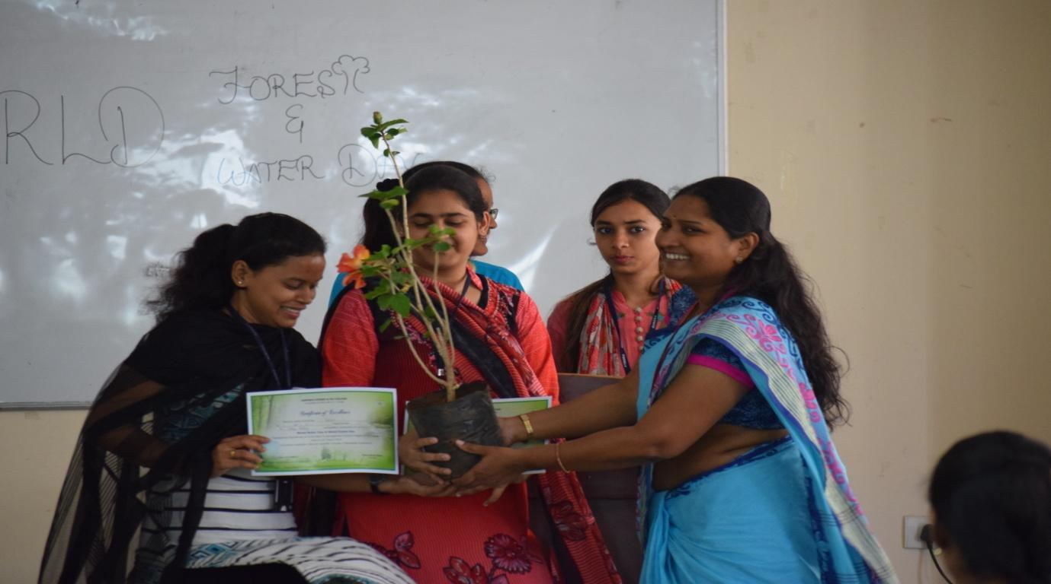
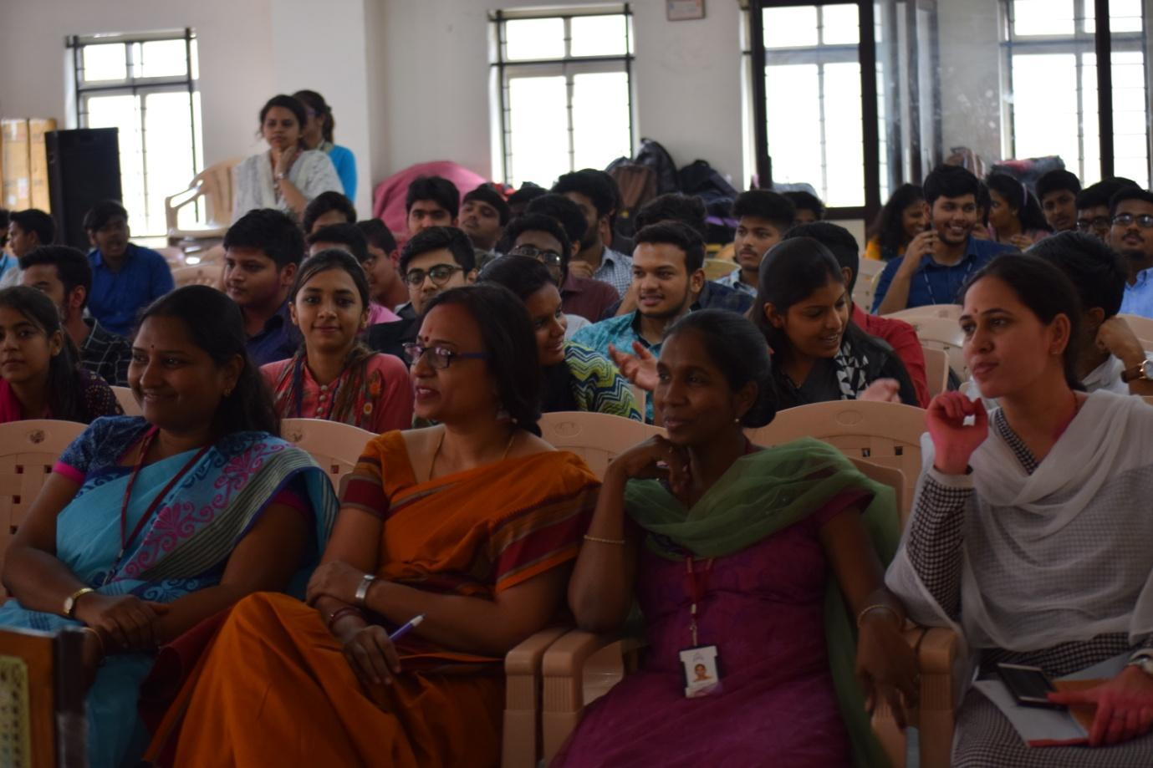

DETAILED REPORT:
The students of BBA 1A and 1B had their class events World Water Day and World Forest Day on 21st and 22nd of March. Since the common theme of both the events was nature, the students and the class incharges decided to combine both the events and do it together. The planning of the events started one week before the event was actually held. The group leaders and the captains of both the classes were asked to come up with a proposal for the class event. On 19th of March the events convenor received the event proposal and after the go ahead given by Principal Sir, the circular regarding the details of the event was sent to all the classes. On March 20th competitions were conducted for the students. Events like Essay writing, Creative writing, Collage making and Debate competitions were conducted.
Collage making was held in room number 310 and three students participated in it. The theme of the competition was water day and forest day.
Creative writing competition was conducted in room number 307. 16 students participated in the competition where the theme of the competition was nature.
Debate competition was a team of 2 event and overall 5 teams participated in it. The topic for the competition was developing the country at the cost of ruining the nature. Every team had a speaker who was first asked to come and put their view forward, the next round was where each of the team had a rebuttal round and the final round was each team defending their point of view.
On 22nd March the students of BBA first year distributed flower saplings to the teaching and the non-teaching staff of the college including the watchmen’s, ayyammas and attenders. At 11 am the official event started in the seminar hall at block 6 of RTC block. First the students did a street play which had powerful slogans imploring everyone to respect nature. Later there was a PowerPoint presentation by Kamal and Ghayas of A and B section respectively. Lastly there was a prize distribution for the competitions held. The winners were given certificates and flower saplings by the Head of the Department Madhavi Latha Maam. The programme ended with a talk by the head of the department asking the students to take a more serious stance on issues relating to nature as they are the future generation.

- LIST OF THE STUDENT COORDINATORS: G V Keerthika and Farah Naeem
- LIST OF THE PARTICIPANTS
Collage Making
S.No | Roll Number | Name | Class & Section
1 | 1051-17-402-006 | Akash kumar Mahato | B.Com(Comp)-2A
2 | 1051-17-468-077 | Amanpreet kaur | MPC's 2B
3 | 1051-17-468-126 | Rubina | MPC's 2C

Creative Writing
S.No | Roll Number | Name | Class & Section
1 | 1051-17-459-022 | Preethi Raj | Bsc-Migc-2A
2 | 1051-17-402-238 | M.Kalyan | B.Com(Comp)-2D
3 | 1051-17-402-168 | K.Raksha Sahasra | B.Com(Comp)-2D
4 | 1051-16-684-047 | Pratibha Modi | BBA-3
5 | 1051-18-402-163 | Amarnath | B.Com(Comp)-1C
6 | 1051-18-401-069 | U.Nikhil | B.Com(Gen)-1B

Essay Writing
S.No | Roll Number | Name | Class & Section
1 | 1051-17-402-176 | Divya.T | B.Com(Comp)-2C
2 | 1051-17-684-006 | B.Vrithika Moses | BBA-2A
3 | 1051-17-684-027 | K.Apurva | BBA-2A
4 | 1051-18-405-025 | Sofia | B.Com(Appl)-1A
5 | 1051-18-405-022 | Rishika Agarwal | B.Com(Appl)-1A
6 | 1051-18-402-127 | R.Preethi | B.Com(Comp)-1C
7 | 1051-17-391-001 | Arpit Shrivastana | BA-II
8 | 1051-17-407-105 | Nisha Fathima | B.Com(Hons)-2B
9 | 1051-18-401-069 | U.Nikhil | B.Com(Gen)-1A
10 | 1051-18-402-163 | Amarnath | B.Com(Comp)-1C

Debate
S.No | Roll Number | Name | Class & Section
1 | 1051-17-459-022 | Preethi Raj | Bsc-Migc-2A
2 | 1051-17-684-101 | Shubh Desai | BBA-2B
3 | 1051-17-407-014 | Shubham Joshi | B.Com(Hons)-2A
4 | 1051-17-401-004 | Akash J Antony | B.Com(Gen)-2A
5 | 1051-17-402-092 | Alisha Charaviya | B.Com(Comp)-2B
6 | 1051-17-402-093 | Dishant Puugalia | B.Com(Comp)-2B
7 | 1051-17-684-064 | Anwar Afzal | BBA-2B
8 | 1051-17-684-047 | Pratibha Modi | BBA-3
9 | 1051-18-684-113 | Manasa | BBA-1B
10 | 1051-17-401-270 | Aman vasaya | B.Com(Gen)-2D

- EVENT PHOTO