Aurora’s Degree & PG College
Chikkadpally, Hyderabad 500020

NAME OF THE EVENT: World Parents Day
NAME OF THE FACULTY : K. Sujatha
DATE: 31-7-18
VENUE: Musheerabad Old Age Home
OBJECTIVES: To make students understand about the relationship, importance, value of the parents.
BRIEF ABOUT THE EVENT: My class event is conducted to know the importance of parents because nowadays children are dropping them in old age homes, by not understanding them and ignoring them from their families.
The conduction of this event would like to make them feel about how the old parents are suffering by missing grandchildren and staying far away from their family.
As students have shown an interest to provide some requirements out of the necessaries and make them feel happy at least for a day.
OUTCOME OF THE EVENT: Students are so happy and actively participated, in serving food and providing some necessaries. They are able to feel the importance of parents and their families.
World parent’s day 2018
A visit to an old age home
Last Sunday(i.e. on 31st July), we the students of B.com(3A GEN) of Aurora’s Degree and PG College(Chikkadpally) visited “LITTLE SISTERS Old Age Home” with our respected class in charge (Sujatha K ).It is an old age home for aged people at Musheerabad(landmark-CSI Wesley church) in Hyderabad.
- We can see old age homes all across the world.
- But unfortunately we could see the pain in their eyes while searching for their wards, which made us feel very sad, as parents are looking back for the children to come and see them at least once out of a busy schedule.
We have spoken with those unfortunate mothers and collected fond memories and learnt a lesson that whenever we won’t care about our parents how would they feel?
Many mothers were still hoping that someday their children will come and ask them to go back home.
“WHERE THE TIME NEVER COMES”
When we arrived there, they felt happy that someone had come to see them. They shared their life stories with us and they also shared others stories also who can’t speak. Our class incharge said hello to everyone there in the old age home.
Every one of us has been blessed by all the old parents.
At last we made a decision that “we will never & ever send our parents to old age home”.
We had learnt a lot of things from them and I feel sorry for those unlucky sons who left their parents at an old age home.
It was a memorable experience for us….we were very happy as one can recognize by seeing our faces.

EVENT PHOTOS
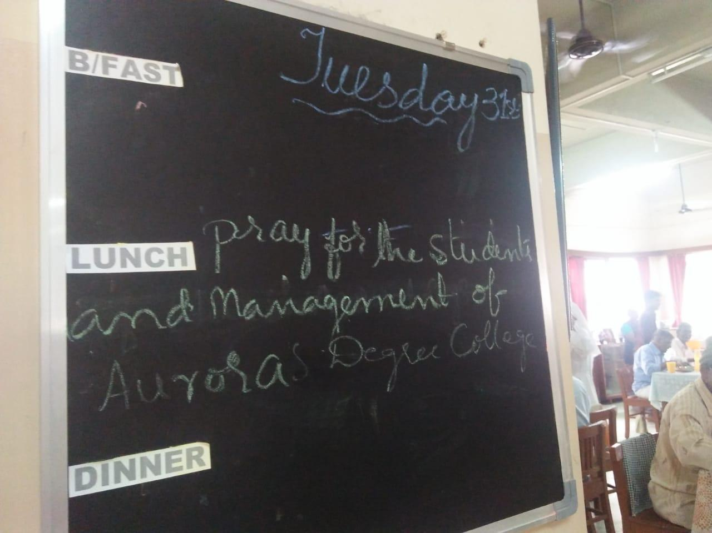

t 