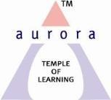
Aurora’s Degree & PG College
Chikkadpally, Hyderabad 500020
NAME OF THE EVENT | An interactive session on The eve of  Sir Dennis Ritchie 78th Birthday
FACULTY INCHARGE | Arjunarao R, Sr.Asst.Professor  Kavya V,Asst professor
DEPARTMENT | Computer Science
DATE | 9th September,2018
VENUE | Aurora’s Auditorium, Block VI,  RTC CROSS Roads, Chikkadpally,HYD
SPEAKER | Arjunarao R, Sr.Asst.Professor  Kavya V,Asst professor

Objective:
The audiences were briefed about the importance of the day and contributions of Dennis Ritchie to the Programming languages revolution. Powerpoint presented documentation on Life of Dennis Ritchie and importance of C Programming language.
The quiz was divided into four rounds: Infinite Bounce, Double or Nothing, Reflex Action and Rapid Fire. Every round was a mixed bag with questions from C language. All the students were at the edge of their seats to know the answers and the participants were very active. This quiz truly was a learning experience, for both the audience and the participants.
OUTCOME:
The students got hands-on experience in learning programming techniques using C language and the Contributes made by Dennis Ritchie in the field of Programming.

Photographs
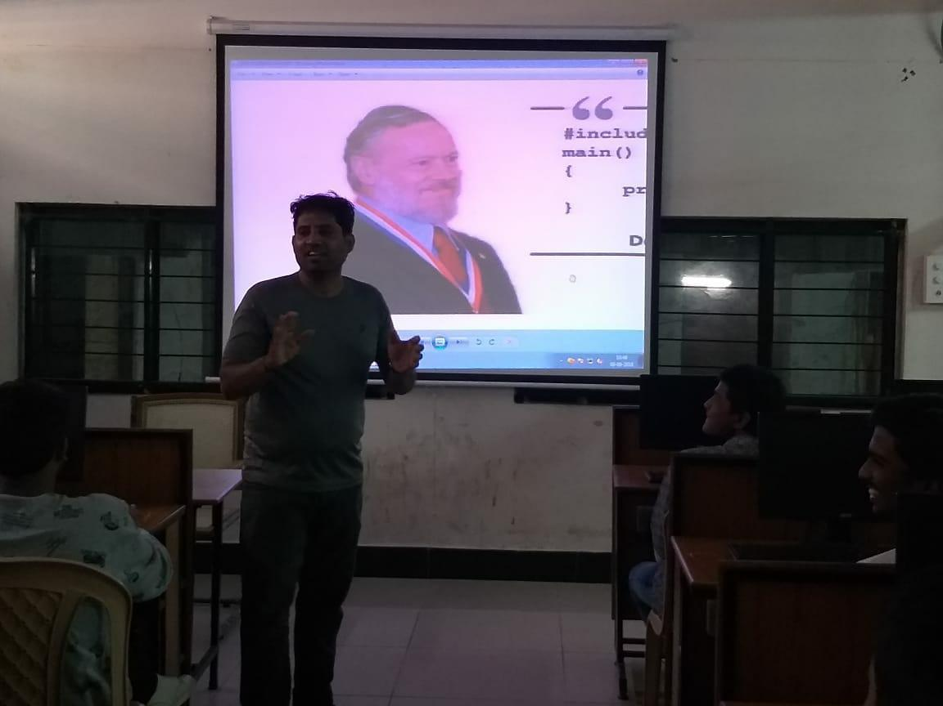 | 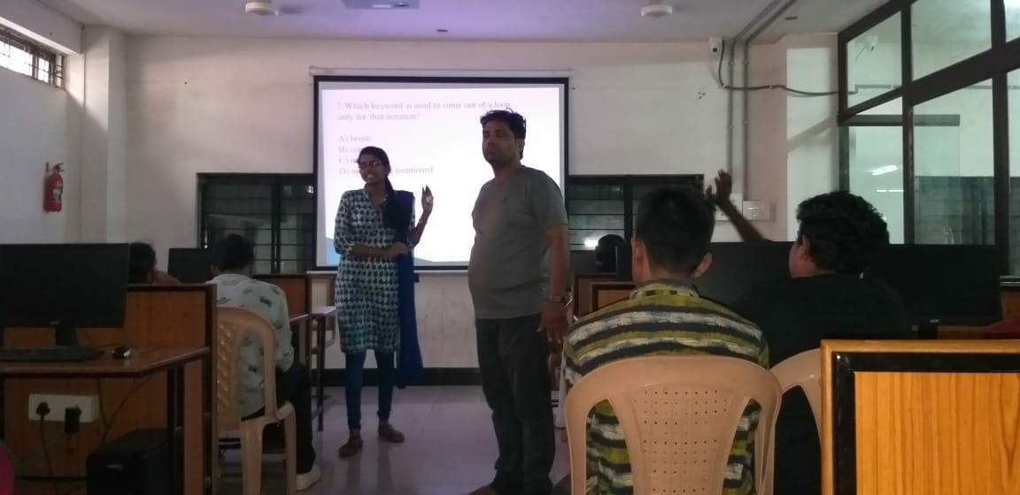
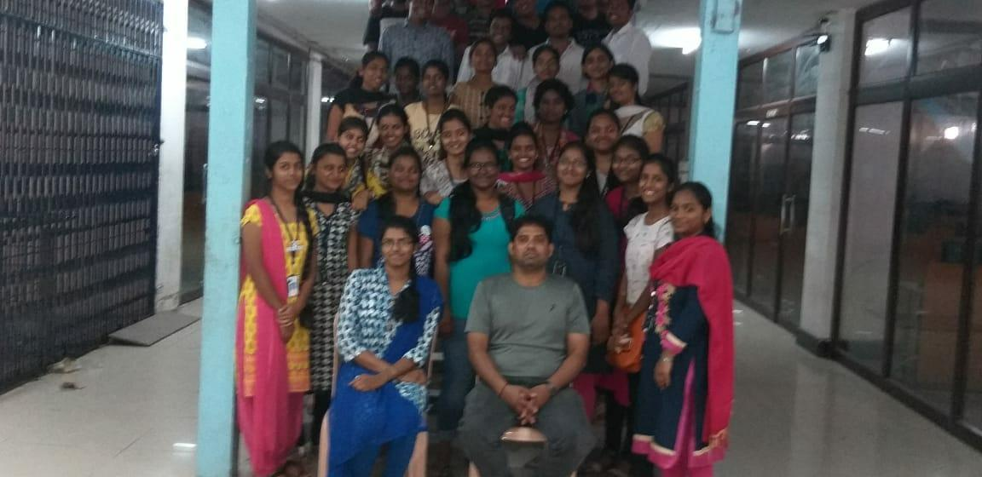 | 