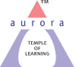
Aurora’s Degree & PG College
(Accredited by NAAC with 'B++' grade)
Chikkadpally,Hyderabad- 500020

NAME OF THE EVENT | TEACHERS’ DAY 2020
TYPE OF EVENT | VIRTUAL TEACHERS’ DAY
FACULTY INCHARGE | Dr. Meera Joshi
DATE& TIME | 5TH September,2020 11:00 AM onwards
VENUE (PLATFORM) | Google Meet
STUDENT CO-ORDINATOR | Captains of & First & Second Years
TARGET AUDIENCE | Faculty & Students of all 3 years

“Teaching is a very noble profession that shapes the character, caliber, and future of an individual.”
We would like to thank you for all the efforts you have put in to make us a better person in life.

INTRODUCTION:-

Institution of Teacher's Day in India, yearly celebrated at 5 September, Sarvepalli's birthday, in honour of Sarvepalli's belief that "teachers should be the best minds in the country".

Dr.Radhakrishnan (1888 — 1975) was an Indian philosopher. He was famous for his work on comparative religion, comparative Eastern and Western philosophy, and was also a teacher in India and at Oxford University in the United Kingdom. He was also a statesman and served as the President of India. He was a great teacher and due to his commendable inputs in India's educational front every year on his birthday, i.e 5th september, we all celebrate Teachers day to pay tribute to our teachers who are like a guiding light in our lives.

OBJECTIVE:-
Remembering Dr. Sarvepalli Radhakrishnan and honouring our teachers.

BRIEF ABOUT THE EVENT:-
Programme initiated with Remembering Dr. Sarvepalli Radhakrishnan.
Principal Sir addressed the gathering and wished all the best to the students for their future endeavours and also appreciated the students for their active participation in the events.
- Welcome video made by Ayush Chhabra – Captain 1st year Generals Section “C”.
- Welcome Speech by Dinky Bhandari from 3rd year Section “B”.
- Short talk by Akash Anthony & Prerna Sunaram from 3rd year SectionA & B respectively.
- Shayari by Pragati Oza – Cultural 1st year Generals Section “C”
- Short talk by Sudhanshu – Captain 2nd Year sharing his college life experience.
- Short talk by seniors (^{3rd} years) on their bonding with Faculty by Rubina Khatun, Payal Sharma, K. Chandravamshi from 3rd year.
- Shayari by Amar Nath – Cultural 2nd year Computers Section “C”
- Faculty –Students Video made by Captains of 1st & 2nd Year
- Vote of thanks by Ayush Chhabra – Captain 1st Year Generals Section “C”

- Student Coordinators
- B. Deepak
- R. Harshitha
- K. Sudhanshu
- Preethi Ash
- Mohammad Azhar Ali
- Ayush Chhabra

All the faculty members were invited with a beautiful virtual invitation card.

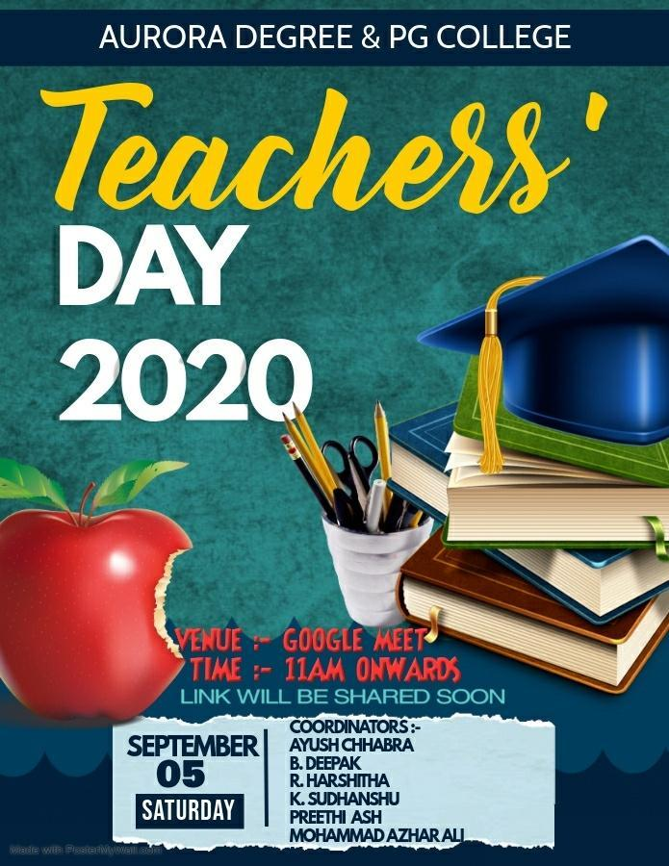

On 5th September, the event started at the Google meet and all the faculty members were warmly welcomed.
The event had various programs like welcome Shayari, Short talk by seniors, Sharing College like experience with faculties.

LIST OF THE PARTICIPANTS: Students of first, second & final year.
Programme started with Remembering Dr. Sarvepalli Radhakrishnan.
Principal Sir Dr. Vishwanadham Bulusu has addressed the gathering and wished the students for their great future and further endeavour’s. Also appreciated students for their dedication towards work.
Students spoke on their college journey, their experiences, learning, participation in various college activities, fun time. Also appreciated the faculty for their valuable support throughout college time. Students were also happy to be a part of Aurora and feel blessed as the college provided much support in various activates. 2nd year students also shared their experiences.
Final year student K. Chandravamshi who has been captain for last 2 years has expressed his experiences of being in the responsible role and said that college has given him the opportunity to take a lead and fulfil the duties of the captain which has built leadership skills and helped in enhancing the personality development.
Final year student Akash is a part of NSS, shared the importance of being in NSS and the college support and encouragement in various activities.
Final year student Niharika shared her experience of being a part of Aurora’s and the encouragement, support and opportunity helped her showcase her talent.
Prerna Sunaram started her experience with Guru Brahma Guru Vishnu Guru Devo Maheshwarah. All of them expressed that Aurora is the best place for the overall development of the students.
Welcome video made by Ayush Chhabra – Captain 1st year Generals Section “C”.
Ms. Pragati Oza of 1st year Generals Section “C” has performed a wonderful shayari on teachers’.
Also Mr. Amar Nath of 2 “C” had performed an indeed performance as Shayari on teachers.
Fantastic Faculty –Students Video made by Captains of 1st & 2nd Year
The event was concluded with a vote of thanks by Ayush Chhabra giving greetings to all the faculty members together once again.

EVENT PHOTOS
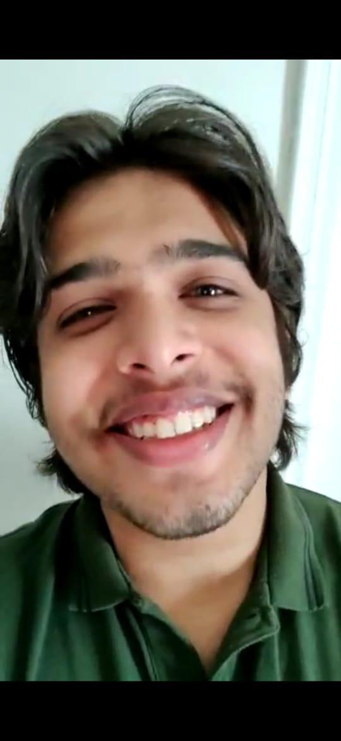
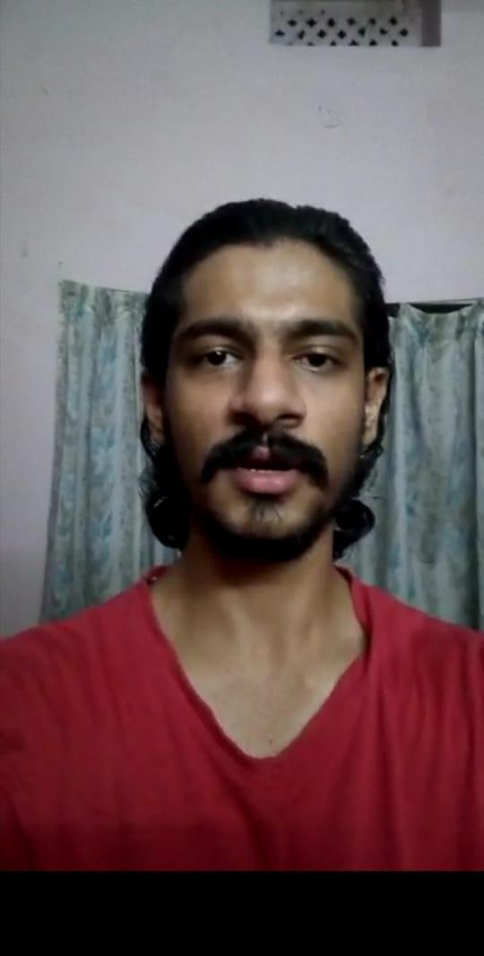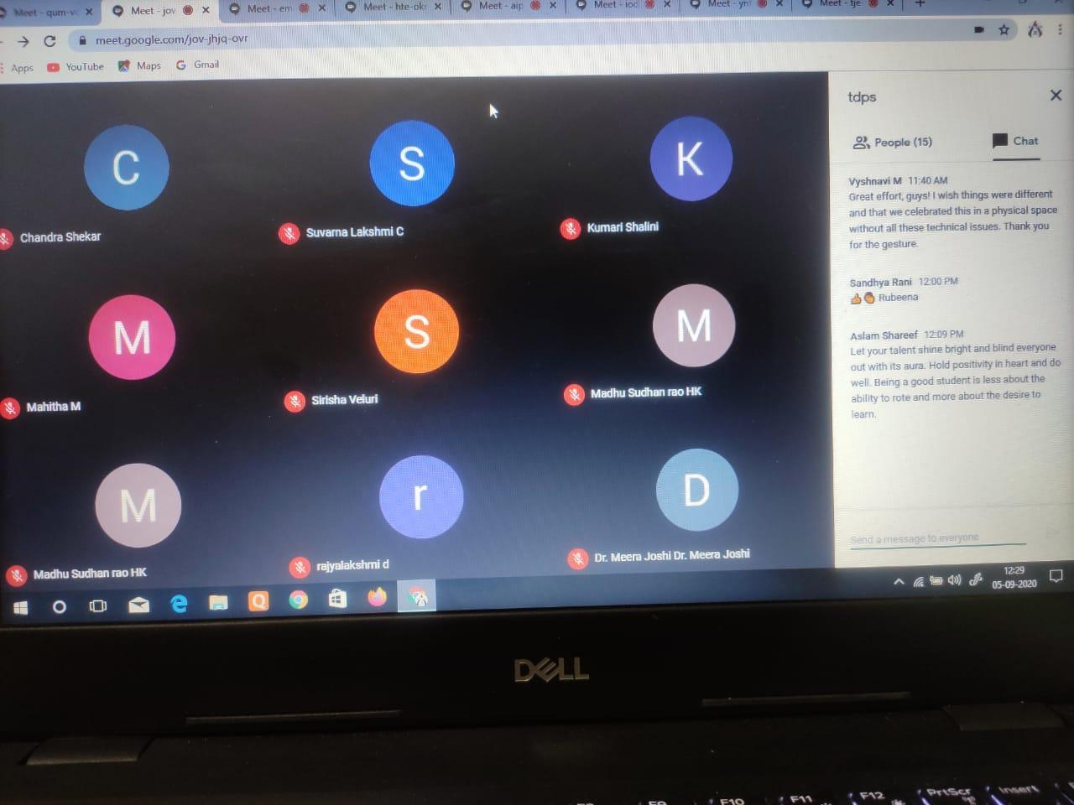
LINK FOR TEACHERS’ DAY:
https://drive.google.com/file/d/1ZqzoXrWXvwBYhvCQMIJwOnEgm5OcA-n9/view?usp=sharing
https://drive.google.com/file/d/1ZqzoXrWXvwBYhvCQMIJwOnEgm5OcA-n9/view?usp=sharing

Aurora's Degree& P.G. College
Chikkadpally, Hyderabad, Telangana-500 020.
(Accredited by NAAC with B++)

NAME OF THE EVENT | TEACHERS’ DAY 2020
TYPE OF EVENT | VIRTUAL TEACHERS’ DAY
FACULTY INCHARGE | Dr. Meera Joshi
DATE& TIME | 5TH September,2020 11:00 AM onwards
VENUE (PLATFORM) | Google Meet
STUDENT CO-ORDINATOR | Captains of & First & Second Years
TARGET AUDIENCE | Faculty & Students of all 3 years
(Accredited by NAAC with B++)

“Teaching is a very noble profession that shapes the character, caliber, and future of an individual.”
We would like to thank you for all the efforts you have put in to make us a better person in life.

INTRODUCTION:-

Institution of Teacher's Day in India, yearly celebrated at 5 September, Sarvepalli's birthday, in honour of Sarvepalli's belief that "teachers should be the best minds in the country".

Dr.Radhakrishnan (1888 — 1975) was an Indian philosopher. He was famous for his work on comparative religion, comparative Eastern and Western philosophy, and was also a teacher in India and at Oxford University in the United Kingdom. He was also a statesman and served as the President of India. He was a great teacher and due to his commendable inputs in India's educational front every year on his birthday, i.e 5th september, we all celebrate Teachers day to pay tribute to our teachers who are like a guiding light in our lives.

OBJECTIVE:-
Remembering Dr. Sarvepalli Radhakrishnan and honouring our teachers.

BRIEF ABOUT THE EVENT:-
Programme initiated with Remembering Dr. Sarvepalli Radhakrishnan.
Principal Sir addressed the gathering and wished all the best to the students for their future endeavours and also appreciated the students for their active participation in the events.
- Welcome video made by Ayush Chhabra – Captain 1st year Generals Section “C”.
- Welcome Speech by Dinky Bhandari from 3rd year Section “B”.
- Short talk by Akash Anthony & Prerna Sunaram from 3rd year SectionA & B respectively.
- Shayari by Pragati Oza – Cultural 1st year Generals Section “C”
- Short talk by Sudhanshu – Captain 2nd Year sharing his college life experience.
- Short talk by seniors (^{3rd} years) on their bonding with Faculty by Rubina Khatun, Payal Sharma, K. Chandravamshi from 3rd year.
- Shayari by Amar Nath – Cultural 2nd year Computers Section “C”
- Faculty –Students Video made by Captains of 1st & 2nd Year
- Vote of thanks by Ayush Chhabra – Captain 1st Year Generals Section “C”

- Student Coordinators
- B. Deepak
- R. Harshitha
- K. Sudhanshu
- Preethi Ash
- Mohammad Azhar Ali
- Ayush Chhabra

All the faculty members were invited with a beautiful virtual invitation card.

On 5th September, the event started at the Google meet and all the faculty members were warmly welcomed.
The event had various programs like welcome Shayari, Short talk by seniors, Sharing College like experience with faculties.

LIST OF THE PARTICIPANTS: Students of first, second & final year.
Programme started with Remembering Dr. Sarvepalli Radhakrishnan.
Principal Sir Dr. Vishwanadham Bulusu has addressed the gathering and wished the students for their great future and further endeavour’s. Also appreciated students for their dedication towards work.
Students spoke on their college journey, their experiences, learning, participation in various college activities, fun time. Also appreciated the faculty for their valuable support throughout college time. Students were also happy to be a part of Aurora and feel blessed as the college provided much support in various activates. 2nd year students also shared their experiences.
Final year student K. Chandravamshi who has been captain for last 2 years has expressed his experiences of being in the responsible role and said that college has given him the opportunity to take a lead and fulfil the duties of the captain which has built leadership skills and helped in enhancing the personality development.
Final year student Akash is a part of NSS, shared the importance of being in NSS and the college support and encouragement in various activities.
Final year student Niharika shared her experience of being a part of Aurora’s and the encouragement, support and opportunity helped her showcase her talent.
Prerna Sunaram started her experience with Guru Brahma Guru Vishnu Guru Devo Maheshwarah. All of them expressed that Aurora is the best place for the overall development of the students.
Welcome video made by Ayush Chhabra – Captain 1st year Generals Section “C”.
Ms. Pragati Oza of 1st year Generals Section “C” has performed a wonderful shayari on teachers’.
Also Mr. Amar Nath of 2 “C” had performed an indeed performance as Shayari on teachers.
Fantastic Faculty –Students Video made by Captains of 1st & 2nd Year
The event was concluded with a vote of thanks by Ayush Chhabra giving greetings to all the faculty members together once again.

EVENT PHOTOS

