Aurora’s Degree & PG College 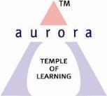
(ACCREDITED BY NAAC WITH 'B++' GRADE)
Chikkadpally, Hyderabad 500020

Event Name: Department Event
Event Title: Telangana Bhasha Dinosthavam
Cell Convener: K.Sujatha
Faculty coordinator: Dr.N. Suryakanthi
Date & Venue: 9th Sept, 2020, Aurora’s Degree &PG College.
Target audience: UG Students
Level: College Level
Budget: Nil
Objective:
The main aim of the event is to create awareness among the students about the richness imbibed in Language through Telangana Bhasha Danosthavam

Proposed activities:
Through Online Will Conduct Virtual Competitions like Elocution, Poetry Recitation along with a Power Point Presentation.

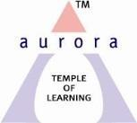

Aurora’s Degree & P.G College
(Accredited by NAAC with ‘B++’ grade)
Chikkadpally, Hyderabad 500020

NAME OF THE EVENT | TELANGANA BHASHA DINOSTHAVAM
FACULTY INCHARGE | Dr. N. Suryakanthi
DEPARTMENT | Languages
DATE | 9thSeptember, 2020
VENUE | Aurora’s Degree & PG College
TARGET AUDIENCE | Telugu Students

Objective: The main aim of the event is to create awareness among the Students about the Telangana Bhasha Dinosthavam

Brief about the event: Telangana BhashaDinosthavam was celebrated on 9thSeptember 2020 Aurora’s Degree & PG College. The event commenced with the introduction of the participants in the Google meet by our honorable Principal Sri.Viswanadham Bulusu , Vice- Principal Sri Sai Krishna. The convener of the event Dr. N. Suryakanthi (Telugu faculty) from Department of Languages will give an introduction speech about KALOJI NARAYANARAO, whose full name was “RAGHUVEERNARAYANLAKSHMIKANTH SRINIVAR RAO RAM RAJA KALOJI”.
Various Presentations like PPt, Songs, Dance and Videos organized through online meet. Student coordinators are Stallin-BtBiC- 3, Durga-BA- 3, Pavan - MPCS- 2C and
Sunny Paul- B.Comp Appli - 2D
Outcome: Students got to know about Kaloji Narayanarao through this event. According to Students view, conducting such events will give them awareness about the opportunities to showcase their talent which motivates and enhances in learning about the works and life of such eminent personalities of Telangana.

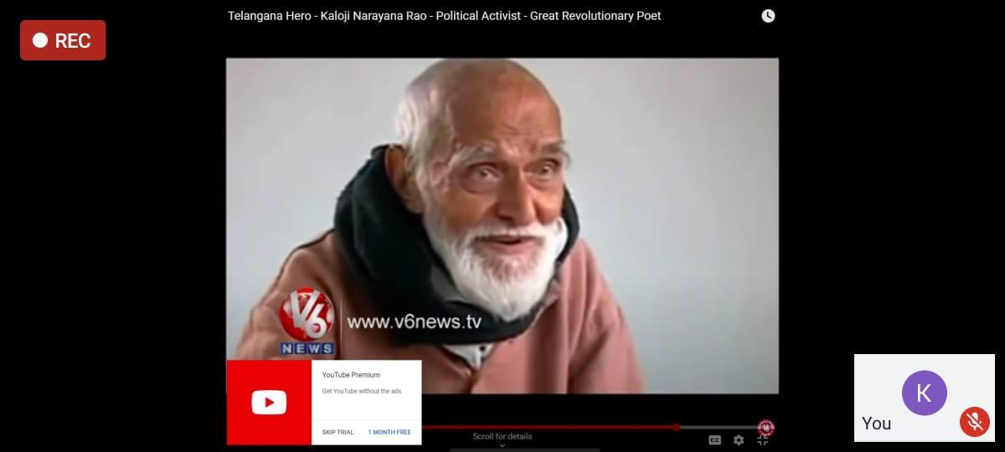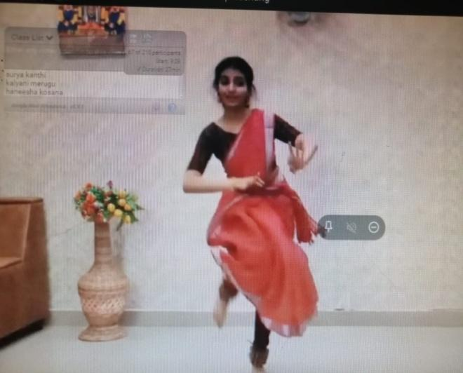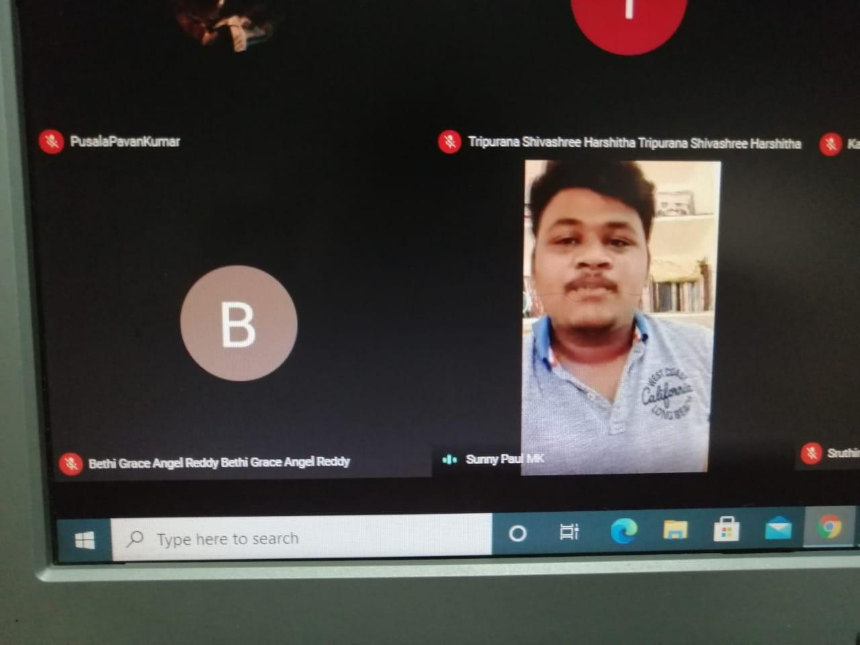

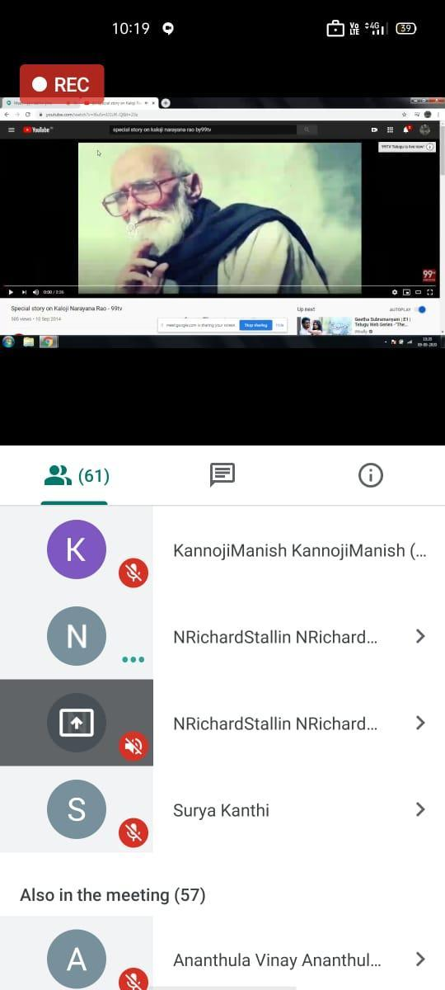

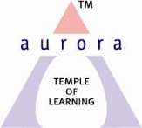

Aurora’s Degree & P.G College
(Accredited by NAAC with ‘B++’ grade)
Chikkadpally, Hyderabad 500020

Detailed Event Report of Telangana Bhasha Dinosthavam
.
Telangana Bhasha Dinosthavam was conducted by Dr. N. Suryakanthi, from Department of Languages on the 9thSeptember, 2020. All the students with their Language Telugu have participated in this event. The main aim of the event is to create awareness among the students about the Telangana Bhasha Dinosthavam
Telangana Bhasha Dinosthavam was celebrated on 9thSeptember 2020 at Aurora’s Degree & PG College, through Google Meet. The event commenced with the introduction of the participants and introductory speech by our honorable Principal Sri. Vishwanandam Bulusu , Vice- Principal Sri Sai Krishna.The convener of the event Dr. N. Suryakanthi (Telugu faculty) from Department of Languages gave an introductory speech about KALOJI NARAYANARAO, whose full name was “RAGHUVEERNARAYANLAKSHMIKANTH SRINIVAR RAO RAM RAJA KALOJI”.
Various Presentations like PPt, Songs, Dance and videos have been presented in Google meet.
Students got to know about Kaloji Narayanarao and his contribution to Telugu Language through this event. They also learnt and knew about the works and life of such eminent personalities of Telangana.

List of members coordinated :
S.No | Name | Section
2 | N.Richard Stallin | Bt.Bi.C -3B
3 | G.Naga Durga | BA - 3
4 | Pavan Kumar | MPCs - 3C
5 | Sunny Paul | B.com Appli -2D

Event Schedule:
- 09:30 am - Dr. N. Suryakanthi convener and Associate professor from Department of Languages started the event allowing the participants to join.
- 09:40 am - Welcome address and Introduction of Dr. Viswanadham Bulusu
- 09:45 am -A Classical dance video shown by Nagadurga
- 10:00 am - A song by Sunny Paul
- 10:10 am - A PPt representation by P. Pavan Kumar
- 10:25 am - A Video of ‘Kaloji’s Mukhamukhi' shown by Dr. N. Suryakanthi
- 10:40 am - Vote of thanks given by Richard Stallin
Conclusion of the event:
The event and its importance and why it is celebrated was briefed and presented to the students to enlighten them about the greatness and richness encompassed in the Telugu Language. The well known Statement, “Desha Bhashalandu Telugu Lessa” enchances the greatness and richness of Telugu Language. The event concluded by enriching the Students with the above mention Concepts.
Number of Students Participated in Event : 82

List of Boy Participants : 63
S.NO | Name of the Student
 | Shaik Nayimuddin
 | Shaik Mohammad Khadar
 | Mohammed Muzakkir
 | Vadde Shivakumar
 | Gaddam Adithya
 | Shaik Muqheet Aadil
 | Meda Siva Sai
 | Ananthula Vinay
 | Rongali Mohan
 | P Sai Kiran
 | Gullipalli Arjun
 | Kolisetty Chaitanya
 | Garlapati Hemanth Raj
 | Konkal Laxminarayanareddy
 | Sreerama Venkata Sai Pavan Kalyan
 | Avusula Vignan
 | B Mangala Sandeep
 | andapally Sri Phaneesh
 | Deshavath Mahesh Babu Naik
 | Sonnapuwar Saketh

21 |  | Puram Abhilash
22 |  | Gangapuram Akshaya
23 |  | Kummara Narendra Babu
24 |  | Karnakanti Udhay Kumar
25 |  | Sattiraju Naga Sai Sri Charan
26 |  | Praveen Kumar
27 |  | Gone Vinay Reddy
28 |  | Pulagam Uday Kumar
29 |  | Neela Sumanth Mudhiraj
30 |  | Thota Lohit Sai
31 |  | Regati Yashwanth
32 |  | Poola Vaishnavi
33 |  | Vadthyavath Anand
34 |  | Kanaparthi Rishikraj
35 |  | Shaik Sohail
36 |  | Thodupunoori Ruchitha
37 |  | Palle Sridhar
38 |  | G Sandhya Reddy
39 |  | Gaddam Prathap
40 |  | T Ashritha
41 |  | Gangula Siddhartha
42 |  | Gutti Arun Kumar
43 |  | P Shivakumar
44 |  | Nitta Mallesh
45 |  | Sirusanagandla Shivarag
46 |  | Kura Siddhartha
47 |  | Mahankali Sanjay
48 |  | Madi Sai Ram Reddy
49 |  | Lingala Maniraj Goud
50 |  | Padigela Praveen Kumar
51 |  | Madi Sai Ram Reddy
52 |  | Lingala Maniraj Goud
53 | Padigela Praveen Kumar
54 | Gudala Akhil
55 | Kala Lalitha Tripura Sundari
56 | G Vinod Kumar
57 | Bethi Grace Angel Reddy
58 | Bingi Jayanth
59 | Dappu Aravind Babu
60 | Ekaamber Kaveti
61 | Gaddala Sairushikanth
62 | Manga Reshwanth Kumar
63 | Akash Pondicherry

List of Girl Participants : 19

1 | Surasani Tejaswini
2 | Sheguri Madhavi
3 | Nagandla Rishitha
4 | Kandela Gaddam Sruthi
5 | Puram Abhilash
6 | Kadapalla Pooja
7 | Sariyam Usha
8 | Challa Sravani
9 | Gudise Sushma
10 | N Shivani
11 | Kantekar Vamshi Krishna
12 | Pottabathni Sanjana
13 | Kondu Prathyusha
14 | Yacham Harshitha
15 | Tripurana Shivashree Harshitha
16 | Gaddaraju Keerthana
17 | Palleni Sruthi
18 | Chirravuri Vaishnavi
19 | Godaba Sai Gnapika

Budget : Nil

Photographs :

