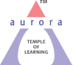
Aurora’s Degree & PG College
(Accredited by NAAC with 'B++' grade)
Chikkadpally,Hyderabad- 500020
Department of Computer Science

EVENT REPORT

EVENT TITLE | Dennis Ritchie Birth Day
TYPE OF EVENT | Department
FACULTY INCHARGE | NavneethaN
DEPARTMENT | Computer Science
DATE | 9.9.2020
VENUE | Online Live PPT PresentationcompetitonGoogle Meet
TARGET AUDIENCE | Intercollege students

OBJECTIVE:
This event has been organized to provide and share awareness to the students about Dennis Ritchie, “Father of the C programming language” and about his contributionsto UNIX which has ported to different machines and platforms.

BRIEF ABOUT THE EVENT:
We started circulating link for registrations on 5.9.2020 forStudents of different States .
Over all 30 students have been registered .
The students who have registered are asked to send ppts by 8.9.2020.from those ppts we have chosen 5 students and asked them to give live presentation on 9.9.2020 at 3.30pm among those 5 studentts we have choosenkarthiksanjay from mpcs2a of Aurora degree and Pg college as a winner
OUTCOME:
The Best Presentation got the E-Certificate

PHOTOGRAPH:
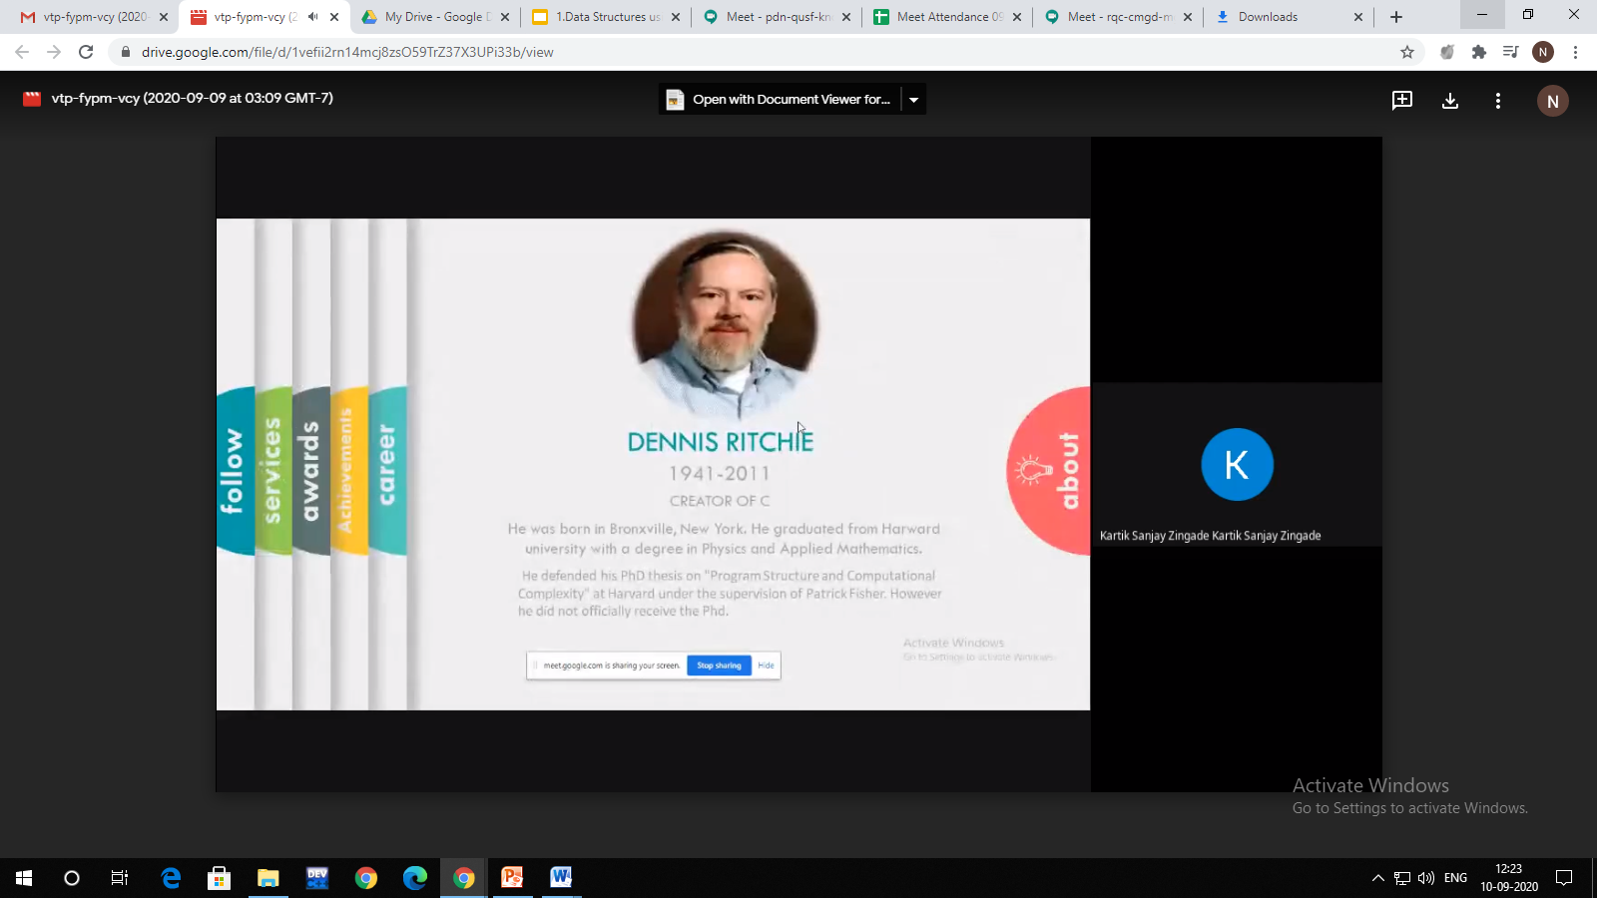

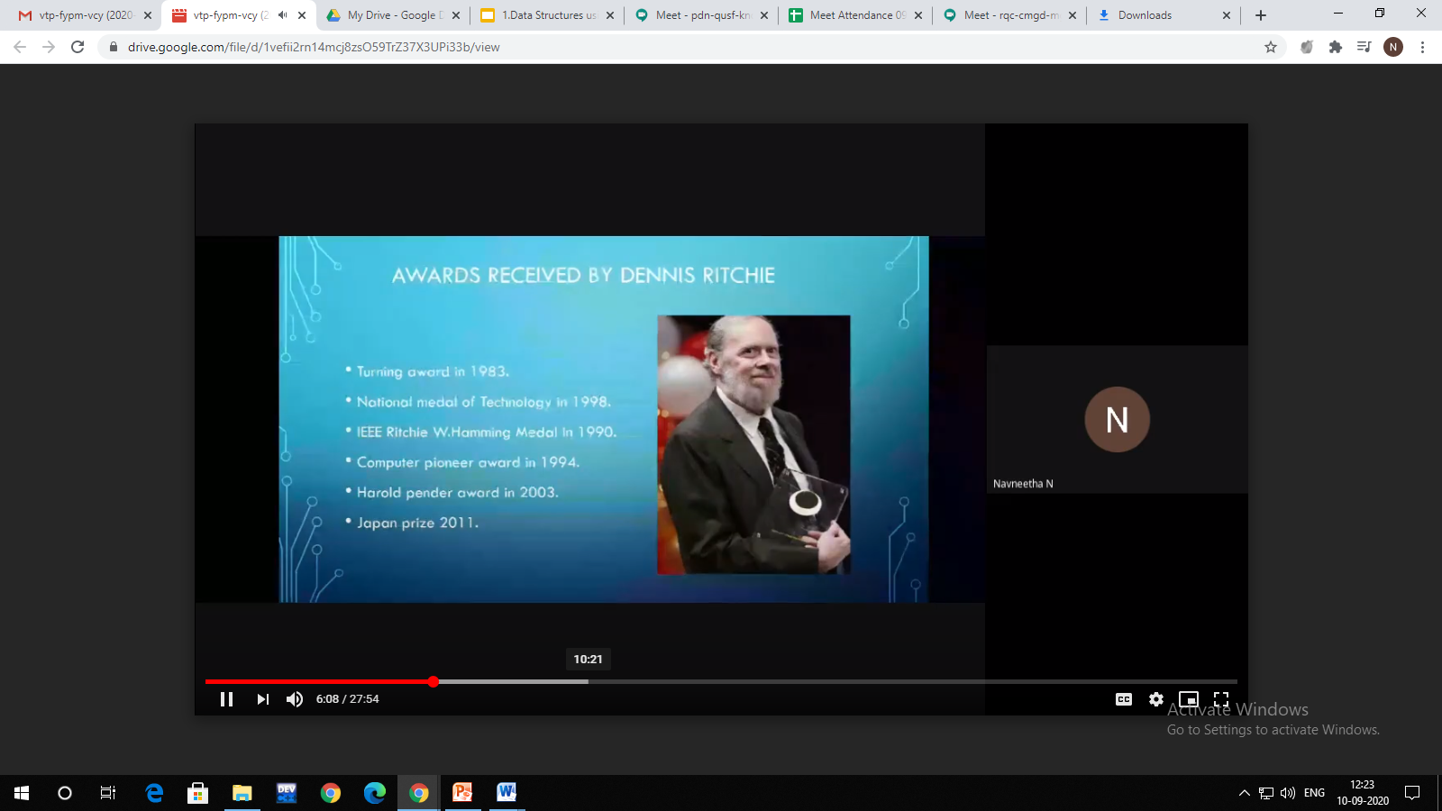

DETAILED REPORT

Title: Dennis Ritchie Birthday
Coordinator: NavneethaN
Venue: Online live Presentation in Google Meet
We started circulating the link for presentationcompetiton on “Dennis Ritchie contributions and achievements in the world of programming “ to different college students
Over all 30 students have been registered for the competiton
The students who have registered are asked to send ppts by 8.9.2020.from those ppts we have chosen 5 students all are from and asked them to give live presentation on 9.9.2020 at 3.30pm among those 5 studentts we have choosenkarthiksanjay from mpcs2a of Aurora degree and Pg college as a winner

Out Come:
The Best Presentation got the E-Certificate

List of Students who have Participate

NAME | ROLLNO | EMAIL ID | PHNO
Amarnath | 105118402163 | Sampath2809@gmail.com | 8919070113
Kartik Sanjay zingade | 105119468003 | zingadekartik@gmail.com | 9550339721
A.Manisha | 105118402007 | avulamanisha9919@gmail.com | 8919521330
Ashish Singh | 105118467042 | mashishsingh18@adc.edu.in | 9391792784
Rishitha | 105119474147 | gpavankumar32@gmail.com | 7386322411

