Aurora’s Degree and PG College 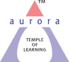
(ACCREDITED BY NAAC WITH ‘B++’ GRADE)
Chikkadpally, Hyderabad 500020
Cultural Committee
EVENT PROPOSAL
for

Tribute to Late S P Bala Subramanyam

Event/Activity Name: Tribute to Late SP Bala Subramanyam

Event/Activity Title: Tribute to Late SP Bala Subramanyam
Cell / Committee/Club Convener/facilitator: Mr Aslam Shareef
Faculty coordinators: Sandhya Rani G
Date: 29-09-2020
Venue: Aurora’s Degree and Pg College
Target audience: Faculty & Students
Platform: Online- Google Meet
Level: National level
Student Volunteer’s: None
Objective: To pay tribute to the Great Singer.
Proposed activities:
- PPT presentation.
- Inviting students, faculty and Alumni to render composition of Shree SP Bala Subramanyam Garu.
Guest/Speaker details: NIL
Budget: NIL
Cultural Convener IQAC Coordinator Principal
Aslam Shareef Dr. Ravi Kiran Dr. Viswanadham Bulusu
Aurora’s Degree & PG College
(ACCREDITED BY NAAC WITH 'B++' GRADE)
Chikkadpally, Hyderabad 500020

EVENT / ACTIVITY SHORT REPORT

NAME OF THE EVENT / ACTIVITY | TRIBUTE TO SP BALASUBRAMANYAM
TYPE OR TITLE OF EVENT / ACTIVITY | TRIBUTE TO SP BALASUBRAMANYAM
FACULTY IN CHARGE | SANDHYA RANI G
DEPARTMENT/CELL/COMMITTEE/CLUB | CULTURAL COMMITTEE
DATE | 29/09/2020
VENUE | GOOGLE MEET
TARGET AUDIENCE | FACULTY, STUDENTS, AND ALUMNI

OBJECTIVE: To give tribute to the great legendary singer.Late Shree S P BALASUBRAMANYAM by remembering him with his songs.

BRIEF ABOUT THE EVENT: As recently SP BALASUBRAMANYAM Garu has passed away. In his remembrance, the cultural committee with the help of alumni and students have organized the event. Faculty, students, and members from outside have participated in the event which was conducted through google meet in the afternoon from 01:30 p.m to 02:30 pm.
OUTCOME: The event was successfully conducted as per schedule.
PHOTOGRAPH:
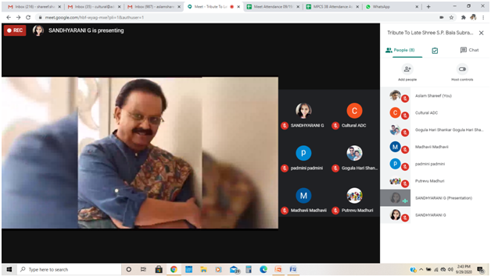

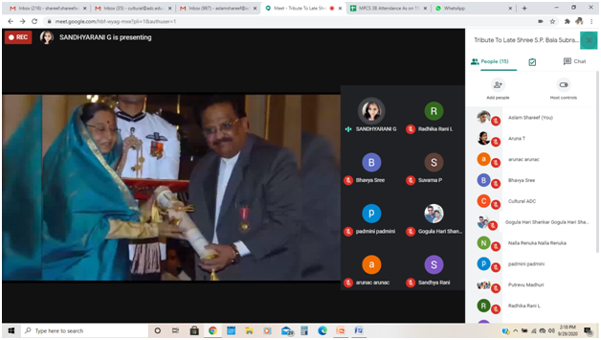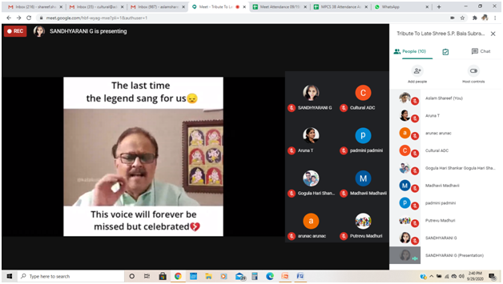

Aurora’s Degree & PG College
(ACCREDITED BY NAAC WITH 'B++' GRADE)
Chikkadpally, Hyderabad 500020

DETAILED REPORT

NAME OF THE EVENT / ACTIVITY | TRIBUTE TO SP BALASUBRAMANYAM
TYPE OR TITLE OF EVENT / ACTIVITY | TRIBUTE TO S P BALASUBRAMANYAM
FACULTY INCHARGE | SANDHYA RANI G
DEPARTMENT/CELL/COMMITTEE/CLUB | CULTURAL COMMITTEE
DATE | 29/09/2020
VENUE | GOOGLE MEET
TARGET AUDIENCE | STUDENTS ,FACULTY AND ALUMNI

- PROGRAM SCHEDULE

S.NO | SCHEDULED PROGRAMME
1. | Introduction Of the event by Sandhya Rani G
2. | Power point presentation on SPB
3. | Video clip on SPB
4. | Video clip on SPB songs
5. | Song Performed by Alumni ,Narender Prajapathi
6. | Video Clip on SPB about his singing career in hindi
7. | Song performed by Aparna pyaram from BCOM 3A
8. | Video clip on SPB with telugu speech.
9. | Song performed by Sri Vaishnavi
10. | SPB Video showing voice for kamal hassan
11. | Video clip showing the best songs of SPB
12. | Video clip showing SPB singing for last time.
13. | Vote of thanks by Aslam Shareef

- LIST OF FACULTY COORDINATORS (DEPARTMENT)

S.NO | FACULTY COORDINATOR
1 | SANDHYA RANI G

- LIST OF THE STUDENT COORDINATORS: NILL
- LIST OF THE PARTICIPANTS:

S.NO | NAME OF THE PARTICIPANT | CLASS & SECTION
1 | Aslam Shareef | -
2 | Cultural ADC | -
3 | Cultural ADC | -
4 | Sistla Sailaja Sistla Sailaja | -
5 | Hari Krishna Desu | -
6 | SANDHYARANI G | -
7 | Kunduru Sudhanshu | -
8 | Sandhya Rani | -
9 | Shiva Shanker G | -
10 | Bhavya Sree | -
11 | Gogula Hari Shankar Gogula Hari Shankar | -
12 | Suvarna P | -
13 | AAnagha AAnagha | -
14 | padmini padmini | -
15 | Manasa b | -
16 | santosh reddy | -
17 | sravan kumar r | -
18 | Dr. Meera Joshi Dr. Meera Joshi | -
19 | Madhavi Latha P | -
20 | Madhavii Madhavii | -
21 | Poornachander P Poornachander P | -
22 | Radhika Rani L | -
23 | Soumya Mohan | -
24 | Udaya Sree | -
25 | unnamalai C | -
26 | Aruna T | -
27 | Madhavi Bulusu | -
28 | Putrevu Madhuri | -
29 | Radhika Diddi | -
30 | Avinash Rangineni | -
31 | arunac arunac | -
32 | Nalla Renuka Nalla Renuka | -
33 | srikrishnamohan | -

- PARAGRAPH ABOUT THE PROCEEDINGS :
As SP Balasubramanyam garu has passed away on 25th September 2020 and we have lost a great singer, the committee have planned to give a tribute to S P Balasubramanyam garu. As planned committee convenor aslam shareef has given a proposal and discussed the same with principal sir and after principal sir approval ,it was informed to vice principal sir to upload it on the college website. Vice principal sir has uploaded it on the college website and an invitation was sent to all the faculty members through cultural mail ID.and also created google meet link and sent it to faculty and students.
As planned the program started at 01:30 sharp by the cultural committee. The faculty coordinator of the event sandhya has given the welcome speech and presented the Powerpoint presentation about S P Balasubramanyam. After that a few videos were played on SPB which represented his songs, his singing career,acting career and so on. Sri Vaishnavi student of aurora degree college from BtBic has performed a song on SPB and college alumni Narender prajapathy has sung a song on SPB song from the movie Roja.Later another student from final year from B.COM Generals 3A Aparna pyaram has also performed a song on SPB. Speech was given in telugu by playing a video on the background by faculty coordinator Ms.Sandhya .The program was actually scheduled for half an hour but it has extended to another half an hour with more videos on SPB. Program has ended at 02:30 pm by vote of thanks given by cultural convenor Mr.Aslam Shareef.

- INCOME AND EXPENDITURE: NILL
- EVENT PHOTOS :

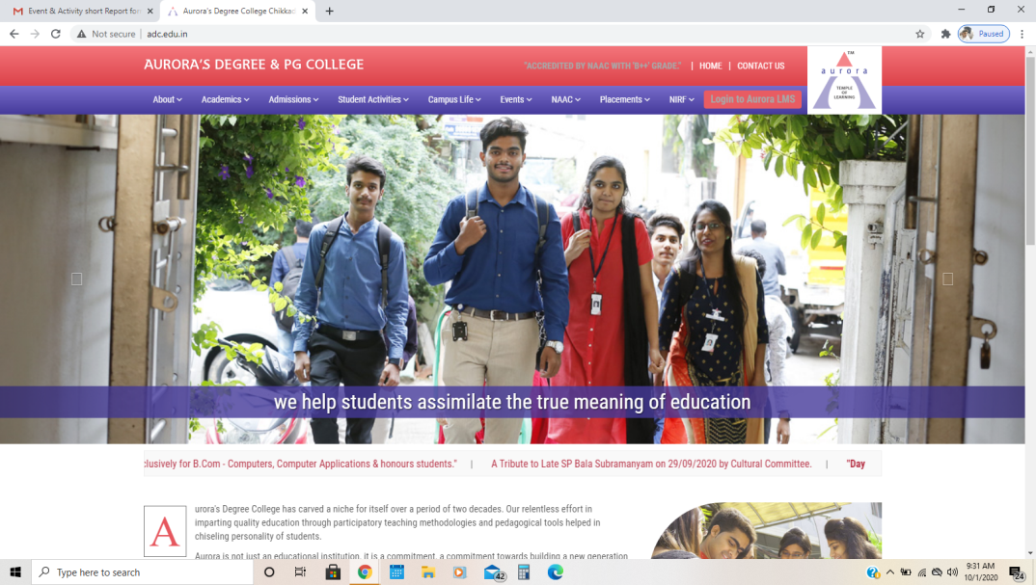

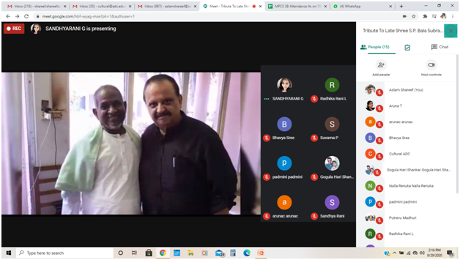

- GUEST PROFILE (IF ANY): NONE
- FEED BACK IF ANY: NONE
- ATTACHMENTS:
EVENT/ACTIVITY PROPOSAL
EVENT / ACTIVITY NOTICE
RECEIPTS - NONE
CERTIFICATES - NONE
LETTERS OF COMMUNICATION - NONE

