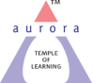
Aurora’s Degree & PG College
(ACCREDITED BY NAAC WITH 'B++' GRADE)
Chikkadpally,Hyderabad- 500020
Department of Computer Science

EVENT REPORT

EVENT TITLE | International Day For Natural Disaster Reduction
TYPE OF EVENT | Class
FACULTY INCHARGE | A.Madhupriya
DEPARTMENT | Computer Science
DATE | 13/10/2020
VENUE | Online(Google Meet)
TARGET AUDIENCE | Students

OBJECTIVE: Held every 13 October, the day celebrates how people and communities around the world are reducing their exposure to disasters and raising awareness about the importance of reining in the risks that they face.
BRIEF ABOUT THE EVENT:Event started at 3:00,Total 92 students have attended and 5 students gave Power Point presentations on basics of Natural and raising awareness about the importance of reining in the risks that they face.
OUTCOME: Students got the awareness, education, preparedness, and prediction and warning systems can reduce the disruptive impacts of a natural disaster on communities. Mitigation measures such as adoption of zoning, land-use practices, and building codes are needed, however, to prevent or reduce actual damage from hazards.
Detailed Report: International Day For Natural Disaster Reduction day is Conducted to get the awareness, education, preparedness, and prediction and warning systems can reduce the disruptive impacts of a natural disaster on communities. Mitigation measures such as adoption of zoning, land-use practices, and building codes are needed, however, to prevent or reduce actual damage from hazards.On this occasion Power Point presentations are conducted in online through Google Meet.
Session started at 3:00 PM. Total 92 Students have participated .Few students K. Pravalika from Bt.Bi.C 3B,G.Sai Poojitha from Mi.G.C 3B , S. Akshitha from B.Com honor’s 2B, B. Harshini from B.Com honor’s 2Aand J.Surekha from MPCS3A have given power point presentation .
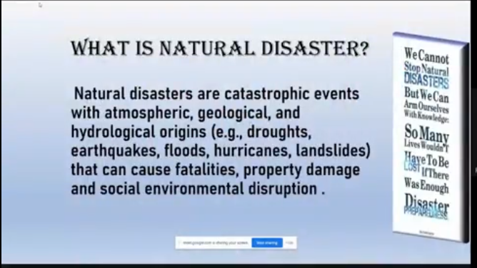
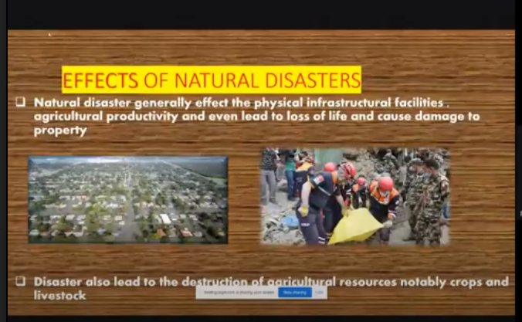
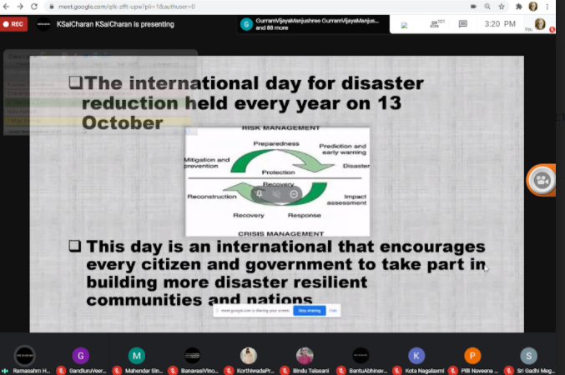

PHOTOGRAPH:
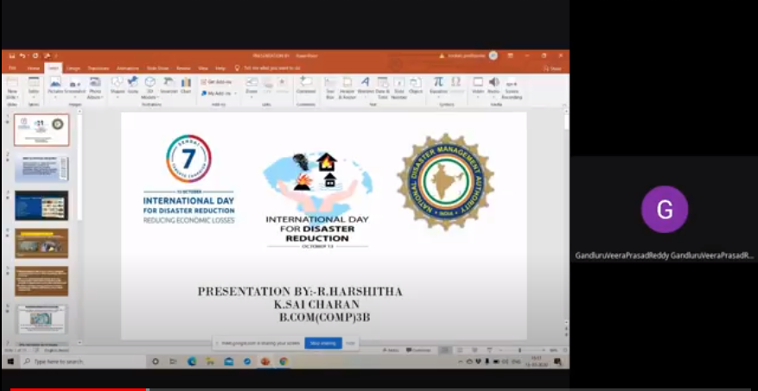

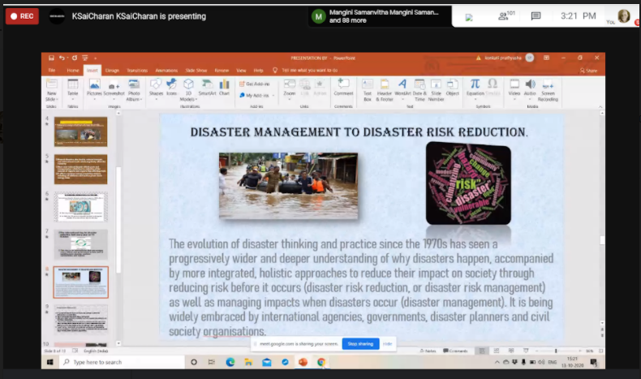

Detailed Report: International Day For Natural Disaster Reduction day is Conducted to get the awareness, education, preparedness, and prediction and warning systems can reduce the disruptive impacts of a natural disaster on communities. Mitigation measures such as adoption of zoning, land-use practices, and building codes are needed, however, to prevent or reduce actual damage from hazards.On this occasion Power Point presentations are conducted in online through Google Meet.
Session started at 3:00 PM. Total 92 Students have participated .Few students K. Pravalika from Bt.Bi.C 3B,G.Sai Poojitha from Mi.G.C 3B , S. Akshitha from B.Com honor’s 2B, B. Harshini from B.Com honor’s 2Aand J.Surekha from MPCS3A have given power point presentation .

