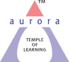
Aurora’s Degree & PG College
(Accredited by NAAC with 'B++' grade)
Chikkadpally, Hyderabad- 500020
Department of Management

EVENT REPORT

EVENT TITLE | Mr. Peter Drucker’s Birthday Celebration
TYPE OF EVENT | Class event-Power point presentation & quiz
FACULTY INCHARGE | Mrs. Soumya Mohan
DEPARTMENT | Management
DATE | 5th Dec 2020
VENUE | Aurora’s Degree and PG College
TARGET AUDIENCE | Students

OBJECTIVE: To celebrate the life and contributions of Mr.Peter Drucker on the occasion of his birthday.
BRIEF ABOUT THE EVENT: The event was conducted on Google meet platform with students preparing a power point presentation about Mr.Peter Drucker. They shared aspects from his personal & professional life and spoke of his various achievements & contribution to management . The presentations were followed by two quizzes compiled by Gnapika, Rachana & Shruthi with much enthusiastic participation by the entire class.
OUTCOME: The students learnt about the various contributions by Mr.Drucker to the field of management.
PHOTOGRAPH:
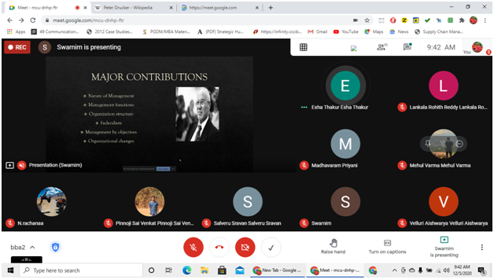
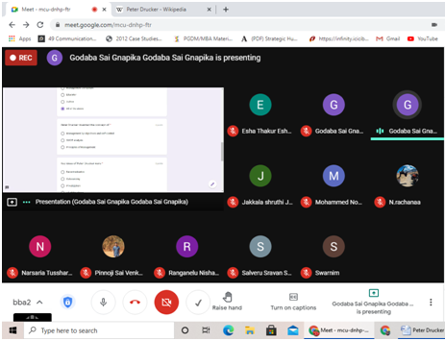

Aurora’s Degree & PG College
(ACCREDITED BY NAAC WITH 'B++' GRADE)
Chikkadpally, Hyderabad 500020

EVENT / ACTIVITY DETAILED REPORT

NAME OF THE EVENT / ACTIVITY | Mr. Peter Drucker’s Birthday Celebration
TYPE OR TITLE OF EVENT / ACTIVITY | Class event-Powerpoint presentation & quiz
FACULTY INCHARGE | Mrs. Soumya Mohan
DEPARTMENT/CELL/COMMITTEE/CLUB | Management
DATE | 5th Dec 2020
VENUE | Aurora’s Degree and PG College
TARGET AUDIENCE | Students

OBJECTIVE: To celebrate the life and contributions of Mr.Peter Drucker on the occasion of his birthday.
BRIEF ABOUT THE EVENT: The event was conducted on Google meet platform with students preparing a powerpoint presentation about Mr.Peter Drucker. They shared aspects from his personal & professional life and spoke of his various achievements & contribution to management . The presentations were followed by two quizzes compiled by Gnapika, Rachana & Shruthi with much enthusiastic participation by the entire class.
OUTCOME: The students learnt about the various contributions by Mr.Drucker to the field of management.
PHOTOGRAPHS:
- LIST OF FACULTY COORDINATORS (DEPARTMENT) : Mrs. Soumya Mohan
- LIST OF THE STUDENT COORDINATORS (NAME , ROLL NO, CLASS & SECTION) :

Name | Roll No. | Class & Section
Esha Thakur | 1051-19-684-129 | BBA 2C
Swarnim | 1051-19-684-123 | BBA 2C
P Rakesh | 1051-19-684-151 | BBA 2C
Gnapika | 1051-19-684-168 | BBA 2C
Rachana | 1051-19-684-133 | BBA 2C
Shruthi | 1051-19-684-148 | BBA 2C
Supraja | 1051-19-684-136 | BBA 2C

- LIST OF THE PARTICIPANTS (NAME , ROLL NO, CLASS & SECTION, NO OF GIRLS, BOYS, CASTE ) :

Name | Roll No. | Class & Section | Gender | Caste
Esha Thakur | 1051-19-684-129 | BBA 2C | Female | BC-B-G
Swarnim | 1051-19-684-123 | BBA 2C | Female | OC-G
P Rakesh | 1051-19-684-151 | BBA 2C | Male | BC-D-B
Gnapika | 1051-19-684-168 | BBA 2C | Female | BC-D-G
Rachana | 1051-19-684-133 | BBA 2C | Female | SC-G
Shruthi | 1051-19-684-148 | BBA 2C | Female | BC-D-G
Sravan | 1051-19-684-155 | BBA 2C | Male | BC-D-B

- DETAILED REPORT:
The event was kick started by Esha & Swarnim who prepared a powerpoint presentation about Mr.Peter Drucker & shared knowledge with their classmates on the great personality. They shared aspects from his personal & professional life and spoke of his various achievements & contribution to management . Contributions like management by objectives, federalism, organisational structure and organisational changes were explained in detail by the participants.

Esha & Swarnim were followed by Sravan who had also prepared a powerpoint presentation in collaboration with Rakesh. Excellent points on Mr. Drucker’s contributions were covered by both the teams.
The presentations were followed by two quizzes compiled by Gnapika, Rachana & Shruthi with much enthusiastic participation by the entire class.
The event concluded by the participants presenting the life and work of Mr. Peter Drucker to the fresher batches of BBA & BCOM, who were very enthusiastic to learn from their seniors & meet them even if it was a virtual meeting.

- BUDGET PLAN : Nil
- EVENT PHOTOS ( MIN 2 MAX 4)
