Aurora’s Degree & PG College
(ACCREDITED BY NAAC WITH 'B++' GRADE)
Chikkadpally, Hyderabad 500020

EVENT / ACTIVITY SHORT REPORT

NAME OF THE EVENT / ACTIVITY | “International Day For Socio-Economic Development”
TYPE OR TITLE OF EVENT / ACTIVITY | Class event
FACULTY INCHARGE | Dr. M. Kanchanmala
DEPARTMENT/CELL/COMMITTEE/CLUB | Management
DATE | 5/12/2020
VENUE | Aurora`s Degree & PG College
TARGET AUDIENCE | BBA1st Year Students

OBJECTIVE: : To communicate to the target audience about the socio-economic development of our country.
BRIEF ABOUT THE EVENT: On the day of the event Students were told about the importance of the
Socio-Economic Development of our nation and its contribution in the overall growth of the nation.
Students were asked to express their views through participating online in the following two activities.
- Elocution
- Poster presentation (Digital or Manual)
OUTCOME: Students participated enthusiastically and have learned various aspects and ways of socio-economic development of our country. They also have understood their role as citizen of the country and their contribution towards the development of our nation.

PHOTOGRAPH:
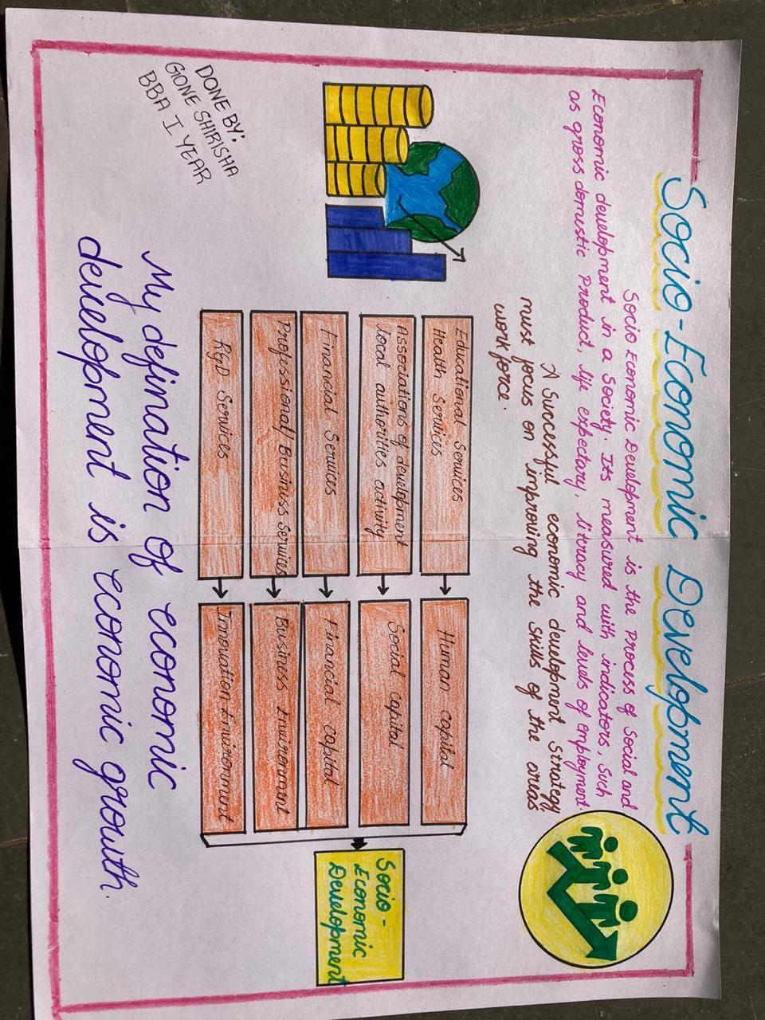

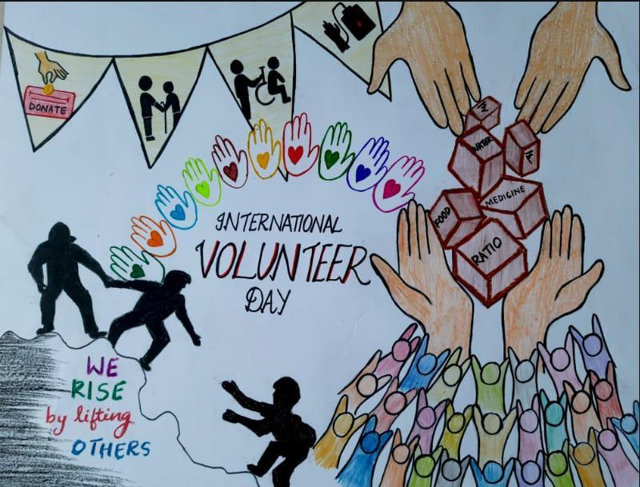

Aurora’s Degree & PG College 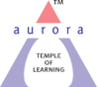
(ACCREDITED BY NAAC WITH 'B++' GRADE)
Chikkadpally, Hyderabad 500020

EVENT / ACTIVITY LONG REPORT

NAME OF THE EVENT / ACTIVITY | “International Day For Socio-Economic Development”
TYPE OR TITLE OF EVENT / ACTIVITY | Class event
FACULTY INCHARGE | Dr.M.Kanchanmala
DEPARTMENT/CELL/COMMITTEE/CLUB | Mrs.K.Sujatha
DATE | 5/12/2020
VENUE | Aurora`s Degree & PG College
TARGET AUDIENCE | BBA1st Year Students

- Program schedule:10.30 am to 2.00 pm
- List of faculty coordinators : Dr. Kanchanmala M.( Depart of management)
- List of student coordinators : Kasturi Tejo Manasa
Roll no- 1051-18-684-113
BBA 3B

- List of participants: Class Activity

Mounika Yadhav BBA 1 video
Tejaswini BBA 1 video
Vinay Kumar Goud BBA 1 video
Sampula Sai Sudheer BBA 1 video
Rangu Uday Kiran BBA 1 video
Tarun Reddy BBA 1 video
Anisha BBA 1 video
Ruchitha Goli BBA 1 video
Yashwanth Kumar BBA 1 video
Navneeth BBA 1 video
Sairam BBA 1 video
Supraja BBA 1 video
Sai Charan BBA 1 poster-handmade
Sanjay Kaushik BBA 1 poster - handmade
Srinidhi Manthri BBA 1 poster - handmade
Gone Shirisha BBA 1 poster - handmade
Pranati Manthri BBA 1 poster - handmade
Ashritha BBA 1 poster - handmade
Akhil Rohan BBA 1 poster- digital
Maniteja BBA 1 poster- digital
Yashwanth Kumar BBA 1 poster-digital
Sairam BBA 1 poster- digital

(Roll numbers and class not yet allotted)

- Paragraph about the proceedings: The event was held on the occasion of socio economic development day on 7th December 2020. Students participated in poster making and video making activities. Dr.Kanchanmala was the faculty in charge of this event and K. Manasa was the student coordinator who communicated to students about the event (online medium), collected work from participants, arranged them and forwarded it to the faculty coordinator. Students were given time of 4 hours to prepare their content. The work was submitted by the end of that day i.e 5th December.

- Income and expenditure: NIL

- Event Photos :

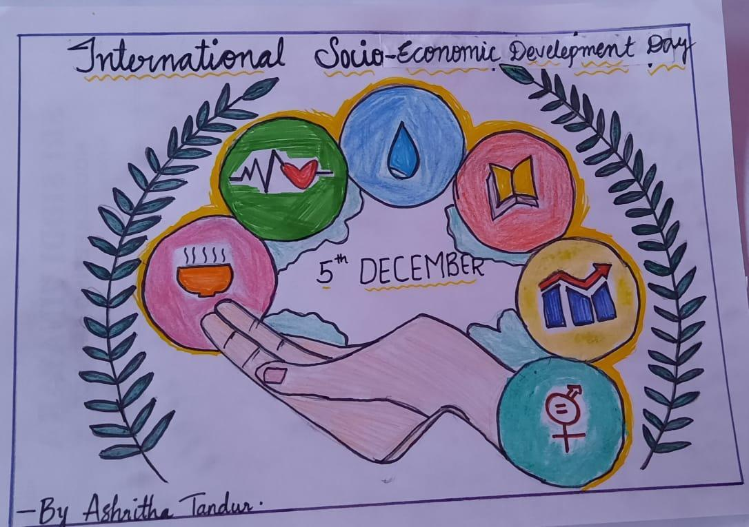

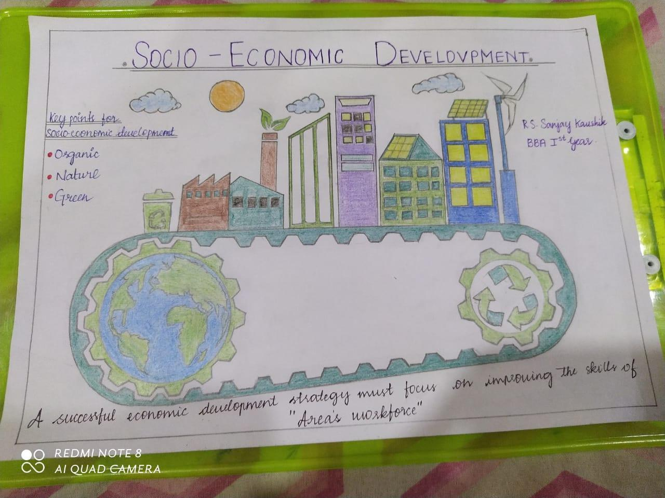
- Guest Profile (if any) : NIL

