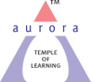
Aurora’s Degree & PG College
(Accredited by NAAC with 'B++' grade)
Chikkadpally, Hyderabad- 500020
Department of Computer Science

EVENT REPORT

EVENT TITLE | Charles Babbage Birthday
TYPE OF EVENT | Department
FACULTY INCHARGE | V Sirisha
DEPARTMENT | Computer Science
DATE | 26-12-2020
VENUE | Online (Google Platform)
TARGET AUDIENCE | First year students

OBJECTIVE: To create awareness among students about Charles Babbage contributions.

BRIEF ABOUT THE EVENT: Every December 26th Charles Babbage birthday is celebrated by Department of Computer Science to create awareness among students about Charles Babbage contributions towards evolution of computers. This year we have celebrated Charles Babbage birthday by conducting power point presentation competition for first year students.

The winners of the Power Point Presentation competition:
- Tata Karuna, First prize
- Chetna Kumari, Second prize
- Kashyap Bharadwaj Srirangam, Third prize

OUTCOME: Students actively participated in the event and gained knowledge on contributions of Charles Babbage and evolution of computers.

PHOTOGRAPH:
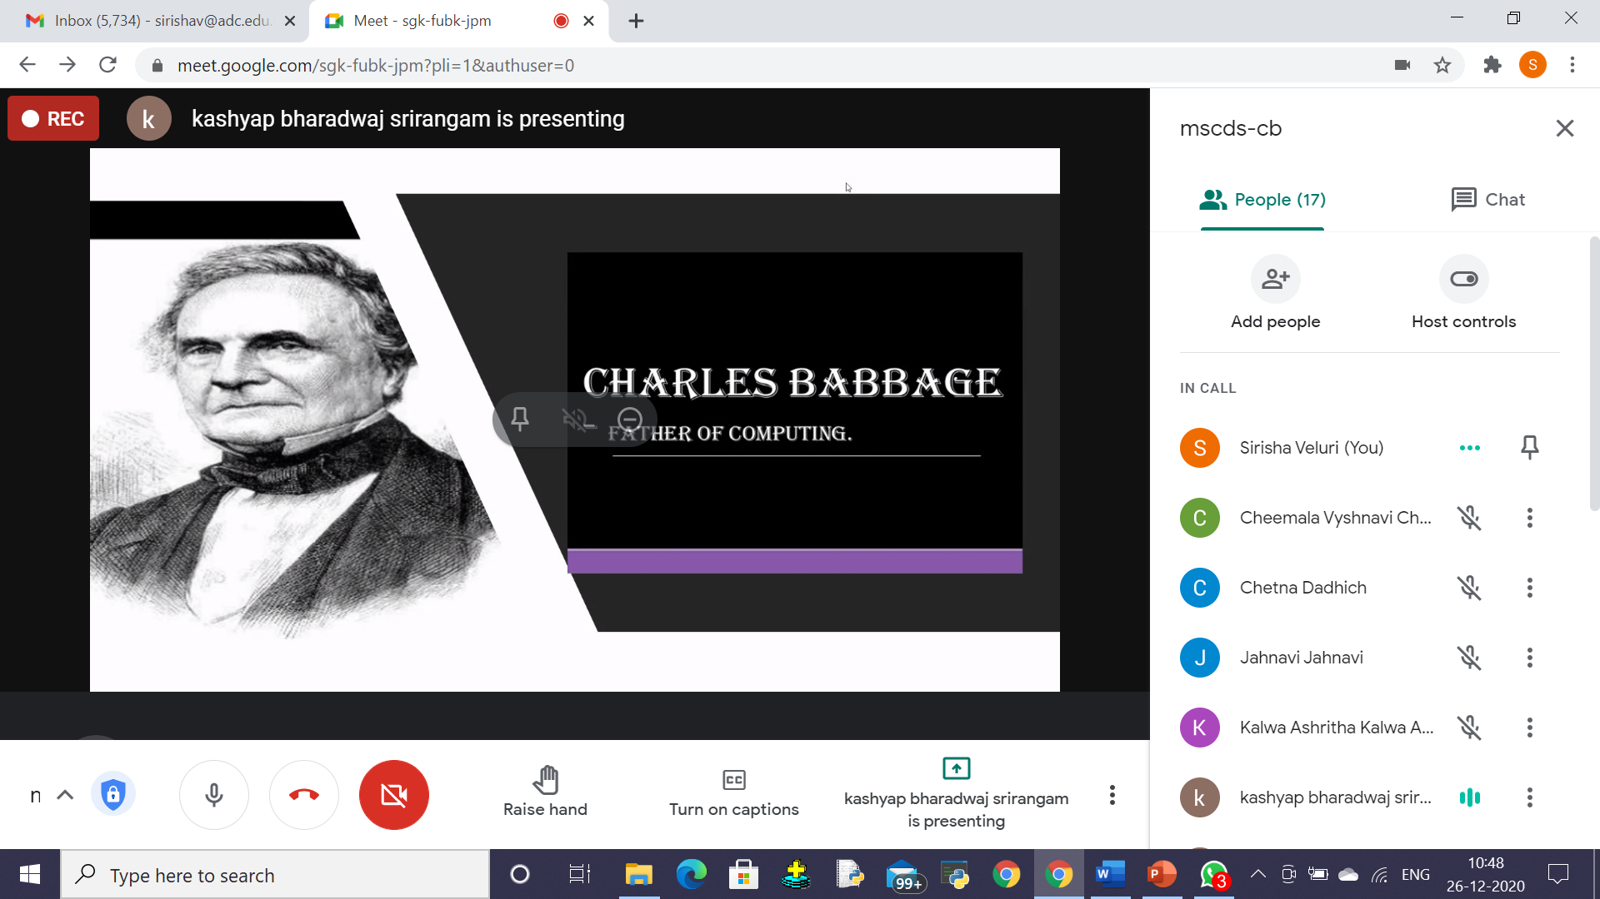
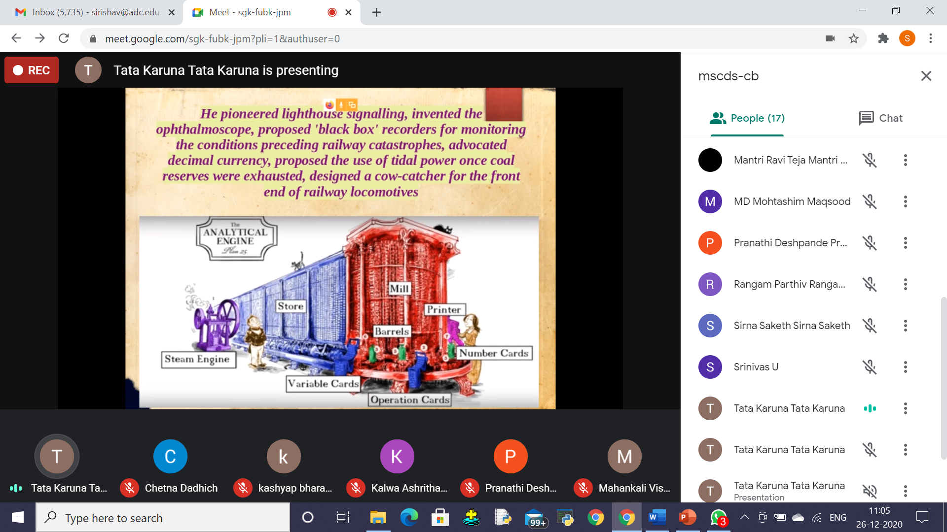

DETAILED REPORT
List of the participants:
Name of the participant | Group
Karuna Tata | Data Science
Chetna Kumari | Data Science
Alekhya Anand Tumma | Data Science
Sirna Saketh | MSCs
Kashyap Bharadwaj Srirangam | MSCs
M.Ravi Teja | Data Science
Kalwa Ashritha | Data Science
Mada Yaswanth | MSCs
Bogam Madhan Raj | MSCs
Birre Venkat Kiran | MSCs
Mushkari Sai Abhinav | MSCs

Photographs:

