Aurora’s Degree & PG College
(Accredited by NAAC with 'B++' grade)
Chikkadpally, Hyderabad- 500020
Department of Management

EVENT PROPOSAL
Type of Event: Class event
Event Title: INTERNATIONAL LABOUR DAY
Cell Convener: Sujatha. K
Faculty in charge: K.Sunitha
Date & Venue: 1-5-2021 & Virtual Meeting on Teams
Target audience: Students
Level: Class.
Budget: Nil
Student volunteer’s: S.V.S.S.Divya Akanksha, T.Abhishek, Ayesha Bibi, G.Supraja, M.Sainath, G.Supraja
Objective: To make the students appreciate to honor the struggle and gain of labour.
Proposed activities: PPT, Poster presentation by BBA First Year Students.

Aurora’s Degree & PG College
(Accredited by NAAC with 'B++' grade)
Chikkadpally, Hyderabad- 500020
Department of Management

EVENT REPORT

EVENT TITLE | INTERNATIONAL LABOUR DAY
TYPE OF EVENT | Class
FACULTY INCHARGE | K. Sunitha
DEPARTMENT | Management
DATE | 01-05-2021
VENUE | Virtual meeting on teams
TARGET AUDIENCE | Students

OBJECTIVE: To Honour the struggle and gain of labour.
BRIEF ABOUT THE EVENT: On the occasion of MAY DAY a day dedicated to the labours who fought for their rights all over the world. The students of BBA 1C portrayed their struggle and paid a tribute by celebrating MAY DAY as an event. The students participated by preparing a Power Point Presentation (PPT) regarding the difficulties they have encountered in past and till date.
OUTCOME: The students acknowledged the labours hard work and struggle confronted them.
PHOTOGRAPH
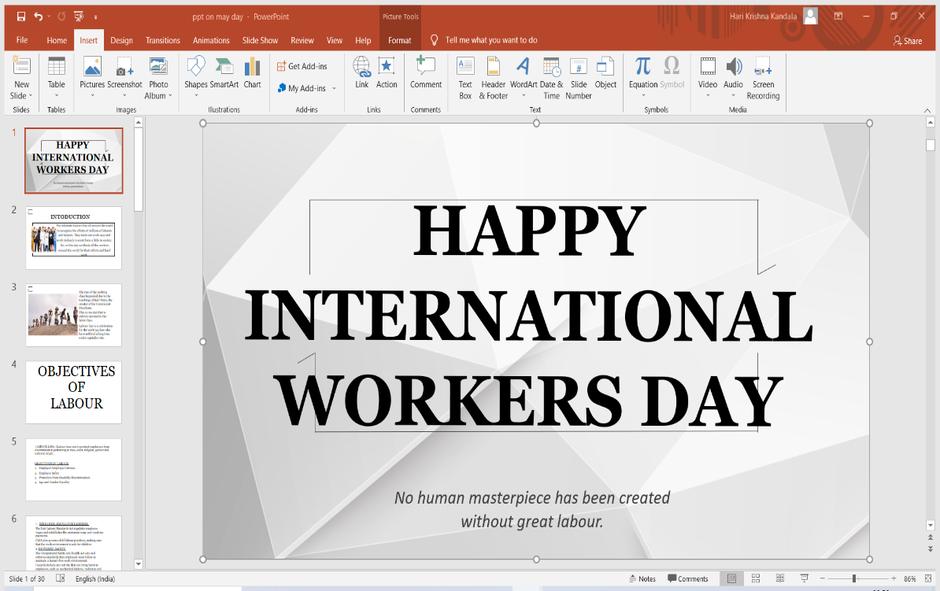

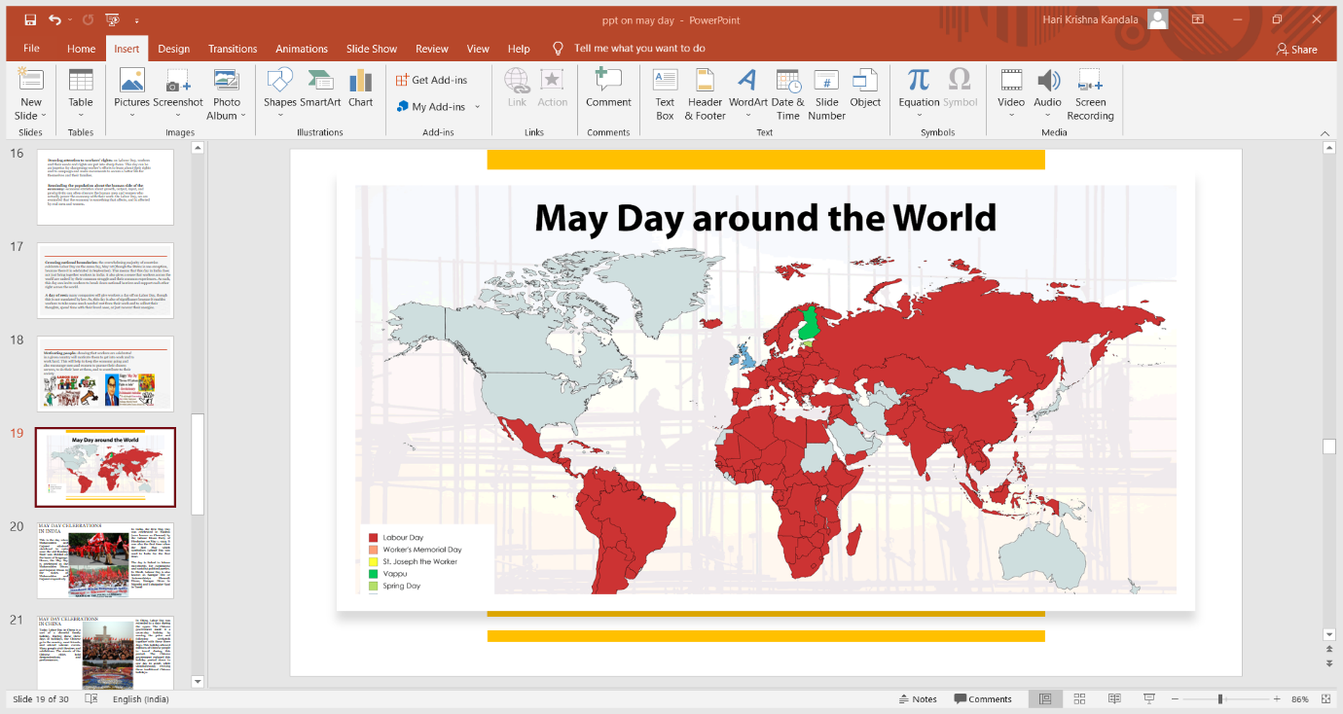

Aurora’s Degree & PG College
(Accredited by NAAC with 'B++' grade)
Chikkadpally, Hyderabad- 500020
Department of Management

EVENT REPORT

EVENT TITLE | INTERNATIONAL LABOUR DAY
TYPE OF EVENT | Class event
FACULTY IN CHARGE | K.Sunitha
DEPARTMENT | Management
DATE | 01-05-2021
VENUE | Virtual Meeting on teams
TARGET AUDIENCE | Students

OBJECTIVE: To honor the struggle and gain of labour.
BRIEF ABOUT THE EVENT: On the occasion of MAY DAY, a day dedicated to the labours who fought for their rights all over the world. The students of BBA 1C portrayed their struggle and paid a tribute by celebrating MAY DAY as an event. The students participated by preparing a Power Point Presentation (P.P.T) regarding the difficulties the labour class have encountered in past and till date.
OUTCOME: The students acknowledged the hard work and struggle confronted by the workers.
DETAILED REPORT:
On the occasion of MAY DAY, a day dedicated to the labours who fought for their rights all over the world. The students of BBA1C portrayed their struggle and paid a tribute. The P.P.T showed up the points such as:
- It is praised yearly on first of MAY to celebrate the difficult works and devotion of works towards the association independent of their capacity and position.
- In the outbreak of the COVID-19, many states have relaxed the labour laws in the favour of the employers/ investors so that foreign investment can be attracted in their states.
- As we realize that workers are the key segments of a developing economy, workers buckle down, like there is no tomorrow for their organizations, and because of this country develops and creates.
- Labor Laws aim to protect employees from discrimination pertaining to race, color, religion, gender and national origin.
- F.L.S.A also governs child labor practices, making sure that the work environment is safe for children.
- To commemorate the workers who sacrificed their life in the Hay market affairs of Chicago in 1886, we celebrate MAY 1st as INTERNATIONAL WORKERS DAY.
- The day is linked to labor movements for communist and socialist political parties.
- MAY DAY celebrates the contribution and sacrifice of workers for the society. The day’s importance dates back to the times when workers in the United States (U.S) started protesting against draconian labor laws, worker’s rights violations, poor working conditions and dreadful work hours.
- MAY DAY is synonymous to workers struggles and the subsequent empowerment in the late 19th century.
- We know that the workers receive minimum pay by selling his own labor. That is the reason why INTERNATIONAL WORKERS DAY is celebrated all over the world. So this day is to promote and encourage INTERNATIONAL labour associations.
- Thus, it is a special day to appreciate and recognize their contribution to society as they are certainly well deserved. Hence this day is dedicated to all the labour class.
LIST OF STUDENT CO-ORDINATORS:
S.NO | ROLL NO | STUDENT NAME | CLASS | Section
1 | 1051-20-684-109 | T. ABHISHEK | B.B.A 1ST YESR | C
2 | 1051-20-684-136 | AYESHA BIBI | B.B.A 1ST YEAR | C
3 | 1051-20-684-149 | SATULURI. VENKATA SESHA SAI DIVYA AKANKSHA | B.B.A 1ST YEAR | C
4 | 1051-20-684-150 | S .V. SAMANVITA | B.B.A 1ST YEAR | C
5 | 1051-20-684-152 | GUMMULURU. BHAGYA LAKSHMI SUPRAJA | B.B.A 1ST YEAR | C
6 | 1051-20-684-176 | MUNDE. SAINATH | B.B.A 1ST YEAR | C

LIST OF STUDENT PARTICIPANTS:
S.NO | ROLL NO. | STUDENT NAME | CLASS | SECTION
01 | 1051-20-684-002 | SANKHLA NIDHI | B.B.A 1ST YEAR | A
02 | 1051-20-684-005 | POOJA GOYAL | B.B.A 1ST YEAR | A
03 | 1051-20-684-010 | SHIVANI KHONDE | B.B.A 1ST YEAR | A
04 | 1051-20-684-012 | ERICA ANN HACKETT | B.B.A 1ST YEAR | A
05 | 1051-20-684-017 | GAURAV PANWAR | B.B.A 1ST YEAR | A
06 | 1051-20-684-020 | KUMKUMA RITHIK | B.B.A 1ST YEAR | A
07 | 1051-20-684-025 | SHIRVI OM PATEL | B.B.A 1ST YEAR | A
08 | 1051-20-684-028 | VANSH AGARWAL | B.B.A 1ST YEAR | A
09 | 1051-20-684-030 | GAUTAM PANWAR | B.B.A 1ST YEAR | A
10 | 1051-20-684-040 | VOHARA KALASH | B.B.A 1ST YEAR | A
11 | 1051-20-684-174 | AVUNOORI PRAVALIKA | B.B.A 1ST YEAR | A
12 | 1051-20-684-054 | GODA ANUSHA | B.B.A 1ST YEAR | B
13 | 1051-20-684-058 | ABBURY SUBRAMANYAM TEJASWINI | B.B.A 1ST YEAR | B
14 | 1051-20-684-059 | RADHARI VARSHITHA YADAV | B.B.A 1ST YEAR | B
15 | 1051-20-684-065 | DESHMUKH ANARIKA | B.B.A 1ST YEAR | B
16 | 1051-20-684-071 | KOLAWAR SAIKIRAN | B.B.A 1ST YEAR | B
17 | 1051-20-684-075 | BADUKALI HEMANTH | B.B.A 1ST YEAR | B
18 | 1051-20-684-077 | NERALLA VISWANADH MARUTHI DEEPAK | B.B.A 1ST YEAR | B
19 | 1051-20-684-097 | ABHISHEK DEY | B.B.A 1ST YEAR | B
20 | 1051-20-684-101 | CHAMANTHI YASHWANTH KUMAR | B.B.A 1ST YEAR | B
21 | 1051-20-684-103 | ROHIT LAHOTI | B.B.A 1ST YEAR | B
22 | 1051-20-684-104 | KATUKAM NAVANEETH | B.B.A 1ST YEAR | B
23 | 1051-20-684-167 | ANTHHATI THRISHIKA | B.B.A 1ST YEAR | B
24 | 1051-20-684-168 | P VISHNU | B.B.A 1ST YEAR | B
25 | 1051-20-684-171 | KORVI EKSHITHA | B.B.A 1ST YEAR | B

BUDGET PLAN: NIL
PHOTOGRAPH:
