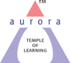
Aurora’s Degree & PG College
(ACCREDITED BY NAAC WITH 'B++' GRADE)
Chikkadpally, Hyderabad 500020

EVENT / ACTIVITY DETAILED REPORT

NAME OF THE EVENT / ACTIVITY | World Wildlife Week
TYPE OR TITLE OF EVENT / ACTIVITY | Endangered Species in India
FACULTY INCHARGE | A.Rebecca Shravanthi
DEPARTMENT/CELL/COMMITTEE/CLUB | Department of Management
DATE | 6-10-2021 to 9-10-2021
VENUE | Aurora’s Degree and PG college
TARGET AUDIENCE | Faculty and Students

- PROGRAM SCHEDULE
Quiz was conducted between 9-30 am to 12-30 pm every day for faculty and students
Poster preparation was conducted during college hours 9am to 4-30 pm

- LIST OF FACULTY COORDINATORS (DEPARTMENT) - A.Rebecca Shravanthi

- LIST OF THE STUDENT COORDINATORS (NAME , ROLL NO, CLASS & SECTION) - No student coordinators

4.LIST OF THE PARTICIPANTS (NAME , ROLL NO, CLASS & SECTION, NO OF GIRLS, BOYS, CASTE )

Name | Roll number | Class &Section
Sadiq aligarh
N Rachana | 1051-19-684-133 | BBA 2 C
Ankala Samuel Sunder Kumar | 1051-19-684-091 | BBA 2 B
Vislavath Sugandhini | 1051-19-684-022 | BBA 2 A
Kala Lalitha Tripura Sundari | 1051-19-684-167 | BBA 2 C
shasthra swetha
erukulla saikumar | 1051-19-684-114 | BBA 2 B
mohammed amer | 1051-19-684-062 | BBA 2 B
gundelli sravanthi
pilla marri bargavi
ayesha bibi | 1051-20-684-136 | BBA 1 C
Satyavarapu Sai Sweekruthi | 1051-20-684-138 | BBA 1 C
Vellu Abhilash Nair | 1051-19-684-143 | BBA 2 C
T Abhishek | 1051-20-684-109 | BBA 1 C
Uddagiri Vinay Kumar | 1051-20-684-117 | BBA 1 C
Gavvalapally Jayin Yadav | 1051-20-684-118 | BBA 1 C
Paka Durga Prasad | 1051-20-684-110 | BBA 1 C
Abbury Subramanyam Tejaswini | 1051-20-684-058 | BBA 1 B
Bejjarapu Vishnu Vardhana Chart | 1051-20-684-112 | BBA 1 C
kalalirajashekargoud_pg@adc.edu.in
Deshmukh Anarika | 1051-20-684-065 | BBA 1 B
leelamanib@adc.edu.in | Faculty
heenar@adc.edu.in | Faculty
Krishna Sharma | 1051-20-684-027 | BBA 1 A
Aennamalla Dhanush Siddhartha | 1051-20-684-159 | BBA 1 C
Vijay Bholenath Guptha | 1051-20-684-081 | BBA 1 B
Jampula Sai Sudheer | 1051-20-684-148 | BBA 1 C
Munde Sainath | 1051-20-684-176 | BBA 1 C
Thummala Pravalika | 1051-20-684-060 | BBA 1 B
Badukali Hemanth | 1051-20-684-075 | BBA 1 B

No. of Girls-11
No. of boys - 17
Faculty - 2

- PARAGRAPH ABOUT THE PROCEEDINGS (TILL THE END OF THE EVENT) -The ‘World Wildlife Week’ Event was conducted by the department of management from 6th Oct to 9th Oct 2021. There were 30 students who participated in this event .This Event was conducted for all Faculty and students.The main purpose of this Event is to create awareness about the Endangered species in India. This week helped us review how many animal species are under the threat of extinction. The department of management had conducted 4 quizzes for Faculty and Students on all four days and also Poster preparation event only for students where students could prepare posters which would be later stuck on the notice board. Even though exams were conducted during the same time few students have participated in the event.

- INCOME AND EXPENDITURE - 0
- EVENT PHOTOS ( MIN 2 MAX 4) -

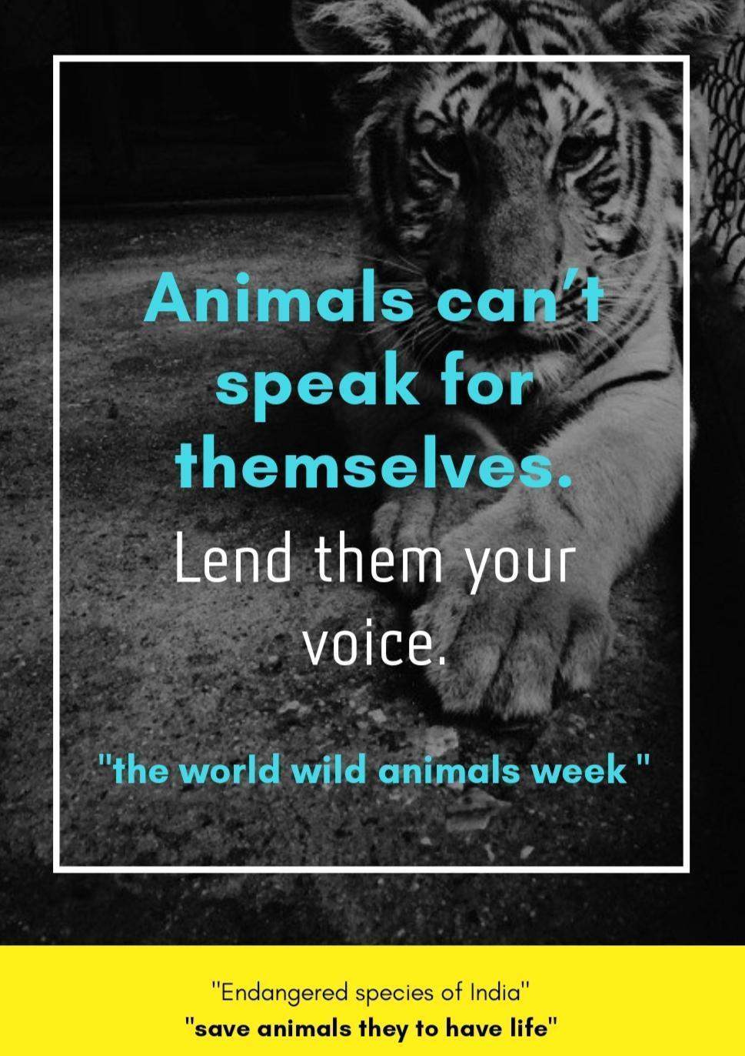
\
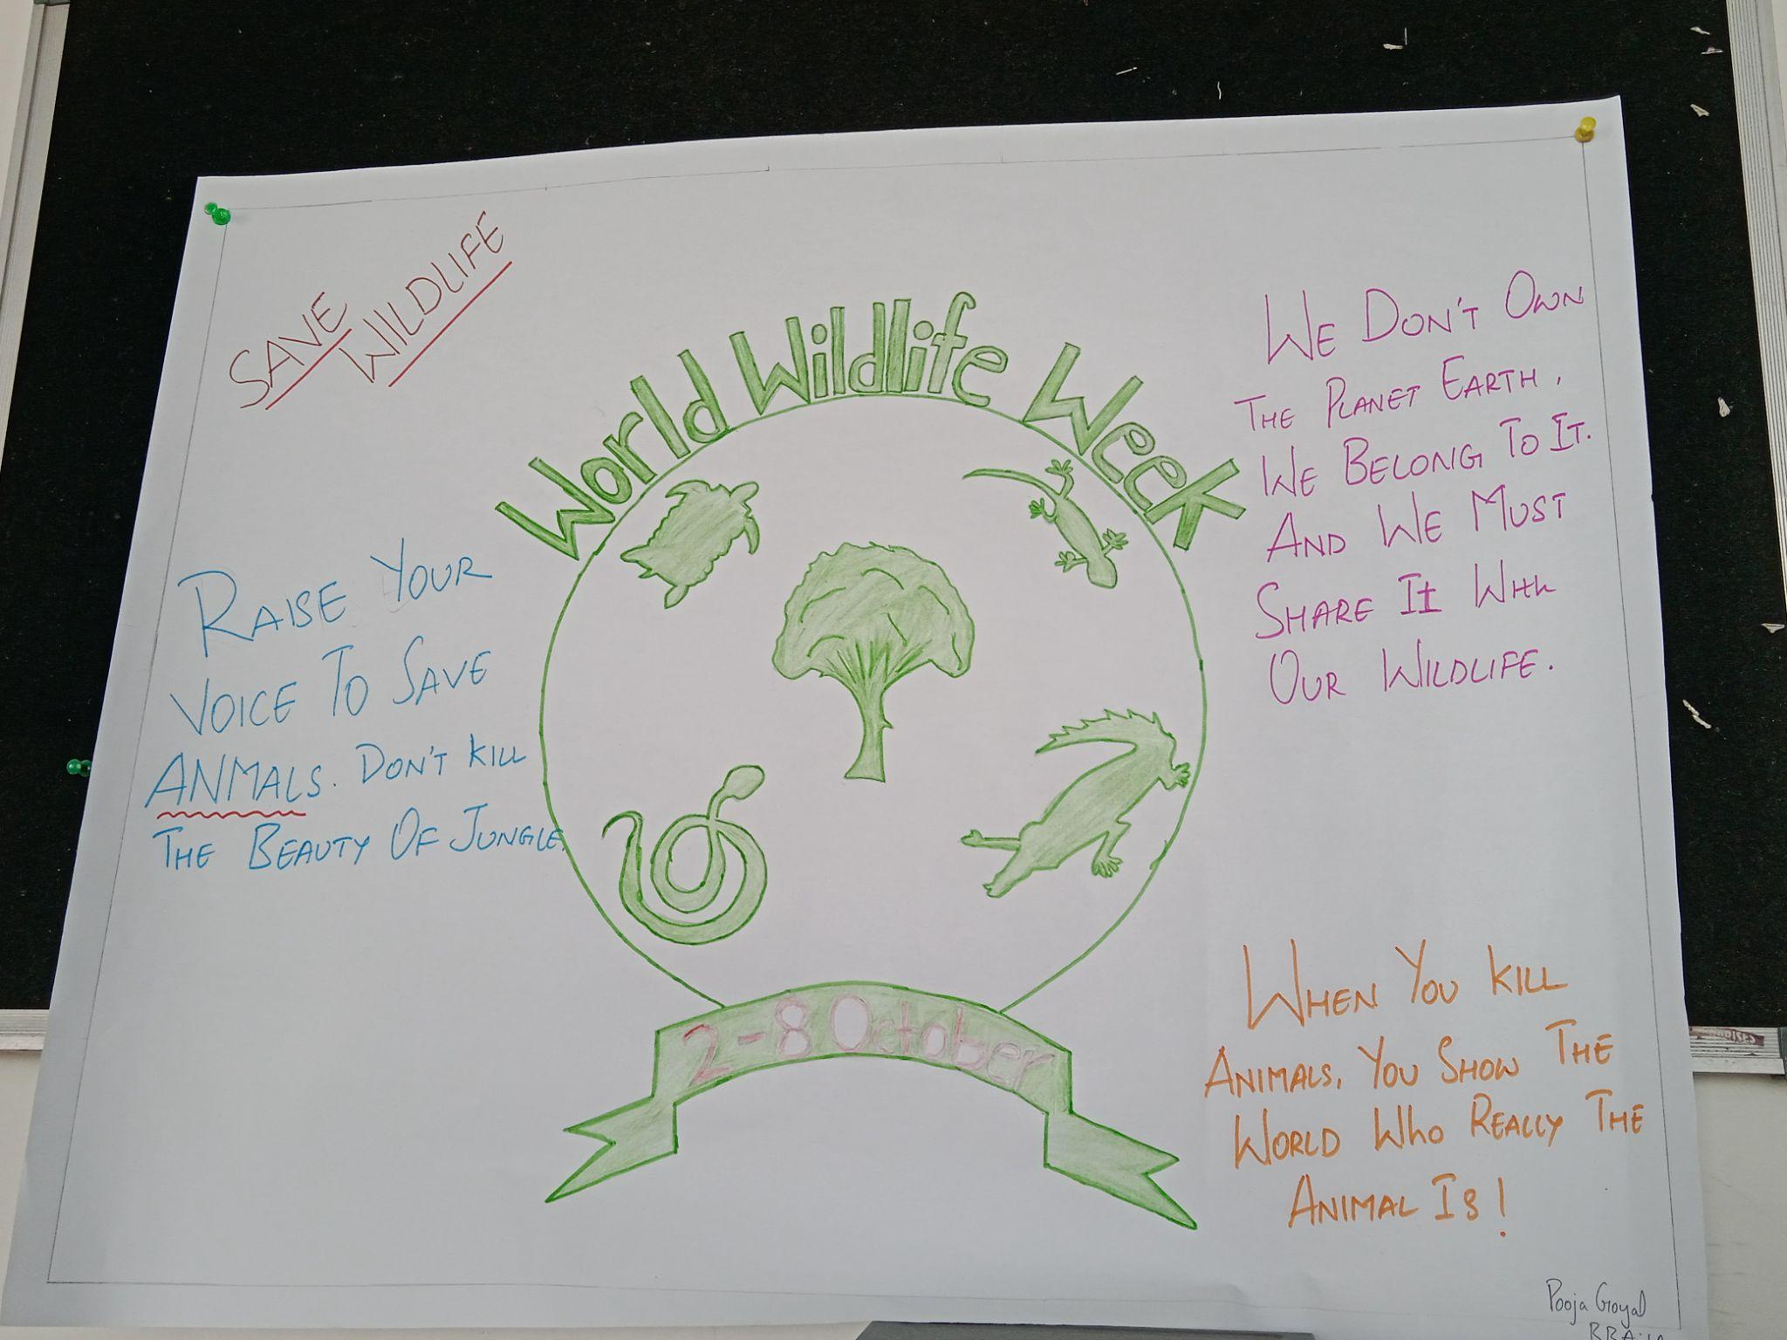

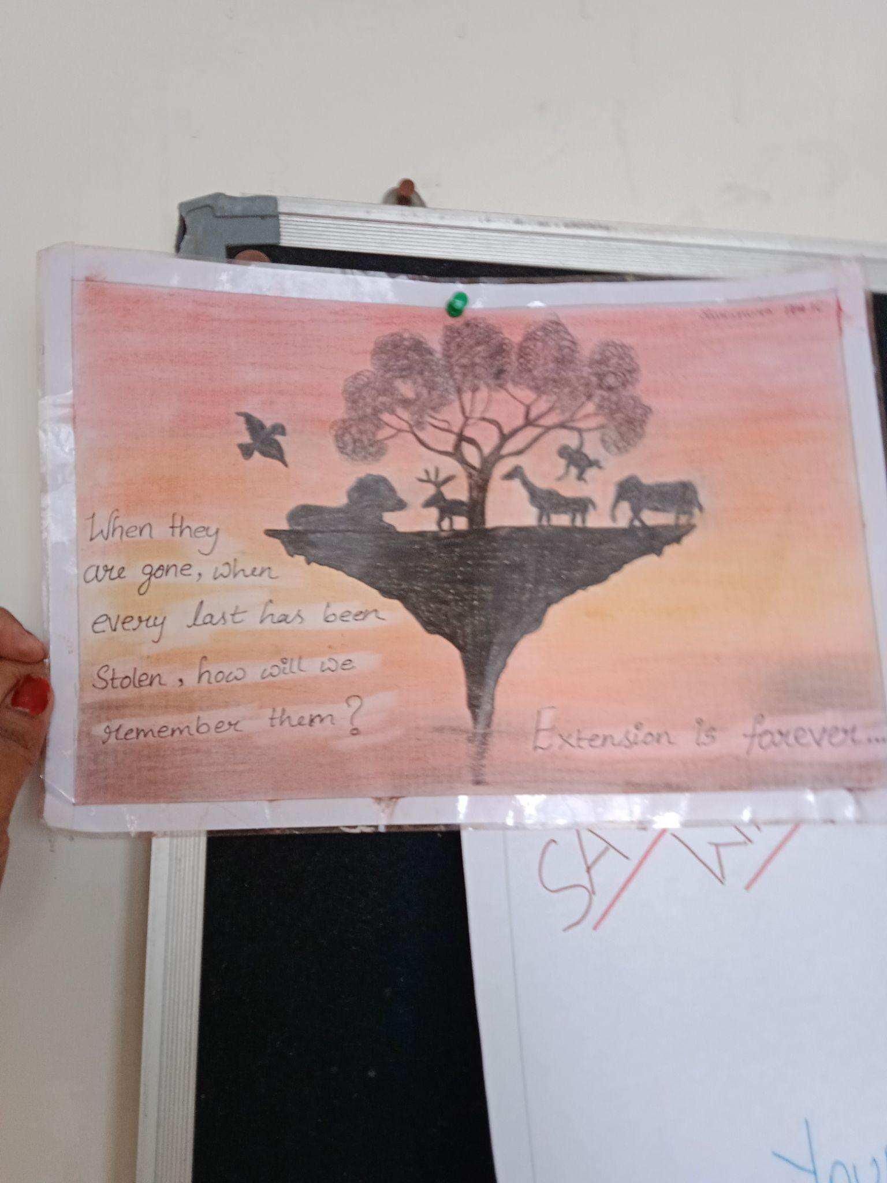

- GUEST PROFILE (IF ANY) - Nill
- FEEDBACK IF ANY - Nill
- ATTACHMENTS:
EVENT/ACTIVITY PROPOSAL - Yes
EVENT / ACTIVITY NOTICE - Yes
RECEIPTS (IF ANY) - Nill
CERTIFICATES (IF ANY)- Yes
LETTERS OF COMMUNICATION (IF ANY) - Nill

