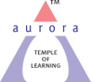
Aurora’s Degree & PG College
(ACCREDITED BY NAAC WITH 'B++' GRADE)
Chikkadpally, Hyderabad 500020

EVENT / ACTIVITY DETAILED REPORT

NAME OF THE EVENT / ACTIVITY | International Day for Eradication of poverty
TYPE OR TITLE OF EVENT / ACTIVITY | Class event
FACULTY INCHARGE | G.Chamundeshwari, J Anil Kumar, N. Renuka
DEPARTMENT/CELL/COMMITTEE/CLUB | Commerce
DATE | 17/10/2021
VENUE | Aurora Degree’s and PG College
TARGET AUDIENCE | Government School Students

PROGRAM SCHEDULE: 17/10/2021 ,1.30 pm to 3.00pm
LIST OF FACULTY COORDINATORS (DEPARTMENT)
G. Chamundeshwari
J. Anil Kumar
N. Renuka
LIST OF THE STUDENT COORDINATORS (NAME , ROLL NO, CLASS & SECTION)
Name | Roll.no | Class | Section
Ayush Chhabra | 1051-19-401-151 | BCom Second Year | 2C
Mahendar Singh | 1051-19-401-001 | BCom Second Year | 2A
Pragati Oza | 1051-19-401-163 | BCom Second Year | 2C
Shruti Agarwal | 1051-19-401-159 | BCom Second Year | 2C
Manisha Dixit | 1051-19-401-137 | BCom Second Year | 2B
Sri Sathya | 1051-19-401-111 | BCom Second Year | 2B
Samanvitha | 1051-19-401-007 | BCom Second Year | 2A
G Akshita | 1051-19-401-002 | BCom Second Year | 2A

LIST OF THE PARTICIPANTS (NAME , ROLL NO, CLASS & SECTION, NO OF GIRLS, BOYS, CASTE )
Name | Class
B Ganga Ram | 9th Class
N Vidhya Sagar | 10th Class
D Rajesh | 10th Class
M Adesh | 10th Class
M. Binnu | 8th class
A Ajay | 9th class
Srujana | 9th class
Ramya | 9th class
Harshini | 9th class
Pavani | 9th Class
Ch. Mounika | 9th class
Tejashwini | 9th class
Lavanya | 10th class
Anitha | 10th class
Chandrakala | 10th class
Swathi | 8th class
Maheshwari | 10th class
Jahnavi | 10th Class
Prathyusha | 8th class
Naga Sri | 8th class
Swathi | 8th class

PARAGRAPH ABOUT THE PROCEEDINGS (TILL THE END OF THE EVENT)
The event started in the afternoon at 1.30 pm by welcoming students of Govt School. Students from Second years have given a speech on Eradication of Poverty. A student volunteer from f Second year Ms G. Akshita thought the students how to decorate diyas by using diyas with water colors and sparkles and pearls. Another Volunteer M. Samanvitha from Second year thought how to make thread bangles by using colorful threads. Pragathi from Second year thought how to make greetings cards by using different color papers. Students have actively participated and learned with enthusiasm. At 03:30 pm event got finished with Vote of thanks. Students were given refreshments at the end of the event.
INCOME AND EXPENDITURE: Nil
EVENT PHOTOS ( MIN 2 MAX 4)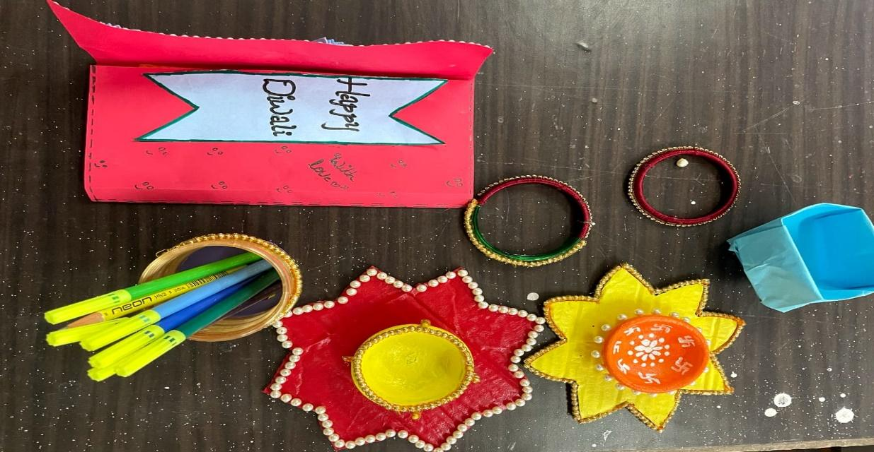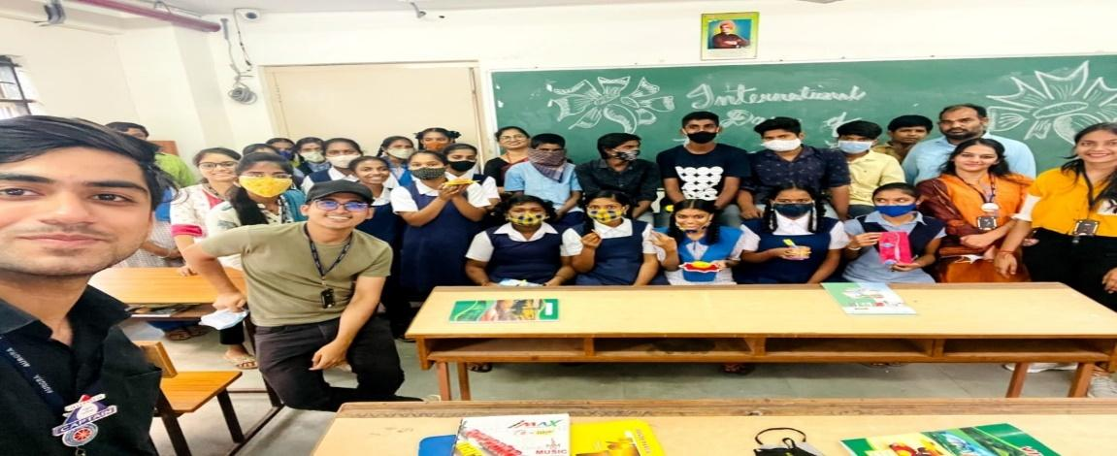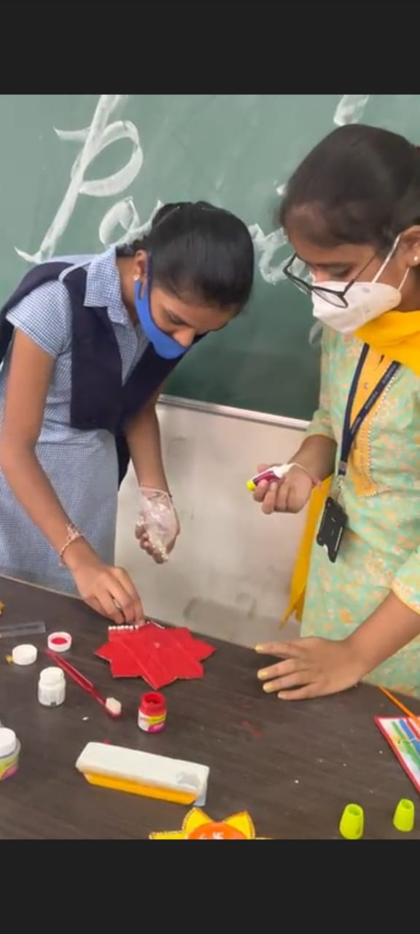

GUEST PROFILE (IF ANY): NIL
FEED BACK IF ANY: NIL

ATTACHMENTS:
EVENT/ACTIVITY PROPOSAL
Event Proposal
Event/Activity Name: B.Com General II Year Class Event
Event/Activity Title: International Day for Eradication of poverty
Faculty coordinator:
1. G.Chamundeshwari, Associate Professor (Department Of Commerce)
2. J. Anil Kumar, Associate Professor (Department Of Commerce)
3. N. Renuka, Assistant Professor (Department Of Commerce)
Date: October 17th, 2021
Venue: Block VI Room No -004 Aurora’s Degree & PG College
Target audience: People from the locality around the college who are deprived and below poverty level.
Platform: Offline
Level: Department Level
Objective:
- To provide a platform and opportunity for learning life skills for the people who are deprived of basic facilities.
- To identify and empower participants about few basic skills needed for earning in day to day life.
Activity Outcome:
- To make the people learn the skills so that they can use it as a means of livelihood.
Period: 2 Hours
Proposed activities:
- Practical training session will be provided on Pot decoration & Diya decoration.
- Handmade Jewellery making.
- Paper Bag Making
- Greeting Cards Making
Trainers’ details:
- Students from 2nd Year trained & possessing the skills
- Mrs. M. Mamatha Associate Professor , Aurora’s Degree & PG College
Budget: Nil
G. Chamundeshwari , Dr. Ravi Kiran Dr. Viswanadham Bulusu
Faculty In-charge IQAC Coordinator Principal

EVENT / ACTIVITY NOTICE:
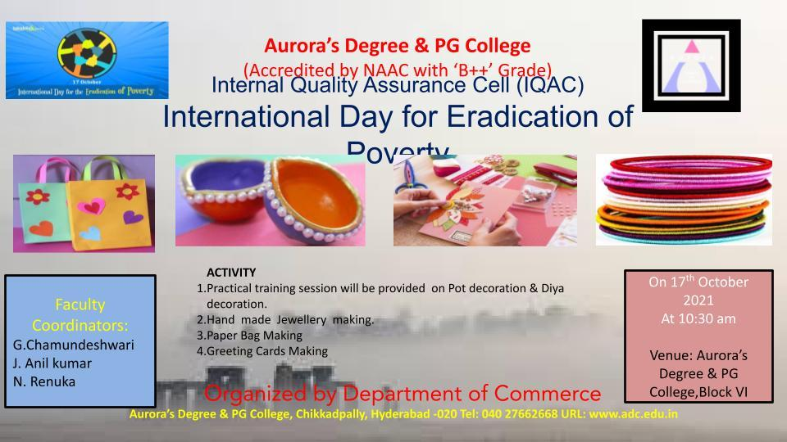

RECEIPTS (IF ANY): Nil

CERTIFICATES (IF ANY): NIL

