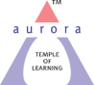
Aurora’s Degree & PG College
(Accredited by NAAC with 'B++' grade)
Chikkadpally, Hyderabad- 500020
Department of Microbiology

EVENT DETAILED REPORT

EVENT TITLE | World Osteoporosis Day
TYPE OF EVENT | Departmental Event
FACULTY INCHARGE | Mrs. Padma M (HOD)
FACULTY COORDINATOR | G.Hiranmayee
DEPARTMENT | Microbiology
DATE | 20th October 2021
VENUE | Microsoft teams
TARGET AUDIENCE | Intermediate and PG Students

PROGRAM SCHEDULE
Date of the event: 20-10-2020
Time of the event: 10:00 am to 01:00 pm
Platform: Microsoft Teams
Link provided to join the event: https://drive.google.com/file/d/1ES5RmfEWgHalLz19Pp-0ucn4OYSfWEbX/view?usp=sharing
LIST OF FACULTY COORDINATORS
S.No | Name of the faculty | Department
1 | Mrs M. Padma (HOD) | Microbiology
2 | Mrs. G. Hiranmayee | Microbiology

LIST OF FACULTY ATTENDED
S.No | Name of the faculty | Department
1 | J Hari Prasad Rao | Vice principal
2 | K. Mary Manjusha | Microbiology

LIST OF STUDENT COORDINATORS
S.No | Name of the student | Roll No | Section
1 | Krupa Rani | 1051-20-518-031 | MSc-Micro
2 | Shazia Hasmi | 1051-20-518-003 | MSc-Micro
3 | Prerana Sanjay | 1051-20-459-038 | MiGC-2

LIST OF STUDENTS (PRESENTERS)
S.No | Name of the student | Roll No | Section | No of Girls | 8
1 | G. Akhilandeshwari | 1051-20-518-022 | MSc-Micro
2 | Krupa Rani | 1051-20-518-031 | MSc-Micro
3 | Bandari Suniyam | 1051-20-518-015 | MSc-Micro
4 | R. Sai Tejaswini | 1051-20-518-029 | MSc-Micro
5 | Shazia Hasmi | 1051-20-518-003 | MSc-Micro
6 | Pailla Prathyusha | 1051-20-518-026 | MSc-Micro
7 | A M Krithika | 1051-20-518-025 | MSc-Micro
8 | Prerana Sanjay | 1051-20-459-038 | MiGC-2
9 | P. Vijay Kumar | 1051-20-518-014 | MSc-Micro | No of Boys | 1

LIST OF THE PARTICIPANTS
S.No | Name | Roll number | section | No of girls | 23
1 | Prerana Sanjay | 1051-20-459-038 | MiGC-2
2 | G. Akhilandeshwari | 1051-20-518-022 | MSc-Micro
3 | Krupa Rani | 1051-20-518-031 | MSc-Micro
4 | Bandari Suniyam | 1051-20-518-015 | MSc-Micro
5 | R. Sai Tejaswini | 1051-20-518-029 | MSc-Micro
6 | Shazia Hasmi | 1051-20-518-003 | MSc-Micro
7 | Pailla Prathyusha | 1051-20-518-026 | MSc-Micro
8 | A M Krithika | 1051-20-518-025 | MSc-Micro
9 | P Sai Bhuvana | 1051-20-518-035 | MSc-Micro
10 | Vairagare Spoorthi | 1051-20-518-001 | MSc-Micro
11 | Reona Arul | 1051-20-518-020 | MSc-Micro
12 | Kalyani Vaishali Rani | 1051-20-518-012 | MSc-Micro
13 | Syeda Amatul Hanna | 1051-20-518-008 | MSc-Micro
14 | Sahithi Chukannagari | 1051-20-518-027 | MSc-Micro
15 | Adla Swathi | 1051-20-518-017 | MSc-Micro
16 | Nenavath Preethi | 1051-20-518-032 | MSc-Micro
17 | S Sudhiksha | 1051-20-518-030 | MSc-Micro
18 | Thokati Niharika | 1051-20-518-011 | MSc-Micro
19 | Syeda Amatul Hanna | 1051-20-518-008 | MSc-Micro
20 | Zara Mehdi | 1051-20-518-004 | MSc-Micro
21 | Chaitanya | 1051-20-518-002 | MSc-Micro
22 | Putchakayala Tejaswi | 1051-20-518-021 | MSc-Micro
23 | Thangella Sneha | 1051-20-518-006 | MSc-Micro
24 | P. Vijay Kumar | 1051-20-518-014 | MSc-Micro | No of boys | 3
25 | Ungurala Vineeth | 1051-20-518-020 | MSc-Micro
26 | M Bhanu Chandar | 1051-20-518-028 | MSc-Micro

PARAGRAPH OF THE PROCEEDINGS
The prime objective is to explore the causes of osteoporosis and to have a cohesive understanding of the clinical condition that is widely spread across people on a global scale.
The event was scheduled on the occasion of world osteoporosis day with an attempt to comprehend the hidden insights and to illustrate the causes of osteoporosis among different age groups on a global scale. The event also emphasizes on the diet of an individual and its relation to associated bone disorders.
The event has proceeded by few of the concerned concepts such as -
- Osteoporosis and arthritis difference
- Prominence of diet in fortifying the bones
- Role of calcium and vitamin D
- Prevalence of the condition among males and females
- Age factor in relation to bone softening
- Preventive measures to counteract osteoporosis
- Prominence of physical exercise
INCOME & EXPENDITURE: Nil
EVENT PHOTOS:
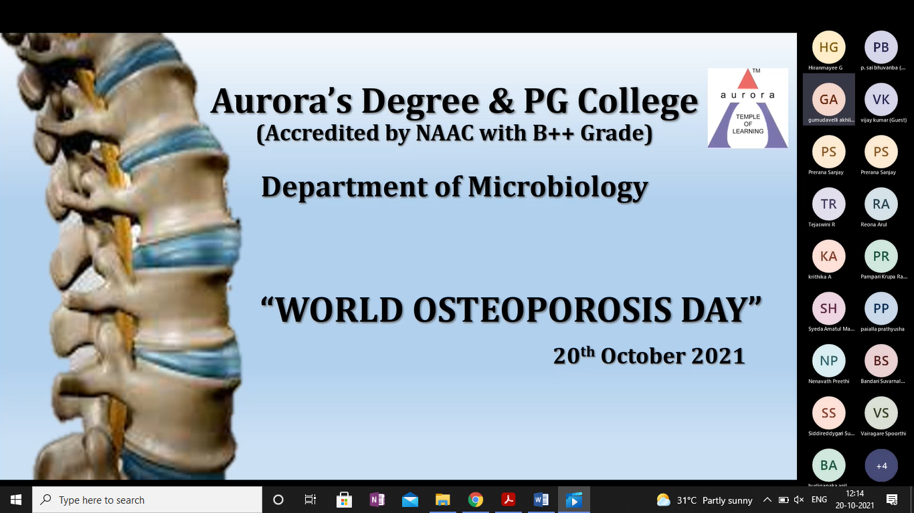
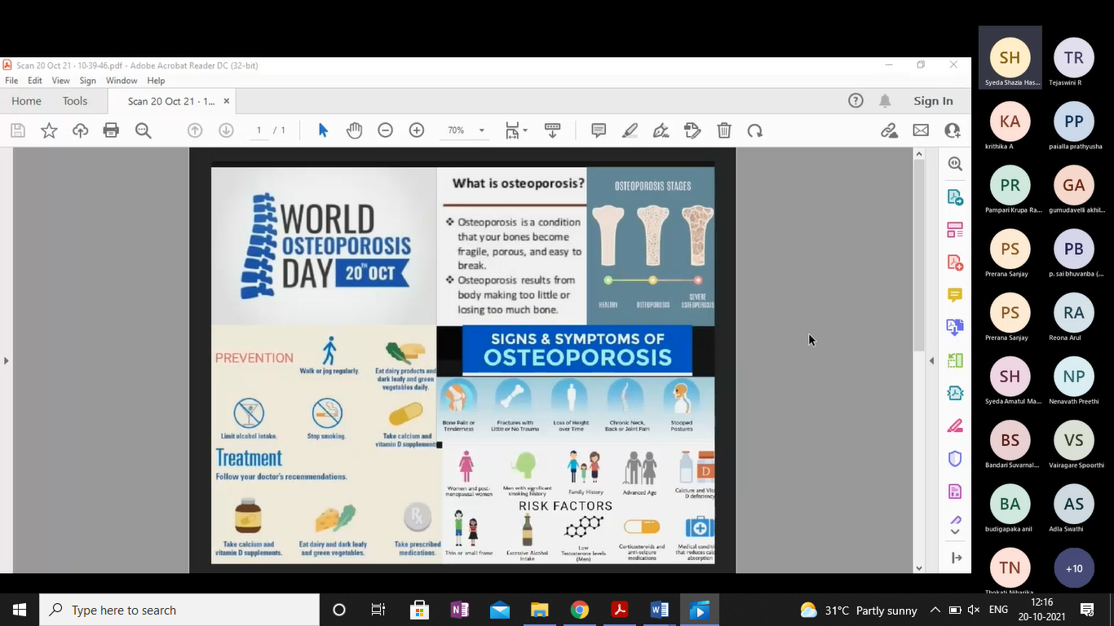
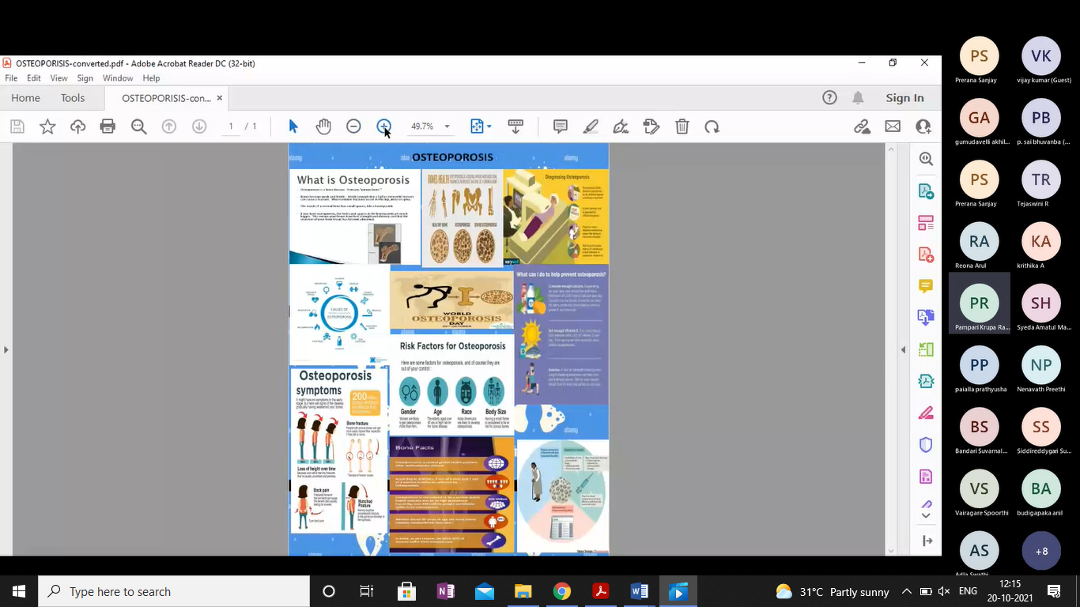

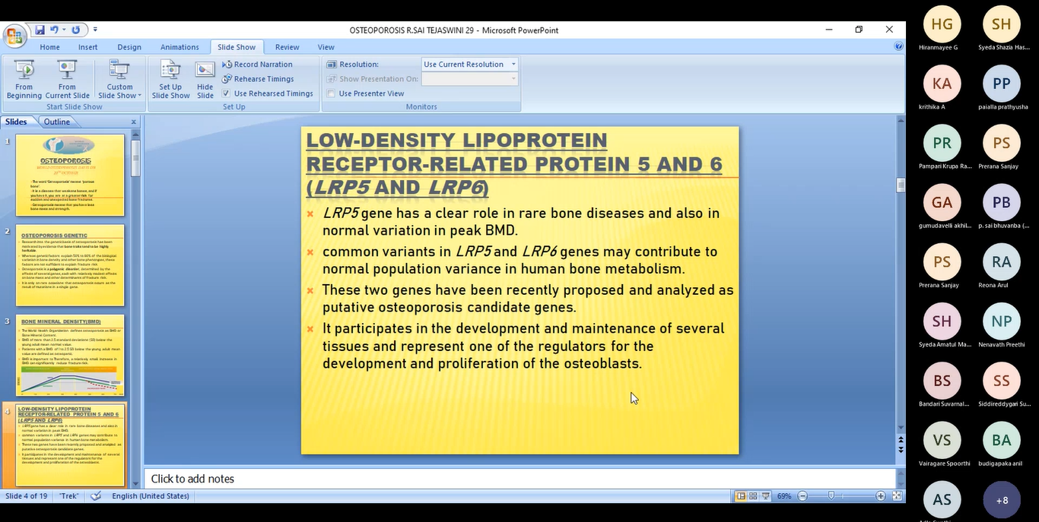

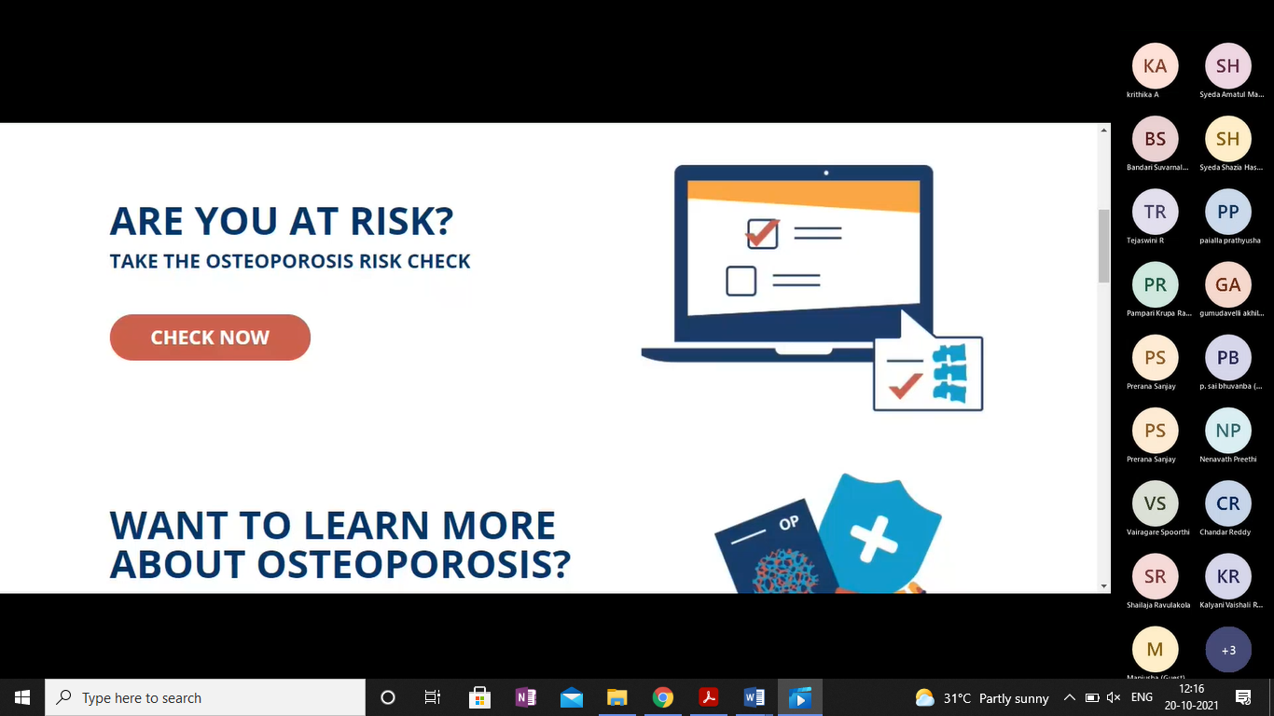

EVENT SCROLL:
