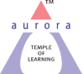
Aurora’s Degree & PG College
(Accredited by NAAC with 'B++' grade)
Chikkadpally, Hyderabad- 500020
EVENT REPORT

EVENT TITLE | International Day for Peace and Tolerance
TYPE OF EVENT | Awareness Program
CLASS EVENT | B.Com. Comp. App 2 A
FACULTY CO ORDINATORS | T. Aruna
DATE | 16-11-2021
VENUE | Aurora Degree and PG College
TARGET AUDIENCE | Faculty & UG Student

- PROGRAM SCHEDULE
10: 00 am to 12: 30 pm | Poster presentation & speeches by students in all the classes
1:00 pm to 2:00 pm | Power point presentation & student speeches

- LIST OF FACULTY COORDINATORS (DEPARTMENT) : -
- LIST OF THE STUDENT COORDINATORS (NAME , ROLL NO, CLASS & SECTION)
S. No. | Roll No. | Name | S. No. | Roll No. | Name
1 | 1051-20-405-001 | J. Asha | 13 | 1051-20-405-113 | E.C. Sai Priya
2 | 1051-20-405-007 | V. Jahnavi | 14 | 1051-20-405-117 | V.S.S.S.V.Choudary
3 | 1051-20-405-010 | B. Rahul | 15 | 1051-20-405-129 | S. Priyanka
4 | 1051-20-405-053 | L. Anil | 16 | 1051-20-405-145 | Sanika
5 | 1051-20-405-058 | G. Nikhil Reddy | 17 | 1051-19-405-077 | Naveen Kumar
6 | 1051-20-405-062 | R.Vamshi Krishna | 18 | 1051-19-405-079 | K. Sreeya
7 | 1051-20-405-063 | A. Sriya | 19 | 1051-19-405-101 | Shashank Alwala
8 | 1051-20-405-065 | B. Geetha Sri | 20 | 1051-19-405-116 | H. Bhagya Sree
9 | 1051-20-405-066 | Ch. Tejaswini | 21 | 1051-19-405-119 | Hemanth
10 | 1051-20-405-088 | G. Jeevan Sai | 22 | 1051-19-405-126 | V. Adarsh Kumar
11 | 1051-20-405-091 | D.S.Sathvik Varma | 23 | 1051-19-405-133 | A. Mohit Kumar
12 | 1051-20-405-092 | B. Baikunth

- LIST OF THE PARTICIPANTS (NAME , ROLL NO, CLASS & SECTION, NO OF GIRLS, BOYS, CASTE ):
S.No. | Stream | Class - Section
1 | B.Com. Regular | 3A, 3B, 3C, 3D; 1A & 1B
2 | B.Com. Comp. App. | 3A, 3B, 3C, 3D, 2A, 2B, 2C, 1A, 1B & 1C,
3 | B. Com. Business Analytics | 1ST YEARS
4 | B. Com. Hons | 3A, 3B & 1ST YEARS
3 | BSC. | MSCS, MPCS, MECS

- PARAGRAPH ABOUT THE PROCEEDINGS (TILL THE END OF THE EVENT)
International Day for Peace and Tolerance is a great educational resource to help learn about how to be a more tolerant person but also the intolerances that may still be happening around the world. Inherently based on the idea that students should come together rather than be divided, International Day for Tolerance is a day to celebrate the differences between cultures and creeds and appreciate what they bring to our lives. The goal of this event is to convey to the audience that tolerance is an important concept that helps people to live together peacefully. Tolerance also means that you don't put your opinions above those of others, even when you are sure that you are right. Tolerant people show strength in that they can deal with different opinions and perspectives.
On 16th November 2021, at 10am student volunteers approached each class with posters and charts giving a brief overview on Peace and Tolerance, the benefits and positive effects on one’s well being. The students acknowledged that being tolerant removes one's self-imposed barriers and allows one to think more broadly and enjoy greater inner peace and that tolerance leads to less stress and greater happiness in the overall community. A Power Point Presentation was also demonstrated regarding the event. Each of the Department faculty was given a white rose as a resemblance of peace.
The student volunteers were provided with snacks for their efforts.
- INCOME AND EXPENDITURE : Nil
- EVENT PHOTOS ( MIN 2 MAX 4)

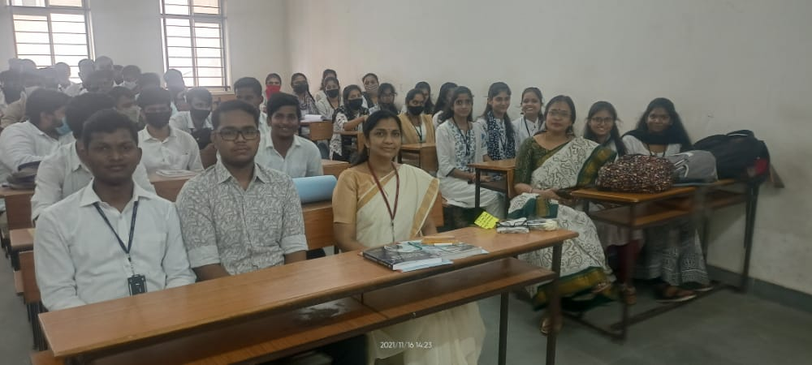

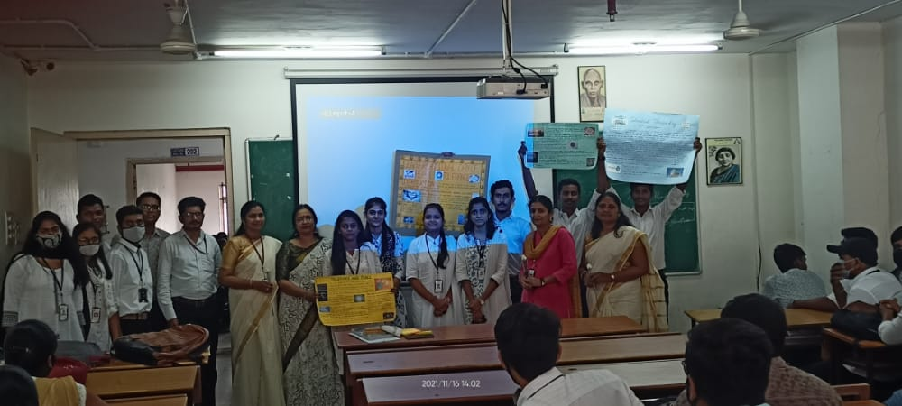

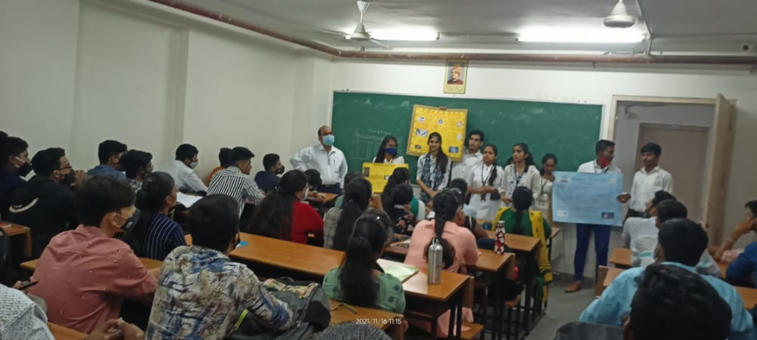
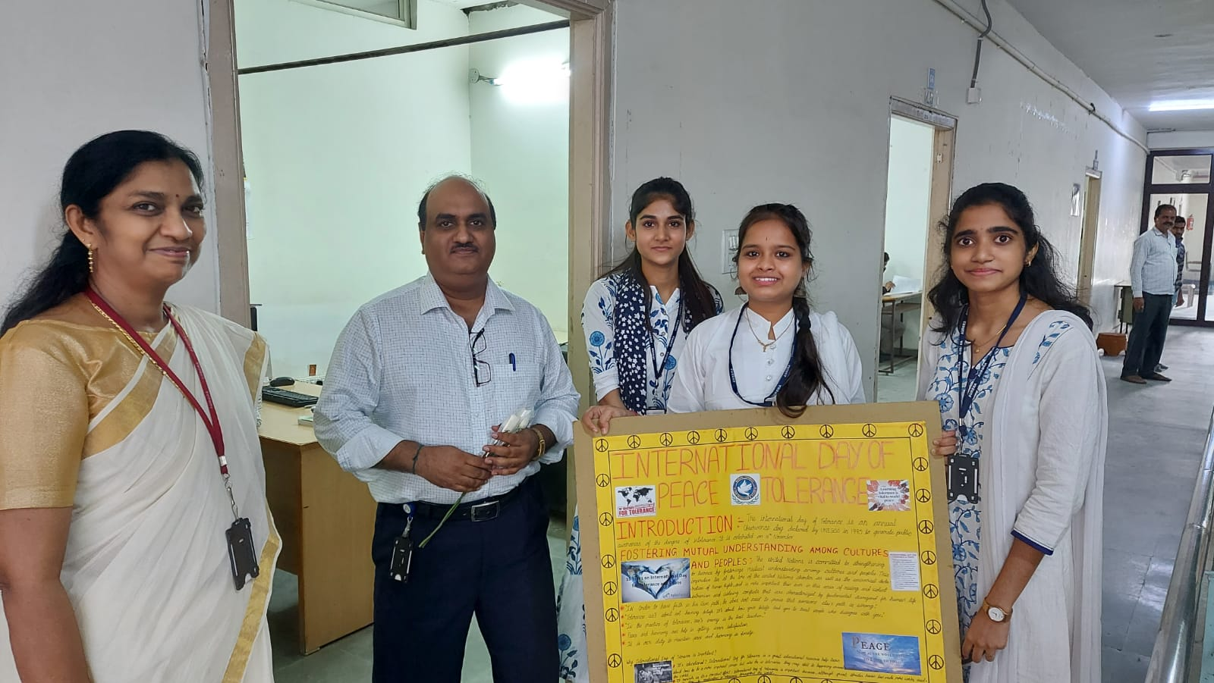

- GUEST PROFILE (IF ANY) -
- FEED BACK IF ANY: -
- ATTACHMENTS:
EVENT/ACTIVITY PROPOSAL
EVENT / ACTIVITY NOTICE
RECEIPTS (IF ANY)
CERTIFICATES (IF ANY)
LETTERS OF COMMUNICATION (IF ANY)

