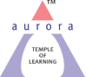
Aurora’s Degree & PG College
(ACCREDITED BY NAAC WITH 'B++' GRADE)
Chikkadpally, Hyderabad 500020

World Computer Literacy Day Detailed Report
NAME OF THE EVENT | World Computer Literacy Day
TYPE OR TITLE OF EVENT | World Computer Literacy Day
FACULTY INCHARGE | Srinivas U, Associate Professor
DEPARTMENT | Computer Science
DATE | 02-12-2021
VENUE | Computer Lab – Block VI, Near RTC ‘X’ Road,Chikkadpally
TARGET AUDIENCE | Bcom Honors First Year Students
Objective:
It is intended to encourage the development of technological skills, create awareness and drive digital literacy in underserved communities
Brief about the event
On 2nd December 2021 event was conducted for the BCom honors first year students on Ms-word and MS-Excel.In this connection explained Advantages and creation of document using formatting features, editing documents ,inserting tables take a print of document using page layout such as page setting, orientation and margins. excel features, creation of worksheet, calculation of data and basic internet concepts were explained
Outcome:
The students are aware about creation of document and formatting features in MS-word, creation of worksheet ,page setting in MS-Excel and Basic internet concepts.
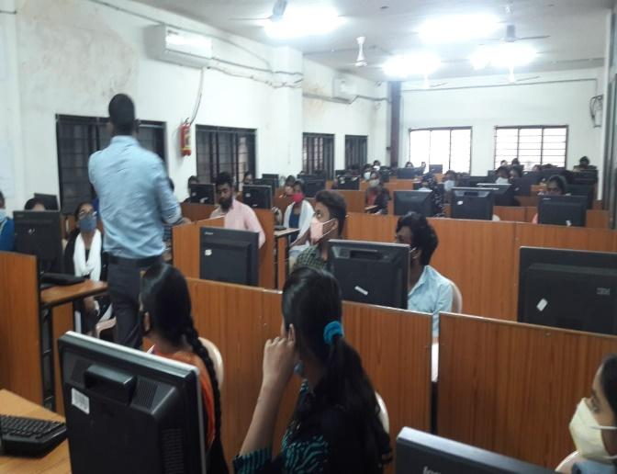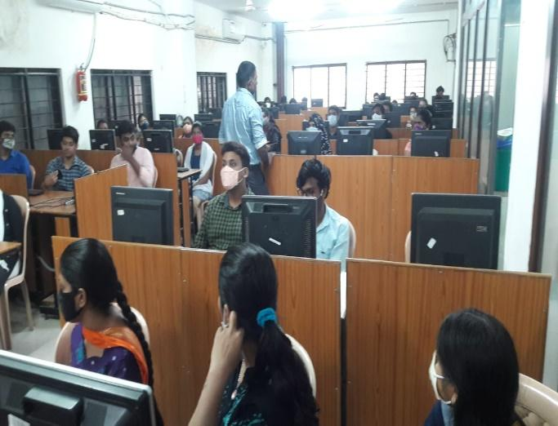

Aurora’s Degree & PG College
(ACCREDITED BY NAAC WITH 'B++' GRADE)
Chikkadpally, Hyderabad 500020

World Computer Literacy Day Detailed Report
NAME OF THE EVENT | World Computer Literacy Day
TYPE OR TITLE OF EVENT | World Computer Literacy Day
FACULTY INCHARGE | Srinivas U, Associate Professor
DEPARTMENT | Computer Science
DATE | 02-12-2021
VENUE | Computer Lab, Block VI, Near RTC ‘X’ Road, Chikkadpally
TARGET AUDIENCE | BCom Honors First Year Students

- PROGRAM SCHEDULE
10 am – 11 am
- LIST OF FACULTY COORDINATORS (DEPARTMENT)
Srinivas U,Department of Computer Science
- LIST OF THE STUDENT COORDINATORS
NIL
- LIST OF THE PARTICIPANTS
BCOM HONS FIRST YEAR STUDENTS

- PARAGRAPH ABOUT THE PROCEEDINGS
On 2nd Decemeber 2021 event was conducted for the BCom honors first year students on MS-word and MS-Excel. In this connection explained Advantages and creation of document using formatting features, editing documents, inserting tables take a print of document using page layout such as page setting, orientation and margins. excel features, creation of worksheet, calculation of data, inserting charts and basic internet concepts were explained.
The following few important topics covered
- Change capitalizations the easy way
- Formatting features of MS-Word
- Inserting Pictures and Images into document
- Applying Borders to the document
- Features of MS-Excel
- Basic formulas and calculations in Excel
- Creation of charts in excel
- Freeze or lock rows and columns in an Excel worksheet
- Basics of Internet
- INCOME AND EXPENDITURE
NIL
- EVENT PHOTOS
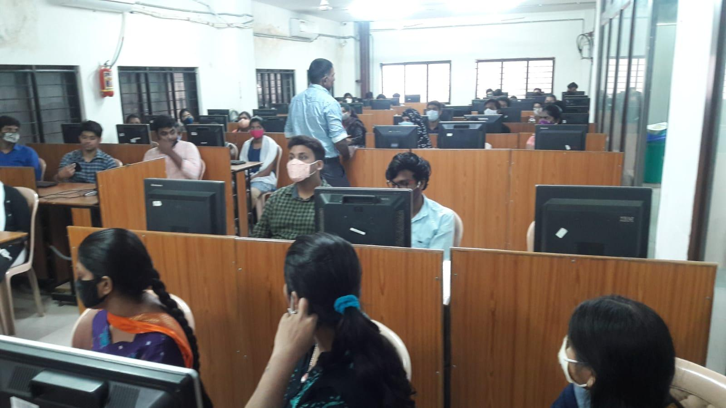

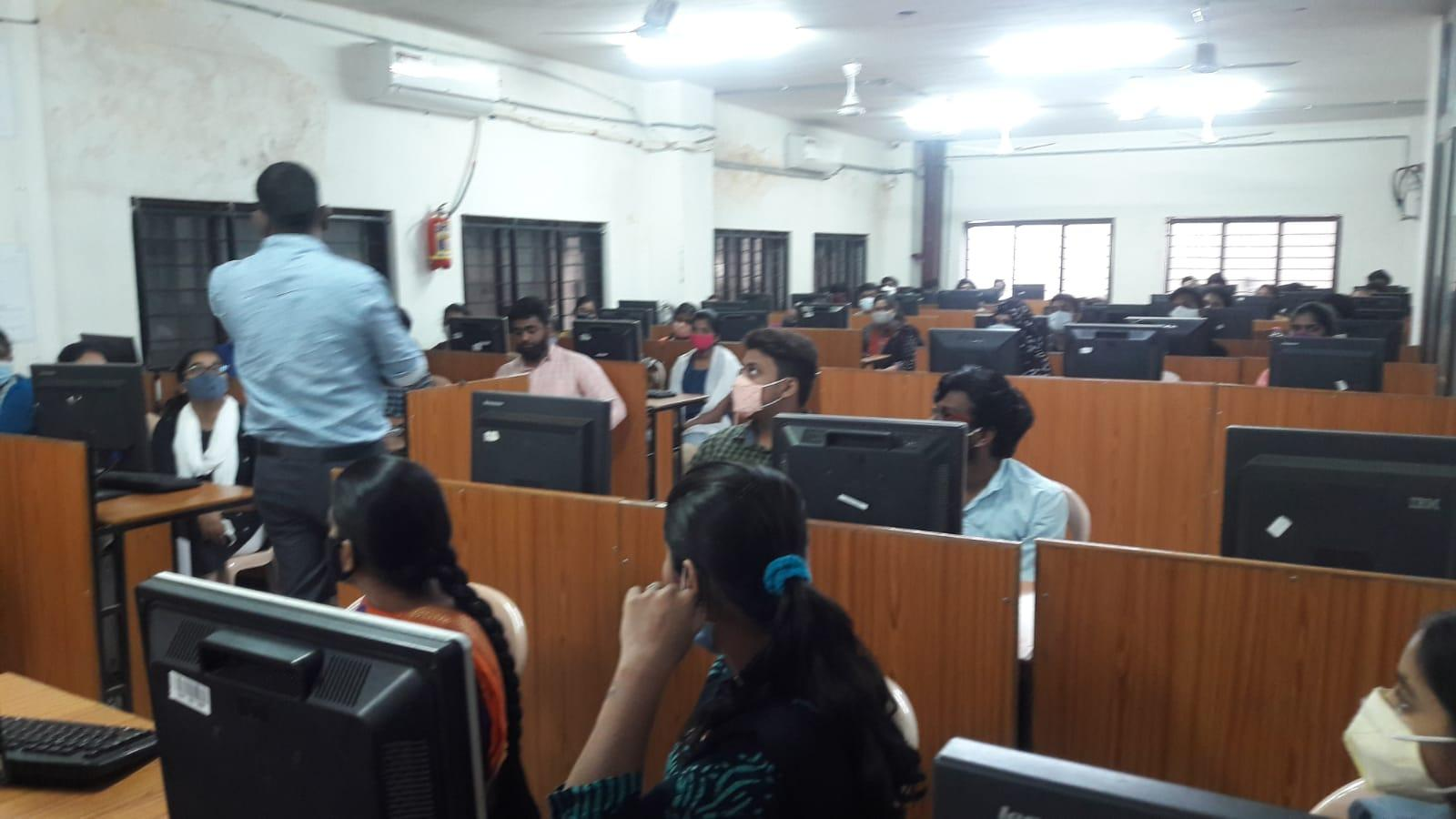
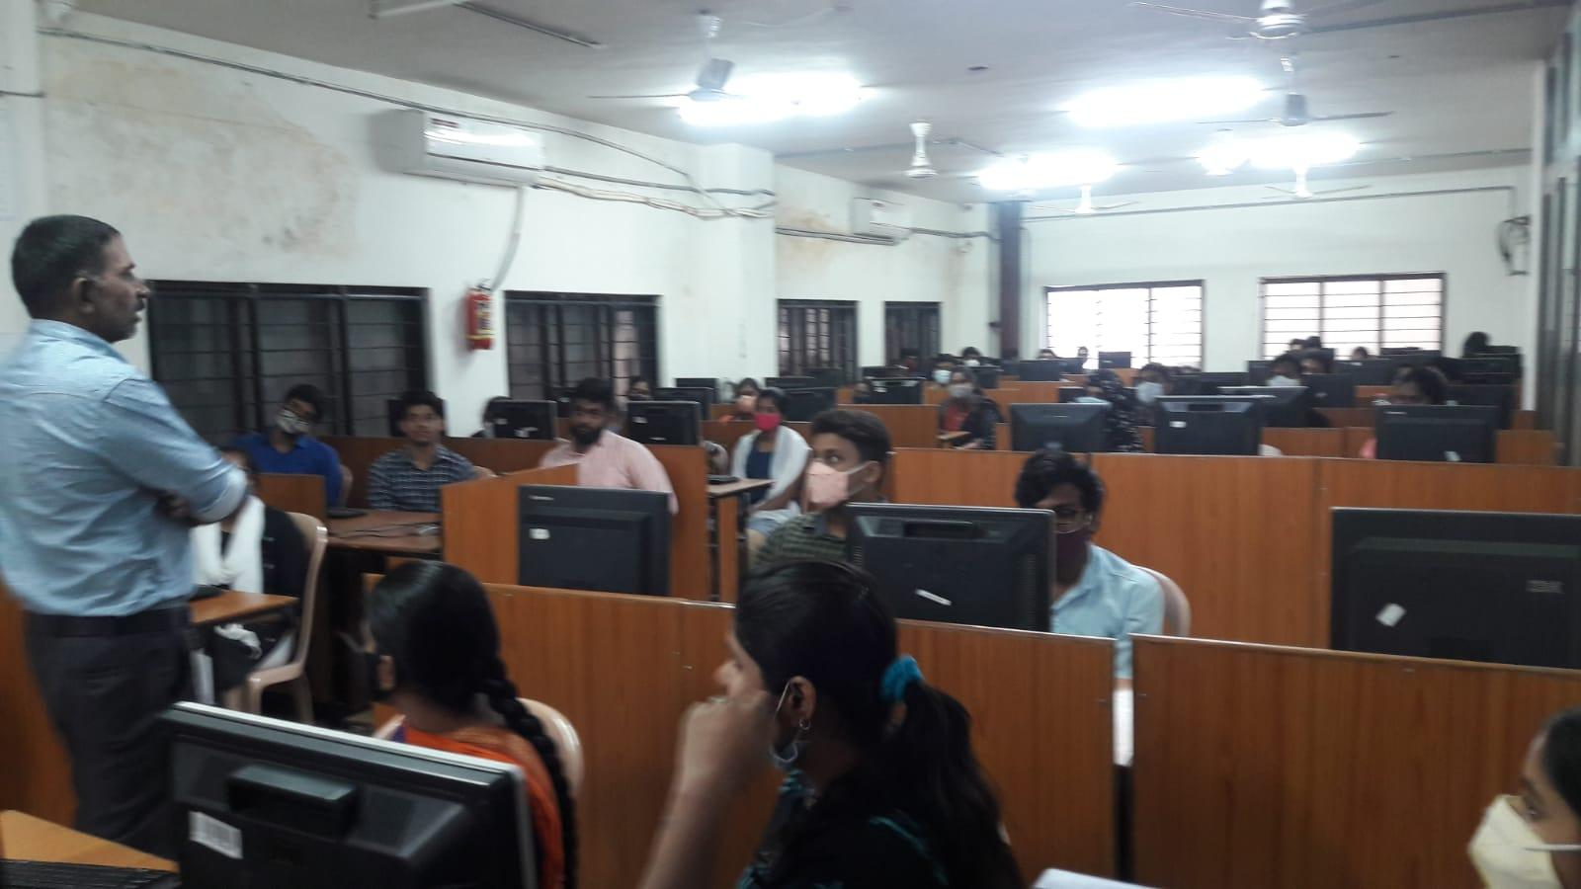
- GUEST PROFILE:
NIL
- FEED BACK
NIL
- ATTACHMENTS:
Event Porposal : Attached

