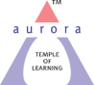
Aurora’s Degree & PG College
(Accreditedby NAAC with 'B++' grade)
Chikkadpally, Hyderabad- 500020
Department of Microbiology

EVENT REPORT

EVENT TITLE | Robert Koch Birth day celebration
TYPE OF EVENT | Departmental Event
FACULTY INCHARGE | Vasudevan
DEPARTMENT | Microbiology
DATE | 11th December 2021
VENUE | Microsoft teams
TARGET AUDIENCE | UG Students

PROGRAM SCHEDULE
Date of the event: 11th December 2021
Time of the event: 9.30 am to 11.30 am
Platform: Microsoft Teams
Link provided to join the event: https://drive.google.com/file/d/1hQpmAEdEd4FPQ8vpEesHIKEI1AI9NVSB/view?usp=sharing
LIST OF FACULTY COORDINATOR
S.No | Name of the faculty | Department
1 | Vasudevan | Microbiology

LIST OF FACULTY ATTENDED
S.No | Name of the faculty | Department
1 | Mr. J Hari Prasad Rao | Vice principal
2 | Mrs. Padma | Microbiology
3 | Mrs. G. Hiranmayee | Microbiology
4 | K. Mary Manjusha | Microbiology

LIST OF STUDENT COORDINATORS
S.No | Name of the student | Roll No | Section
1 | Akanksha | 1051-21-459-006 | MiGC 1
2 | Harshitha | 1051-21-471-007 | MiBiC 1
3 | Namitha Yadav | 1051-20-459-032 | MiGC 2
4 | Prerna | 1051-20-459-038 | MiGC 2

LIST OF STUDENTS (PARTICIPATED)
S.No | Name of the student | Roll No | Section | No of girls | 5
1 | Akanksha | 1051-21-459-006 | MiGC 1
2 | C.Jahnavi | 1051-21-459-020 | MiGC 1
3 | Yamini sindhu | 1051-21-459-021 | MiGC 1
4 | Harshitha | 1051-21-471-007 | MiBiC 1
5 | Prerana Sanjay | 1051-20-459-038 | MiGC 2
6 | Raghuvamsh | 1051-21-471-013 | MiBiC 1 | No of boys | 1

LIST OF STUDENTS (ATTENDED)
S.No | Name of the student | Roll No | Section | No of girls | 16
1 | Akanksha | 1051-21-459-006 | MiGC 1
2 | C.Jahnavi | 1051-21-459-020 | MiGC 1
3 | Yamini sindhu | 1051-21-459-021 | MiGC 1
4 | Shivani | 1051-21-459-028 | MiGC 1
5 | Harshitha | 1051-21-471-007 | MiBiC 1
6 | Namita Yadav | 1051-20-459-032 | MiGC 2
7 | Prerana Sanjay | 1051-20-459-038 | MiGC 2
8 | K. Prathyusha | 1051-20-459-040 | MiGC 2
9 | Bandari Varsha | 1051-20-471-012 | MiBiC 2
10 | Umm Malkan | 1051-19-459-048 | MiGC 3B
11 | Saraswath Sharma | 1051-19-459-054 | MiGC 3B
12 | Preksha Gupta | 1051-19-459-057 | MiGC 3B
13 | Sanyukta Rawat | 1051-19-459-058 | MiGC 3B
14 | Ethakula Dhanalakshmi | 1051-19-459-071 | MiGC 3B
15 | Chanda Anusha | 1051-19-471-020 | MiBiC 3
16 | Palleni Sruthi | 1051-19-471-029 | MiBiC 3
17 | k Raju kumar | 1051-21-459-029 | MiGC 1 | No of boys | 10
18 | Nitish | 1051-21-471-012 | MiBiC 1
19 | Raghuvamsh | 1051-21-471-013 | MiBiC 1
20 | Jerome Elliott | 1051-20-459-001 | MiGC 2
21 | Sundaresan | 1051-20-459-009 | MiGC 2
22 | Kanudla Ganeshbabu | 1051-20-459-010 | MiGC 2
23 | Lokesh | 1051-20-459-035 | MiGC 2
24 | Sadineni Shreyas | 1051-20-471-004 | MiBiC 2
25 | Kanaparthi Rishikraj | 1051-19-459-068 | MiGC 3B
26 | sohail shaik | 1051-19-459-069 | MiGC 3B

Paragraph about the proceedings
Heinrich Hermann Robert Koch (11 December 1843 – 27 May 1910) was a German physician and microbiologist. As the discoverer of the specific causative agents of deadly infectious diseases including tuberculosis, cholera, and anthrax, he is regarded as one of the main founders of modern bacteriology. The event was organized on the occasion of Robert Koch’s birth anniversary with the intent of commemorating his valuable contributions towards mankind and his efforts in the development of bacteriology and medical microbiology. Robert Koch is one of the prominent names in the field of microbiology and pathology who has redefined medical microbiology and bacteriology to an extent of disclosing hidden facts with scientific validation.
The discipline of bacteriology and medical microbiology seems to be incomplete without him and his discoveries. Some on his findings have been used as principles in comprehending infectious diseases. He has extensively worked on the etiology and epidemiology of several infectious diseases including cholera, anthrax and TB which were of severe health concern. He extensively worked on pure culture techniques and was the first scientific investigator to cultivate microbes on a solid medium.
The event scheduled on the 11th December 2021 was organized on Microsoft teams. The online event commenced at 9.30 am and lasted till 11.30 pm. Talks in accordance with Robert Koch’s extensive work were presented by the UG students. The session included power point and poster presentation by the students.
OUTCOME:
- Discoveries in bacteriology and medical microbiology
- Insights of acquired immunity
- Studies on anthrax disease
- Studies on TB
- Cultivation of microbes on a solid medium
- Infectious diseases
- Gelatin and its role in microbiology
- Spore and vegetative forms on the microbes
INCOME & EXPENDITURE: NIL

EVENT PHOTOS
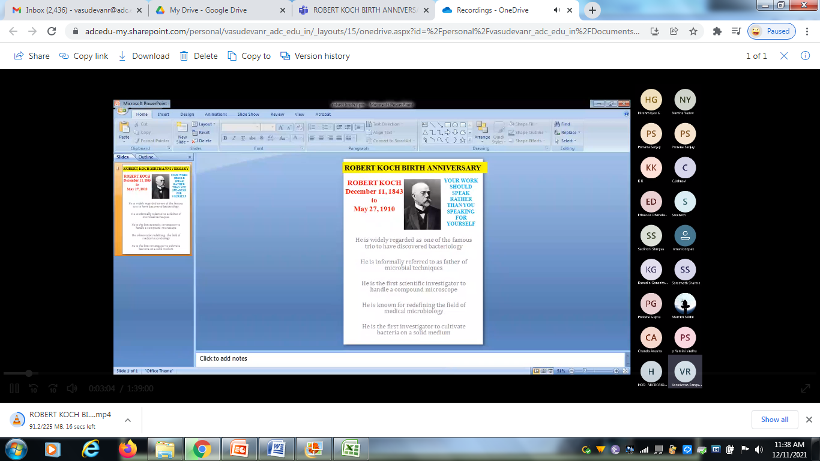
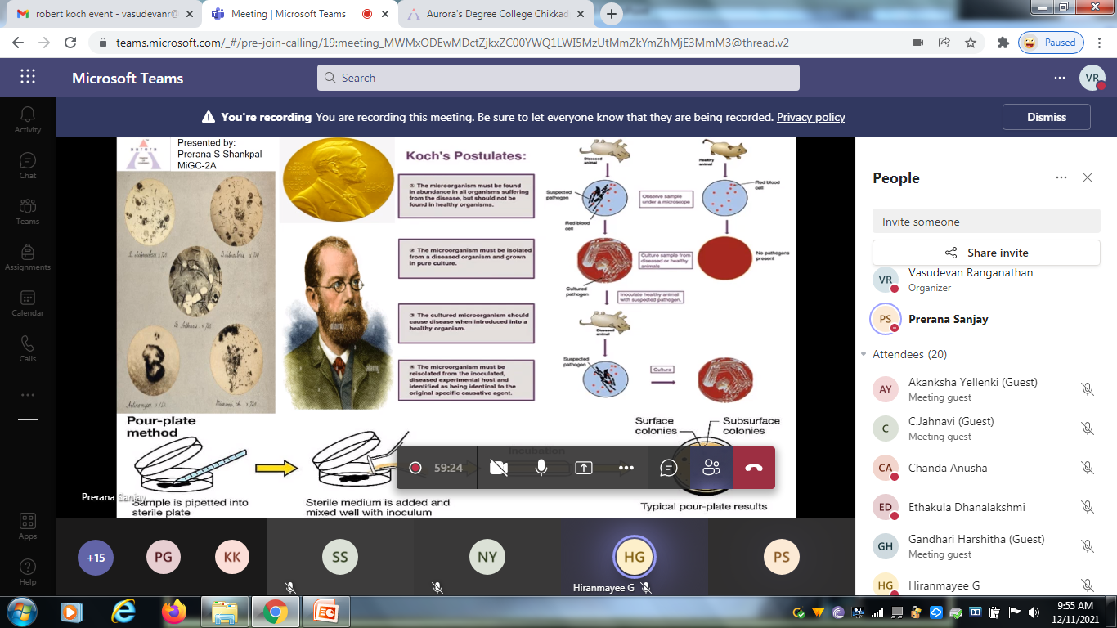
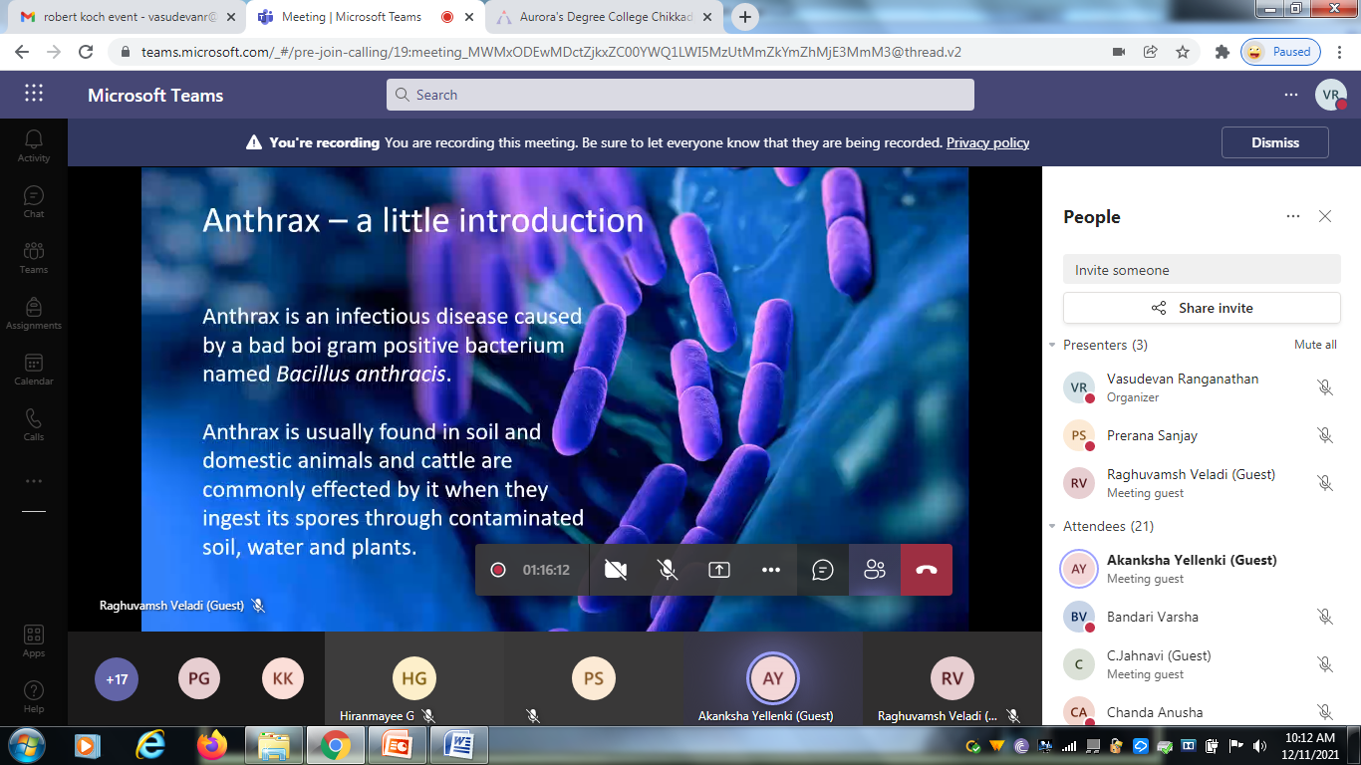

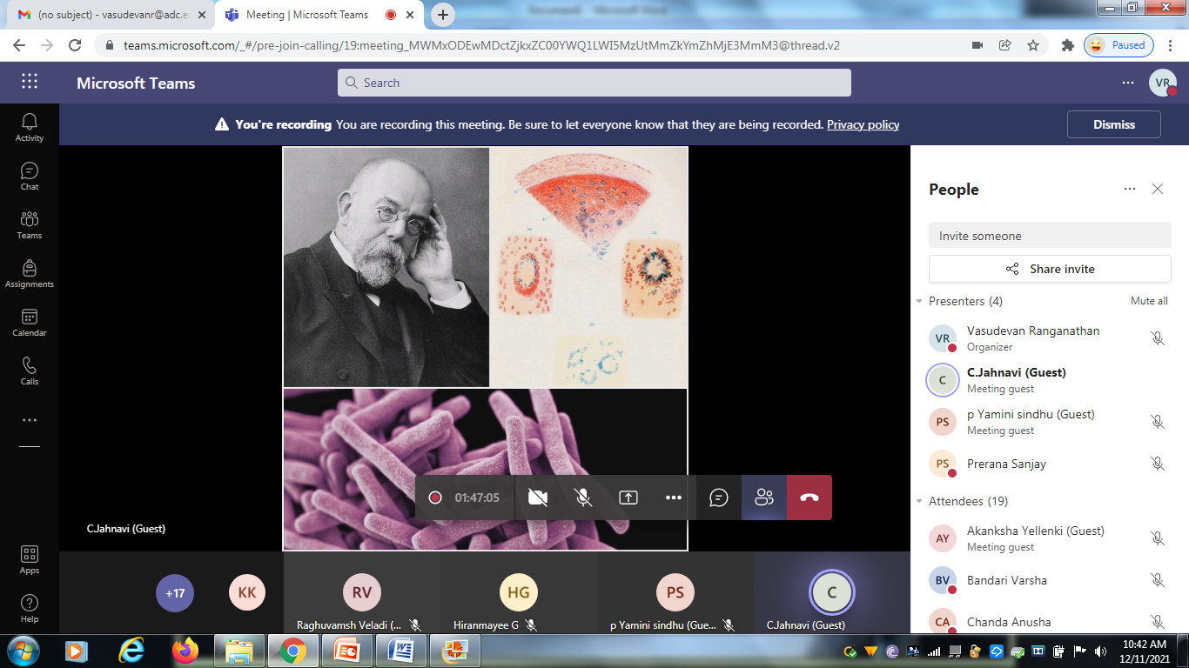
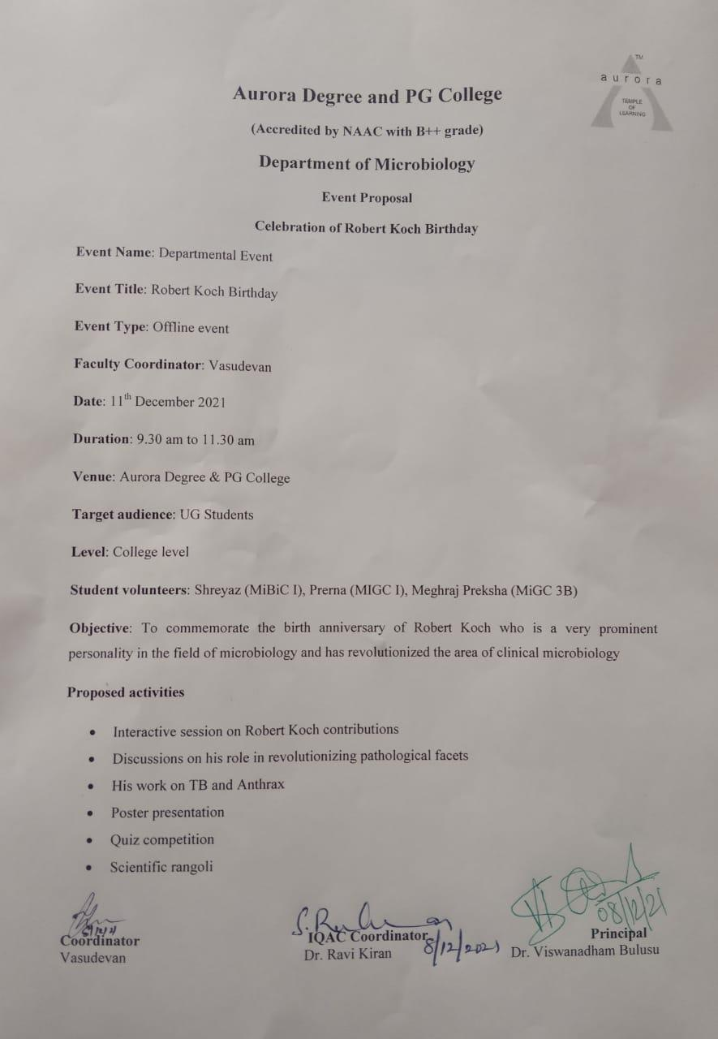
Note: The event was supposed to be an offline event as you can find the proposal in accordance with the same but as it was a holiday (Second Saturday), the event was conducted online on Microsoft teams

