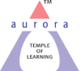
Aurora’s Degree & PG College
(Accreditedby NAAC with 'B++' grade)
Chikkadpally, Hyderabad- 500020
Department of Microbiology

EVENT REPORT

EVENT TITLE | Louis Pasteur Birth day celebration
TYPE OF EVENT | Departmental Event
FACULTY INCHARGE | Vasudevan
DEPARTMENT | Microbiology
DATE | 27th December 2021
VENUE | Aurora’s degree & PG College
TARGET AUDIENCE | UG & PG Students

PROGRAM SCHEDULE
Date of the event: 27th December 2021
Time of the event: 9.30 am to 12.30 am
Event type: Offline
Venue: Aurora’s Degree & PG College
FACULTY COORDINATOR
S.No | Name of the faculty | Department
1 | Vasudevan | Microbiology

LIST OF STUDENT COORDINATORS
S.No | Name of the student | Roll No | Section
1 | Akanksha | 1051-21-459-006 | MiGC 1
2 | Nikhil M | 1051-19-459-051 | MiGC 3B
3 | Preksha Gupta | 1051-19-459-057 | MiGC 3B
4 | Sneha | 1051-20-518-006 | MSC Microbiology III Sem

LIST OF UG STUDENTS (PARTICIPATED)
S.No | Name of the student | Roll No | Section | No of girls | 14
1 | B. Vaishnavi | 1051-20-459-037 | MiGC 2
2 | A. Poojitha | 1051-20-471-009 | MiBiC 2
3 | G. Akanksha | 1051-20-471-015
4 | Ch. Sravani | 1051-19-459-021 | MiGC 3A
5 | Prachi Sharma | 1051-19-459-030
6 | Megha | 1051-19-459-034
7 | S. Neha | 1051-19-459-035
8 | Shruthi Dubey | 1051-19-459-052 | MiGC 3B
9 | Simrah | 1051-19-459-053
10 | Saraswath Sharma | 1051-19-459-054
11 | Preksha Gupta | 1051-19-459-057
12 | Fathima | 1051-19-459-062
13 | Chanda Anusha | 1051-19-471-020 | MiBiC 3
14 | Palleni Sruthi | 1051-19-471-029
15 | Vairagare spoorthi | 1051-20-518-001 | MSC Microbiology Sem III
16 | Shazia | 1051-20-518-003
17 | Zara Mehdi | 1051-20-518-004
18 | Thangella sneha | 1051-20-518-006
19 | Hannah | 1051-20-518-008
20 | Reona Arul | 1051-20-518-010
21 | Suniyam | 1051-20-518-015
22 | A M krithika | 1051-20-518-025
23 | Kairamkonda Raju Kumar | 1051-21-459-029 | MiGC 1 | No of boys | 4
24 | Sri Kousthub | 1051-21-471-003 | MiBiC 1
25 | Shashidhar | 1051-21-471-008
26 | Divyanshu Basuthkar | 1051-19-459-010 | MiGC 3A

Paragraph about the proceedings
Microbiology is an applied discipline of Life Science which explores various facets affiliated to microscopic creatures ranging from their growth and development to metabolism and death. Many pioneers have attempted to comprehend the subject but one name that out stands among all the pioneers is Louis Pasteur. He is commonly regarded as the father Microbiology not just because of his findings but because of his novel ideas that convinced the scientific community. His level of perception and perseverance towards the subject was exceptional and complements his significant contributions in the field of Microbiology.
Louis Pasteur (1822 – 28 September 1895) was a French chemist and microbiologist renowned for his discoveries of the principles of vaccination, microbial fermentation, and pasteurization. His research in chemistry led to remarkable breakthroughs in the understanding of the causes and preventions of diseases, which laid down the foundations of hygiene, public health and much of modern medicine. His works are credited to saving millions of lives through the developments of vaccines for rabies and anthrax. He is regarded as one of the founders of modern bacteriology and has been honoured as the "father of bacteriology and as the "father of microbiology. Pasteur was responsible for disproving the doctrine of spontaneous generation. Under the auspices of the French Academy of Sciences, his experiment demonstrated that in sterilized and sealed flasks, nothing ever developed; and, conversely, in sterilized but open flasks, microorganisms could grow.
The event was conducted between 9.30 am to 12.30 pm and include oral and poster presentation that lasted till 11 am. Scientific rangoli was scheduled on the same day from 11 am onwards that lasted till 12.30 pm.
INCOME & EXPENDITURE: NIL
EVENT PHOTOS

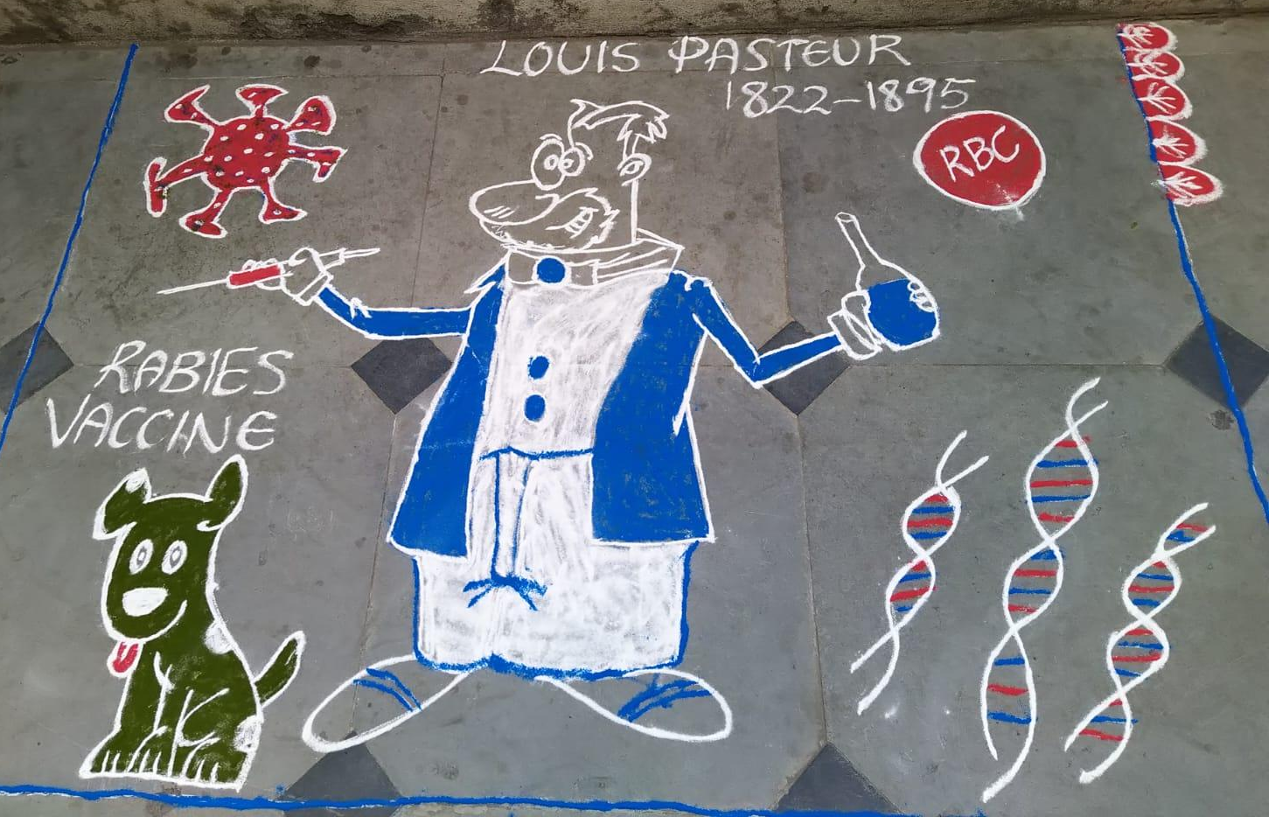

Event proposal
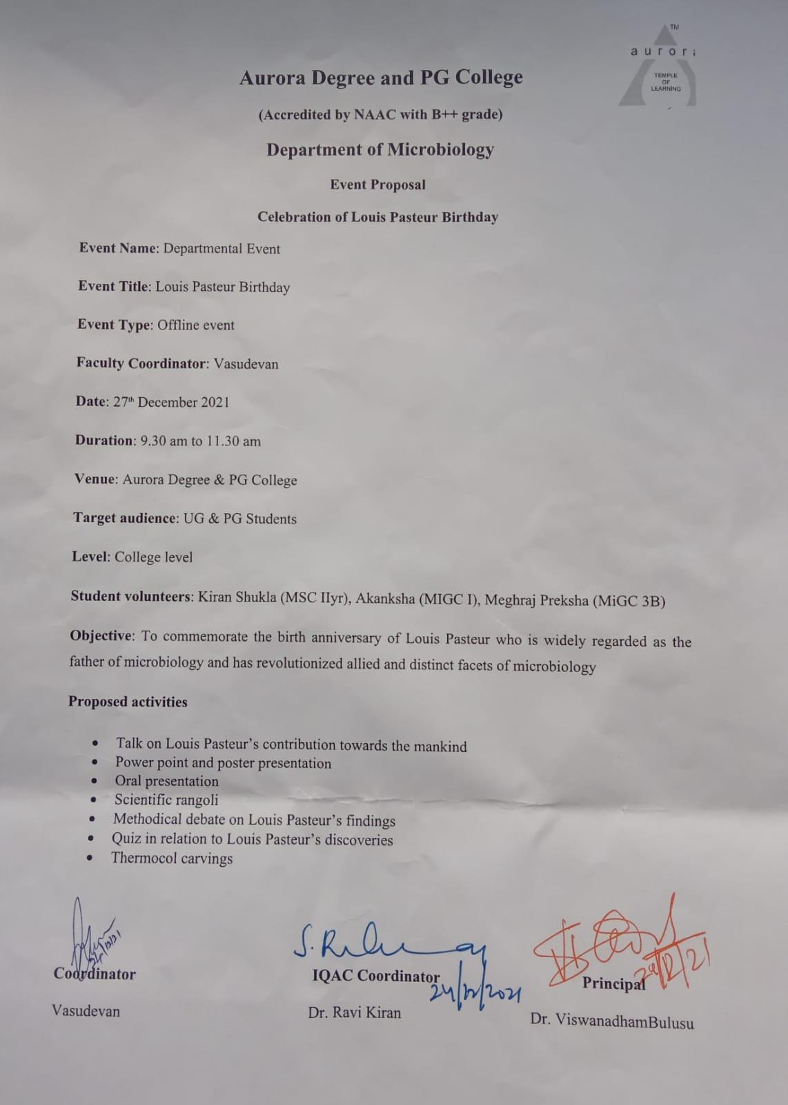

Event notice
