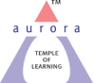
Aurora’s Degree & PG College
(Accredited by NAAC with 'B++' grade)
Chikkadpally, Hyderabad- 500020
Department of Microbiology

EVENT DETAILED REPORT

EVENT TITLE | International Day of Women and Girls in Science
TYPE OF EVENT | Departmental Event
FACULTY COORDINATOR | G.Hiranmayee
DEPARTMENT | Microbiology
DATE | 11th February 2022
VENUE | Aurora’s Degree & PG College, Block- VI
TARGET AUDIENCE | PG Students

PROGRAM SCHEDULE
Date of the event: 11-02-2022
Time of the event: 01:00 pm to 03:00 pm
Venue: Aurora’s Degree & PG College, Block-VI

LIST OF FACULTY COORDINATORS
S.No | Name of the faculty | Department
1 | G. Hiranmayee | Microbiology

LIST OF FACULTY ATTENDED
S.No | Name of the faculty | Department
1 | M.Padma | HOD-Microbiology
2 | Rajini | HOD-Computer Science
3 | C.Aruna | HOD-Physics & Electronics
4 | Dr. Ravikiran | HOD-Biochemistry
5 | G.Bindu | Biochemistry
6 | Sunitha | Biochemistry
7 | K.Mary Manjusha | Microbiology
8 | R.Vasudevan | Microbiology

LIST OF STUDENT COORDINATORS
S.No | Name of the student | Roll No | Section
1 | S. Venkata Chaitanya | 1051-20-518-002 | MSc-Microbiology-2nd yr
2 | G Akhilandeshwari | 1051-20-518-022 | MSc-Microbiology-2nd yr
3 | K.Santhoshi Shravani |  | MSc-Microbiology – 1st yr

LIST OF PARTICIPANTS:
S.No | Name of the student | Roll No | Section | No. of Girls | 25
1 | G. Akhilandeshwari | 1051-20-518-022 | MSc-Microbiology
2 | Krupa Rani | 1051-20-518-031 | MSc-Microbiology
3 | K Pranitha | 1051-20-518-007 | MSc-Microbiology
4 | S.Venkata Chaitanya | 1051-20-518-002 | MSc-Microbiology
5 | Pailla Prathyusha | 1051-20-518-026 | MSc-Microbiology
6 | A M Krithika | 1051-20-518-025 | MSc-Microbiology
7 | Ch Sahithi | 1051-20-518-027 | MSc-Microbiology
8 | T.Sneha | 1051-20-518-006 | MSc-Microbiology
9 | Reona Arul | 1051-20-518-010 | MSc-Microbiology
10 | N.Preethi | 1051-20-518-032 | MSc-Microbiology
11 | Zara Mehdi | 1051-20-518-004 | MSc-Microbiology
12 | P.Prathyusha | 1051-20-518-026 | MSc-Microbiology
13 | R.Shailaja | 1051-20-518-023 | MSc-Microbiology
14 | B.Sravani |  | MSc-Microbiology
15 | Shraddha Kulkarni |  | MSc-Microbiology
16 | K.Santhoshi Sravani |  | MSc-Microbiology
17 | Afiya Kauser |  | MSc-Microbiology
18 | Syeda Ameena Banu |  | MSc-Microbiology
19 | Bindu priya |  | MSc-Microbiology
20 | Soniya |  | MSc-Microbiology
21 | Blesscy |  | MSc-Microbiology
22 | B. Sangeetha Sudha |  | MSc-Microbiology
23 | B.V.S.Yasaswini |  | MSc-Biochemistry
24 | Kamati Shivani |  | MSc-Biochemistry
25 | P.Sai Sumanth |  | MSc-Microbiology | No. of Boys | 3
26 | N.Vamshidhar Reddy |  | MSc-Microbiology
27 | G.Ganesh |  | MSc-Microbiology

LIST OF THE ATTENDEES
S.No | Name | Roll number | section
1 | Bandari Suniyam | 1051-20-518-015 | MSc-Micro | No. of Girls | 13
2 | R. Sai Tejaswini | 1051-20-518-029 | MSc-Micro
3 | Shazia Hasmi | 1051-20-518-003 | MSc-Micro
4 | Pailla Prathyusha | 1051-20-518-026 | MSc-Micro
5 | A M Krithika | 1051-20-518-025 | MSc-Micro
6 | P Sai Bhuvana | 1051-20-518-035 | MSc-Micro
7 | Vairagare Spoorthi | 1051-20-518-001 | MSc-Micro
8 | Adla Swathi | 1051-20-518-017 | MSc-Micro
9 | S Sudhiksha | 1051-20-518-030 | MSc-Micro
10 | Thokati Niharika | 1051-20-518-011 | MSc-Micro
11 | Mary Evanjali |  | MSc-Micro
12 | Christina |  | MSc-Micro
13 | V.Spoorthi |  | MSc-Micro
14 | P. Vijay Kumar | 1051-20-518-014 | MSc-Micro | No .of Boys | 4
15 | Ungurala Vineeth | 1051-20-518-020 | MSc-Micro
16 | M Bhanu Chandar | 1051-20-518-028 | MSc-Micro
17 | Kiran Shukla | 1051-20-518-034 | MSc-Micro

PARAGRAPH OF THE PROCEEDINGS
The prime objective of the event is to commemorate the achievemnets of the women in the field of science that has in turn contributed towards the progress of the mankind. The event has started with an Introduction about the significance of the day. Many posters were presented considering the theme as “Role of women in science”. It is aimed at discussing the prominence of women in STEM (Science, Technology, Engineering and Mathematics) disciplines. The most informative talk on this occasion was about the Awards and Recognitions given to the young women in the field of science as the honour of excellence. The event proceeded on with the following Hightlights such as -
- Significance of the women in Science & technology
- Prominence of Women Scientists in the field of Science
- Role of Women in the Music of Science
- Revolutionary aspects of Women scientific investigators
- Awards and Recognitions to a Young Women Scientists
The event was graced with the presence of Departmental Heads of our college.
INCOME & EXPENDITURE: Nil
EVENT PHOTOS:
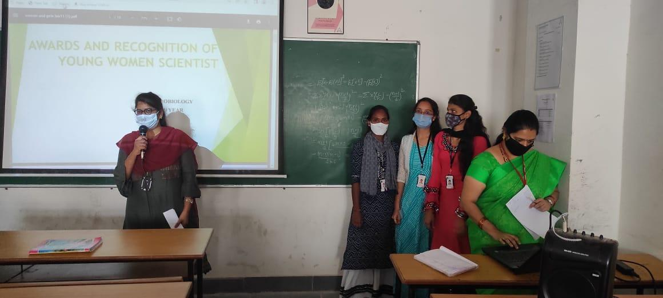
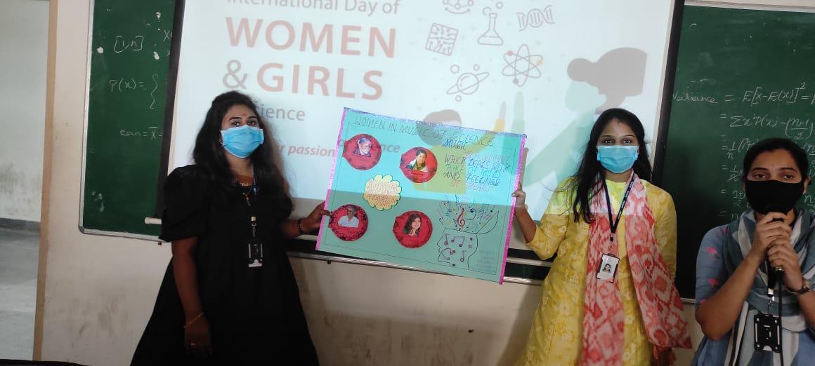

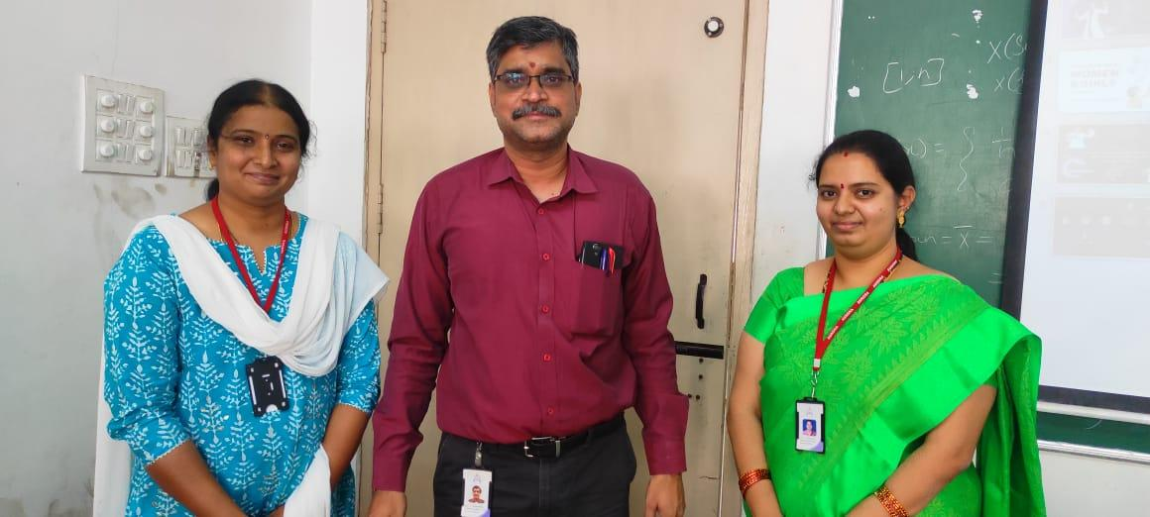
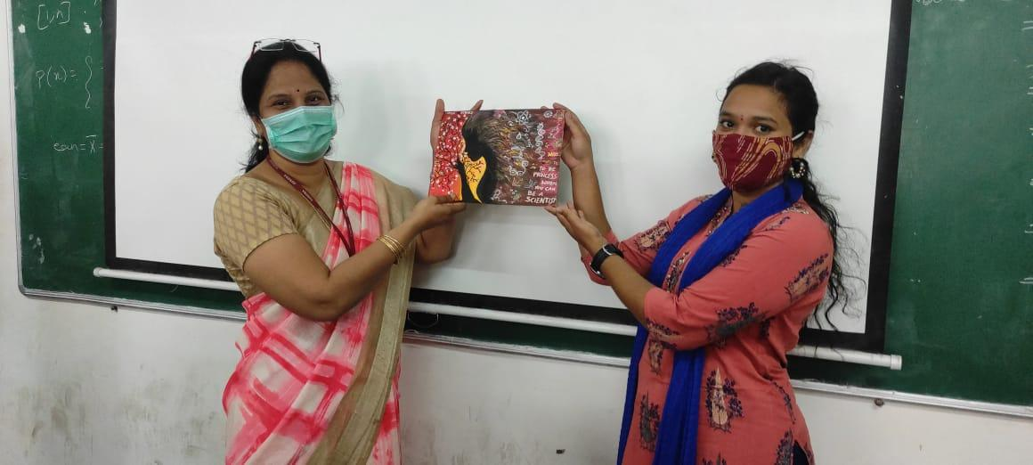

EVENT SCROLL:
