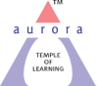
Aurora’s Degree & PG College
(ACCREDITED BY NAAC WITH 'B++' GRADE)
Chikkadpally, Hyderabad 500020

EVENT / ACTIVITY DETAILED REPORT

NAME OF THE EVENT / ACTIVITY | Matrubhasha Dinotsavam
TYPE OR TITLE OF EVENT / ACTIVITY | Class Event
FACULTY INCHARGE | Dr. N Suryakanthi  R.Heena
DEPARTMENT/CELL/COMMITTEE/CLUB | Languages
DATE | 21 February2022
VENUE | RTC Cross Road Block 6
TARGET AUDIENCE | UG Students

- PROGRAM SCHEDULE : The programme was scheduled on 21 February 2022 from 10 a.m to 11 am. At RTC cross road Block 6
- The programme began at 10 a.m
- At around 10.10 am convener Dr. N. Suryakanthi welcomed the Students.
- The Event programme began at 10.15 a.m
- The programme ended with a vote of thanks given by R.Heena.

2. LIST OF FACULTY COORDINATORS (DEPARTMENT)
S.no | Faculty Name | Role | Department
1 | Dr.N. Surya Kanti | Convener | Associate Professor – Department of Second languages
2 | Mrs. Heena | Member | Assistant Professor Second languages

- LIST OF THE STUDENT COORDINATORS (NAME , ROLL NO, CLASS & SECTION)
NAME | ROLL NO | CLASS & SECTION
C.John simon | 1051-21-459-027 | MIGc
S.Shivani | 1051-21-459-028 | MIGc
Pooja.Goyal | 1051-21-684-005 | BBA

- LIST OF THE PARTICIPANTS (NAME , ROLL NO, CLASS & SECTION, NO OF GIRLS, BOYS, CASTE )
Yes

Name of the students | Roll number | Class & Section
S.Shivani | 1051-21-459-028 | MIGc
C.John simon | 1051-21-459-027 | MIGc
Aakoju Pranathi Chary | 1051-20-009-016 | MA English
M Vidya Rani | 1051-20-009-001 | MA English
D Mounika | 1051-20-009-023 | MA English
Yarrolla Supriya | 1051-20-009-024 | MA English
Gajula Saritha | 1051-20-009-004 | MA English
Gattigundla Durga Neeharika | 1051-20-009-019 | MA English
Boddu Shashi Kumar | 1051-20-009-020 | MA English
Adlagatla Vyshnavi | 1051-20-009-003 | MA English
J Ganapathi Naidu | 1051-20-009-012 | MA English
Thummala Shirisha | 1051-20-009-007 | MA English
Chamanapelli Shivaprasad | 1051-20-009-013 | MA English
G Suresh | 1051-20-009-014 | MA English
P Chandana | 1051-20-009-010 | MA English
Manupati Sagar | 1051-20-009-017 | MA English
Sistla Pranamya | 1051-20-009-005 | MA English
Pooja.Goyal | 1051-21-684-005 | BBA
Salla Deekshitha | 1051-21-459-025 | MiGC
Pochaveni Kavya | 1051-21-459-026 | MiGC
Kairamkonda Raju Kumar | 1051-21-459-029 | MiGC
Maseedhpally Sanjana | 1051-21-459-030 | MiGC
Firdous Fatima | 1051-21-459-001 | MiGC
Tejaswini Talikota | 105121459-002 | MiGC
Swetha Kumari | 1051-21-459-003 | MiGC
Sapna Ghosh | 1051-21-471-001 | MiBiC
Sumanth Venkata Sai Ayancha | 1051-21-471-002 | MiBiC
Guduri Shivani | 1051-21-471-014 | MiBiC
Karre Laxmi Prasanna | 1051-21-488-047 | BtBic
Mohammad Haneef | 1051-21-488-048 | BtBic
Nujella Mani Deepak | 1051-21-488-049 | BtBic
Hemanth badukali | 1051-20-684-075 | BBA 1B
Sirigiri Aishwarya | 1051-21-488-002 | BtBic
Kusshika Hemanth | 1051-21-488-003 | BtBic
Faizuddin Mohammed | 1051-21-488-004 | BtBic
Neha Anjum | 1051-21-488-005 | BtBic
Kanani Muskan Dilesh | 1051-21-488-006 | BtBic
M Pallavi | 1051-21-488-007 | BtBic
Abdul Waheed Khan | 1051-21-488-008 | BtBic
Dalugari Sathyanarayana Reddy | 1051-21-488-009 | BtBic
Nishath Farheen | 1051-21-488-010 | BtBic
Tumbalam Kureshi Azaharuddin | 1051-21-488-011 | BtBic
Alicia Mary Frantz | 1051-21-488-012 | BtBic
P Keerthi Chandana | 1051-21-488-013 | BtBic
Syed Ansar | 1051-21-488-014 | BtBic
Kandukuri Nagur Basha | 1051-21-488-015 | BtBic
G.RUCHIKA | 1051-19-405-156 | B.computers application 2C
Mousumi Samanta | 1051-19-405-162 | B.computers application 2C
Soniya sunka | 1051-19-405-163 | B.computers application 2C
seema arni | 1051-19-405-190 | B.computers application 2C
Monika Agarwal | 1051-20-401-0021 | Bcom(gen) , 1A

PARAGRAPH ABOUT THE PROCEEDINGS (TILL THE END OF THE EVENT)
Event started at 10.00 AM, students from our College joined. The program started with introduction. Introduction was given by Dr. N Suryakanthi & Heena. After introduction, matrubhasha song was presented both in Telugu and Hindi languages. After the song C.John simon first year have anchored very effectively. Telugu power point presentation & Hindi power point presentation was also shown and the content was explained. Some students put forth their views about matrubhasha.M.K Sunny paul final year students sings a song .kashish sharma presented Hindi poetry . More than 50 participants in this event. Students actively participated in this program conducted by Language department. The event was successful. At the end of the informative session vote of thanks was given by R.Heena and this was followed by a photo session. The event ended around 11.30 AM.

6.INCOME AND EXPENDITURE
Nil
7.EVENT PHOTOS ( MIN 2 MAX 4)

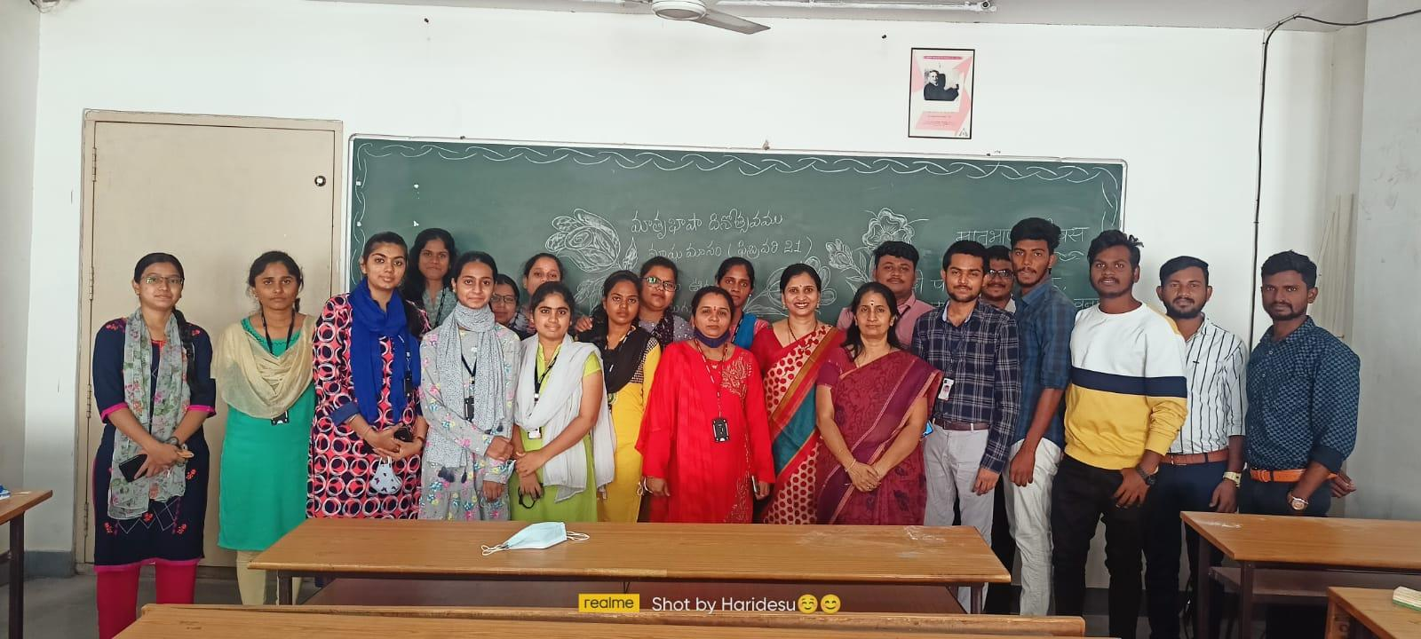
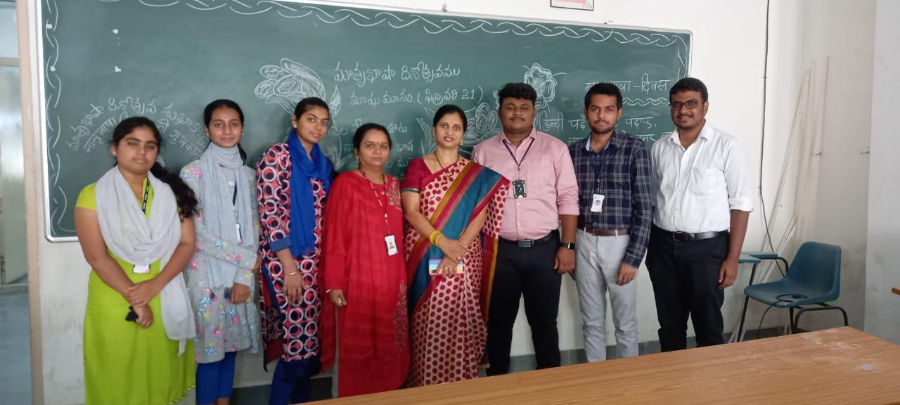
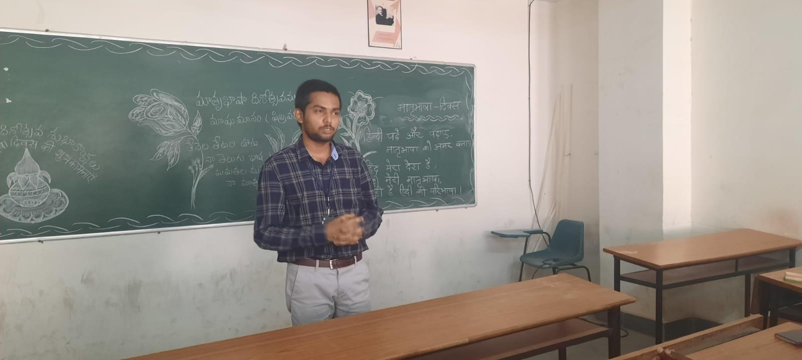

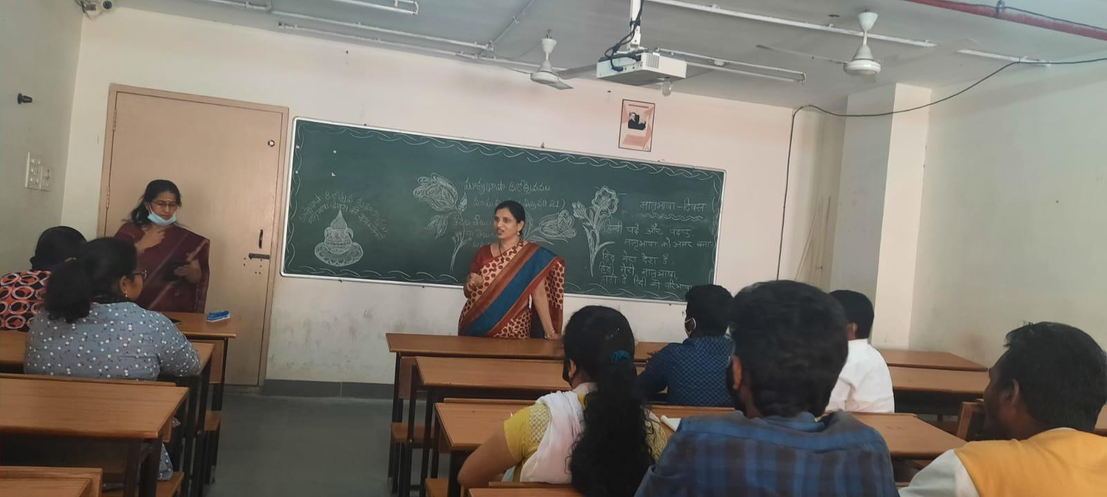

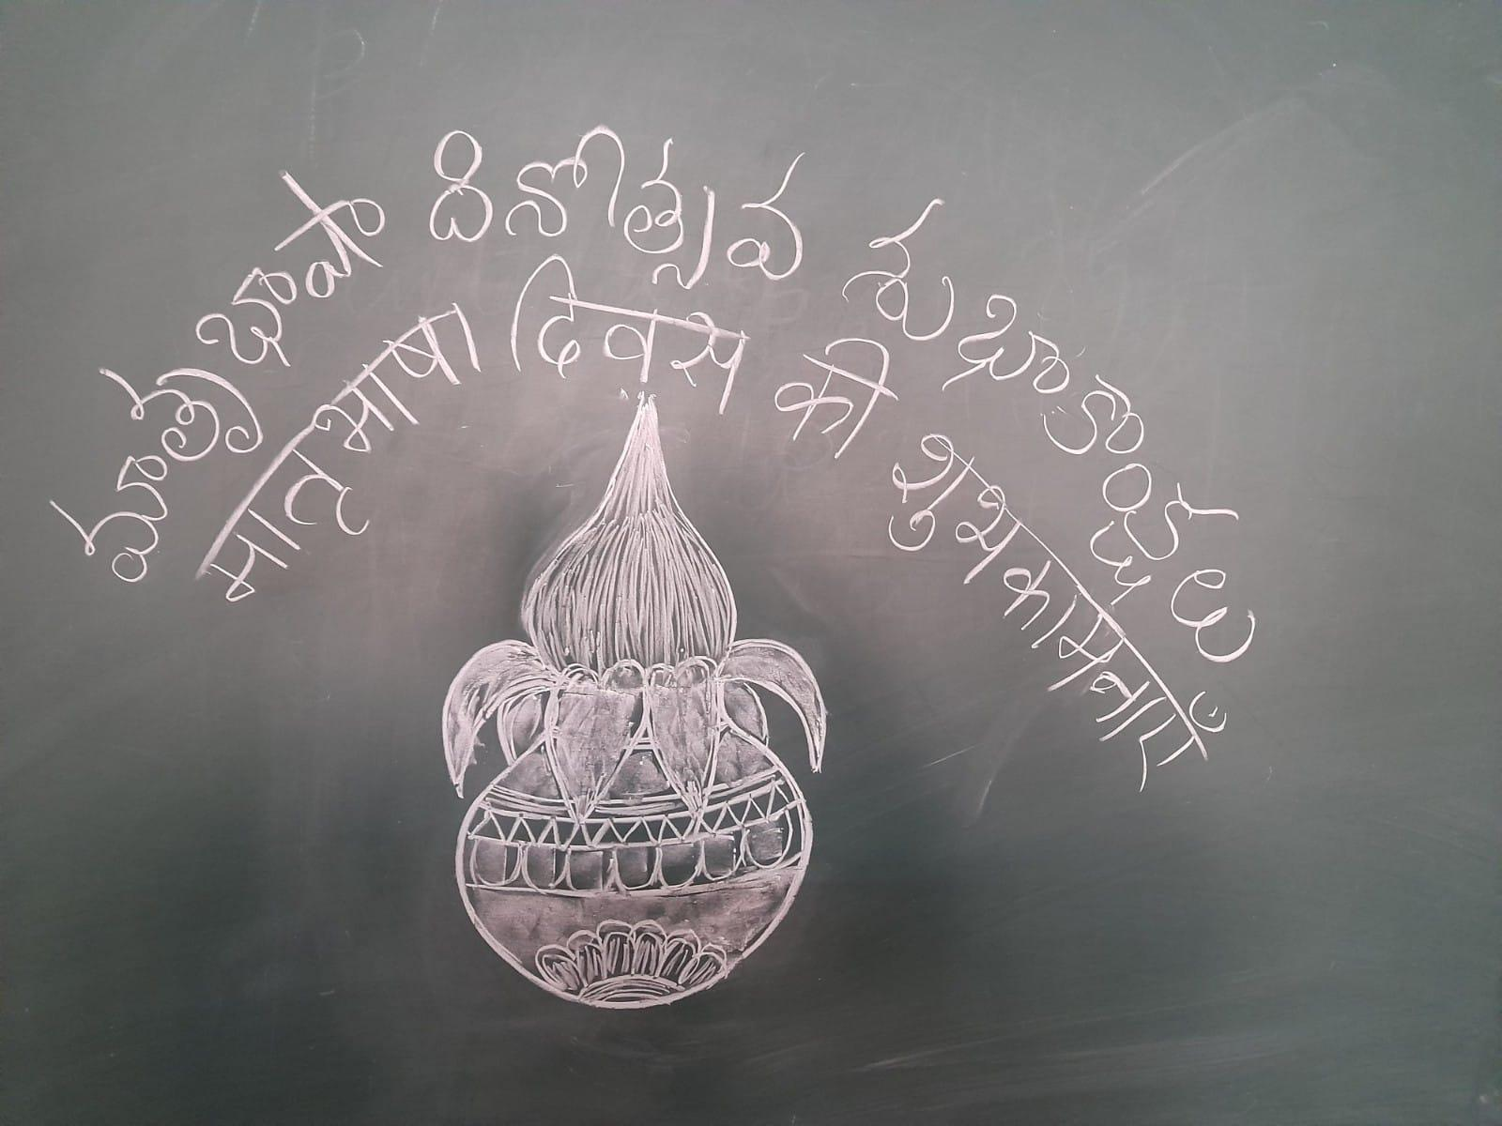
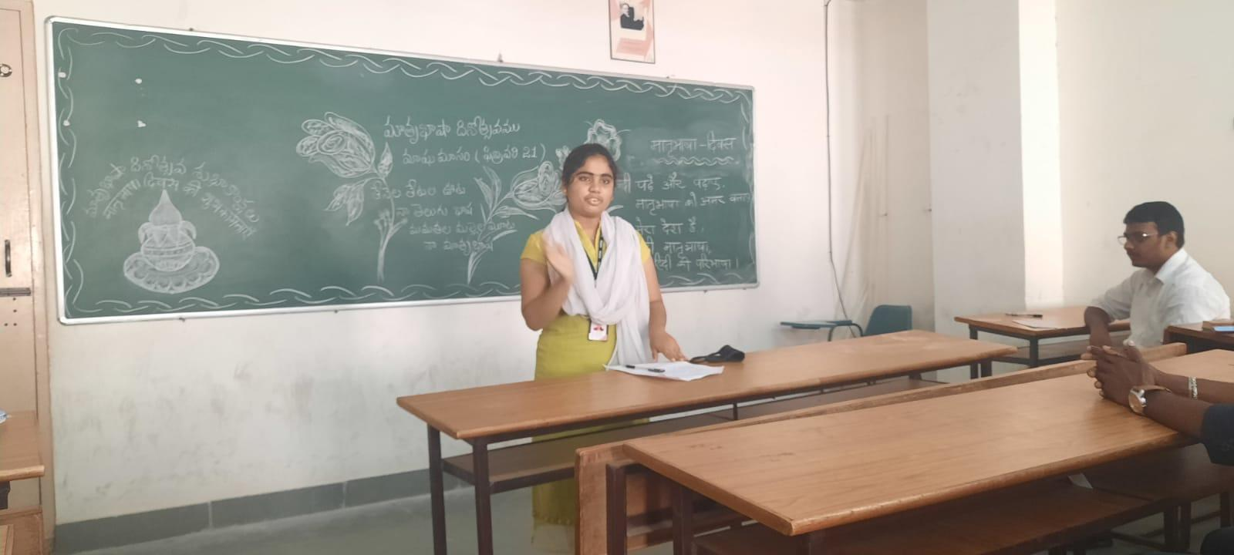

EVENT/ACTIVITY PROPOSAL
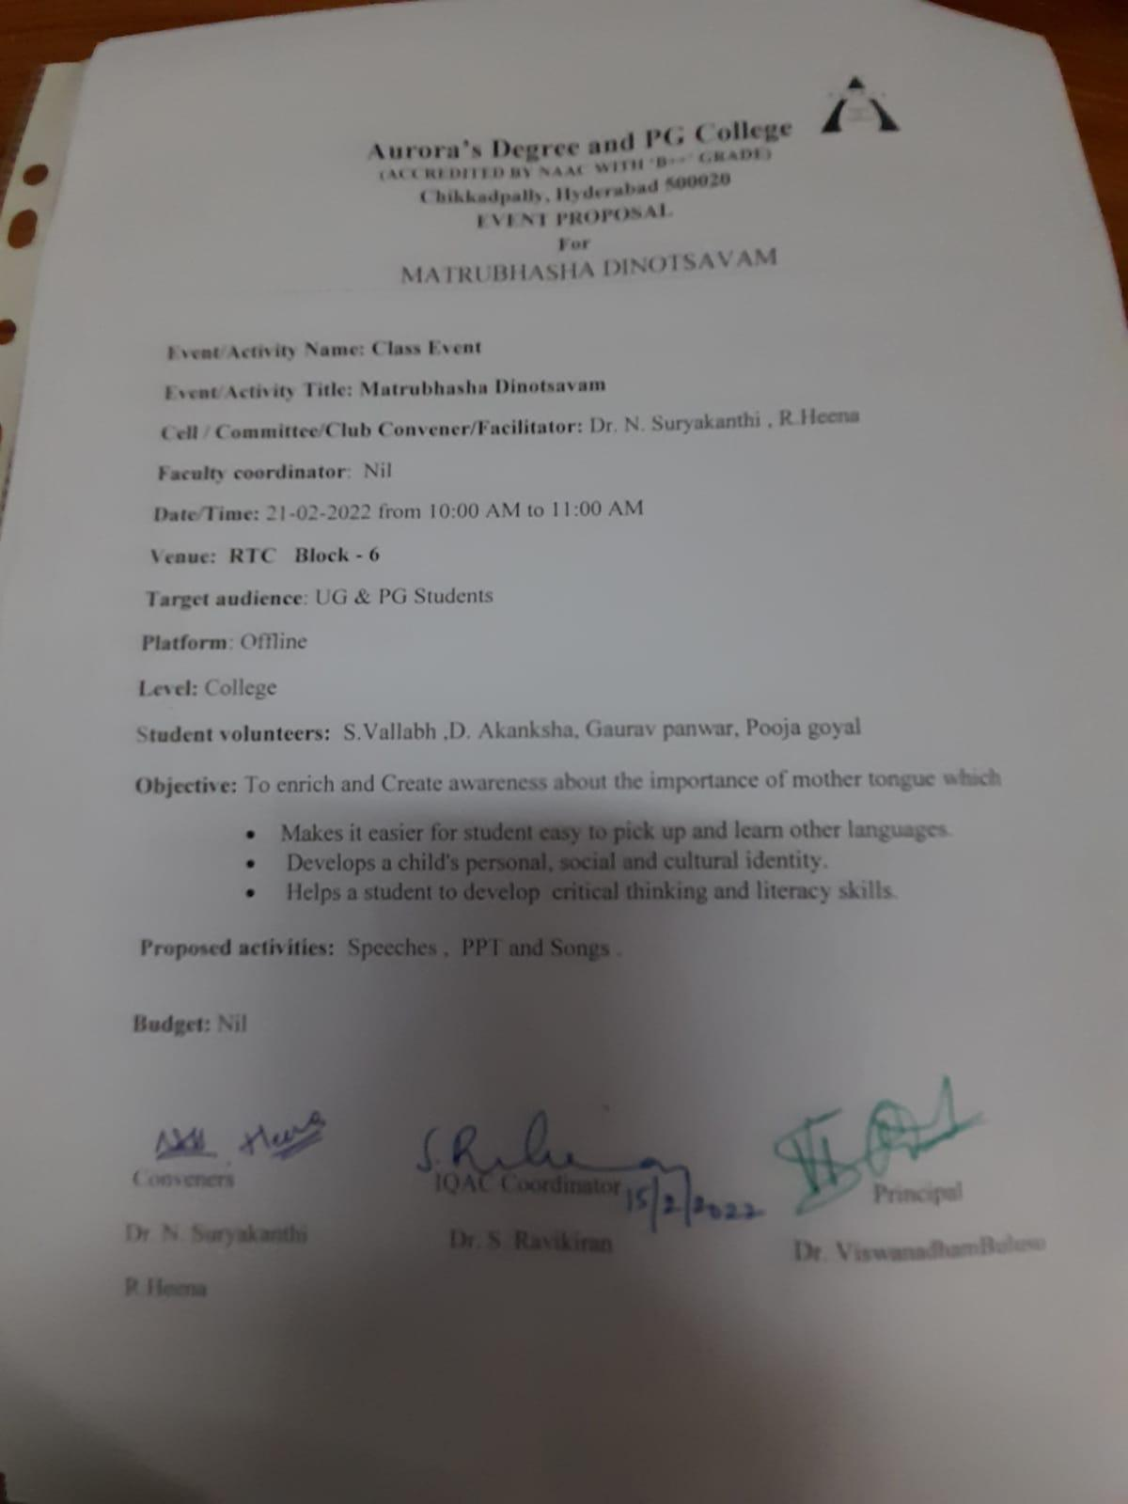EVENT / ACTIVITY NOTICE
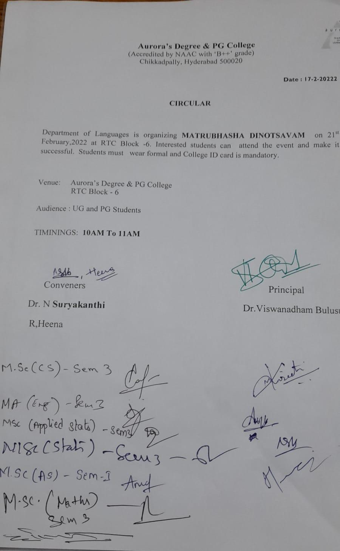

GUEST PROFILE (IF ANY)
Nil
FEED BACK IF ANY
Nil
RECEIPTS (IF ANY)
Nil
CERTIFICATES (IF ANY)
Nil
LETTERS OF COMMUNICATION (IF ANY)
Nil

