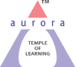
Aurora’s Degree & PG College
(ACCREDITED BY NAAC WITH 'B++' GRADE)
Chikkadpally, Hyderabad 500020

EVENT / ACTIVITY DETAILED REPORT

NAME OF THE EVENT / ACTIVITY | International Women’s Day
TYPE OR TITLE OF EVENT / ACTIVITY | International Women’s Day
FACULTY INCHARGE | Dr. N. Suryakanthi
DEPARTMENT/CELL/COMMITTEE/CLUB | Women Empowerment Cell
DATE | 7th & 8th March 2022
VENUE | Aurora’s Auditorium
TARGET AUDIENCE | Faculty and staff

- PROGRAM SCHEDULE
Time | Programme Details
10 am | Welcome Address by WEC
10:10 am | Lighting of the lamp
10:15 am | Prayer Song
10:20 am | Speech by the Principal
10:30 – 10:40am | Speech by interested faculty
10.40 am to 12:00 pm | Entertainment Session (e.g., games such as ‘Tambola’)
12:00 pm | Photo Session
12.15 pm | Vote of Thanks by WEC

- LIST OF FACULTY COORDINATORS (DEPARTMENT)
S.no | Faculty Name | Role | Department
1 | Dr. N. Surya Kanthi | WEC Convener | Associate Professor – Department of Second languages
2 | G.Chamundeshwary | WEC Member | Associate Professor – Department Of Commerce
3 | Ms. Heena | WEC Member | Assistant Professor – Department of Languages
4 | K. Sravanthi | WEC Member | Assistant Professor – Department of Chemistry
5. | A. Sharon Priyanka | WEC Member | Assistant Professor – Department of English

- LIST OF THE STUDENT COORDINATORS (NAME , ROLL NO, CLASS & SECTION): NA
- LIST OF THE PARTICIPANTS (NAME , ROLL NO, CLASS & SECTION, NO OF GIRLS, BOYS, CASTE ): NA
- PARAGRAPH ABOUT THE PROCEEDINGS (TILL THE END OF THE EVENT)

The International Women’s Day celebrations was a two-day programme conducted by the Women Empowerment Cell on 7th March 2022 and 8th March 2022. This programme was aimed at celebrating women’s day with the faculty and staff.
The main event was conducted on 7th March in the presence of the entire staff and faculty, with the principal as the chief guest for the event. The programme began with the welcome speech given by WEC member Ms. A. Sharon Priyanka who was the host for the event. After the welcome speech, there was lighting of the lamp ceremony by the all the heads of the departments followed by a prayer song by faculty member Ms Madhavi Bulusu. A speech was given on this occasion by principal, Dr Viswanadham Bulusu, where he congratulated all the women present both faculty and staff and encouraged them. Soon after, there was a time of sharing where interested faculty and staff members could come forward and share their views on women and their role and importance in the society. Many faculty members came forward and shared their thoughts and encouraged the gathering. The programme then moved onto to the fun session where the WEC team conducted games. The first game was the chits game where faculty and staff members had to pick a chit and then perform the task written on it. The ones who performed the task were rewarded with chocolates. The next game was tambola, where all participated enthusiastically. The winners were awarded with chocolates and a round of applause. The event finally came to a close with a vote of thanks given by the WEC convenor, Dr N. Suryakanthi. A photo session was conducted. The gathering was left to spend time enjoying each other’s company while relishing the refreshments served, before heading back to their respective departments.
For the event conducted on 8th March, the faculty were asked to dress in colour coordinated clothes where each department had to choose a colour of their choice as the colour code for the day and everyone part of that department had to wear that specific colour. All the faculty members enthusiastically participated in this event. Also, as part of the event, each department had to click to a picture with the members in colour coordinated clothes. These pictures were then shared to the Women Empowerment Cell, which would further be shared on the official college website as part of the celebrations.
- INCOME AND EXPENDITURE
- EVENT PHOTOS ( MIN 2 MAX 4) Day One - 1

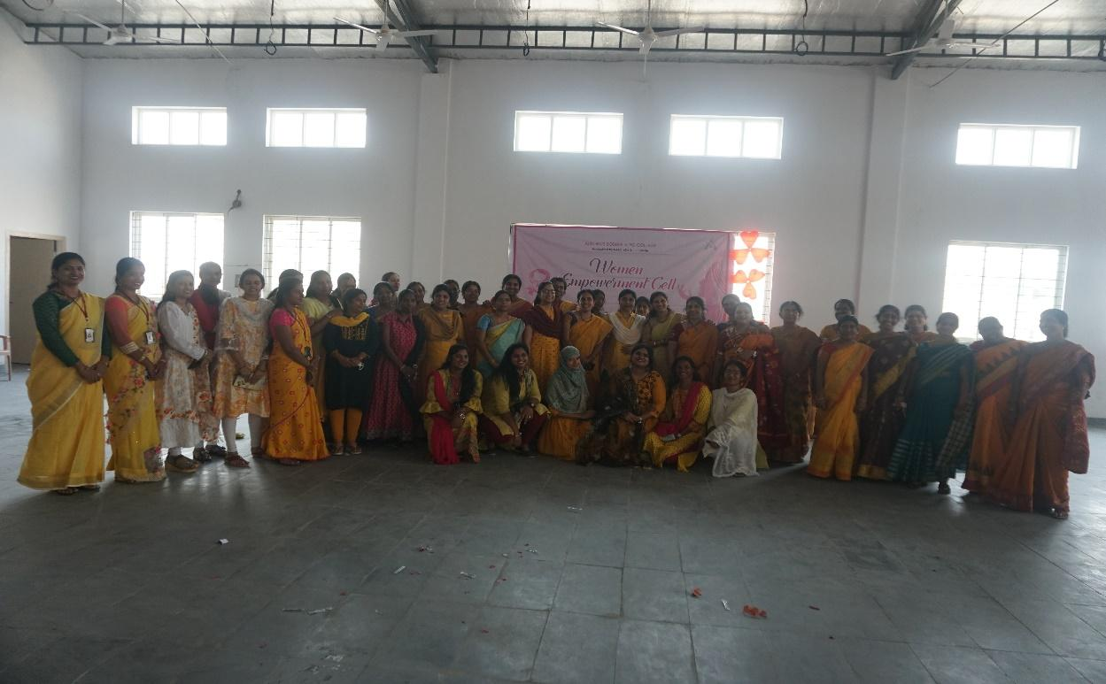

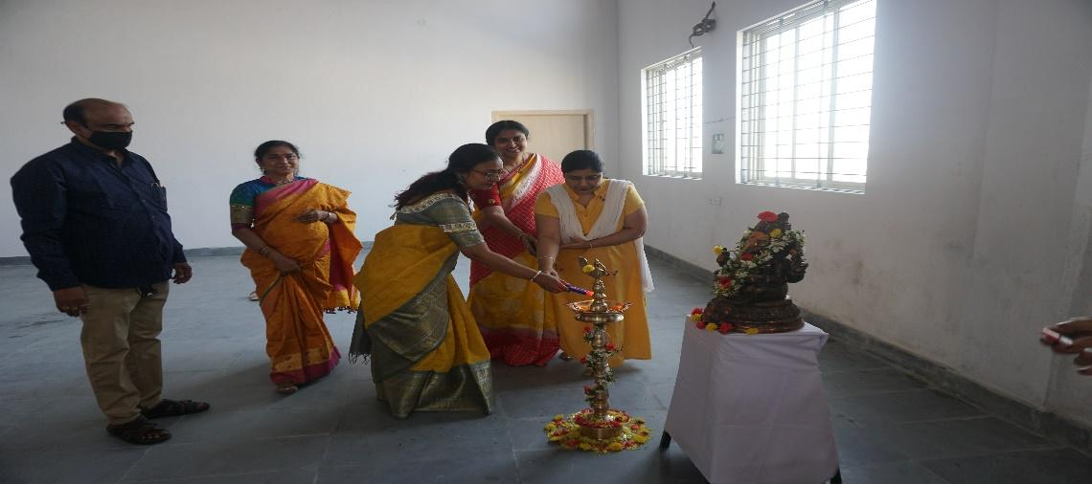
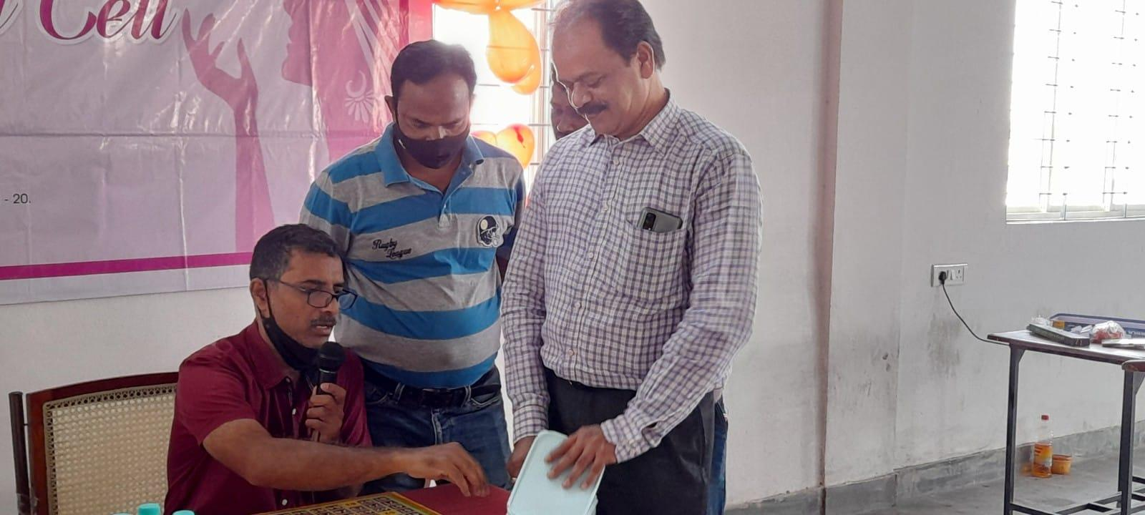

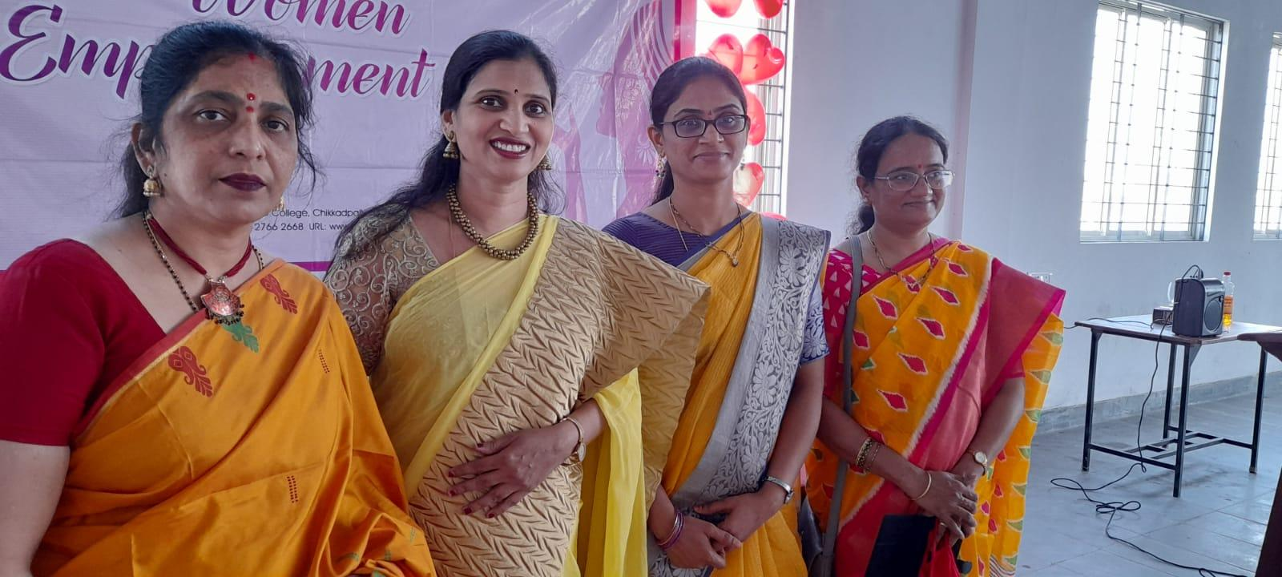
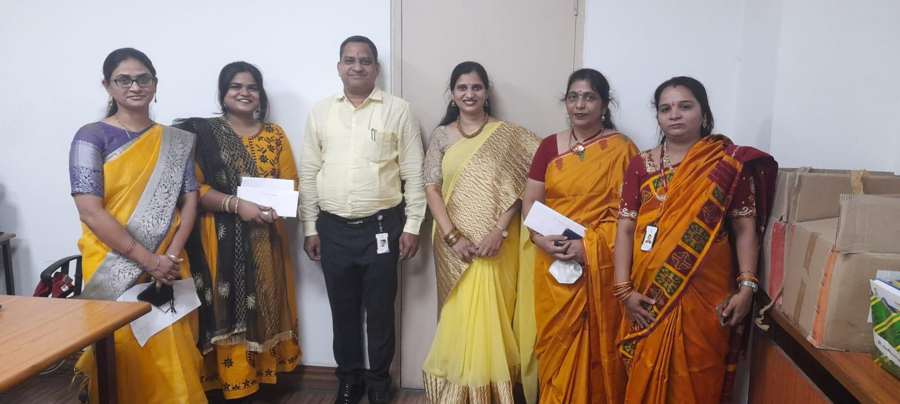
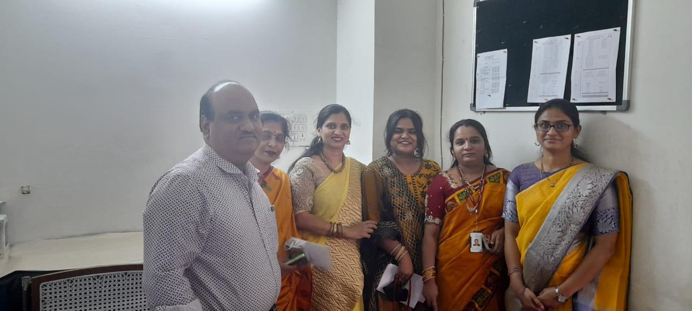
Day 2
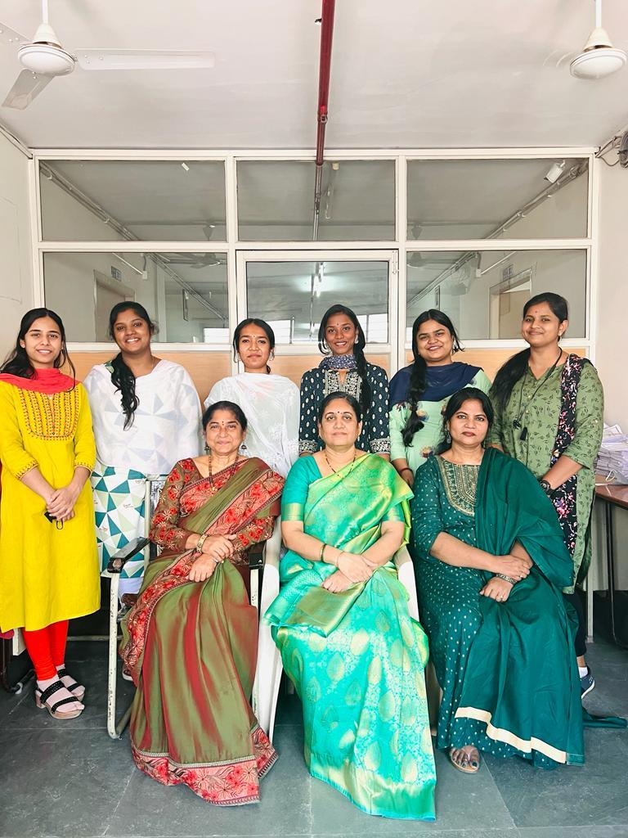
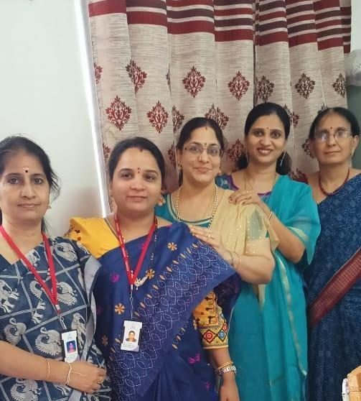
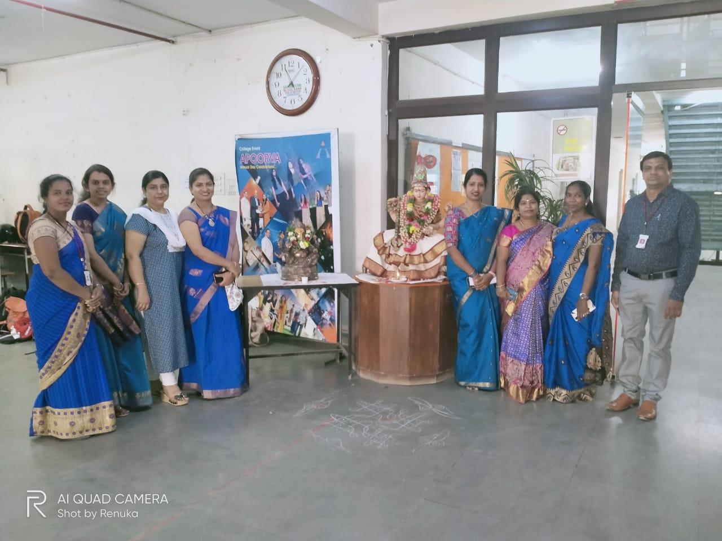
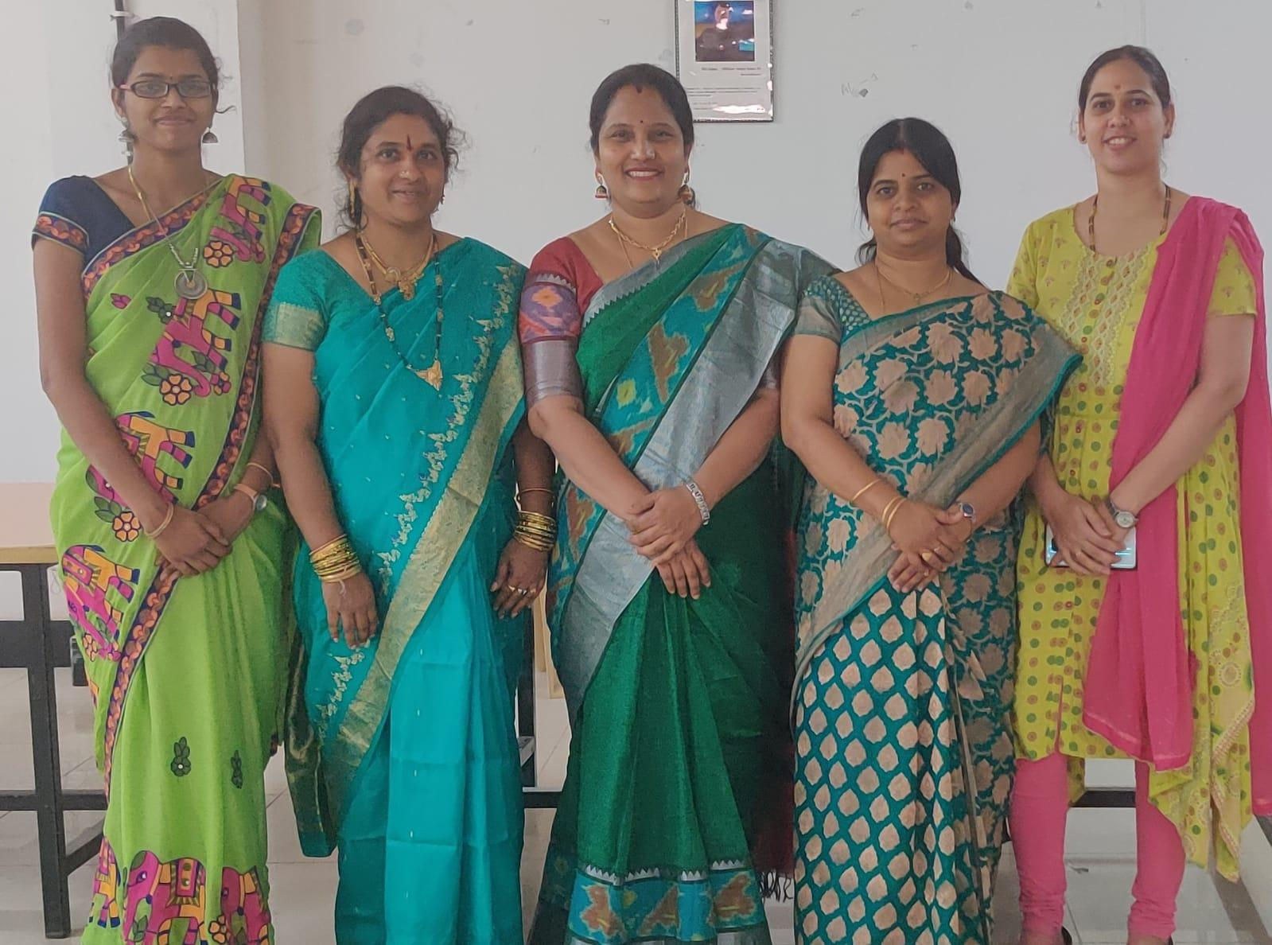
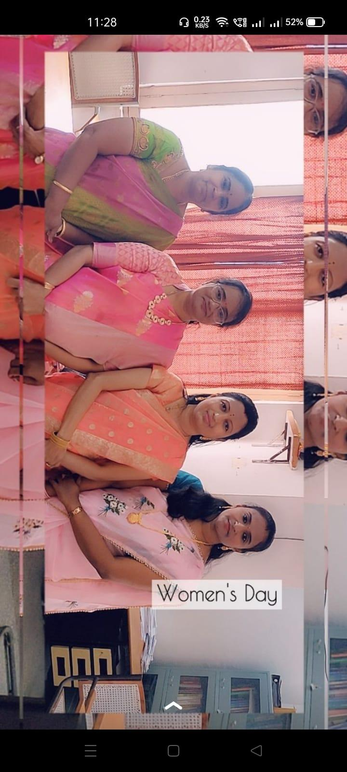
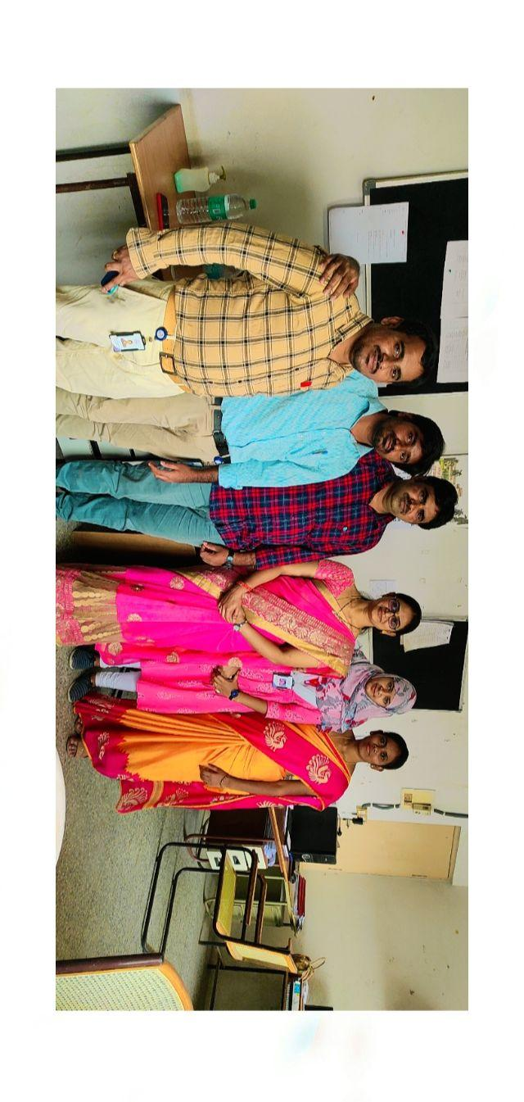
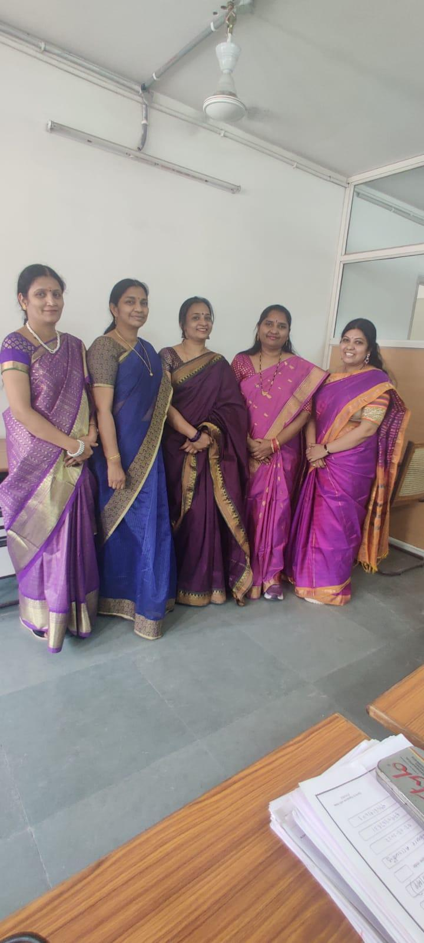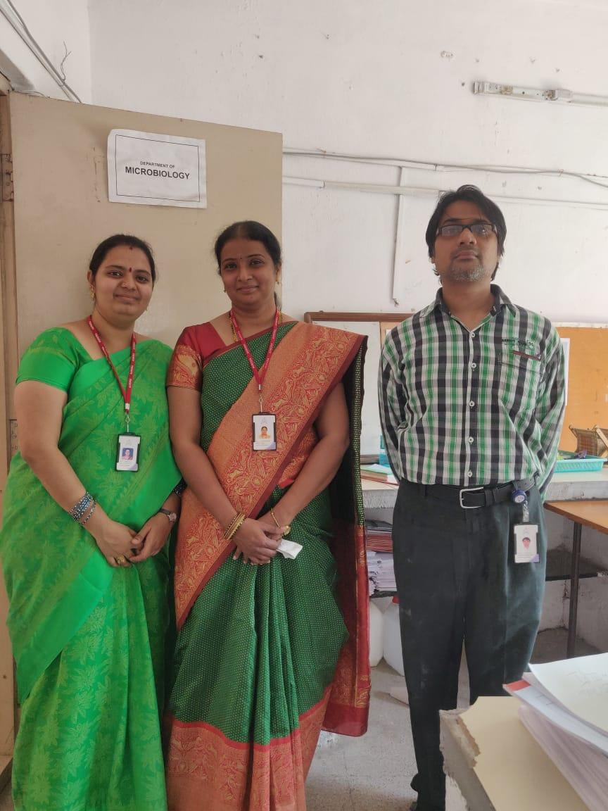

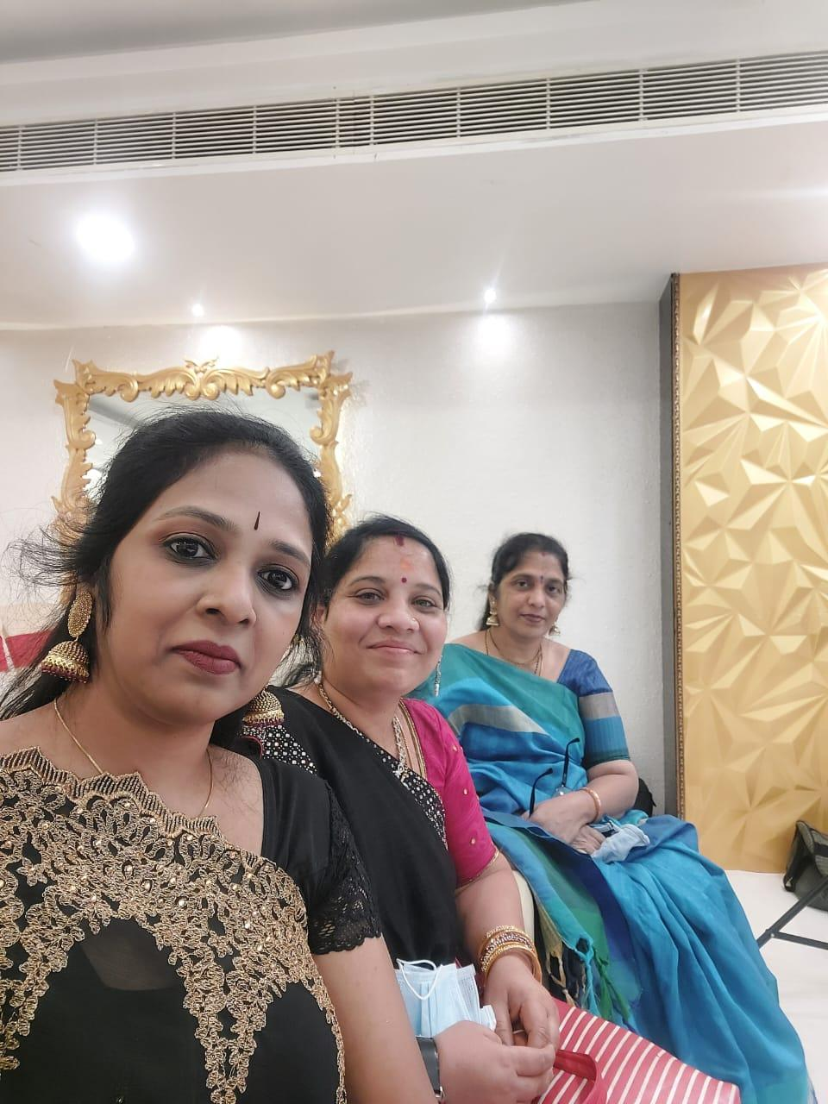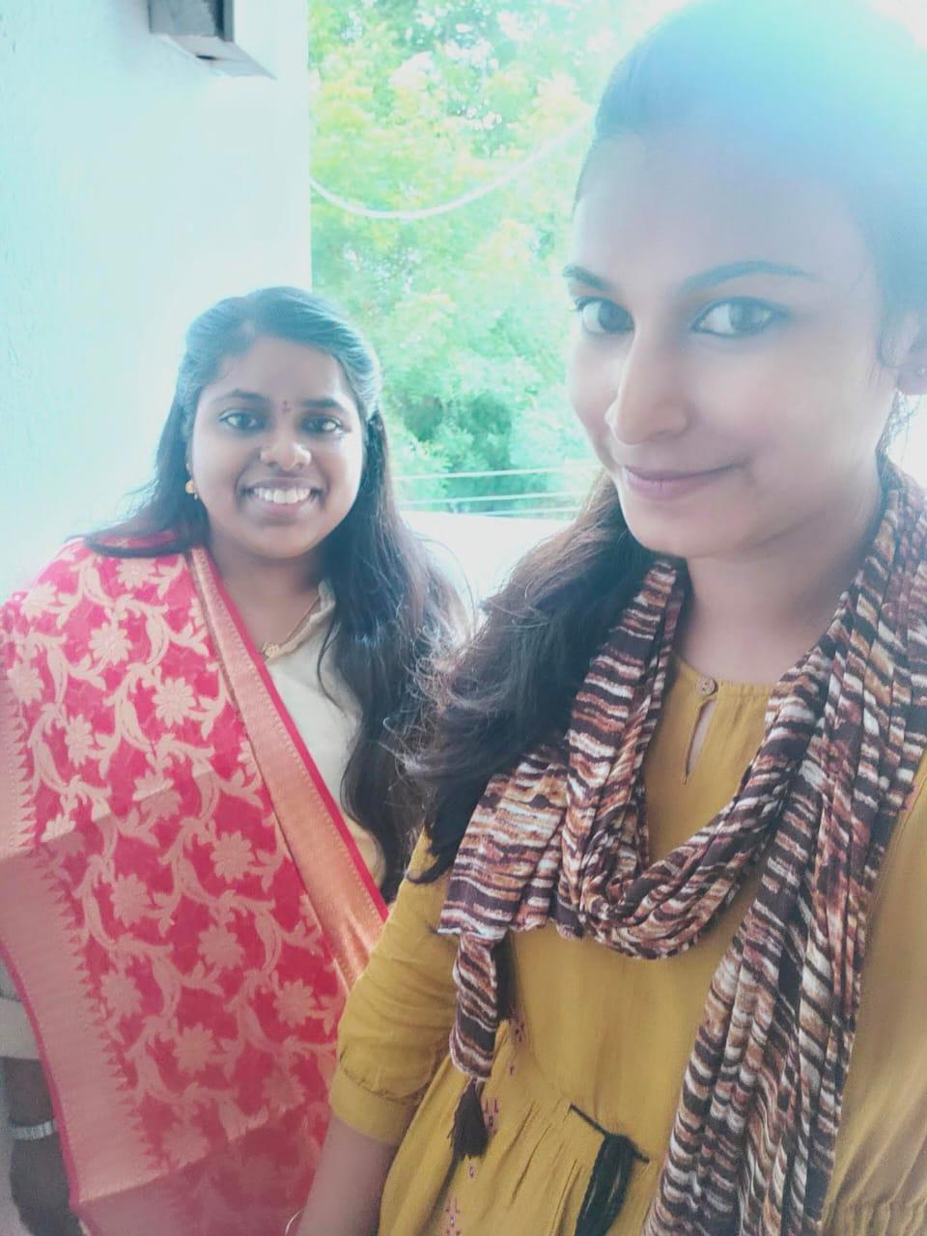

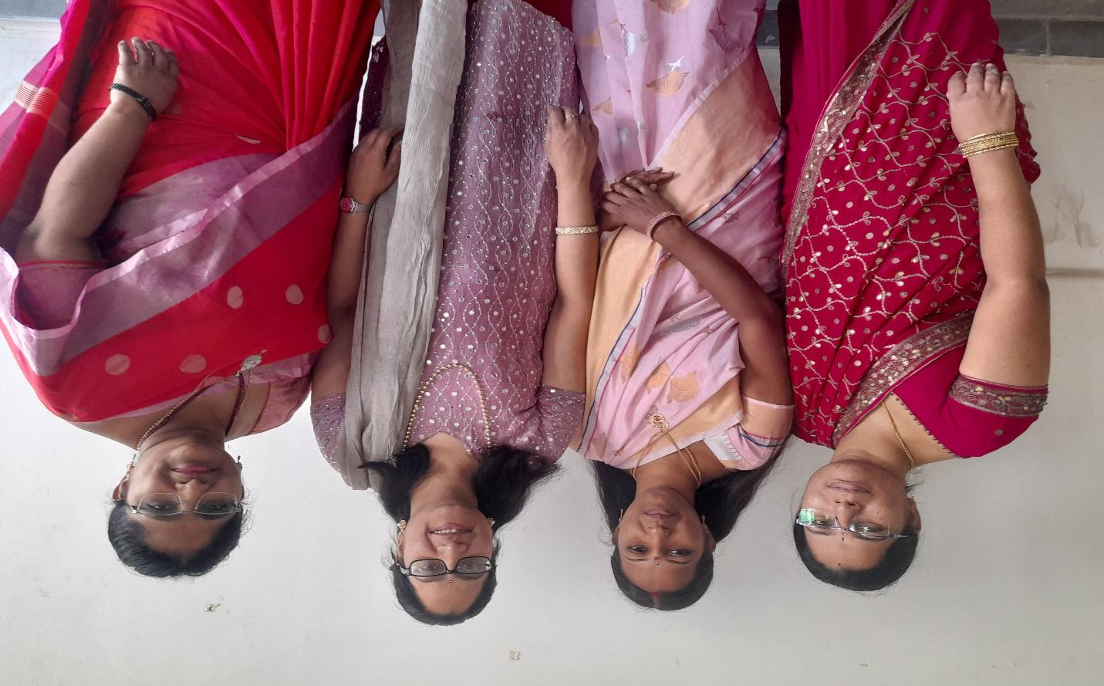
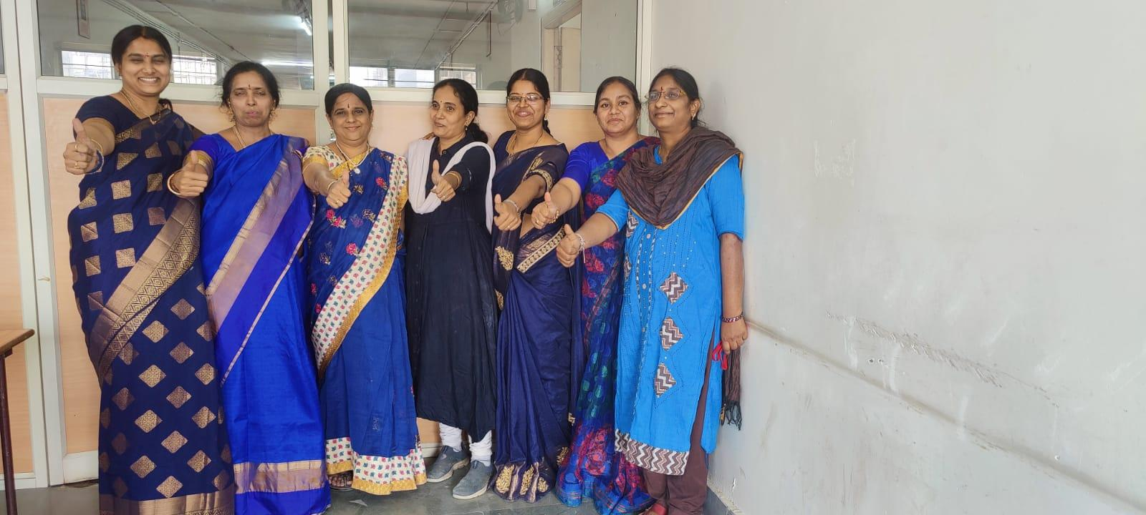

8.GUEST PROFILE (IF ANY) : Nil
9. ATTACHMENTS:
10.EVENT/ACTIVITY PROPOSAL
Aurora’s Degree and PG College
(ACCREDITED BY NAAC WITH ‘B++’ GRADE)
Chikkadpally, Hyderabad 500020
Women Empowerment Cell
EVENT PROPOSAL
For

International Women’s Day
Event/Activity Name: International Women’s Day
Event/Activity Title: International Women’s Day
Cell / Committee/Club Convener/Facilitator: Dr. N. Suryakanthi
Faculty coordinators: WEC Members.
Date/Time: 08-03-2022 from 10:00 AM to 12:30 PM.
Venue: Aurora’s Degree and PG College, RTC block.
Target audience: Faculty
Platform: Offline
Level: College
Student volunteers: NA
Objective: To empower and celebrate womanhood.
Proposed activities: Recreational events for faculty
- Sharing opinion on International Women’s Day by the faculty.
- Fun games
- Singing programme
Guest/Speaker details: Dr. Viswanadham Bulusu Principal, Aurora’s Degree & PG CollegeBudget: Nil

WEC Convener IQAC Coordinator Principal
Dr. N. Suryakanthi Dr. S. Ravikiran Dr. Viswanadham Bulusu
8. FEED BACK IF ANY - NA

- EVENT / ACTIVITY NOTICE
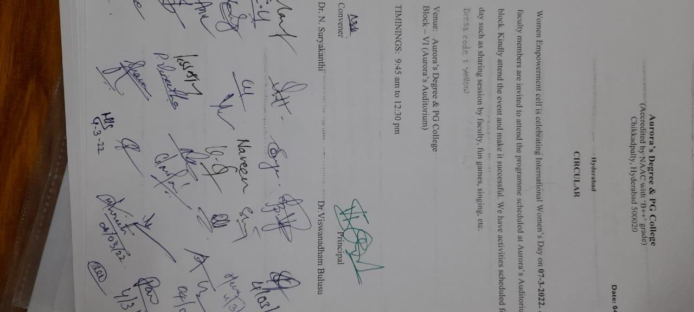

- RECEIPTS (IF ANY) - NA
- CERTIFICATES (IF ANY) - NA
- LETTERS OF COMMUNICATION (IF ANY) - NA

