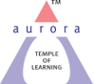
Aurora’s Degree & PG College
(ACCREDITED BY NAAC WITH 'B++' GRADE)
Chikkadpally, Hyderabad 500020

EVENT / ACTIVITY DETAILED REPORT

NAME OF THE EVENT / ACTIVITY | WORLD WATER DAY
TYPE OR TITLE OF EVENT / ACTIVITY | SCIENCE EXIHIBITION
FACULTY INCHARGE | P MADHAVI LATHA
DEPARTMENT/CELL/COMMITTEE/CLUB | COMPUTER APPLICATIONS
DATE | 22-03-2022
VENUE | Aurora’s Degree and PG college , Rtc block.
TARGET AUDIENCE | Students and Faculty of Aurora’s Degree and PG college and Government school students

- PROGRAM SCHEDULE: 11:00am to 3:30pm
- LIST OF FACULTY COORDINATORS (DEPARTMENT):
P MADHAVI LATHA

- LIST OF THE STUDENT COORDINATORS (NAME , ROLL NO, CLASS & SECTION) :
NAME | STREAM | ROLLNO | MOBILE NUMBER
G JEEVAN SAI | BCOM COMPUTER APPLICATIONS 2B | 088 | 9492327097
ASIM SAIF | BCOM COMPUTER APPLICATIONS 2C | 149 | 9704242966
KAMANDALAM NIKHITHA | BCOM COMPUTER APPLICATIONS2A | 009 | 9100833300
P KAVYA | MCOM 2ND YEAR | 010 | 6301129166

- LIST OF THE PARTICIPANTS (NAME ,STREAM, ROLLNO,MOBILE NUMBER )
NAME | STREAM | ROLLNO | MOBILE NUMBER
SANIKA MANILALPATIL | BCOM COMPUTER APPLICATION 2C | 145 | 7794887491
D TANUJU APRANA | BCOM COMPUTER APPLICATION 2C | 139 | 6361387698
G JEEVAN SAI | BCOM COMPUTERS APPLICATION 2B | 088 | 9492327097
S PRIYANKA | BCOM COMPUTERS APPLICATION 2B | 129 | 7989167007
A SRIYA | BCOM COMPUTER APPLICATION 2A | 063 | 8328030502
KAMANDALAM NIKITHA | BCOM COMPUTER APPLICATION 2A | 009 | 9100833300
KAMANDALAM HARPITHA | BCOM COMPUTER APPLICATION 1B | 080 | 9121833300
H OMKAR | MCOM 2ND YR | 031 | 7993542717
P AKSHAY | MCOM 2ND YR | 026 | 6304241396
BHAVANI | MCOM 2ND YR | 008 | 7671943213
SADIQH YALIGAR | MCOM 2ND YR | 006 | 9346875576
M VENKATESH | MCOM 2ND YR | 030 | 9133690785
SREEMALLIK | MCOM 2ND YR | 011 | 8247793137
P KAVYA | MCOM 2ND YR | 010 | 6301129166
D PREETHI | MCOM 2ND YR | 007 | 9573126891
MANAV RAJ | B COM COMPUTER APPLICATION 2C | 150 | 7702662821
ASIM SAIF | B COM COMPUTER APPLICATION 2C | 149 | 9704242966
PANDRE KIRAN | B COM COMPUTER APPLICATION 2C | 152 | 6300617819
FURQAAN | B COM COMPUTER APPLICATION 2C | 135 | 9989159791
ASHISH SINGH | B COMCOMPUTER APPLICATION 1B | 114 | 7207168286
K VISHAL | B COMCOMPUTER APPLICATION 1B | 107 | 6281944802
GORAV KUMAR | B COMCOMPUTER APPLICATION 1B | 120 | 9391024638
PARIDI | B COMCOMPUTER APPLICATION 1B | 088 | 7780119280
POOJITHA | B COMCOMPUTER APPLICATION 1B | 073 | 8688153082
C RANI | B COMCOMPUTER APPLICATION 1B | 063 | 8328618904
K SINDHU | B COM COMPUTER APPLICATION 2C | 149 | 8309477612
N VIGNESH | B COM COMPUTER APPLICATION 2C | 166 | 9381264375
G NIKHIL | B COM COMPUTER APPLICATION 2A | 058 | 9392861240

- PARAGRAPH ABOUT THE PROCEEDINGS (TILL THE END OF THE EVENT)
The event was on the main theme which was given by the government of India i.e. “GROUND WATER –MAKING THE INVISIBLE VISBLE”. Event started at 11 Am with brief orientation about the importance of ground water making invisible to visible. On this day we have organized an exhibition displaying posters and models on the theme made by B.Com Computer Applications and M.Com students. Students gave presentation of their models and have enlightened the viewers regarding the techniques and ways to save and restore ground water and some of the live examples too. Students and faculty from Government school, our students and faculty have visited the stalls. The event ended at 3:30pm after Principal sir, Heads of various departments visited the stalls.The main objective of organizing the exhibition was to awake people regarding saving water which is an essential step for any individual
- INCOME AND EXPENDITURE : Rs.500 ( Biscuit packets were distributed to students)
- EVENT PHOTOS ( MIN 2 MAX 4)

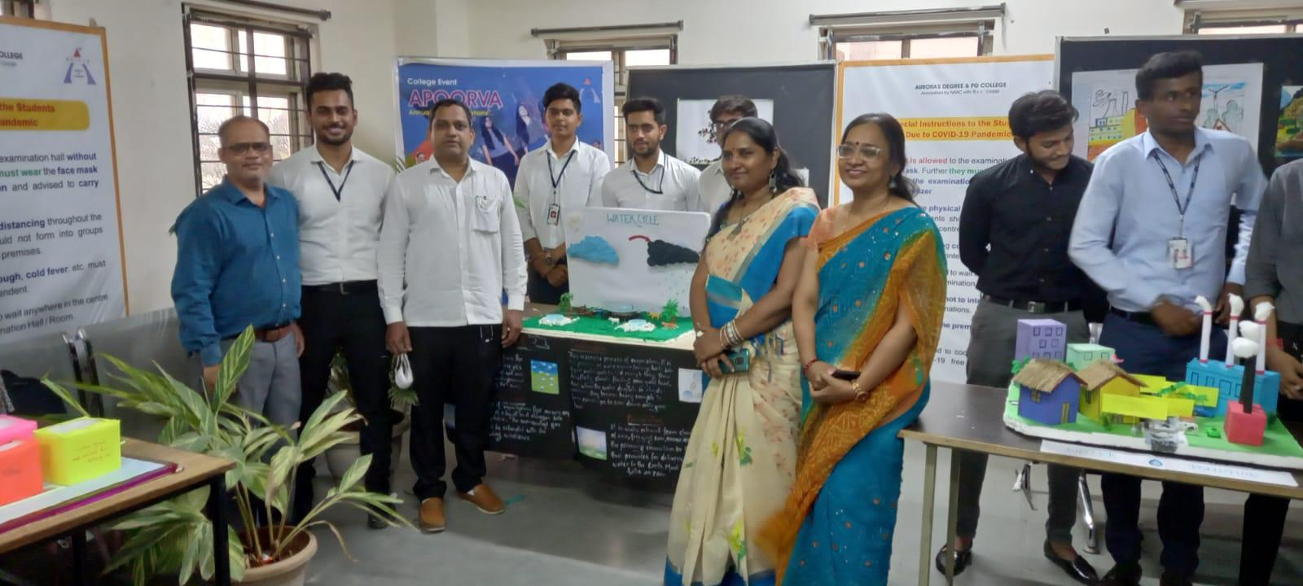

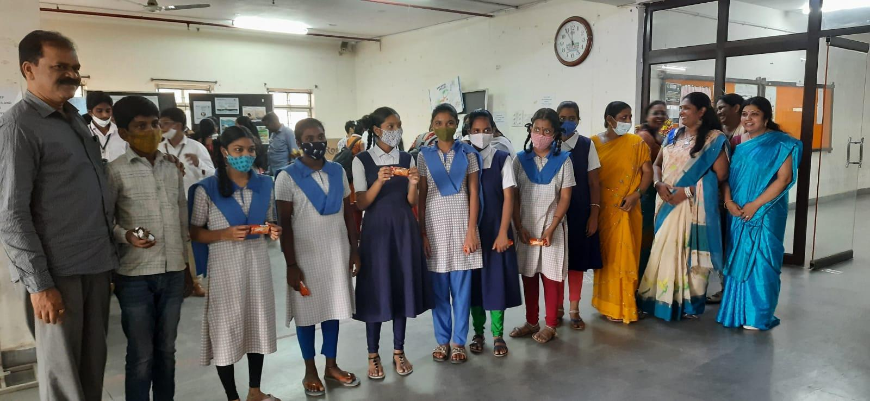

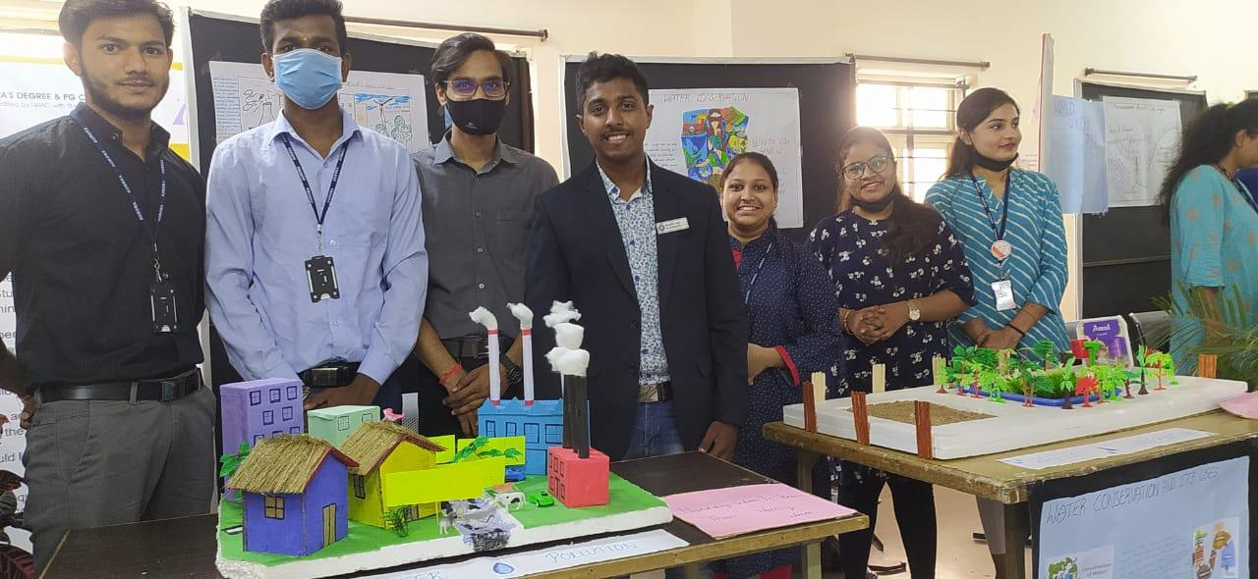

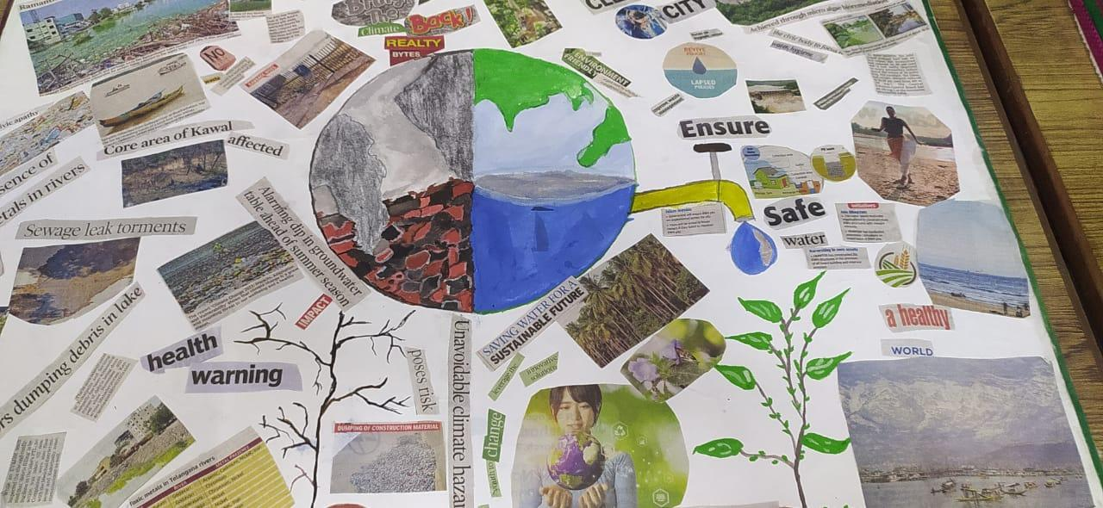

- GUEST PROFILE (IF ANY):NIL
- FEED BACK IF ANY:NIL
- ATTACHMENTS:
EVENT/ACTIVITY PROPOSAL:
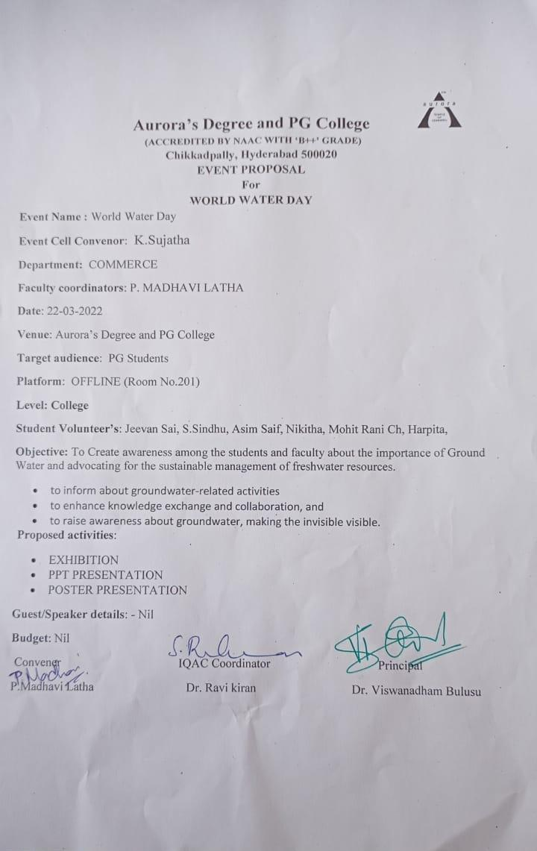

EVENT / ACTIVITY NOTICE:NIL
RECEIPTS (IF ANY):NIL
CERTIFICATES (IF ANY):NIL
LETTERS OF COMMUNICATION (IF ANY):NIL

