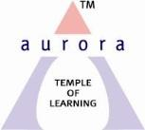
Aurora’s Degree & PG College
(ACCREDITED BY NAAC ‘B++’ GRADE)
Chikkadpally, Hyderabad 500020
EVENT / ACTIVITY DETAILED REPORT
NAME OF THE EVENT | Sanskrit Day
TYPE OF EVENT | Class Event
FACULTY INCHARGE | D. Hari Krishna
DEPARTMENT | Languages
DATE | August 18th 2021
VENUE | Online Through PPT
TARGET AUDIENCE | UG Students

- PROGRAM SCHEDULE
Online Through PPT
- LIST OF THE STUDENT COORDINATORS (NAME , ROLL NO, CLASS & SECTION)
D. Hari Krishna
- LIST OF THE PARTICIPANTS (NAME , ROLL NO, CLASS & SECTION, NO OF GIRLS, BOYS, CASTE )
NILL
- PARAGRAPH ABOUT THE PROCEEDINGS (TILL THE END OF THE EVENT)

OBJECTIVE:
To bring awareness among the students about the richness and importance of the language Sanskrit and its learning

BRIEF ABOUT THE EVENT:
Every year Sanskrit day is celebrated on the Sravana Pournima day. Sanskrit day is celebrated to increase the awareness and richness imbibed in the language and makes it reachable to each individual. It can be said that the present has its roots deeply established in the past. In the present pandemic times too the rich culture and tradition mentioned in the Sanskrit treatises is being followed. The glory of the language shows the importance with people celebrating the Sanskrit day worldwide.
The richness and subject integration with relevance to Sanskrit has been presented and thrown light.
Sanskrit can be said as a language of civilization which can be mentioned more effective than the other languages of civilization such as Greek, Chinese, Latin etc.. Sanskrit language is called otherwise as Devabhasha, Amaravani, Geervanabhasha too.
Now in every continent and every nation Sanskrit is being learnt as this is the only language through ages which has given the aspects, rules, philosophical truths, administration, polity and social values medicine. In the present day this is also said and believed to be the most compatible language to computer also.
Self realization of an individual, understanding the world can be achieved though the knowledge of Sanskrit as Sanskrit can be said an embedded language which has in it rich treasures in all kinds of sciences and philosophy to transform oneself into a better individual and in turn a better society can be achieved.
OUTCOME:
The Sanskrit day has enriched the participants in understanding and knowing about the rich culture and tradition embedded in it with respect to the present situations too. It has been understood that the rich culture, traditions and values followed and urged have been mentioned way back through Vedas, Puranas, Upanishads and other Sanskrit treatises
EVENT LINK-
https://docs.google.com/presentation/d/17p54ztQYb-ye9-6yUXA9CfEeM9hYTJBs/edit?usp=sharing&ouid=118420274057938942815&rtpof=true&sd=true
INCOME AND EXPENDITURE
NO
EVENT PHOTOS ( MIN 2 MAX 4)

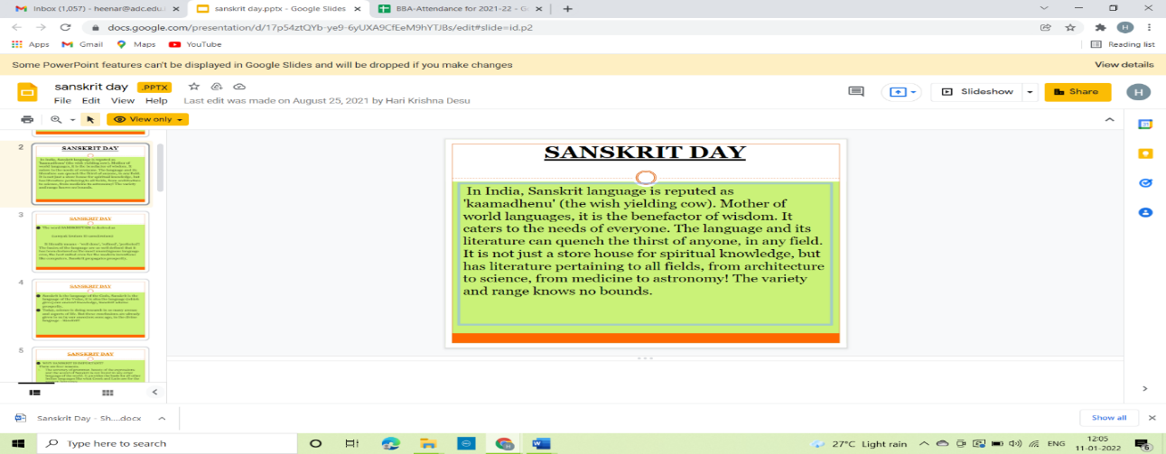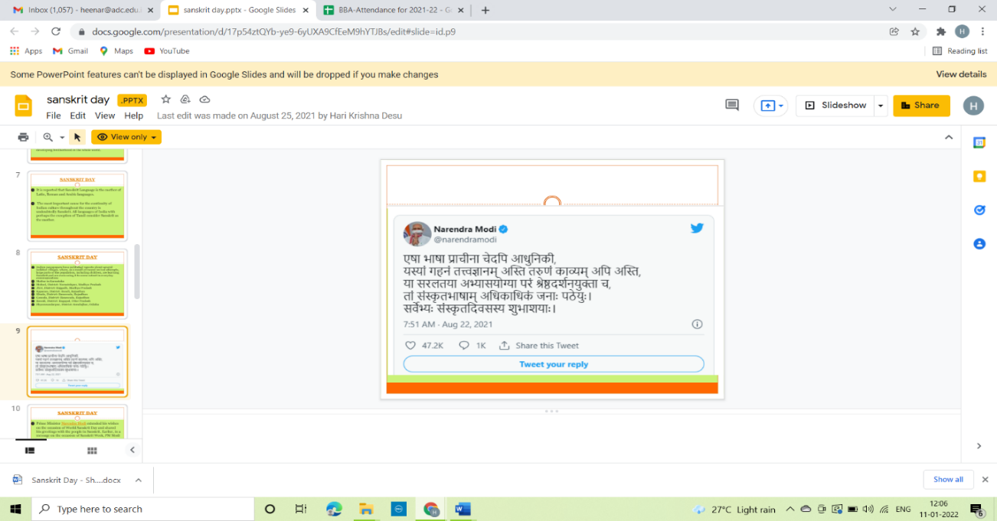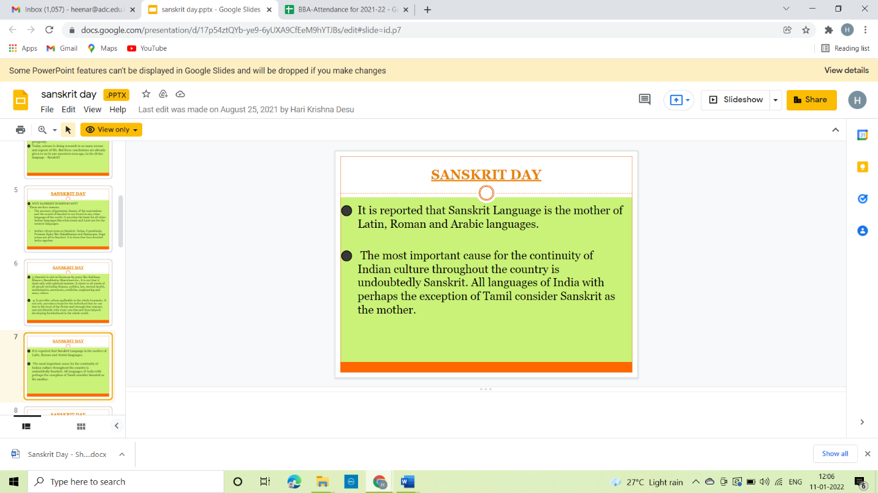
7.GUEST PROFILE (IF ANY)
NO
8.FEED BACK IF ANY
NO
9.ATTACHMENTS:
NO
EVENT/ACTIVITY PROPOSAL
(CLASS -EVENT)

