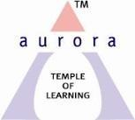

Aurora’s Degree & P.G College
(Accredited by NAAC with ‘B++’ grade)
Chikkadpally, Hyderabad 500020

NAME OF THE EVENT | TELANGANA BHASHA DINOSTHAVAM
FACULTY INCHARGE | Dr. N. Suryakanthi
DEPARTMENT | Languages
DATE | 9thSeptember, 2021
VENUE | Aurora’s Degree & PG College
TARGET AUDIENCE | Telugu Students

Objective: The main aim of the event is to create awareness among the Students about the Telangana Bhasha Dinosthavam

Brief about the event: Telangana BhashaDinosthavam was celebrated on 9thSeptember 2021 Aurora’s Degree & PG College. The event commenced with the introduction of the participants in the Online Microsoft Teams by our honorable Principal Sri.Viswanadham Bulusu , Vice- Principal Sri Sai Krishna. The convener of the event Dr. N. Suryakanthi (Telugu faculty) from Department of Languages will give an introduction speech about KALOJI NARAYANARAO, whose full name was “RAGHUVEERNARAYANLAKSHMIKANTH SRINIVAR RAO RAM RAJA KALOJI”.
Various Presentations like PPt, Songs, and Videos organized through online meet. Student coordinators are B.V.Anjali -MSCS- 1, SaiDivyaAkanksha-BBA-1, SunilKumar – B.Com Gen- 1C and Sunny Paul- B.Comp Appli - 2D
Outcome: Students got to know about Kaloji Narayanarao through this event. According to Students view, conducting such events will give them awareness about the opportunities to showcase their talent which motivates and enhances in learning about the works and life of such eminent personalities of Telangana.

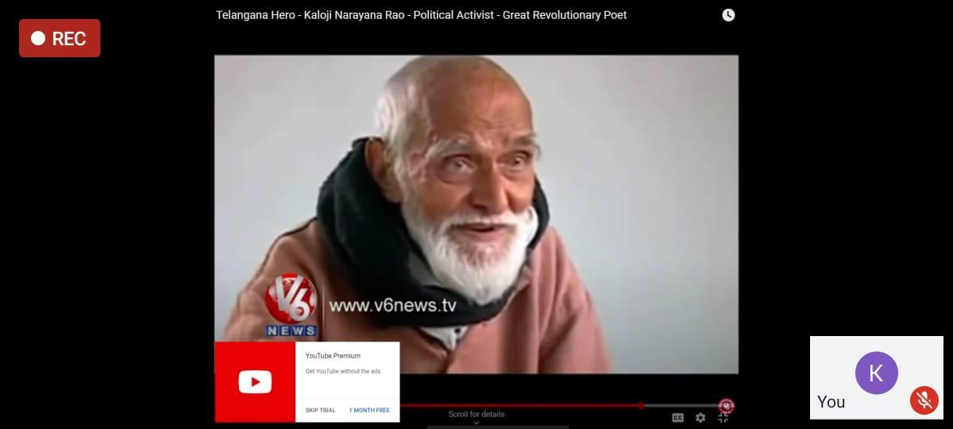

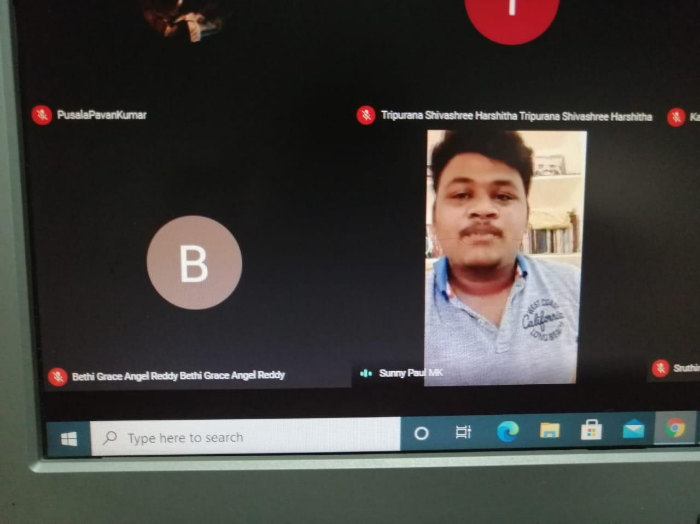

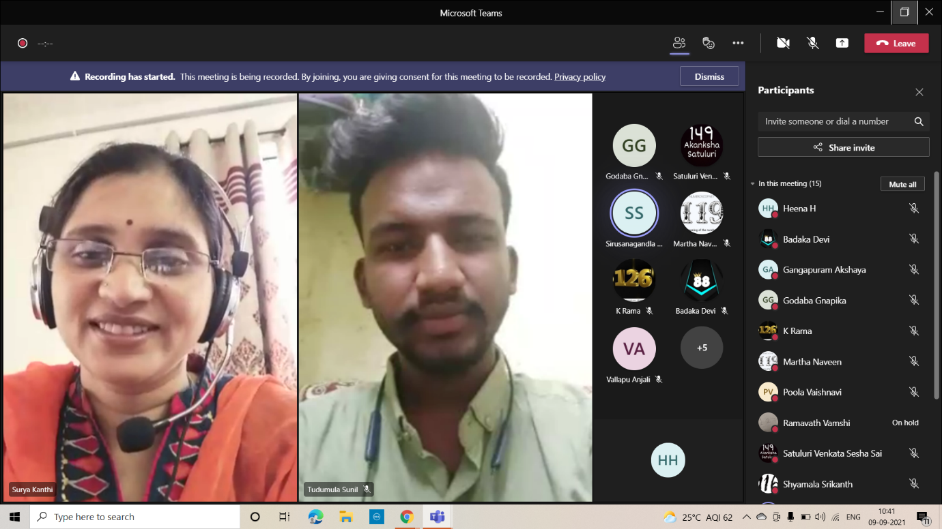

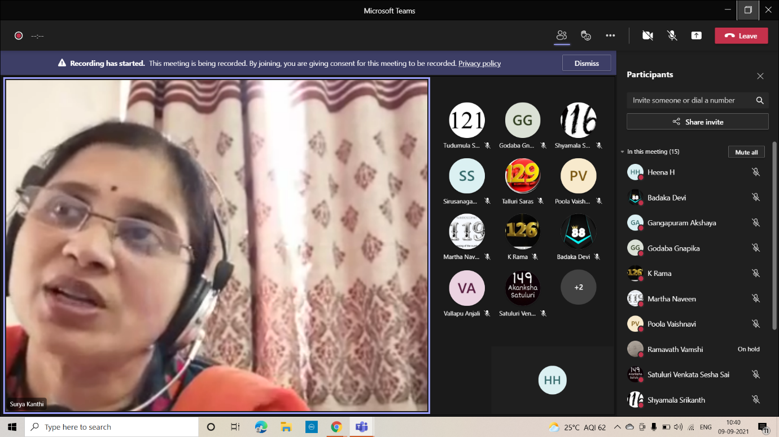

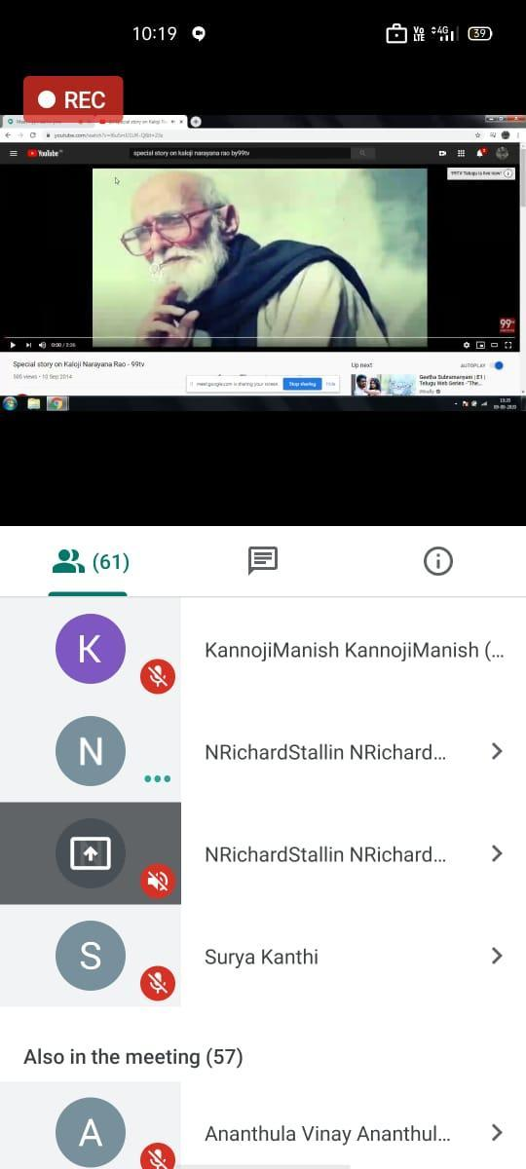

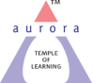
Aurora’s Degree & PG College
(ACCREDITED BY NAAC WITH 'B++' GRADE)
Chikkadpally, Hyderabad 500020

EVENT / ACTIVITY DETAILED REPORT

NAME OF THE EVENT / ACTIVITY | TELANGANA BHASHA DINOTSAVAM
TYPE OR TITLE OF EVENT / ACTIVITY | Dr. N. Suryakanthi
FACULTY INCHARGE | Languages
DEPARTMENT/CELL/COMMITTEE/CLUB | Department
DATE | 9thSeptember, 2021
VENUE | Aurora’s Degree & PG College
TARGET AUDIENCE | Telugu Students

- PROGRAM SCHEDULE
10:00 am - Dr. N. Suryakanthi convener and Associate professor from Department of Languages started the event allowing the participants to join.
10:10 am - Welcome address and Introduction of Dr. Viswanadham Bulusu
10:15 am -A Classical dance video shown by Nagadurga
10:20 am - A song by Sunny Paul
10:25 am - A PPt representation by T. SunilKumar
10:60 am - A Video of ‘Kaloji’s Mukhamukhi' shown by Dr. N. Suryakanthi
11:00 am - Vote of thanks given by T. SunilKumar

- LIST OF FACULTY COORDINATORS (DEPARTMENT)
Dr.N.Suryakanthi
- LIST OF THE STUDENT COORDINATORS (NAME , ROLL NO, CLASS & SECTION)
S.No | Name | Section
1 | T. SunilKumar | B.Com Gen - B
2 | SaiDivyaAkanksha | BBA-1
3 | B.V.Anjali | MSCS- 1
4 | Sunny Paul | B.com Appli -2D

- LIST OF THE PARTICIPANTS (NAME , ROLL NO, CLASS & SECTION, NO OF GIRLS, BOYS, CASTE )
List of Boy Participants: 63
S.NO |  | Name of the Student
 |  | Shaik Nayimuddin
 |  | Shaik Mohammad Khadar
 |  | Mohammed Muzakkir
 |  | Vadde Shivakumar
 |  | Gaddam Adithya
 |  | Shaik Muqheet Aadil
 |  | Meda Siva Sai
 |  | Ananthula Vinay
 |  | Rongali Mohan
 |  | P Sai Kiran
 |  | Gullipalli Arjun
 |  | Kolisetty Chaitanya
 |  | Garlapati Hemanth Raj
 |  | Konkal Laxminarayanareddy
 |  | Sreerama Venkata Sai Pavan Kalyan
 |  | Avusula Vignan
 |  | B Mangala Sandeep
 |  | andapally Sri Phaneesh
 |  | Deshavath Mahesh Babu Naik
 |  | Sonnapuwar Saketh
21 | Puram Abhilash
22 | Gangapuram Akshaya
23 | Kummara Narendra Babu
24 | Karnakanti Udhay Kumar
25 | Sattiraju Naga Sai Sri Charan
26 | Praveen Kumar
27 | Gone Vinay Reddy
28 | Pulagam Uday Kumar
29 | Neela Sumanth Mudhiraj
30 | Thota Lohit Sai
31 | Regati Yashwanth
32 | Poola Vaishnavi
33 | Vadthyavath Anand
34 | Kanaparthi Rishikraj
35 | Shaik Sohail
36 | Thodupunoori Ruchitha
37 | Palle Sridhar
38 | G Sandhya Reddy
39 | Gaddam Prathap
40 | T Ashritha
41 | Gangula Siddhartha
42 | Gutti Arun Kumar
43 | P Shivakumar
44 | Nitta Mallesh
45 | Sirusanagandla Shivarag
46 | Kura Siddhartha
47 | Mahankali Sanjay
48 | Madi Sai Ram Reddy
49 | Lingala Maniraj Goud
50 | Padigela Praveen Kumar
51 | Madi Sai Ram Reddy
52 | Lingala Maniraj Goud
53 | Padigela Praveen Kumar
54 | Gudala Akhil
55 | Kala Lalitha Tripura Sundari
56 | G Vinod Kumar
57 | Bethi Grace Angel Reddy
58 | Bingi Jayanth
59 | Dappu Aravind Babu
60 | Ekaamber Kaveti
61 | Gaddala Sairushikanth
62 | Manga Reshwanth Kumar
63 | Akash Pondicherry

List of Girl Participants : 19

1 | Surasani Tejaswini
2 | Sheguri Madhavi
3 | Nagandla Rishitha
4 | Kandela Gaddam Sruthi
5 | Puram Abhilash
6 | Kadapalla Pooja
7 | Sariyam Usha
8 | Challa Sravani
9 | Gudise Sushma
10 | N Shivani
11 | Kantekar Vamshi Krishna
12 | Pottabathni Sanjana
13 | Kondu Prathyusha
14 | Yacham Harshitha
15 | Tripurana Shivashree Harshitha
16 | Gaddaraju Keerthana
17 | Palleni Sruthi
18 | Chirravuri Vaishnavi
19 | Godaba Sai Gnapika

- PARAGRAPH ABOUT THE PROCEEDINGS (TILL THE END OF THE EVENT)
Telangana Bhasha Dinosthavam was conducted by Dr. N. Suryakanthi, from Department of Languages on the 9thSeptember, 2021. All the students with their Language Telugu have participated in this event. The main aim of the event is to create awareness among the students about the Telangana Bhasha Dinosthavam
Telangana Bhasha Dinosthavam was celebrated on 9thSeptember 2021 at Aurora’s Degree & PG College, through OnlineMicrosoft Teams. The event commenced with the introduction of the participants and introductory speech by our honorable Principal Sri. Vishwanandam Bulusu , Vice- Principal Sri Sai Krishna.The convener of the event Dr. N. Suryakanthi (Telugu faculty) from Department of Languages gave an introductory speech about KALOJI NARAYANARAO, whose full name was “RAGHUVEERNARAYANLAKSHMIKANTH SRINIVAR RAO RAM RAJA KALOJI”.
Various Presentations like PPt, Songs, and videos have been presented in Google meet.Students got to know about Kaloji Narayanarao and his contribution to Telugu Language through this event. They also learnt and knew about the works and life of such eminent personalities of Telangana.

- INCOME AND EXPENDITURE
Nil

- EVENT PHOTOS ( MIN 2 MAX 4)

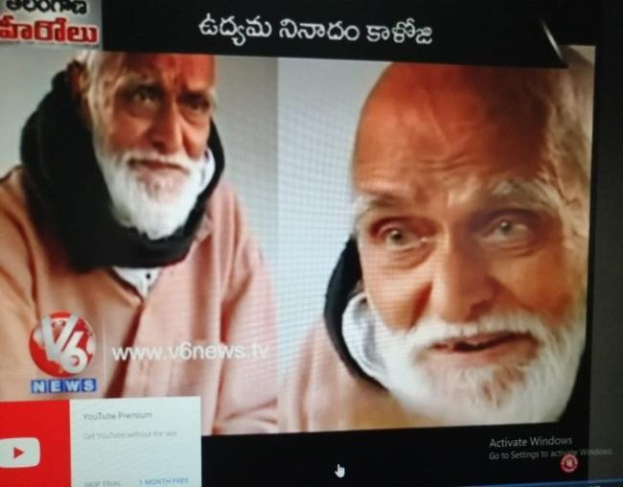
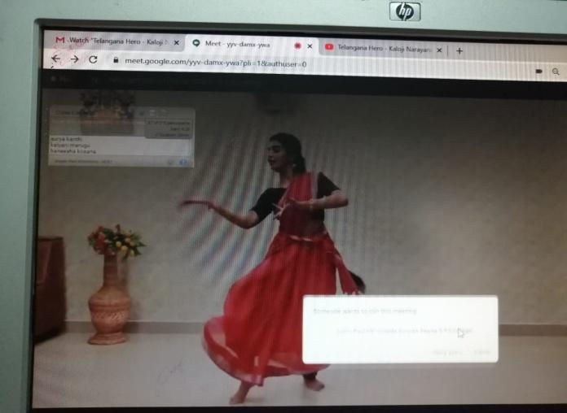
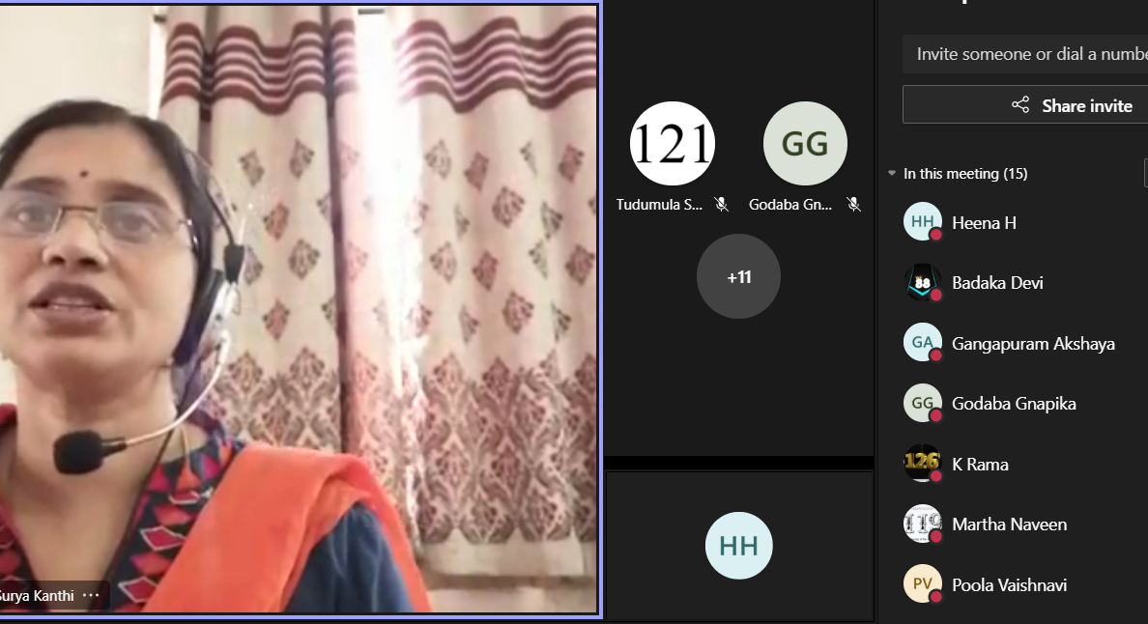

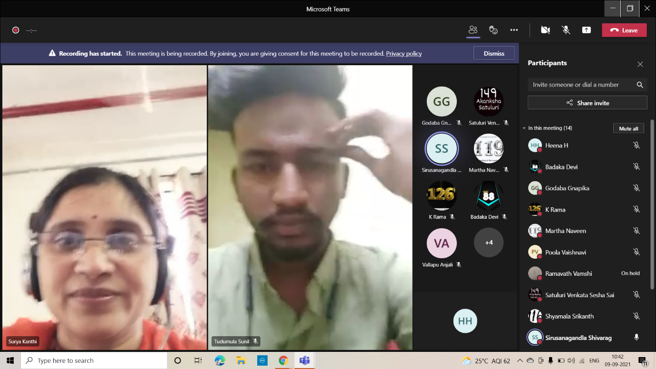

- GUEST PROFILE (IF ANY)
Nil

- FEED BACK IF ANY
Nil

- ATTACHMENTS:
Nil

- EVENT/ACTIVITY PROPOSAL

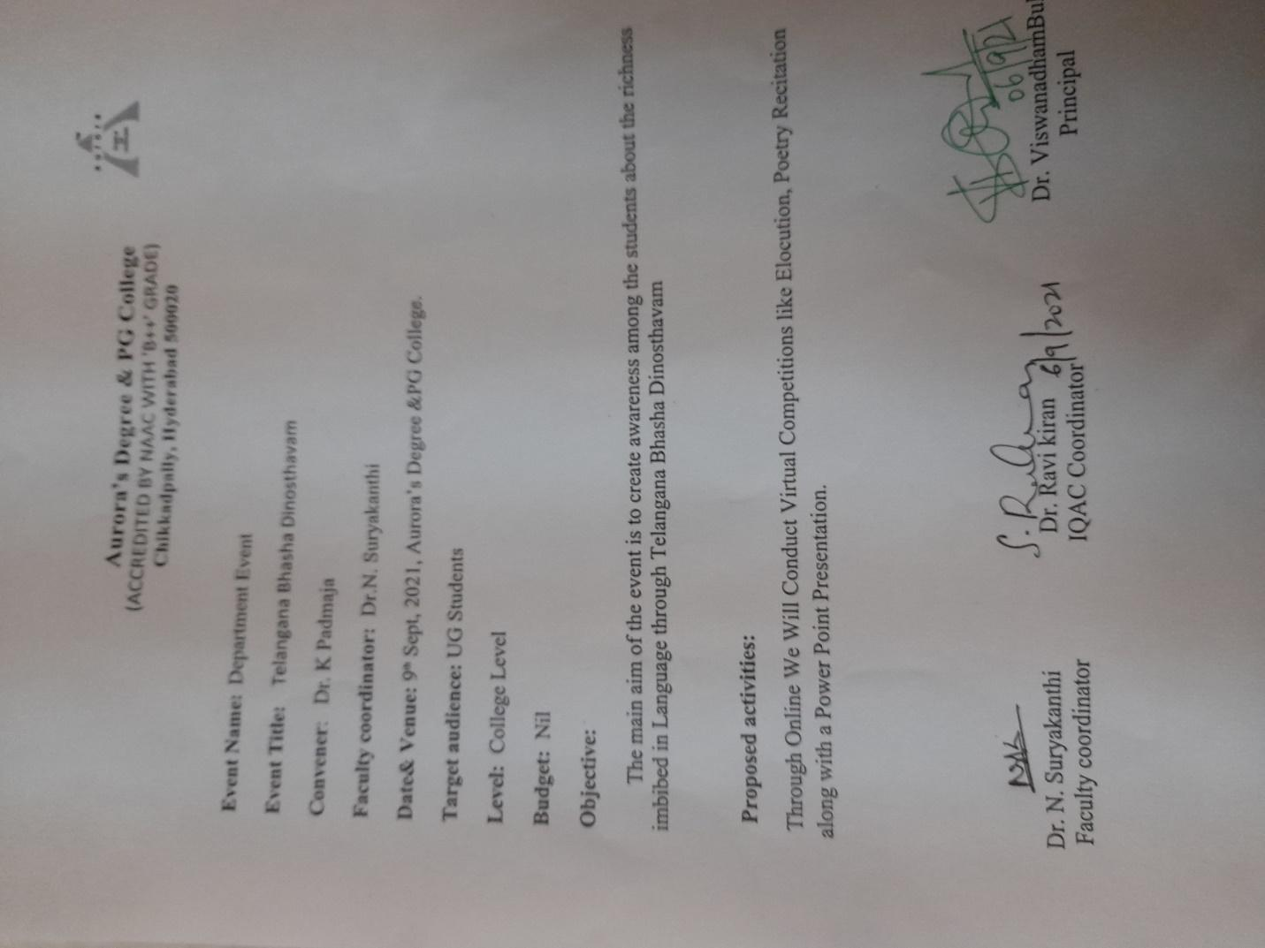

- EVENT / ACTIVITY NOTICE
Nil
- RECEIPTS (IF ANY)
Nil

- CERTIFICATES (IF ANY)
Nil

- LETTERS OF COMMUNICATION (IF ANY)
Nil

