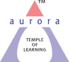
Aurora’s Degree & PG College
(Accreditedby NAAC with 'B++' grade)
Chikkadpally, Hyderabad- 500020
Department of Microbiology

EVENT DETAILED REPORT

EVENT TITLE | Cycle of Life Concept - Sergei Winogradsky Birthday
TYPE OF EVENT | Departmental Event
FACULTY INCHARGE | Vasudevan
DEPARTMENT | Microbiology
DATE | 1st Spetember 2022
VENUE | Aurora’s Degree & PG College, Chikadpally
TARGET AUDIENCE | UG Students

PROGRAM SCHEDULE
Date of the event: 1st September 2022
Time of the event: 1.00 pm to 2.30 pm
Venue: Aurora’s Degree & PG College, Chikadpally

LIST OF FACULTY COORDINATORS
S.No | Name of the faculty | Department
1 | Vasudevan | Microbiology

LIST OF FACULTY ATTENDED
S.No | Name of the faculty | Department
1 | K. Mary Manjusha | Microbiology
2 | Dr. Laxminarayana | Microbiology

LIST OF STUDENT COORDINATORS
S.No | Name of the student | Roll No | Section
1 | Akaknsha | 1051-21-459-006 | MiGC2
2 | Shreyas | 1051-20-471-004 | MiBiC3
3 | Prerna | 1051-20-459-038 | MiGC3

LIST OF STUDENTS (PRESENTERS)
S.No | Name of the student | Roll No | Section | No of girls | 2
1 | Y. Akansha | 1051-21-459-006 | MiGC2
2 | S. Prerna | 1051-20-459-038 | MiGC3
3 | S. Swaminathan | 1051-21-459-009 | MiGC2 | No of boys | 3
4 | V. Raghuvamsh | 1051-21-471-013 | MiBiC2
5 | S. Shreyas | 1051-20-471-004 | MiBiC3

LIST OF THE PARTICIPANTS

S.No | Name of the student | Roll No | Section | No of girls | 4
1 | Akansha | 1051-21-459-006 | MiGC2
2 | S. Deekshitha | 1051-21-459-025 | MiGC2
3 | T. Keerthi | 1051-21-471-011 | MiBiC2
4 | S. Prerna | 1051-20-459-038 | MiGC3
5 | T. Sreenath | 1051-21-459-005 | MiGC2 | No of boys | 7
6 | S. Swaminathan | 1051-21-459-009 | MiGC2
7 | C. Vivek Sagar | 1051-21-459-012 | MiGC2
8 | K. Rajukumar | 1051-21-459-029 | MiGC2
9 | Nitish | 1051-21-471-012 | MiBiC2
10 | V. Raghuvamsh | 1051-21-471-013 | MiBiC2
11 | S. Shreyas | 1051-20-471-004 | MiBiC3

PARAGRAPH OF THE PROCEEDINGS
The departmental event was scheduled on the occasion of Sergei Winigradsky’s birthday with the intent of exploring the hidden insights of cycle of life concept. The event started at 1.00 pm and lasted for one and half hours. The prime objective was to highlight the contributions of Sergei Winogradsky in microbiology and his role as the founder of Soil Microbiology. Life is a complicated process which fortifies the organism as various echelons through interconnected biological processes.
Cycle of life concept
A biogeochemical cycle (or more generally a cycle of matter is the pathway by which a chemical substance cycles (is turned over or moves through) the biotic and the abiotic compartments of Earth. The biotic compartment is the biosphere and the abiotic compartments are the atmosphere, hydrosphere and lithosphere. There are biogeochemical cycles for chemical elements, such as for calcium, carbon, hydrogen, mercury, nitrogen, oxygen, phosphorus, selenium, iron and sulfur, as well as molecular cycles, such as for water and silica. There are also macroscopic cycles, such as the rock cycle, and human-induced cycles for synthetic compounds such as polychlorinated biphenyls (PCBs).
In some cycles there are reservoirs where a substance can remain or be sequestered for a long period of time. Life cycle, in biology, is the series of changes that the members of a species undergo as they pass from the beginning of a given developmental stage to the inception of that same developmental stage in a subsequent generation. In many simple organisms, including bacteria and various protists, the life cycle is completed within a single generation: an organism begins with the fission of an existing individual; the new organism grows to maturity; and it then splits into two new individuals, thus completing the cycle.

INCOME & EXPENDITURE: Nil
EVENT PHOTOS:
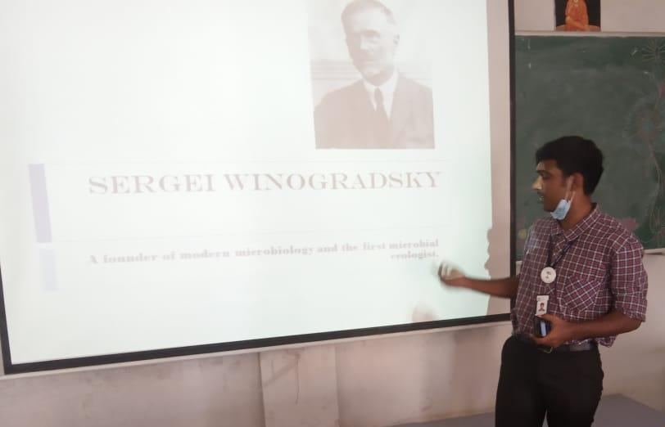
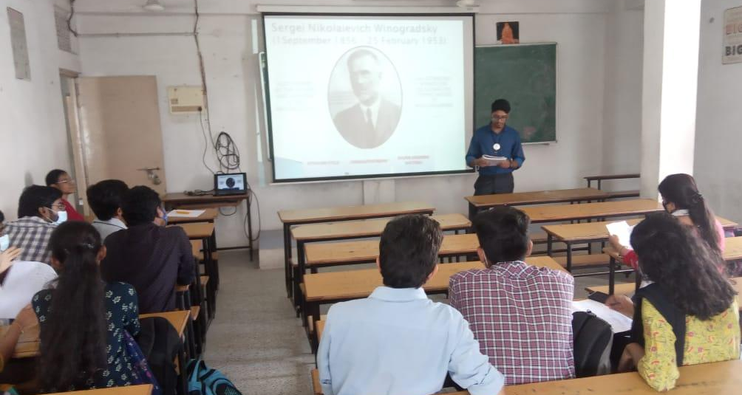

EVENT SCROLL:
