Aurora’s Degree & PG College 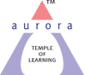
(ACCREDITED BY NAAC WITH ‘B++’ GRADE)
Chikkadpally, Hyderabad
Brief Report
On
E-Waste Management Day

NAME OF THE EVENT | E-Waste Management Day
TYPE OF EVENT | College level
FACULTY INCHARGE | R.Sravan Kumar
DEPARTMENT | Electronics
DATE | 14th October, 2022
VENUE | Aurora’s Degree and PG College, Chikkadpally
TARGET AUDIENCE | B.Sc M.E.Cs students

OBJECTIVE:
To create awareness among the students regarding E-Waste and the importance of its re-cycling process.
BRIEF ABOUT THE EVENT:
The Department of Electronics, Aurora’s Degree and PG College organise this event with great enthusiasm every year. This year, two students of III B.Sc. M.E.Cs gave a power point presentation in their class to motivate the remaining students towards the E-Waste Management process. A few students presented posters on the E-Waste Management concept. The department also collected E-waste from the entire college student body and delivered it to Earth Sense Recycle Private Limited in Hyderabad for recycling.
OUTCOME:
Students gained practical knowledge through this power point presentation and also they gained knowledge on different machines used in the industry for recycling of E-Waste. They also learned how to discard E-Waste materials without causing of any damage to Earth.
Photographs:
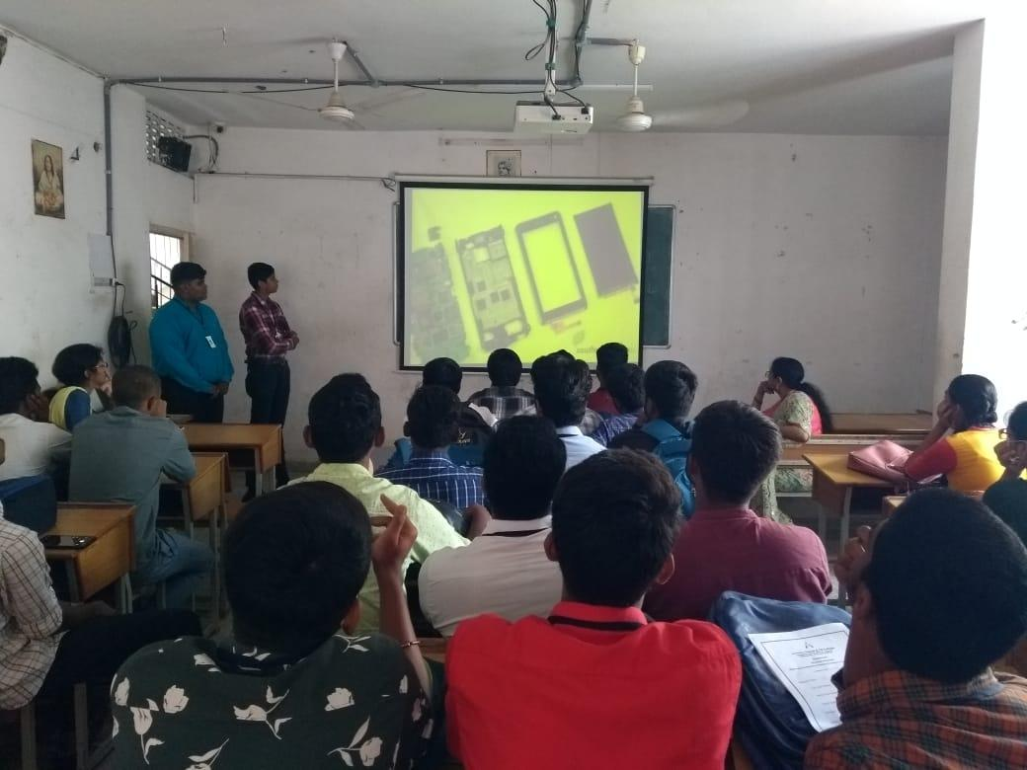
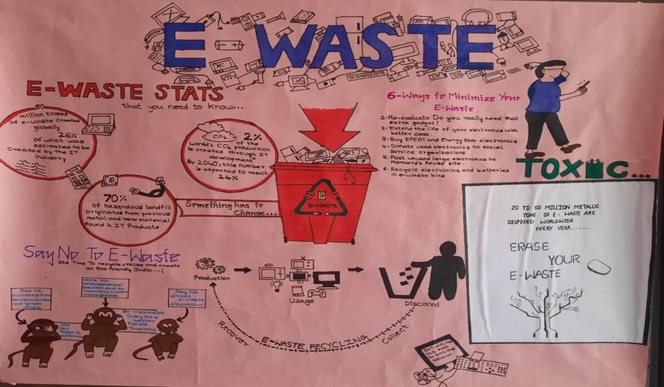

Aurora’s Degree & PG College
(ACCREDITED BY NAAC WITH ‘B++’ GRADE)
Chikkadpally, Hyderabad
A Detailed Report
On
E-Waste Management Day

NAME OF THE EVENT | E-Waste Management Day
TYPE OF EVENT | College level
FACULTY INCHARGE | R.Sravan Kumar
DEPARTMENT | Electronics
DATE | 14th October, 2022
VENUE | Aurora’s Degree and PG College, Chikkadpally
TARGET AUDIENCE | B.Sc M.E.Cs students

1. PROGRAM SCHEDULE
11:00 am to 12:00 noon Power point presentation
12:00 noon to 12:30 pm Poster presentation
12-10-2022 to 15-10-2022 (4 days) collection of E-Waste from students of the college.
2. VENUE
Aurora’s Degree and PG College – Block I, Room No: 306
3. LIST OF FACULTY COORDINATORS
R.Sravan Kumar, Assoc.Prof, Dept. of Electronics.
4. LIST OF THE STUDENT COORDINATORS
M.Abhishek - III B.Sc. (1051-20-474-019)
G.Ramcharan -III B.Sc. (1051-20-474-027)

5. LIST OF PRESENTEES
Power Point presentation by M.Abhishek - III B.Sc. (1051-20-474-019)
G Ramcharan -III B.Sc. (1051-20-474-027)
Poster presentation by M Naga Lakshmi –III B.Sc. (1051-20-474-002)
Basvaraj Sajjan –II B.Sc. (1051-21-474-001)

6. LIST OF PARTICIPANTS
S.No | Roll number | Name | Class | Section
1 | 1051-20-474-001 | S Gouthami Reddy | MECs | A
2 | 1051-20-474-002 | M Naga Lakshmi | MECs | A
3 | 1051-20-474-003 | M Divya Reddy | MECs | A
4 | 1051-20-474-004 | M Laharika | MECs | A
5 | 1051-20-474-005 | K Rushika | MECs | A
6 | 1051-20-474-006 | Para Vardhini | MECs | A
7 | 1051-20-474-007 | AVineela | MECs | A
8 | 1051-20-474-008 | D Sainishkala | MECs | A
9 | 1051-20-474-009 | B Rani Reddy | MECs | A
10 | 1051-20-474-010 | K Venkat Ram | MECs | A
11 | 1051-20-474-011 | B Goutham Raj | MECs | A
12 | 1051-20-474-012 | Rahul Sharma | MECs | A
13 | 1051-20-474-013 | Mekala Ruthvik | MECs | A
14 | 1051-20-474-014 | Tatipally Phanindra | MECs | A
15 | 1051-20-474-015 | B Niranjan Reddy | MECs | A
16 | 1051-20-474-016 | P Abhinay | MECs | A
17 | 1051-20-474-017 | M Kamalakar | MECs | A
18 | 1051-20-474-018 | Yandala Lokesh | MECs | A
19 | 1051-20-474-019 | Methree Abhishek | MECs | A
20 | 1051-20-474-020 | M N V Sri Jatish | MECs | A
21 | 1051-20-474-021 | Rajiv S | MECs | A
22 | 1051-20-474-022 | Kura Sai Prakash | MECs | A
23 | 1051-20-474-023 | K Sai Gowtham | MECs | A
24 | 1051-20-474-024 | P Indra Reddy | MECs | A
25 | 1051-20-474-025 | B Rohit | MECs | A
26 | 1051-20-474-026 | Kura Srihari | MECs | A
27 | 1051-20-474-027 | G Ram Charan | MECs | A
28 | 1051-20-474-028 | A Sudheer Kumar | MECs | A
29 | 1051-20-474-029 | S Srikanth | MECs | A
30 | 1051-20-474-030 | Ramavath Sachin | MECs | A
31 | 1051-20-474-031 | G Dileep Goud | MECs | A
32 | 1051-20-474-032 | Kodipe Vara Prasad | MECs | A
33 | 1051-20-474-033 | Batte Prasad | MECs | A
34 | 1051-20-474-034 | Vurukula Sanjay | MECs | A
35 | 1051-20-474-035 | Pallikonda Madhu | MECs | A
36 | 1051-20-474-036 | Kushi Joshi | MECs | A
37 | 1051-20-474-037 | T Shiva Kumar | MECs | A
38 | 1051-20-474-038 | Artham Sai Nitin | MECs | A
39 | 1051-20-474-039 | D Uday Kiran | MECs | A
40 | 1051-20-474-040 | T Krishna Prasad | MECs | A
41 | 1051-20-474-042 | Thota Tarun | MECs | A
42 | 1051-20-474-043 | Chintala Vikas | MECs | A
43 | 1051-20-474-044 | S Chandra Kumar | MECs | A
44 | 1051-20-474-045 | Sirinagula Sohan | MECs | A
45 | 1051-20-474-046 | Dandu Ankith | MECs | A
46 | 1051-20-474-047 | Adhu Shiva Pavan | MECs | A
47 | 1051-20-474-048 | G Vivek | MECs | A
48 | 1051-20-474-049 | Chigurlla Arjun | MECs | A
49 | 1051-20-474-050 | K Varun Kumar | MECs | A
50 | 1051-20-474-051 | K Dinesh Chary | MECs | A
51 | 1051-20-474-052 | P Bhargava Sai | MECs | A

7. ABOUT THE EVENT PROCEEDINGS

The term "E-Waste" is an abbreviation of "electronic and electrical waste". E-Waste is a term used to cover items of all types of electrical and electronic equipment and its parts that have been discarded by the owner as waste without the intention of re-use. Examples of electronic waste are TVs, computer monitors, printers, scanners, keyboards, mice, cables, circuit boards, lamps, clocks, flashlight, calculators, phones, answering machines, digital/video cameras, radios, VCRs, DVD players, MP3 and CD players.
The Department of Electronics, Aurora’s Degree and PG College organise this event with great enthusiasm every year. This year, two students of III B.Sc. M.E.Cs gave a power point presentation in their class to motivate the remaining students towards the E-Waste management process. In the presentation, students explained about E-Waste materials and how E-waste materials are harmful to the atmosphere. They also explained how reducing, reuse, and recycling mechanisms are helpful in the control of E-waste.

A few students presented posters on the E-waste management concept. In their poster presentation, students explained the E-waste status in India, what the different ways to minimise the E-waste are, and how to save the earth from E-waste.

The department also collected E-waste from the entire college student body and delivered it to Earth Sense Recycle Private Limited in Hyderabad for recycling. In this regard, the following E-waste materials are deposited by the students..
Mobile phones, Computer key board and mouses, Laptop charges and Internet routers.

To check if the objective of the programme was met, we collected feedback orally from students. Everyone gave good feedback.

8. INCOME AND EXPENDITURE
NIL

9. EVENT PHOTGRAPHS

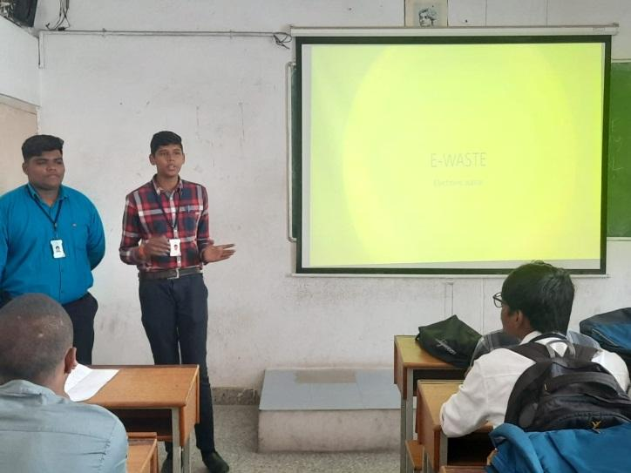
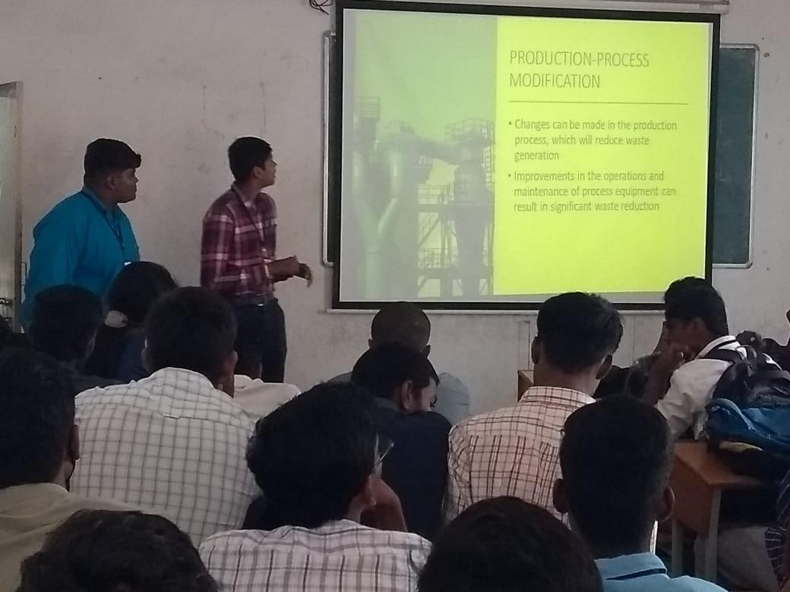

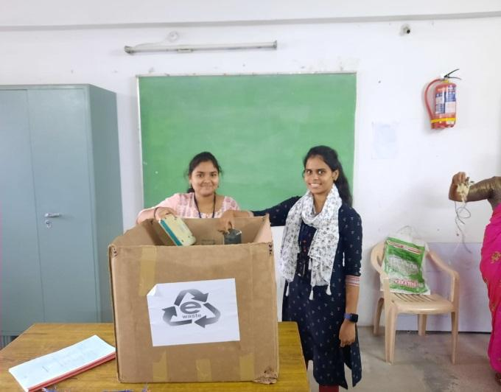

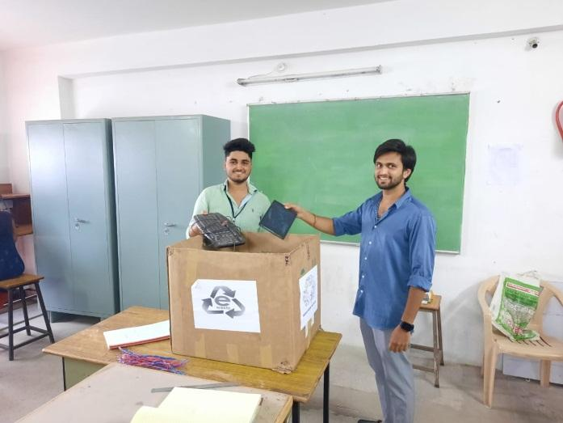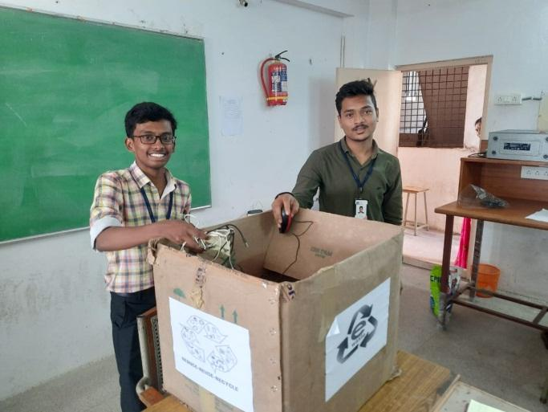

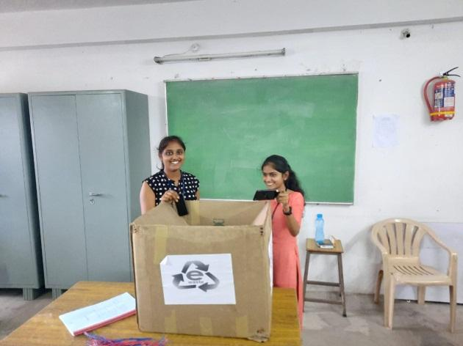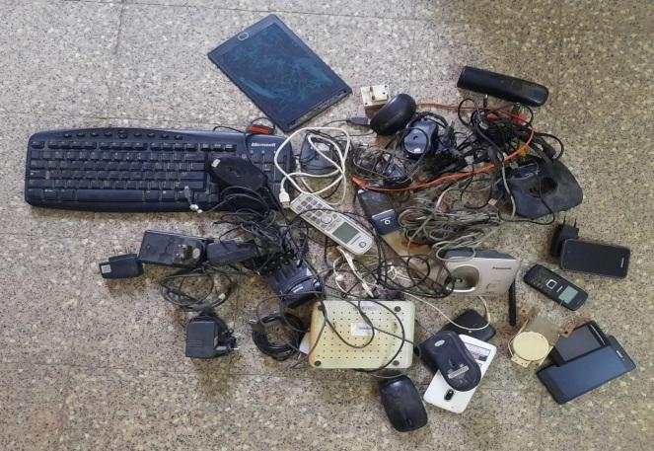

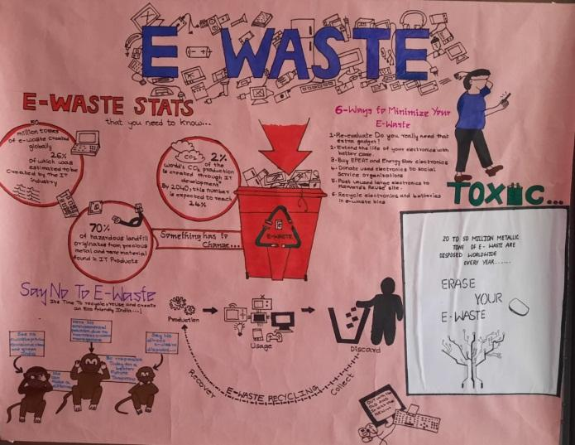
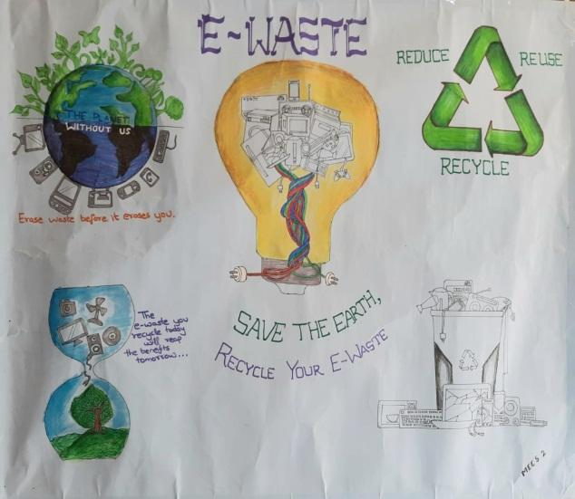
10. GUEST PROFILE: N/A
11. FEEDBACK
To check if the objective of the programme was met, we collected feedback orally from students. Everyone gave good feedback.
12. ATTACHMENTS:
EVENT/ACTIVITY PROPOSAL: Attached
EVENT / ACTIVITY NOTICE: Attached
RECEIPTS: N/A
CERTIFICATES: Attached
LETTERS OF COMMUNICATION: N/A

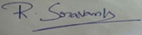
Event coordinator
(R. Sravan Kumar)

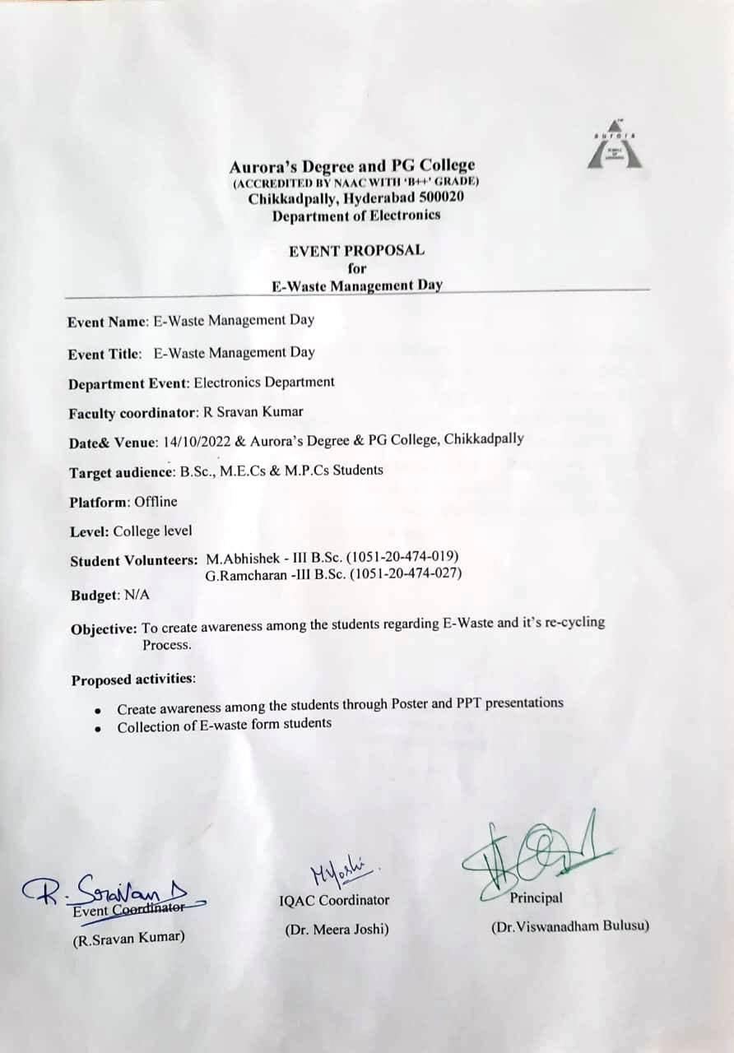

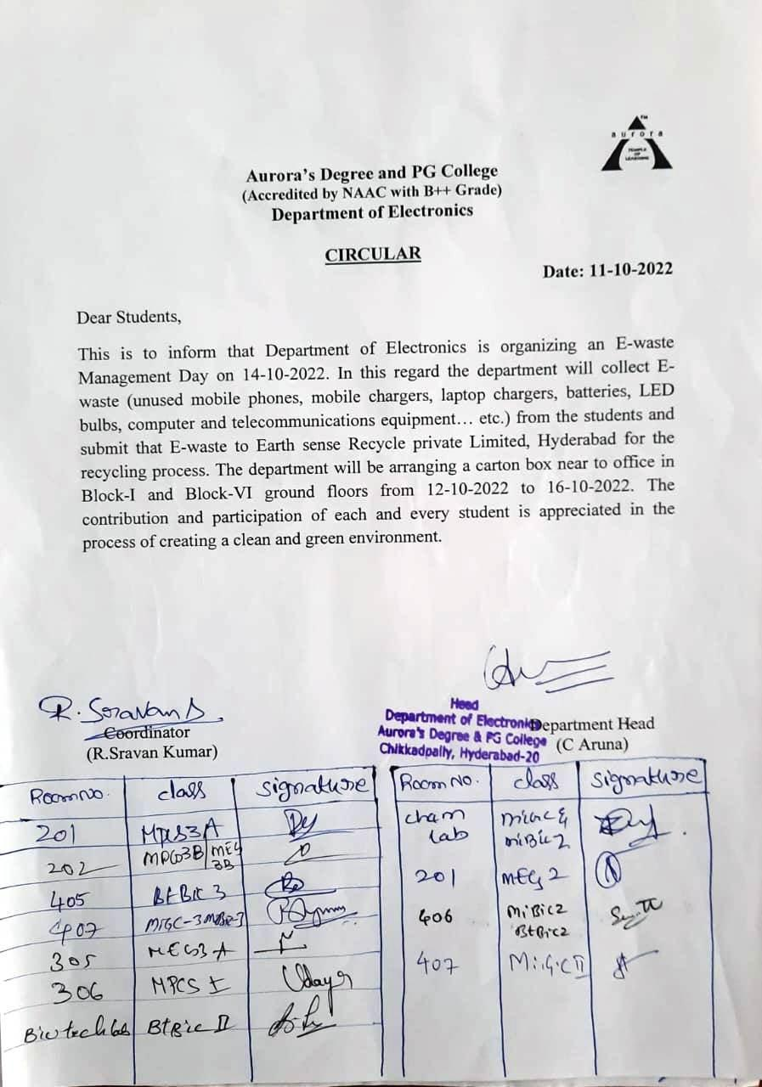

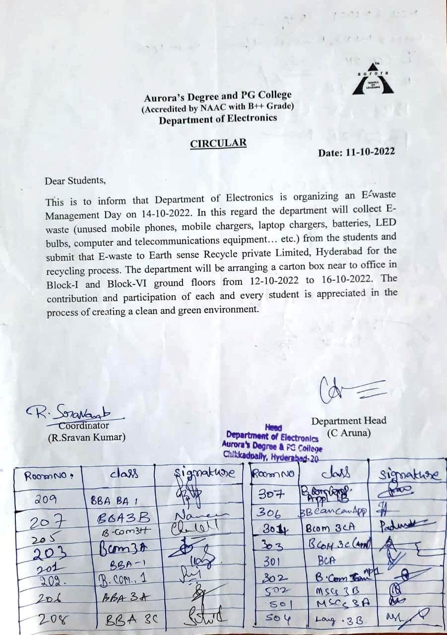

Certificate given by Earth Sense Recycle Pvt.Ltd

