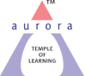
Aurora’s Degree and PG College
(ACCREDITED BY NAAC WITH ‘B++’ GRADE)
Chikkadpally, Hyderabad 500020
Department of Physics

EVENT PROPOSAL
for
Dr APJ Abdul Kalam Birthday

Event Name: Dr. APJ Abdul Kalam Birthday
Event Title: Dr. APJ Abdul Kalam Birthday
Department : Physics Department
Faculty coordinator: C. Aruna, B. Udaya Sree
Date & Venue: 15-10-2022 & Aurora’s Degree & PG College, Chikkadpally
Target audience: B.Sc., M.P.Cs and M.E.Cs Students
Platform: Offline
Level: Department level
Student Volunteer’s: Sai Balaji MPCs 3A, Aritra Dey MPCs 3B and Ratnesh MPCs 2
Budget: Rs.400/-

Objective: To pay tribute to the Great hero “A Missile Man Of India” Dr. APJ Abdul Kalam.
Proposed activities:
- Poster presentation and Power Point Presentaion
- Quiz Competition

Event Coordinator IQAC Coordinator Principal
C. Aruna (Dr. Meera Joshi) (Dr. Viswanadham Bulusu) B. Udaya Sree

Aurora's Degree & PG College
(ACCREDITED BY NAAC WITH ‘B++’ GRADE)
Chikkadpally, Hyderabad
Brief Report
On
Dr APJ Abdul Kalam Birthday

NAME OF THE EVENT / ACTIVITY | Dr APJ Abdul Kalam Birthday Celebrations
TYPE OR TITLE OF EVENT / ACTIVITY | Dr APJ Abdul Kalam Birthday Celebrations
FACULTY INCHARGE | CAruna  B.Udaya Sree
DEPARTMENT/CELL/COMMITTEE/CLUB | Physics
DATE | 13-10-2022 & 15-10-2022
VENUE | Aurora's Degree & PG College
TARGET AUDIENCE | B.Sc., I, II and III Year students

OBJECTIVE:
- To pay tribute to Missile man of India Dr. APJ Abdul Kalam
- To ignite and enlighten the minds of the students by presenting his life history
- To develop the presentation skills and leadership qualities of students
BRIEF ABOUT THE EVENT
On account of Dr. APJ. Abdul Kalam Birthday Celebrations Department of Physics has organized Quiz competition for students on his life history, inventions, quotes and awards .
A total of 9 groups 27 participants from MPCS & MECS have actively participated in the quiz organized on 13th October. A tribute remembering the eminent personality was paid by a video & PPT presentation by students on 15th October. Announcement of Prize winners and distribution of prizes were done.
OUTCOME: Students got motivated by his simple living and inspirational thinking. And his quotes Ignited the minds of students and faculty also.

PHOTOGRAPH:
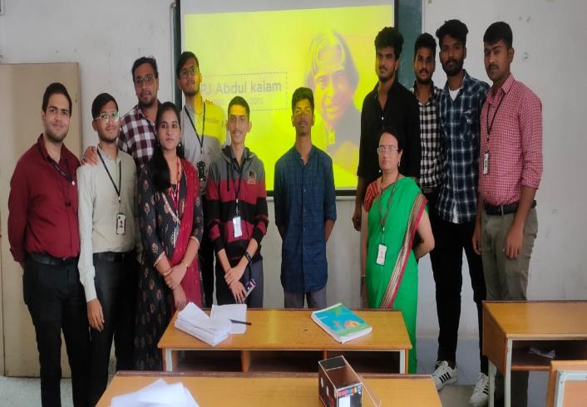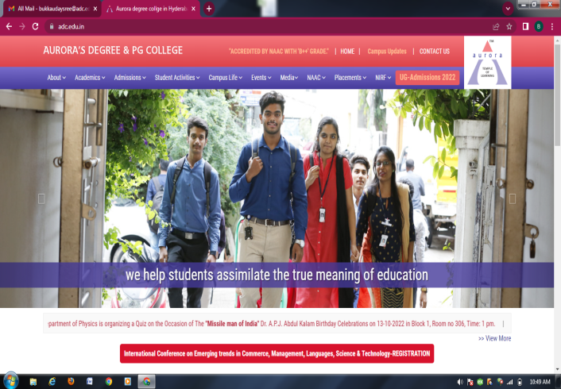
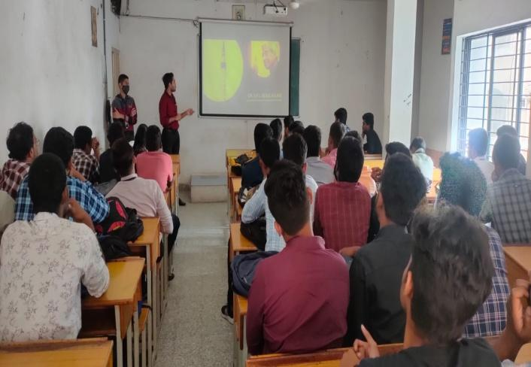
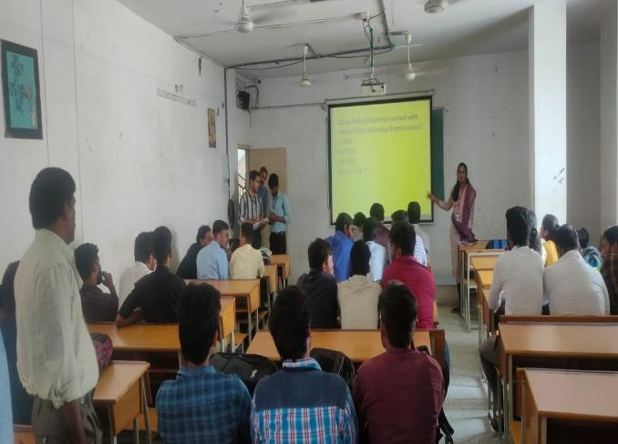

Aurora’s Degree & PG College
(ACCREDITED BY NAAC WITH 'B++' GRADE)
Chikkadpally,Hyderabad 500020

EVENT / ACTIVITY DETAILED REPORT

NAME OF THE EVENT / ACTIVITY | Dr. APJ Abdul Kalam Birthday Celebration
TYPE OR TITLE OF EVENT / ACTIVITY | Dr. APJ Abdul Kalam Birthday Celebration
FACULTY INCHARGE | CAruna  B.Udaya Sree
DEPARTMENT/CELL/COMMITTEE/CLUB | Physics
DATE | 13/10/2022,15/10/2022
VENUE | Aurora's Degree & PG College
TARGET AUDIENCE | Undergraduate Students

PROGRAM SCHEDULE
- Quiz:
Date: 13/10/2022
Timings: 1:00 pm -2:00 pm
LIST OF FACULTY COORDINATORS:
1.C.Aruna
Asssociate Professor
Dept. of Electronics
2.B.Udaya Sree
Asst.Professor
Dept. of Physics
3.LIST OF THE STUDENT COORDINATORS
Name | Roll. No | Section
Aritra Dey | 105119468003 | MPCs 3B
Ratnesh | 105119468049 | MPCs 2

4.LIST OF THE PARTICIPANTS
S.No | Roll Number | Name | Class/Section | Male/Female
1 |  | N.Vidyadhar | MPCS1 | M
2 |  | Hariharan | MPCS1 | M
3 |  | M.Bharath kumar goud | MPCS1 | M
4 | 1051-21-468-031 | P.Sanjana | MPCS2 | F
5 | 1051-21-468-004 | Khushi Sheikh | MPCS2 | F
6 | 1051-21-468-009 | N.Rohan | MPCS2 | M
7 | 1051-21-468-036 | M.Sai Nithin | MPCS2 | M
8 | 1051-21-468-016 | S.Akhil | MPCS2 | M
9 | 1051-21-468-014 | D.Naveen | MPCS2 | M
10 | 1051-21-468-002 | Abhijith | MPCS2 | M
11 | 1051-21-468-039 | Premsagar | MPCS2 | M
12 | 1051-21-468-027 | L.Bharath kumar | MPCS2 | M
13 | 1051-21-474-011 | Vishnu | MECS2 | M
14 | 1051-20-468-042 | Anand | MPCS3A | M
15 | 1051-20-468-040 | Badri | MPCS3A | M
16 | 1051-20-468-041 | Monith | MPCS3A | M
17 | 1051-20-468-029 | Sai ram | MPCS3A | M
18 | 1051-20-468-021 | Giri Raju | MPCS3A | M
19 | 1051-20-468-058 | Mohammed Adnan | MPCS3B | M
20 | 1051-20-468-059 | Mohammed Amaan | MPCS3B | M
21 | 1051-20-468-060 | Mohd Abdul Mutaleeb | MPCS3B | M
22 | 1051-20-468-056 | R.Harivatsa | MPCS3B | M
23 | 1051-20-468-050 | Aritra Dey | MPCS3B | M
5.PARAGRAPH ABOUT THE PROCEEDINGS
Program Schedule:
S.No | Event | Date | Time | Room No
1. | Quiz Competition | 13-10-22 | 1.00PM to 3.00 PM | 202
2. | Inaugural speech and Power Point Presentation by Students | 15-10-2022 | 11.00AM to 12.00 PM | 202
3. | Documentary Presentation and Prize Distribution | 15-10-2022 | 12.00 PM to 1.00 PM | 202

On account of Dr. APJ. Abdul Kalam Birthday Celebrations Department of Physics has organized Quiz on his Inventions, quotes, etc for students. A total of 27 participants are actively participated in the quiz organized on 13th October 2022.
On the day of event a Power point presentation was given by student of MPCs 3B Aritra Dey on his inventions and awards. A student of MPCs 3A Nikhil and Pavan presented his life history. A documentary was presented on how Dr APJ Abdul Kalam from small town of India became great scientist and President of India. The event was concluded by announcement of Prize winners and distribution.
6.INCOME AND EXPENDITURE:

S. No | Details | Amount
1 | Pens for prize winners(40*10) | 400

7.EVENT PHOTOS:
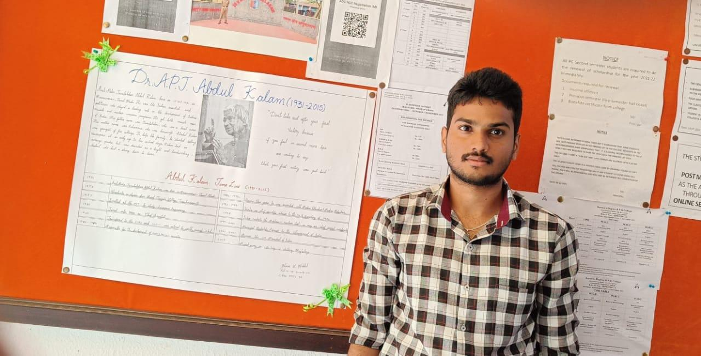
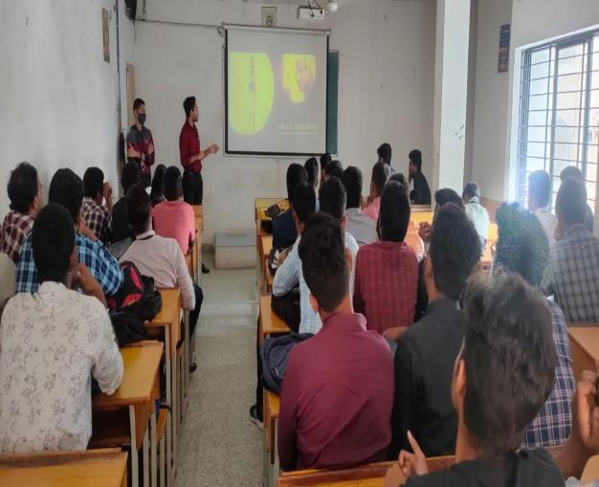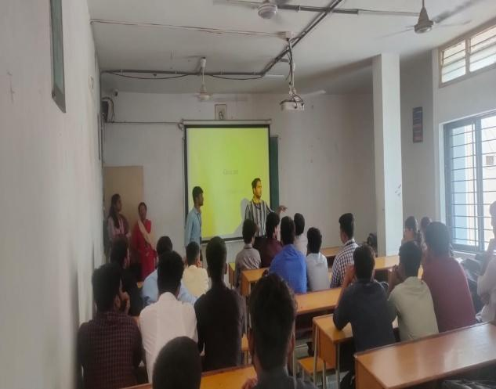

8.GUEST PROFILE: N/A
9.FEED BACK :Participants were very much interested and actively participated and gave a positive feedback for the events conducted.
10.Attachments:
EVENT/ACTIVITY PROPOSAL: Attached
EVENT / ACTIVITY NOTICE:

RECEIPTS: N/A
CERTIFICATES: N/A
LETTERS OF COMMUNICATION: N/A

