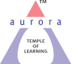
Aurora’s Degree & PG College
(Accredited By Naac With 'B++' Grade)
Chikkadpally, Hyderabad 500020

EVENT / ACTIVITY DETAILED REPORT

NAME OF THE EVENT / ACTIVITY | Kalidasa Jayanti
TYPE OR TITLE OF EVENT / ACTIVITY | Kalidasa Jayanti – Class Room Activity
FACULTY INCHARGE | M. Ramalakshmi Anasuya
DEPARTMENT/CELL/COMMITTEE/CLUB | Languages
DATE | 16 th November 2022
VENUE | Class Room – III year Students,  Aurora’s Degree & PG College,  RTC Block.
TARGET AUDIENCE | UG Sanskrit Students

- PROGRAM SCHEDULE:
- The program was scheduled on 16 ^{th} November 2022
- The program began at 10:00 am. ended around 10:50 am
- M.Ramalakshmi Anasuya
- During the session only a photo session was conducted.
- At 10:40 vote of thanks was given by M. Ramalakshmi Anasuya.
- Mr. Vinuthan & Mr. Sahith and Ms.Nikhitha Rao
Given thanking note at the end of the program.

- LIST OF FACULTY COORDINATORS
S.no | Faculty Name | Role | Department
1 | M.Ramalakshmi Anasuya | Faculty In-charge | Assistant Professor – Department of Second languages
- LIST OF THE STUDENT COORDINATORS (NAME , ROLL NO, CLASS & SECTION)
NAME | ROLL NO | CLASS & SECTION
P.Vinuthan Reddy | 1051-20-468-095 | B.SC – MPCS -- 3B
Y. Sahith Srivathsa | 1051-20-488-036
V.Sneha | 1051-20-488-004 | B.SC – BTBIC-3
G.Bhavika | 1051–20–488-006 | B.SC – BTBIC-3
B.Jeevan | 1051-20-488-033 | B.SC- BTBIC- 3
G.Premkumar | 1051-20-488-009 | B.SC- BTBIC-3
V. Nikhitha Rao | 1051-20-488-041 | B.SC- BTBIC- 3
N. Geethanjali | 1051-20-488-046 | B.SC- BTBIC- 3

- LIST OF THE PARTICIPANTS (NAME , ROLL NO, CLASS & SECTION, NO OF GIRLS, BOYS, CASTE )

Total Number of Participants | Number of Girls | Number of Boys
48 | 17 | 31

- PARAGRAPH ABOUT THE PROCEEDINGS (TILL THE END OF THE EVENT)
This creative and educative event was organized by the Languages Department of Aurora’s Degree & PG College. This great session was handled by the Sanskrit faculty M.Ramalakshmi Anasuya and Sanskrit students took part in this event. The target audience and participants of this event are UG Sanskrit students.

The program began with prayer and held the attention of the audience. The session laid focus on Kalidasa’s scripts. This event enlightened the Sanskrit students through speeches and discussion on poetic style of Kalidasa, They discussed about the works of Kalidasa. And his simplistic and lucid style of writing.
Faculty coordinator M. Ramalakshmi Anasuya along with the students of BTBIC - 3 and MPCS 3B played a key role in motivating students to attend this session. Towards the end of the session, the students were engaged in group discussion. And Mr. Vinuthan (MPCs-3B) and Ms. Sneha (BTBIC-3) given vote of thanks with everyone expressed their satisfaction and gratitude for the session.
The event began with a shloka, and held the attention of the audience. The session laid focus on scripts and treatises of Kalidasa the Poet and matchless Author of India. Main motto of this session is to create and develop the creative skills with in the students.“Don’t give up” kind of attitude. And also want to spread the Kalidasa’s extraordinary creative skills to the next generation, as an honor and felt it is also the duty and responsibility of each and every student to preserve such an incredible literary treasure of our country. By knowing who they are and what their contribution to their motherland, each student is obliged to spread the fragrance of this country’s rich literary heritage worldwide.

Synopsis of the event:

The students enlightened and enriched this event through their speeches and discussions. Mr.Sahith Drew the picture of Kalidasa he expressed his motivational words about Kalidasa and Ms. Sneha (BtBic- 3) did anchoring part, Mr. Vinuthan spoke about Kalidasa’s life, and sang “Shyamala Dandakam”, Ms. NikhithaRao from BtBic-3 spoke about Raghuvamsam, Ms. Geetanjali (BtBic-3) spoke about Meghadooth kavyam, Premkumar (ByBic-3) spoke about Abhijhnana Shakunthalam, Ms. Bhavika (BtBic-3) spoke about Kumarasambhavam, Jeevan (BTBic-3) spoke about Vikramorvaseeyam.

The students considered this kind of event as an honor and felt it is very important to know about such a great scholars of our country. By knowing who they are and what their contribution to their motherland, and increased the native luck of the country all over the world each student is obliged to spread the fragrance of this country’s rich literary heritage worldwide.

- INCOME AND EXPENDITURE: NIL

- EVENT PHOTOS ( MIN 2 MAX 4)

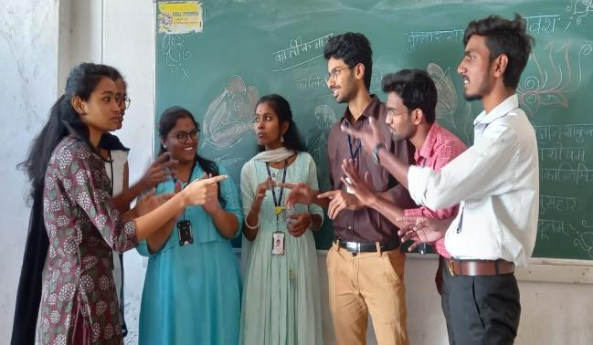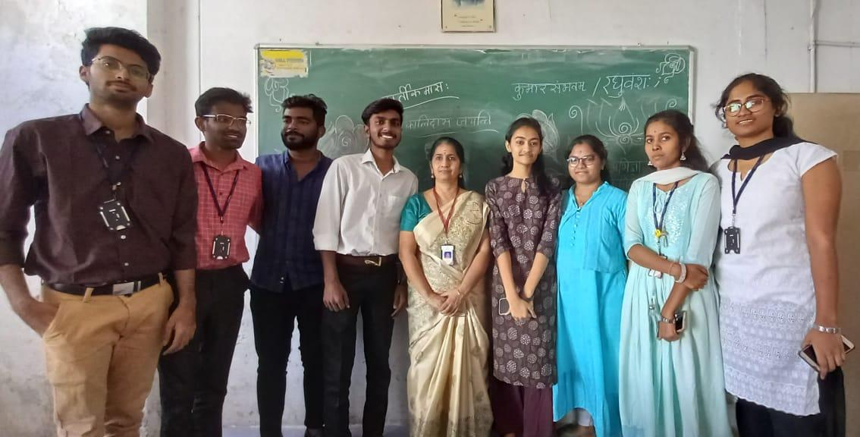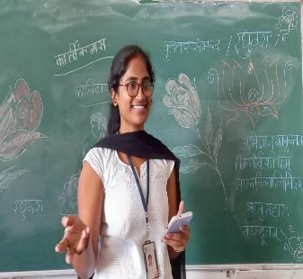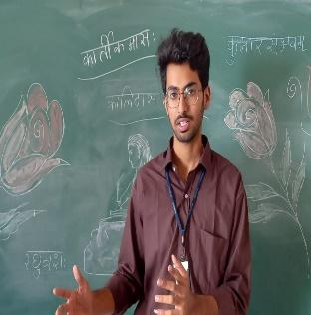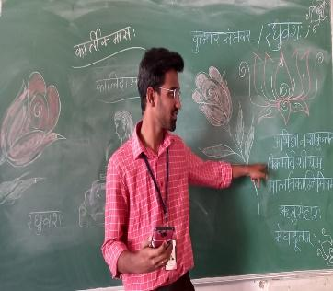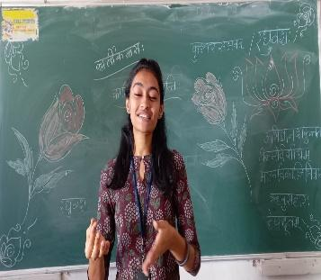
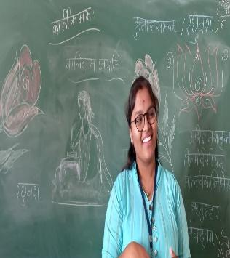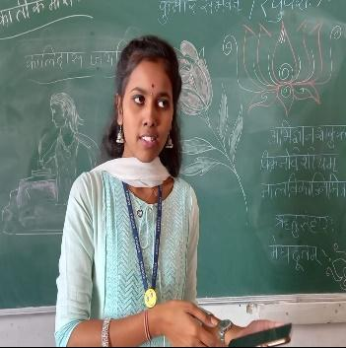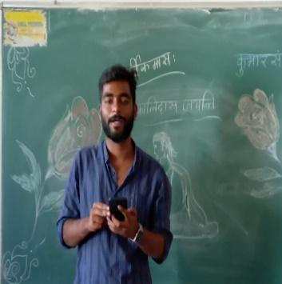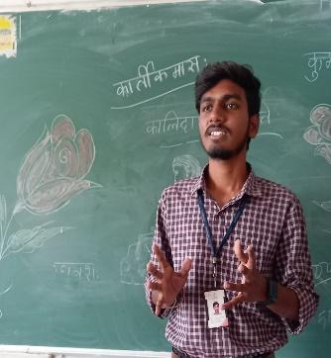

8. GUEST PROFILE (IF ANY) : NA
9. FEEDBACK IF ANY: Yes
This was a great opportunity for gaining the knowledge about the great Indian scholars and their ancient Scripts. The main objective of the event is to create awareness among the students about Great Indian scholars and also to develop creative skills with in their minds. All the students were happy to be a part of this event .Most of the students showed their interest and enthusiasm to know more about the Indian scholars and scriptures in detailed. They got to know about right & better way of using the valuable time and creative skills. It was an interesting and inspirable session with the students. Few students want to pen their creative and imaginary thoughts. Everyone expressed their satisfaction and gratitude for the session.

10. EVENT / ACTIVITY NOTICE:

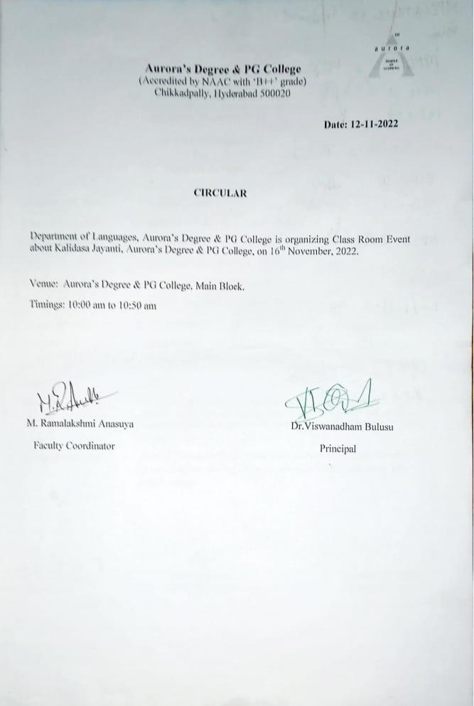

11. EVENT/ACTIVITY PROPOSAL:

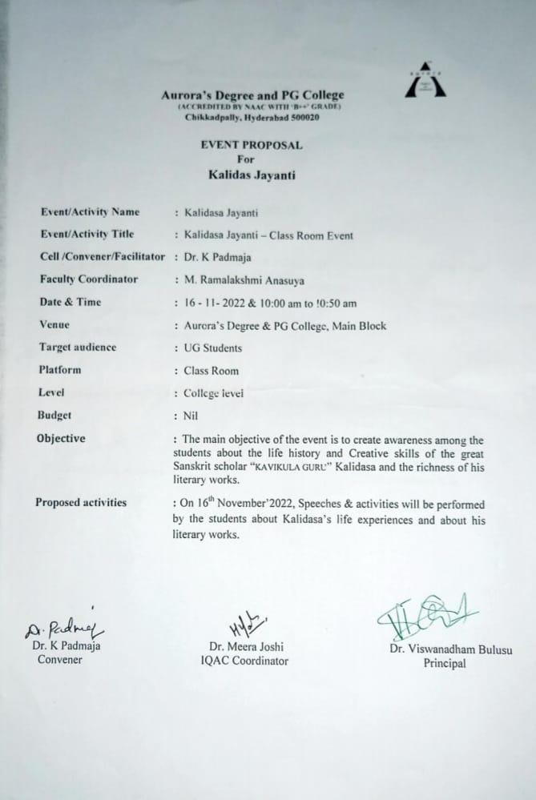
- RECEIPTS (IF ANY) : NO
- CERTIFICATES (IF ANY) : NO
- LETTERS OF COMMUNICATION (IF ANY) : NA

*****

