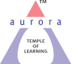
Aurora’s Degree & PG College
(ACCREDITED BY NAAC WITH 'B++' GRADE)
Chikkadpally, Hyderabad 500020

EVENT / ACTIVITY DETAILED REPORT

NAME OF THE EVENT / ACTIVITY | Tagore’s Day
TYPE OR TITLE OF EVENT / ACTIVITY | Intra College
FACULTY INCHARGE | P. Vineetha
DEPARTMENT/CELL/COMMITTEE/CLUB | English Department
DATE | 6-8-2022 & 7-8-2022
VENUE | Musheerabad Government School & Aurora’s Degree and P.G College, Block VI, RTC X Roads.
TARGET AUDIENCE | Students of Musheerabad Government School and Aurora’s Degree and P.G College

- PROGRAM SCHEDULE
MUSHEERABAD GOVERNMENT HIGH SCHOOL on 6-8-2022
- SONG
- A Talk about Rabindranath Tagore
- Dance
- Quiz
- Prize Distribution
AURORA’S DEGREE AND P.G COLLEGE on 6-8-2022
- Lighting of the Lamp
- Song
- Role Play
- Dance
- Vote of thanks
- Food Fest
AURORA’S DEGREE AND P.G COLLEGE on 7-8-2022
- Poetry Recitation Competition

- LIST OF FACULTY COORDINATORS (DEPARTMENT):
S. No | Name | Department
1 | S. Padmavthi | English
2 | Moumitha Santra | English
3 | B. Vyshnavi | English
4 | A. Sharon Priyanka | English
5 | Dr. P. Bharathi | English
6 | P. Sona | English
7 | Malleswara Rao | English
- LIST OF THE STUDENT COORDINATORS (NAME , ROLL NO, CLASS & SECTION)
      - Rani Chaudhary
      - Vidhisha Sanghvi
- LIST OF THE PARTICIPANTS (NAME , ROLL NO, CLASS & SECTION, NO OF GIRLS, BOYS, CASTE )
S.No | Roll No | Name | Class/Section | Activity
1 | 1051-20-459-015 | Medida Lokesh | MiGC 3 | Dance
2 | 1051-20-474-067 | Naresh Kumar N | MECS 3B | Dance
3 | 1051-20-467-051 | Dhanush Chikoti | MSCS 3A | Dance
4 | 1051-20-488-028 | K.M.Vishwa Adithya | BtBiC 3 | Dance
5 | 1051-20-405-074 | K. Rithika Reddy | Capp 2B | Dance
6 | 1051-20-405-063 | Rani Choudhary | Capp 2B | Dance
7 | 1051-20-407-009 | Vidhisha P Sanghvi | Hons 3 | Dance
8 | 1051-20-407-007 | Vrridhi Dugar | Hons 3 | Dance & Role play

S.No | Roll No | Name | Class/Section | Activity
1 | 1051-20-684-138 | S.Sai Sweekruthi | BBA 3C | Song
2 | 1051-20-684-012 | Erica Ann Hackett | BBA 3A | Song
3 | 1051-20-684-049 | Akhil Rohan M | BBA 3A | Song
4 | 1051-21-684-064 | K. Chrislyn Evanle | BBA 2B | Song
5 | 1051-21-471-013 | Raghuvamsh Veladi | MiBiC 2 | Song
6 | 1051-21-459-014 | E. Namaami | MiGC 3 | Song

S.No | Roll No | Name | Class/Section | Activity
1 | 1051-20-401-121 | Tudumula Sunil Kumar | Gen 3B | Role play

S.No | Roll No | Name | Class/Section | Activity
1 | 1051-20-407-048 | Sujeeth Rag | Hons 3 | Volunteer
2 | 1051-20-684-044 | Omar Mohammed Ibrahim | BBA 3A | Volunteer
3 | 1051-20-401-113 | Teja Vardhan | Gen 3B | Volunteer
4 | 1051-20-471-006 | Madhan | MiBiC 3 | Volunteer

Food Fest
S.No | Roll No | Name | Class/Section | Stall
1 | 1051-20-401-006 | Swagata Kundu | Gen 3A | Jhal Muri
2 | 1051-20-401-121 | Tudumula Sunil Kumar | Gen 3B | Rasgulla
3 | 1051-21-405-105 | Pratham Goel | C.App 2B | Rasmalai
4 | 1051-21-405-064 & 080 | K. Devi Prasanna & K. Harpita | C.App 2B | Fuchka(Pani puri)
5 | 1051-20-407-023 &014 | Kanchan Vijayvargiya & Manisha Mandal | Hons 3 | Fuchka(Pani puri)
6 | 1051-20-401-118 & 088 | C. Deepthanush & B. Devi Charan | Gen 3B | Kala Jamun

- PARAGRAPH ABOUT THE PROCEEDINGS (TILL THE END OF THE EVENT)
Tagore’s Day was held on 6th August, 2022 in memory of Rabindranath Tagore with the intention to commemorate his works. The first event was held at Musheerabad government school where students of Aurora Degree and P.G College visited the school to introduce the Bengali language, culture and tradition to the students. The singing of our national anthem signaled the beginning of the event. The participants then performed a Rabindra Sangeet followed by a dance performance and a speech was given by one of our Faculty members on Tagore. Later an oral quiz was conducted on Tagore where the children were asked simple questions about him. The audience there participated enthusiastically and the winners were awarded prizes.
The second event was held in the auditorium of Block VI after the participants returned to college. As previously scheduled, the event began with lighting of the lamp. The students sang “Ekla Cholo” a motivational song by Tagore. A role play was enacted to help audience know more about Tagore. A Bengali dance was performed along with the traditional “Dhunuchi” dance form. Our national anthem was sung to mark the end of the event. A vote of thanks was proposed before everyone dispersed for the food fest that was being conducted in the lobby of block 6.
On 7th August, 2022 a poem recitation completion was scheduled where the participants were supposed to recite a poem written by Tagore. But due to the unfortunate demise of our faculty Mr. Jaiprakash, the competition was cancelled and only a few faculties of the English department along with few students gathered to pay respect to him.

- INCOME AND EXPENDITURE
- EVENT PHOTOS ( MIN 2 MAX 4)
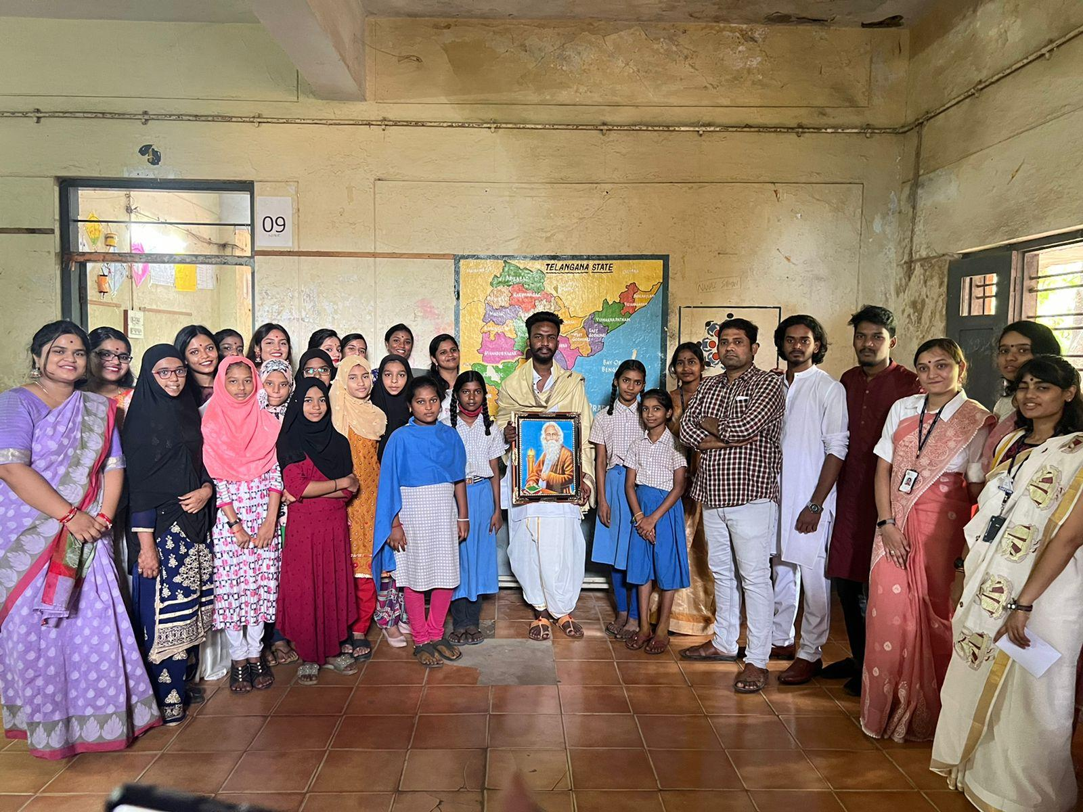
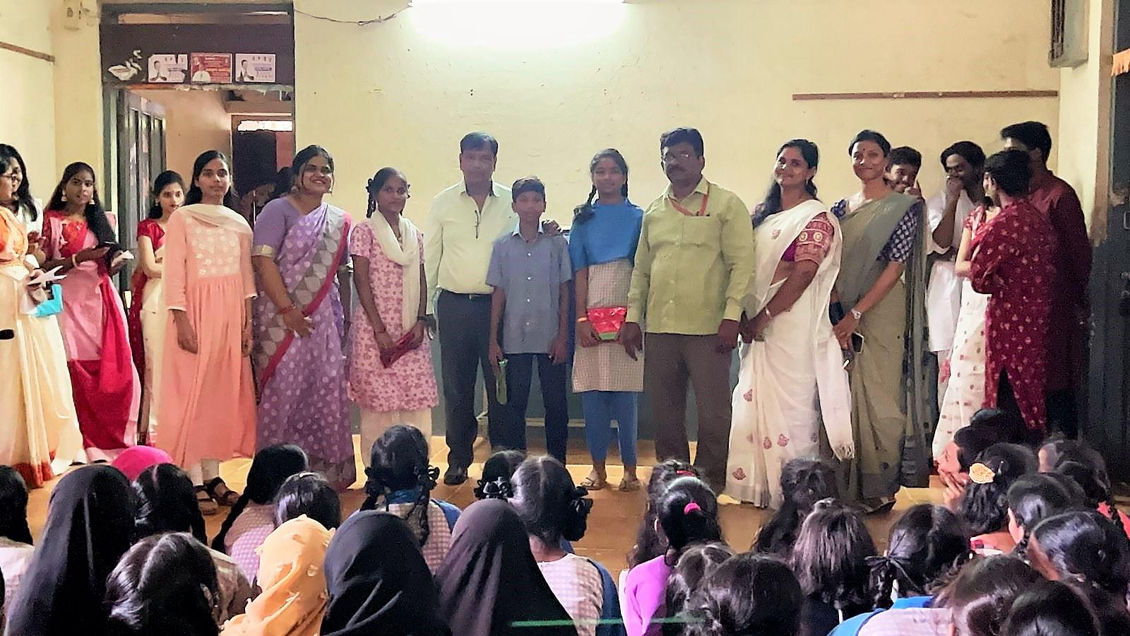
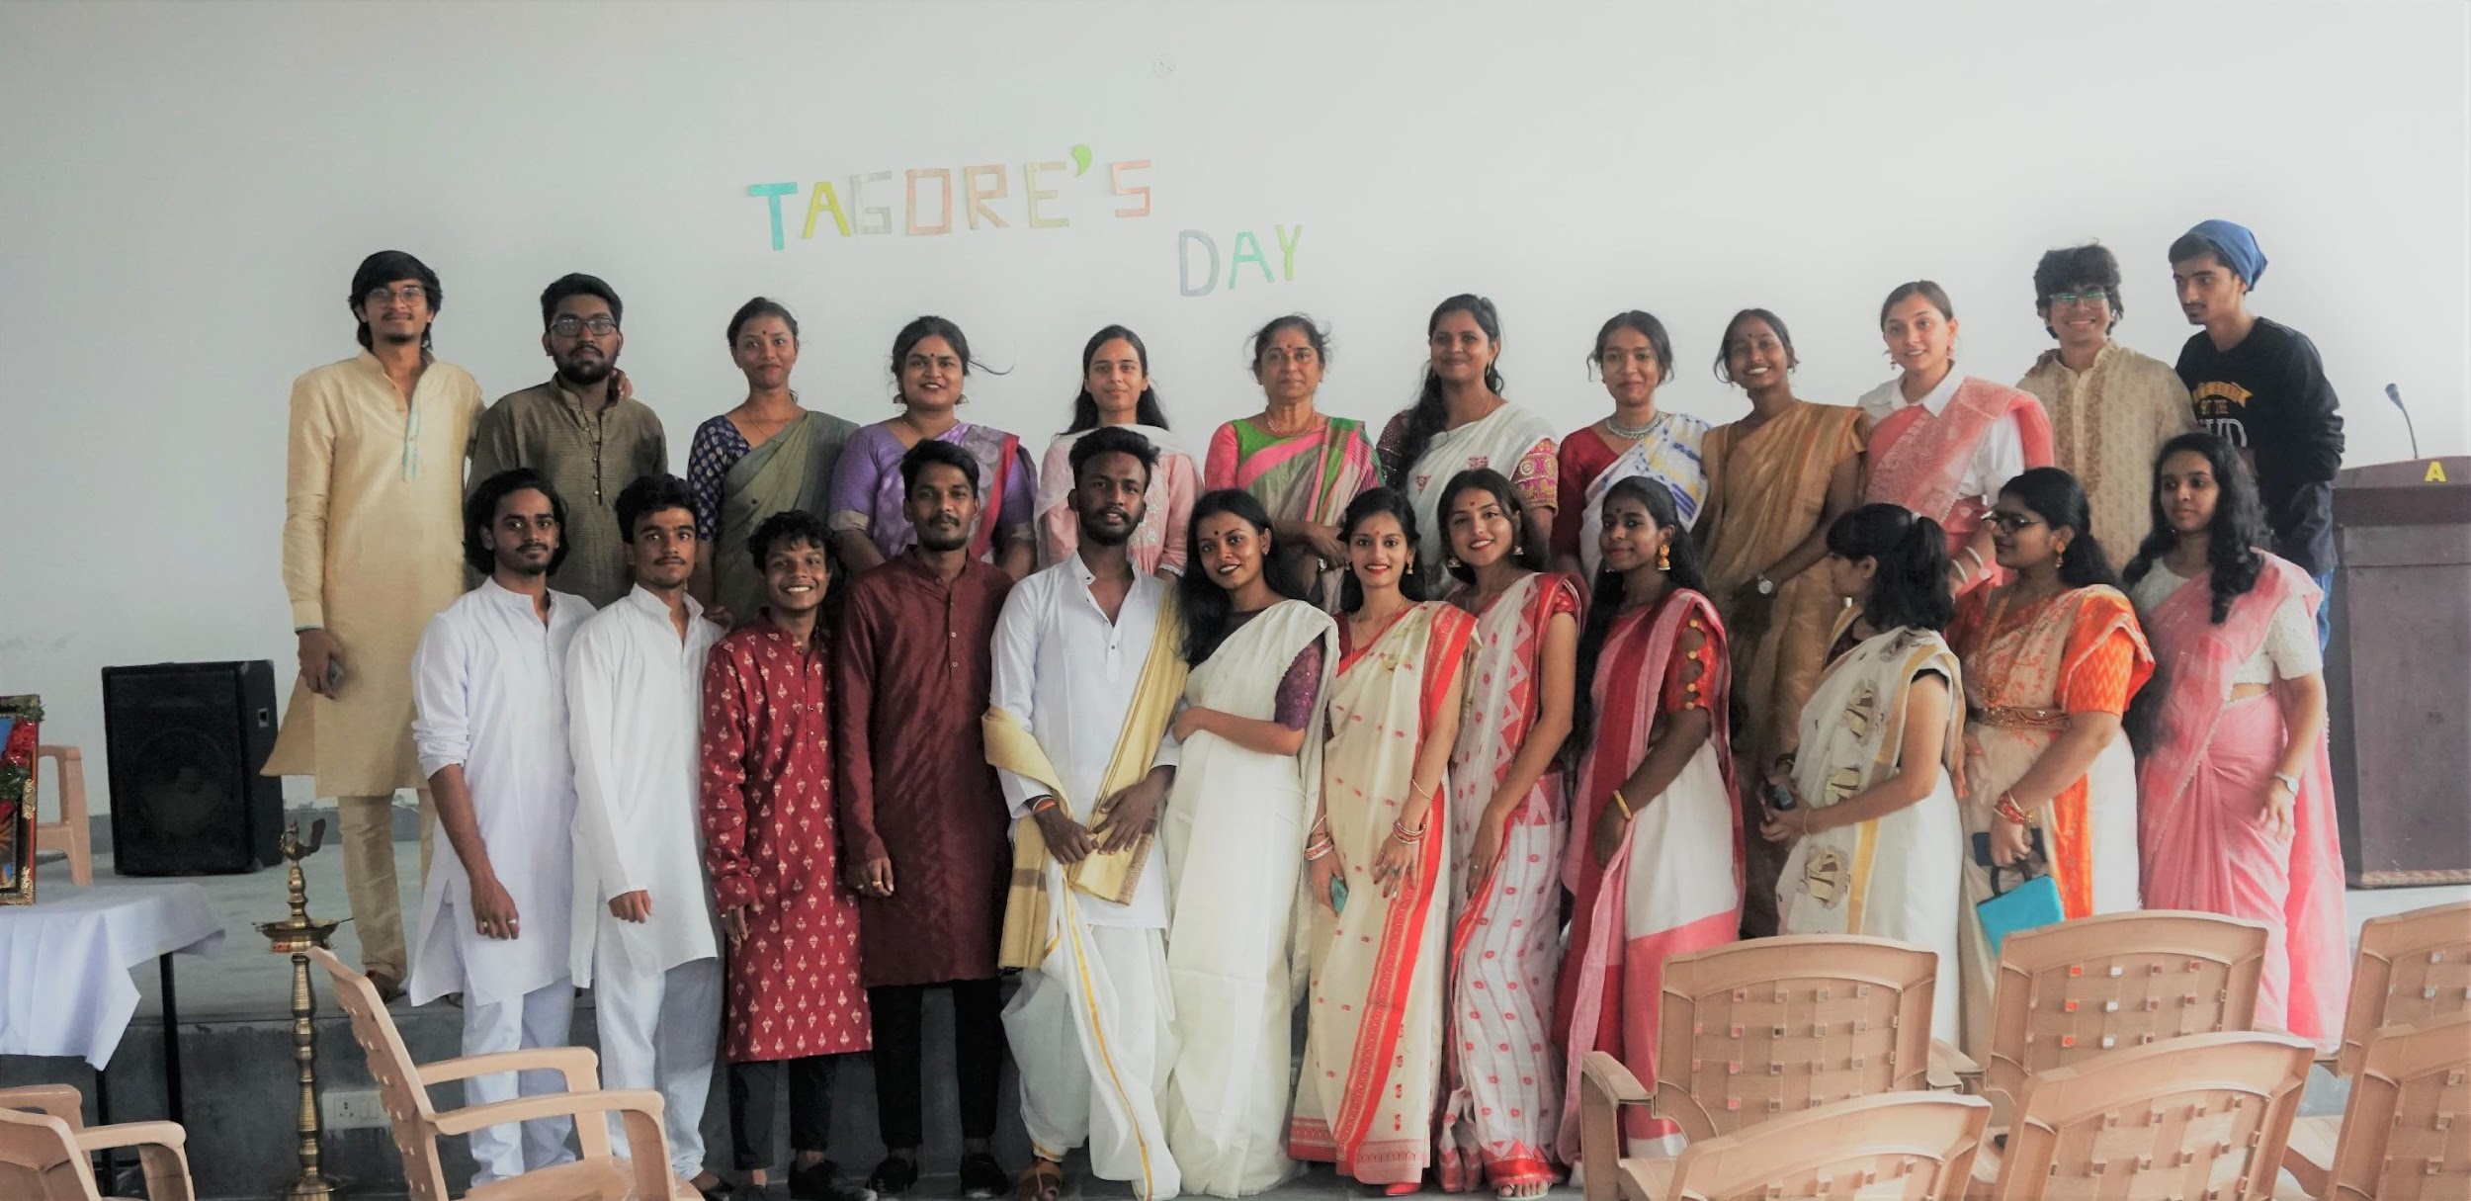
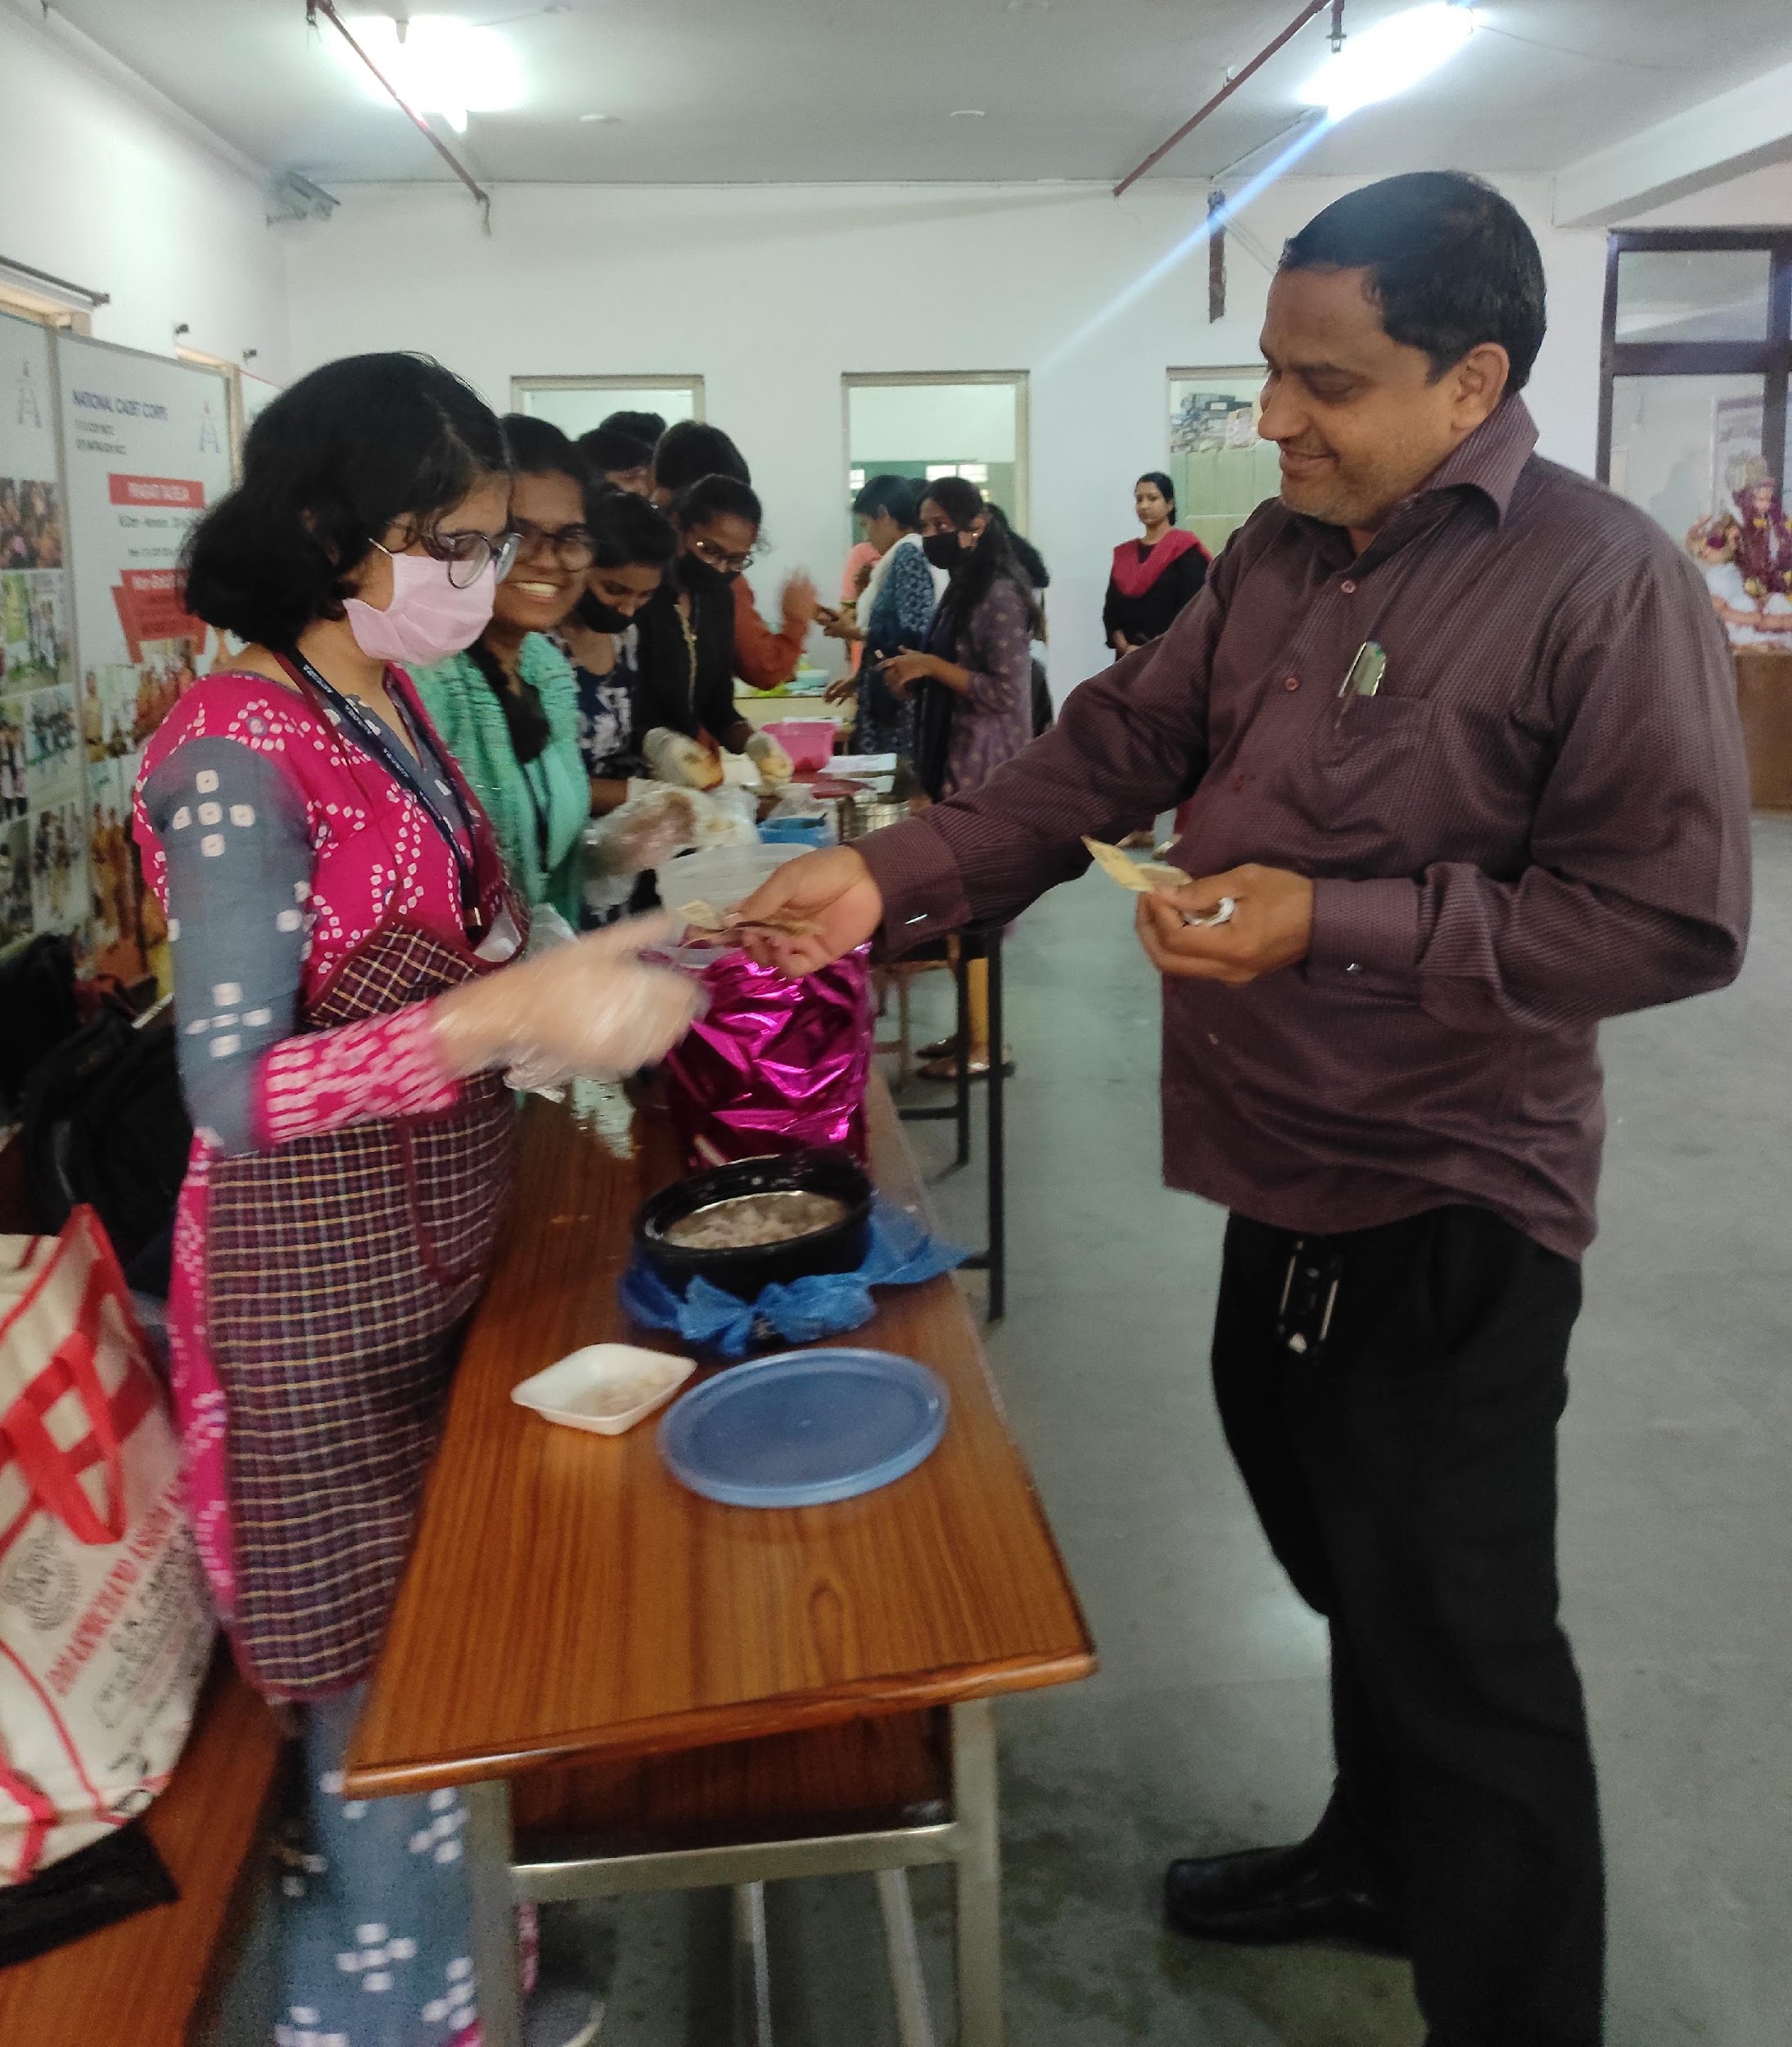

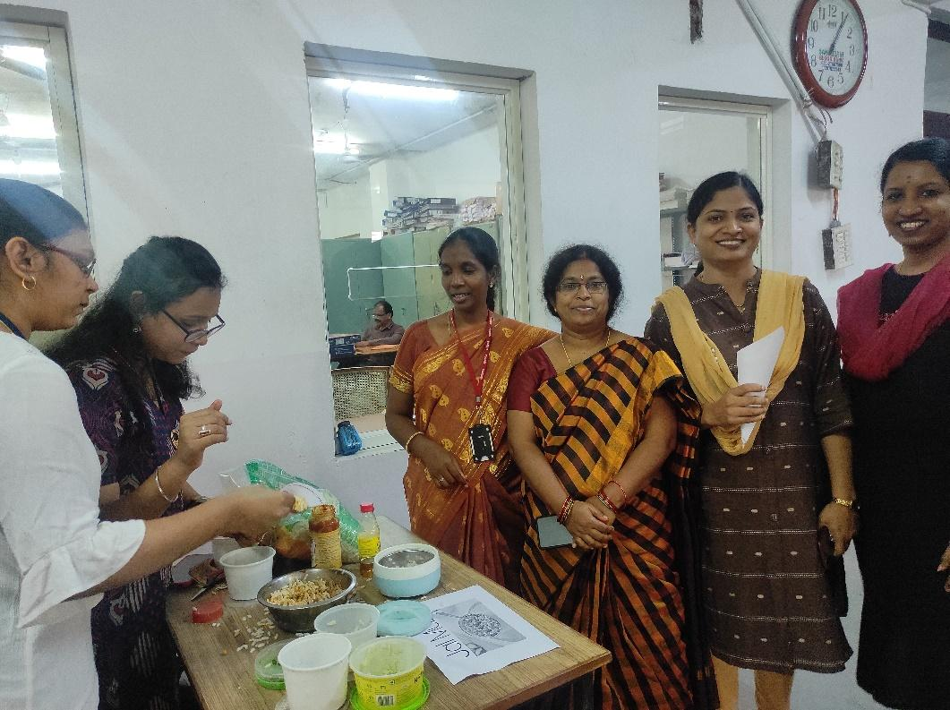
- GUEST PROFILE (IF ANY) - Nil
- FEED BACK IF ANY- Nil
- ATTACHMENTS:
EVENT/ACTIVITY PROPOSAL
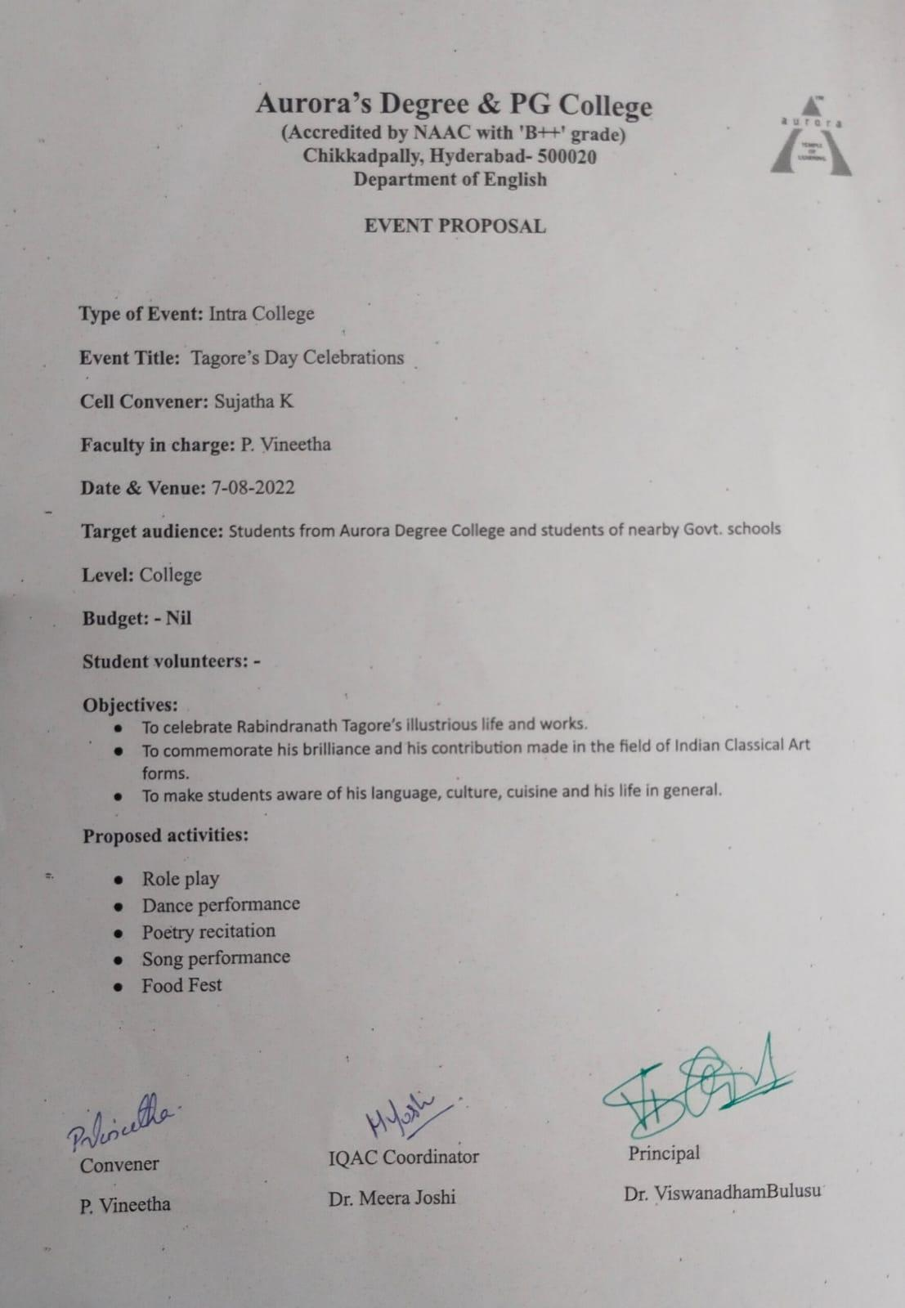

EVENT / ACTIVITY NOTICE
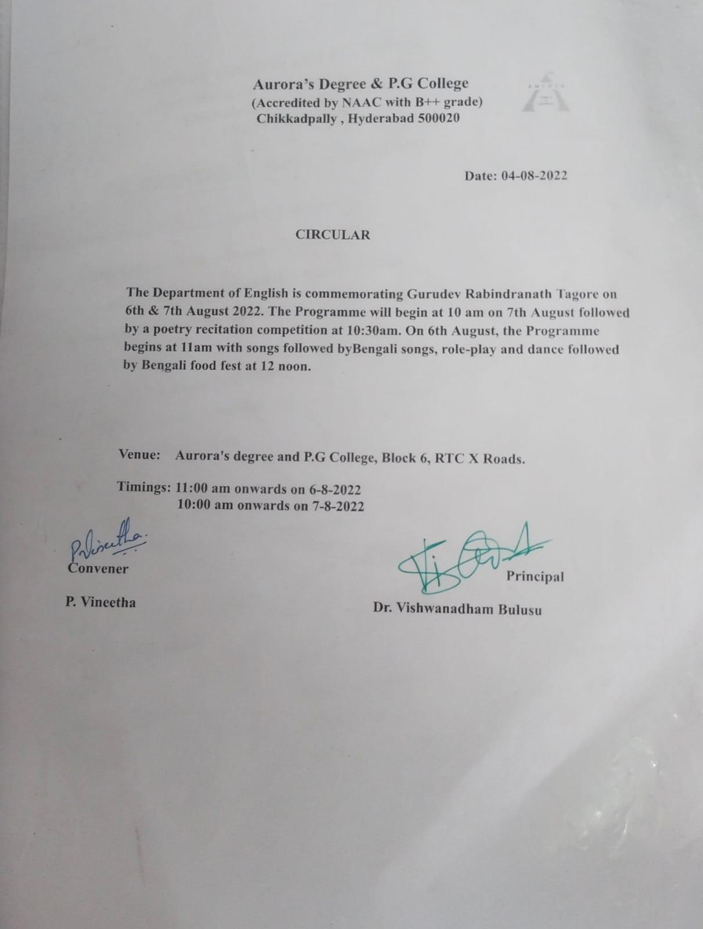
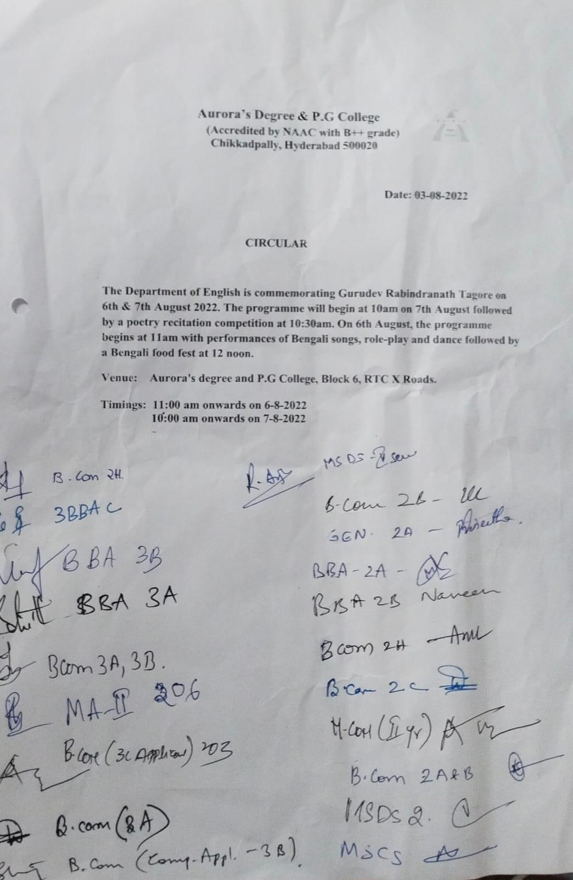

RECEIPTS (IF ANY)- Nil
CERTIFICATES (IF ANY)- Nil
LETTERS OF COMMUNICATION (IF ANY)- Nil

