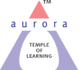
Aurora’s Degree & PG College
(Accredited by NAAC with 'B++' grade)
Chikkadpally, Hyderabad- 500020
Department of Biochemistry

EVENT REPORT

EVENT TITLE | Sir Hans Krebs Birthday Celebrations
TYPE OF EVENT | Departmental
FACULTY INCHARGE | Lakshmi lavanya
DEPARTMENT | Biochemistry
DATE | 25/08/22
VENUE | Main block
TARGET AUDIENCE | All students of UG

OBJECTIVE:
- To provide students with the opportunity to develop research and communication skill.
- To engage the students in a systematic process of research appropriate to the subject.

BRIEF ABOUT THE EVENT:
The citric acid cycle (CAC)—also known as the Krebs cycle or the TCA cycle (tricarboxylic acid cycle) is a series of chemical reactions to release stored energy through the oxidation of acetyl-CoA derived from carbohydrates, fats, and proteins. The Krebs cycle is used by organisms that respire (as opposed to organisms that ferment) to generate energy, either by anaerobic respiration or aerobic respiration. In addition, the cycle provides precursors of certain amino acids, as well as the reducing agent NADH that are used in numerous other reactions. Its central importance too many biochemical pathways suggests that it was one of the earliest components of metabolism and may have originated abiogenically.
To mark the importance of Citric acid cycle which was studied and discovered by Sir Hans Krebs, we department of Biochemistry have celebrated the Birthday of Sir Hans Krebs on 25th Aug 2022.
Sir Hans Krebs was born at Germany on August 25th 1900. He was a pioneer scientist in the study of cellular respiration. He is best known for his discoveries of two important sequences of chemical reactions that take place in the cells of humans and many other microorganisms, namely citric acid cycle and urea cycle. The former, often eponymously known as ”Krebs Cycle” is the key sequence of metabolic reactions that provide energy in the cells of humans and other oxygen respiring organisms and its discovery earned Krebs a “Nobel Prize in Physiology and Medicine” in 1953.
As a part of celebration we have conducted competitions like PowerPoint presentation and Essay writing. The theme for the power Point presentation was Adventures in Hormones, Metabolism and Behavior, and Effect of Exercise and Nutrition in case of cardiovascular diseases, whereas the theme for Essay writing was Biochemistry during the life and time of Sir Hans Krebs to the present.
The event started at 11:15 am with a brief introduction about Sir Hans Krebs and his discovery i.e., TCA cycle followed by power point presentations and essay writing by the students. A total of 6 students participated in the event of which 2 students participated in the PowerPoint presentation and 4 students participated in essay writing, in them 1 student participated in both the competitions.
After completion of the competitions, results were announced by Ms. G Sunitha and Ms. G Bindu. The program ended at 12:30pm.
LIST OF THE STUDENT COORDINATORS: Nil
LIST OF THE PARTICIPANTS
S.NO | NAME OF THE STUDENT | ROLL NO. | CLASS | NAME OF THE EVENT
 | B. Tulsi Bai | - | Bt.Bi.C-2 | Essay writing and Power Point Presentation
 | Varanvi | - | Bt.Bi.C-2 | Essay writing
 | Keerthi | - | Mi.Bi.C-2 | Essay writing
 | Apoorva | - | Mi.Bi.C-2 | Essay writing
 | Sasidhar | - | Mi.Bi.C-2 | Essay writing
 | Pravali | - | Bt.Bi.C-2 | Power Point Presentation

WINNERS OF THE COMPETITION
S.NO | NAME OF THE STUDENT | ROLL NO. | CLASS | NAME OF THE EVENT | RESULT
 | B. Tulsi Bai | - | Bt.Bi.C-2 | Essay writing | Winner
 | B. Tulsi Bai | - | Bt.Bi.C-2 | Power Point Presentation | Winner
 | Sasidhar | - | Mi.Bi.C-2 | Essay writing | Runner up
BUDGET PLAN: Nil
PHOTOGRAPHS
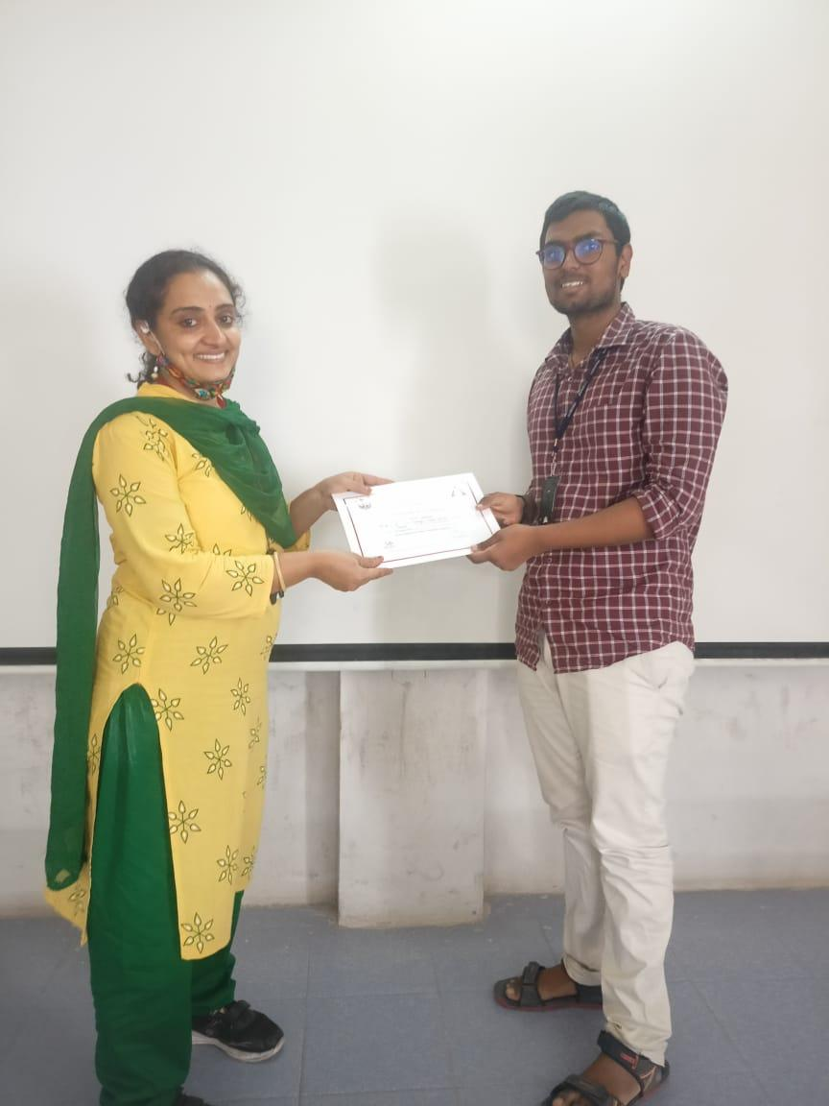 | 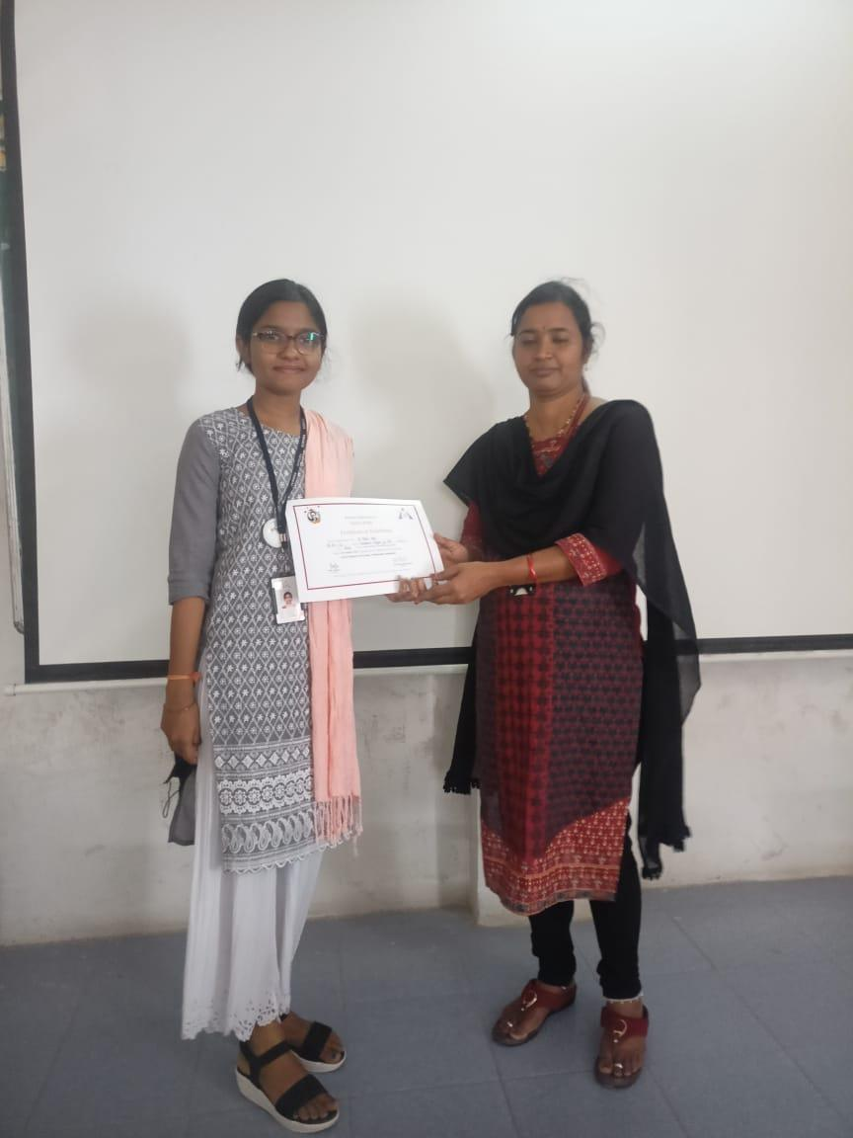
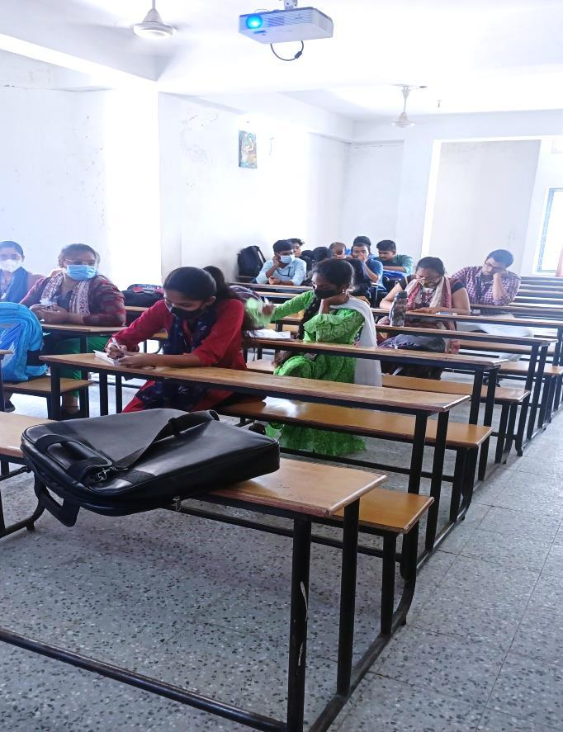 | 