Aurora’s Degree & PG College
(ACCREDITED BY NAAC WITH 'B++' GRADE)
Chikkadpally, Hyderabad 500020
Event Long Report
NAME OF THE EVENT / ACTIVITY | Alumni Placement Training
TYPE OR TITLE OF EVENT / ACTIVITY | Alumni Guest Lecture Series
FACULTY INCHARGE | S.Krishna Priya
DEPARTMENT | Commerce
DATE | 31ST Oct, 1st & 4th Nov, 2023
VENUE | Computer Lab 2, Block VI, Near:- RTC X Roads, Hyd.
TARGET AUDIENCE | All Final Year Students of B.Com Computer Applications & B.Com Business Analytics

- PROGRAM SCHEDULE:
DATE | TIME | Name of the Alumni Guest Speaker | Topic Covered
31st October 2023 | 9:30am - 11:00am | T V Rithika | Dos and Don’ts in Resume
31st October 2023 | 11am - 12:30pm | Sudhanshu Vyas | How to prepare for Aptitude Tests for Placements
1st November 2023 | 10am – 11:30am | Thinderu Sharath Kumar | How to Ace your Self Introduction in Interview
1st November 2023 | 11:30am - 1pm | Vaishnavi N | Importance of Body Language during Interview
4th November 2023 | 10am – 1pm | Mirza Shahavar Begum | How to Ace any Group Discussion

- LIST OF THE FACULTY COORDINATORS:

Sl. No. | Name of the faculty | Department | Designation
1 | MS. Krishna Priya S | Commerce | Associate Professor

- LIST OF THE STUDENT COORDINATORS:
Roll.No | Name of the Placement Coordinator | Class/Section
1051-21-405-059 | Kenche Ramya | B.com 3Comp Appl A
1051-21-405-88 | Paridhi | B.com 3Comp Appl B
1051-21-538-18 | Shashikanth | B.com 3 Business Analytics

- LIST OF THE PARTICIPANTS:
S.No | ROLL Number |  | Name of the Student
1 | 1051-21-405-001 |  | Naam Neha
2 | 1051-21-405-002 |  | Pittala Shalem Raju
3 | 1051-21-405-003 |  | Dumpala Shravani
4 | 1051-21-405-004 |  | Shakamuri Karthik Sai
5 | 1051-21-405-005 |  | Gangadhari Shiva Prasad
6 | 1051-21-405-006 |  | Praveen Kumar Dadige
7 | 1051-21-405-007 |  | Mothkuri Laxmi Narsa Goud
8 | 1051-21-405-008 |  | Busapur Rathan Prasad Reddy
9 | 1051-21-405-009 |  | Kasarla Abhinav
10 | 1051-21-405-010 |  | Dodla Vinay Kumar Reddy
11 | 1051-21-405-011 |  | Bandigari Sairam
12 | 1051-21-405-012 |  | Badge Sai Vardhan
13 | 1051-21-405-013 |  | Nandigama Vishal
14 | 1051-21-405-014 |  | Mosali Neha Reddy
15 | 1051-21-405-015 |  | Yelugani Richith Goud
16 | 1051-21-405-016 |  | Guggilla Vamshi Krishna
17 | 1051-21-405-017 |  | Gudekar Prem Kumar
18 | 1051-21-405-018 |  | Paka Samyuth
19 | 1051-21-405-019 |  | Muktha Sneha
20 | 1051-21-405-020 |  | Kondaru Vijay
21 | 1051-21-405-021 |  | Chilakala Shiva Sai Manikanta
22 | 1051-21-405-022 |  | K Swathi
23 | 1051-21-405-023 |  | Lanka Sailatha
24 | 1051-21-405-024 |  | Sai Vamshi Varma Dubba
25 | 1051-21-405-025 |  | Gawkree Rohit Raj
26 | 1051-21-405-026 |  | Gangapuram Karthik
27 | 1051-21-405-027 |  | Thadagoni Jayanth Goud
28 | 1051-21-405-028 |  | Kurmilla Sharathnath Goud
29 | 1051-21-405-029 |  | Nune Harika
30 | 1051-21-405-030 |  | Peddabomma Abhilash
31 | 1051-21-405-031 |  | Sreesha Deshpande
32 | 1051-21-405-032 |  | E Harshitha
33 | 1051-21-405-033 |  | N Ramakanth Raju
34 | 1051-21-405-034 |  | Dhatrika Sharanya
35 | 1051-21-405-035 |  | Atla Laxma Reddy
36 | 1051-21-405-036 |  | M Naga Shashidhar Goud
37 | 1051-21-405-037 |  | Manchala Anil Kumar
38 | 1051-21-405-038 |  | M Pavan
39 | 1051-21-405-039 |  | Beesam Sai Teja
40 | 1051-21-405-040 |  | Gaddam Lokesh Yadav
41 | 1051-21-405-041 |  | Vennakuchi Nandagopal
42 | 1051-21-405-042 |  | Dyappa Achuth Reddy
43 | 1051-21-405-043 |  | Mathapati Keertan Swamy
44 | 1051-21-405-044 |  | Badri Kalyan Kumar
45 | 1051-21-405-045 |  | Palakollu Sri Devi
46 | 1051-21-405-046 |  | Ratanpalke Pradeep
47 | 1051-21-405-047 |  | Om Prakash Sharma
48 | 1051-21-405-048 |  | Babburi Charankumar
49 | 1051-21-405-049 |  | Addagulla Pavan Kumar
50 | 1051-21-405-050 |  | Kurmagadda Pandu Vibhas
51 | 1051-21-405-052 |  | Lingampally Sai Sneha
52 | 1051-21-405-053 |  | Somesh Pimpale
53 | 1051-21-405-054 |  | Gunna Venkatesh
54 | 1051-21-405-055 |  | Saddi Rohit Reddy
55 | 1051-21-405-056 |  | Pandi Venkat
56 | 1051-21-405-057 |  | Mamidi Teja
57 | 1051-21-405-058 |  | Thirumani Manikanta
58 | 1051-21-405-059 |  | Kenche Ramya
59 | 1051-21-405-060 |  | Shanigarapu Nehasri
60 |  | 1051-21-405-061 | Karanam Aashrith Sai Pawan
61 |  | 1051-21-405-062 | Mansi B Khurdale
62 |  | 1051-21-405-064 | Kuchana Devi Prasanna
63 |  | 1051-21-405-065 | Mandalam Harini
64 |  | 1051-21-405-066 | Devarajan Akhila Dev
65 |  | 1051-21-405-067 | N Sahithi
66 |  | 1051-21-405-068 | Rechintala Pavan Kumar
67 |  | 1051-21-405-069 | Erukulla Sravani
68 |  | 1051-21-405-071 | Thamatham Eshwar Kumar
69 |  | 1051-21-405-072 | H Shabana Asmeen
70 |  | 1051-21-405-073 | Boda Poojitha
71 |  | 1051-21-405-074 | Kundavarapu Rithika Reddy
72 |  | 1051-21-405-075 | Sarosia Krithika Jaiswal
73 |  | 1051-21-405-076 | Kasala Shreya
74 |  | 1051-21-405-077 | Udutha Bhavana
75 |  | 1051-21-405-078 | C Manisha
76 |  | 1051-21-405-079 | Gundagula Nikhitha
77 |  | 1051-21-405-080 | Kamandalam Harpitha
78 |  | 1051-21-405-081 | T Vaishali
79 |  | 1051-21-405-082 | Bathula Pranav
80 |  | 1051-21-405-083 | Varkala Tejaswini
81 |  | 1051-21-405-084 | Gonda Manish
82 |  | 1051-21-405-086 | Jonnalagadda Madhu Lohit
83 |  | 1051-21-405-087 | Pawar Tejaswi
84 |  | 1051-21-405-088 | Paridhi
85 |  | 1051-21-405-089 | Ajmeera Ankitha
86 |  | 1051-21-405-090 | Kamlesh Khatri
87 |  | 1051-21-405-091 | Kartick Shee
88 |  | 1051-21-405-092 | Das Aditya
89 |  | 1051-21-405-093 | K Ronit Jaiswal
90 |  | 1051-21-405-094 | D Nandini
91 |  | 1051-21-405-095 | Vadlamani Sriman Narayana
92 |  | 1051-21-405-096 | Arjun Venkatesh
93 |  | 1051-21-405-097 | Akash Dileep
94 |  | 1051-21-405-098 | Himanshu Agarwal
95 |  | 1051-21-405-099 | Nehal Saha
96 |  | 1051-21-405-100 | Salla Anirudh
97 |  | 1051-21-405-101 | Shubham Mishra
98 |  | 1051-21-405-102 | Krishna Pandey
99 |  | 1051-21-405-103 | Gurumitkal Sai Chandra
100 |  | 1051-21-405-104 | Easuraj John Paul
101 |  | 1051-21-405-105 | Pratham Goel
102 |  | 1051-21-405-106 | Gadhgay Yogesh
103 |  | 1051-21-405-107 | Kotagiri Vishal
104 |  | 1051-21-405-108 | Pawan Yadav
105 |  | 1051-21-405-109 | Yalamaly Shivani
106 |  | 1051-21-405-110 | Hemanth Kumar Bansiwal
107 |  | 1051-21-405-111 | Karthik Joshi
108 |  | 1051-21-405-112 | Prashant Khatri
109 |  | 1051-21-405-113 | T Yash Singh
110 |  | 1051-21-405-114 | Ashish Singh
111 |  | 1051-21-405-115 | Thote Mahesh Shivaji
112 |  | 1051-21-405-116 | Harsh Thakur
113 |  | 1051-21-405-117 | Krishi Agarwal
114 |  | 1051-21-405-118 | Anusri Durga Prasad
115 |  | 1051-21-405-119 | Pandiya Premchand
116 |  | 1051-21-405-120 | Gorav Kumar Bardia
117 |  | 1051-20-405-101 | M. Pavan Kumar
118 |  | 1051-21-405-121 | Konapuram Rahul
119 |  | 1051-21-405-122 | Ramjus Yuvraj Kumar
120 |  | 1051-21-405-123 | Mohammed Abdul Raheem
121 |  | 1051-21-405-124 | Jammula Vijay Ramchandra Reddy
122 |  | 1051-21-405-125 | Pawan Singh
123 |  | 1051-21-405-126 | Kanduluri Jai Sri Datta
124 |  | 1051-21-405-127 | Shivarathri Aakanksha
125 |  | 1051-21-405-128 | Dodla Shivani
126 |  | 1051-21-405-129 | Sricharan Aureshi
127 |  | 1051-21-405-130 | Palleti Mohan Kumar
128 |  | 1051-21-405-131 | Mopati Venkata Bhanusri Vedavyas
129 |  | 1051-21-405-132 | Yatham Pavan Yadav
130 |  | 1051-21-405-133 | Charuguntla Ajay Jayadhar
131 |  | 1051-21-405-134 | Kodam Balanikitha
132 |  | 1051-21-405-135 | Aluri Suhas Raj
133 |  | 1051-21-405-136 | Pasupunoori Poojitha
134 |  | 1051-21-405-137 | Basani Uday
135 |  | 1051-21-405-138 | Naradla Jeshwanth Reddy
136 |  | 1051-21-405-139 | Chippalaturthi Pranay
137 |  | 1051-21-405-140 | Bandari Pravalika
138 |  | 1051-21-405-141 | Gumpalli Vinod
139 |  | 1051-21-405-142 | Suguru Sai Priya
140 |  | 1051-21-538-001 | Ashwini Krishnan Charikallimil
141 |  | 1051-21-538-002 | Sumeet Kumar Jaiswal
142 |  | 1051-21-538-003 | Laxmi
143 |  | 1051-21-538-004 | Dev Joshi
144 |  | 1051-21-538-005 | Ashish Pandiya
145 |  | 1051-21-538-006 | Ramawat Harsh
146 |  | 1051-21-538-009 | Angarkar Shreya
147 |  | 1051-21-538-010 | Eshanth Suri
148 |  | 1051-21-538-011 | Aliya Tabassum
149 |  | 1051-21-538-012 | Manav Singh
150 |  | 1051-21-538-013 | Gangishetty Sheker Suhas
151 |  | 1051-21-538-014 | Jilla Priyanka
152 |  | 1051-21-538-015 | Modepu Yuvaraj Chandra Goud
153 |  | 1051-21-538-016 | Dosala Hrudai Keertan
154 |  | 1051-21-538-017 | Durgam Lokesh
155 |  | 1051-21-538-018 | Pampana Sashikanth
156 |  | 1051-21-538-019 | Ajja Bhuvana
157 |  | 1051-21-538-020 | Govindarajan Hariharan
158 |  | 1051-21-538-021 | Nampally Surya Teja
159 |  | 1051-21-538-022 | M Rakshitha
160 |  | 1051-21-538-023 | Mutukula V S R Akshith Angeerasa
161 |  | 1051-21-538-024 | N Jaivish

- PARAGRAPH ABOUT THE PROCEEDINGS :
The Department of Commerce – Computer Applications conducted a series a Guest Lectures as a part of Placement Training by Alumni Students. This Series of Guest Lectures were planned so that the Students will understand different phases of placement and get equipped with the required knowledge to get them placed. On day 1 the first Guest Speaker oriented students about the Do’s and Don’ts in Resume and made them prepare online a perfect resume. The second Guest Speaker informed students about different online websites where they can practice aptitude free of cost and made the students do a few mock aptitude tests. Day 2 the Guest Speaker oriented students about how to make a self-introduction very impactful. Day 3 the Guest Speaker first informed students about the rules to be followed in a Group Discussion and made students involved in Group Discussions on various topics. All the speakers explained their respective topics in a detailed manner and even shared their personal experiences while facing the interview. All the students cleared their doubts with lot of enthusiasm and participated in the activities which is conducted by them.

- INCOME & EXPENDITURE: NIL

- EVENT PHOTOS :

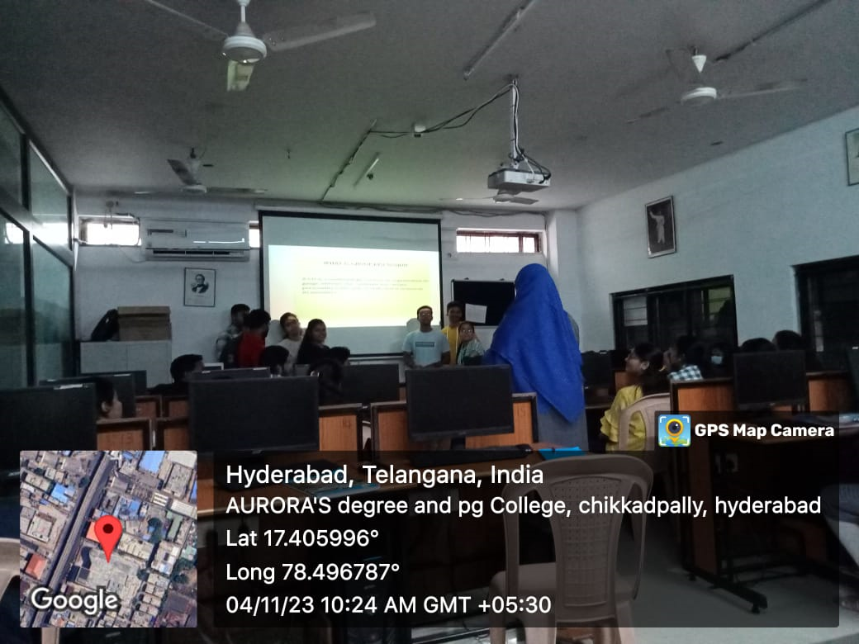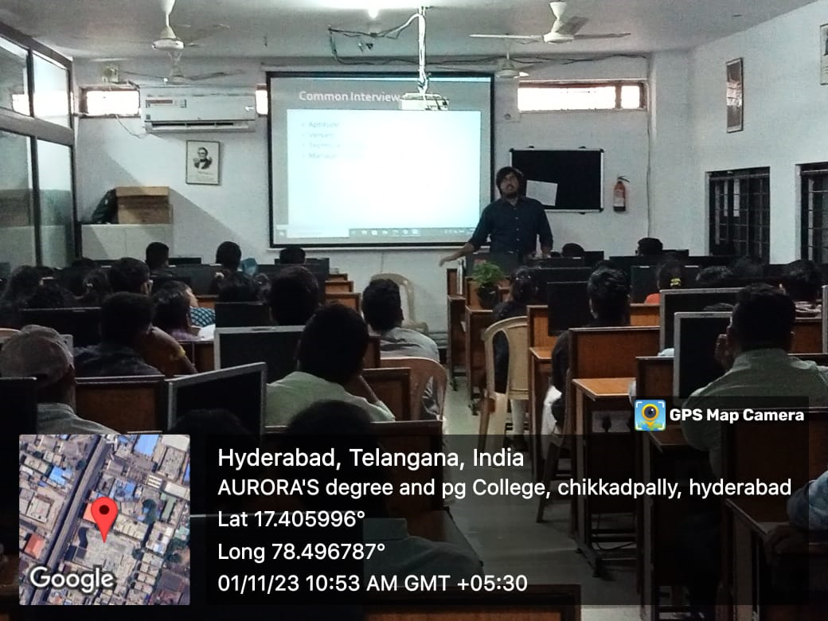

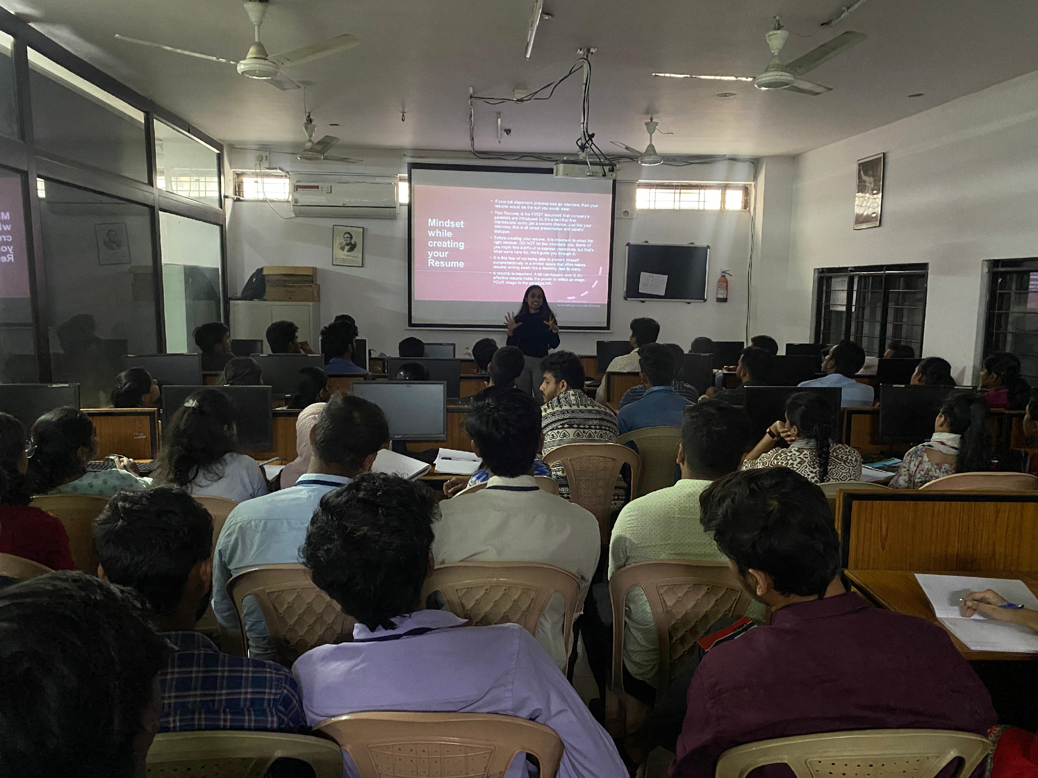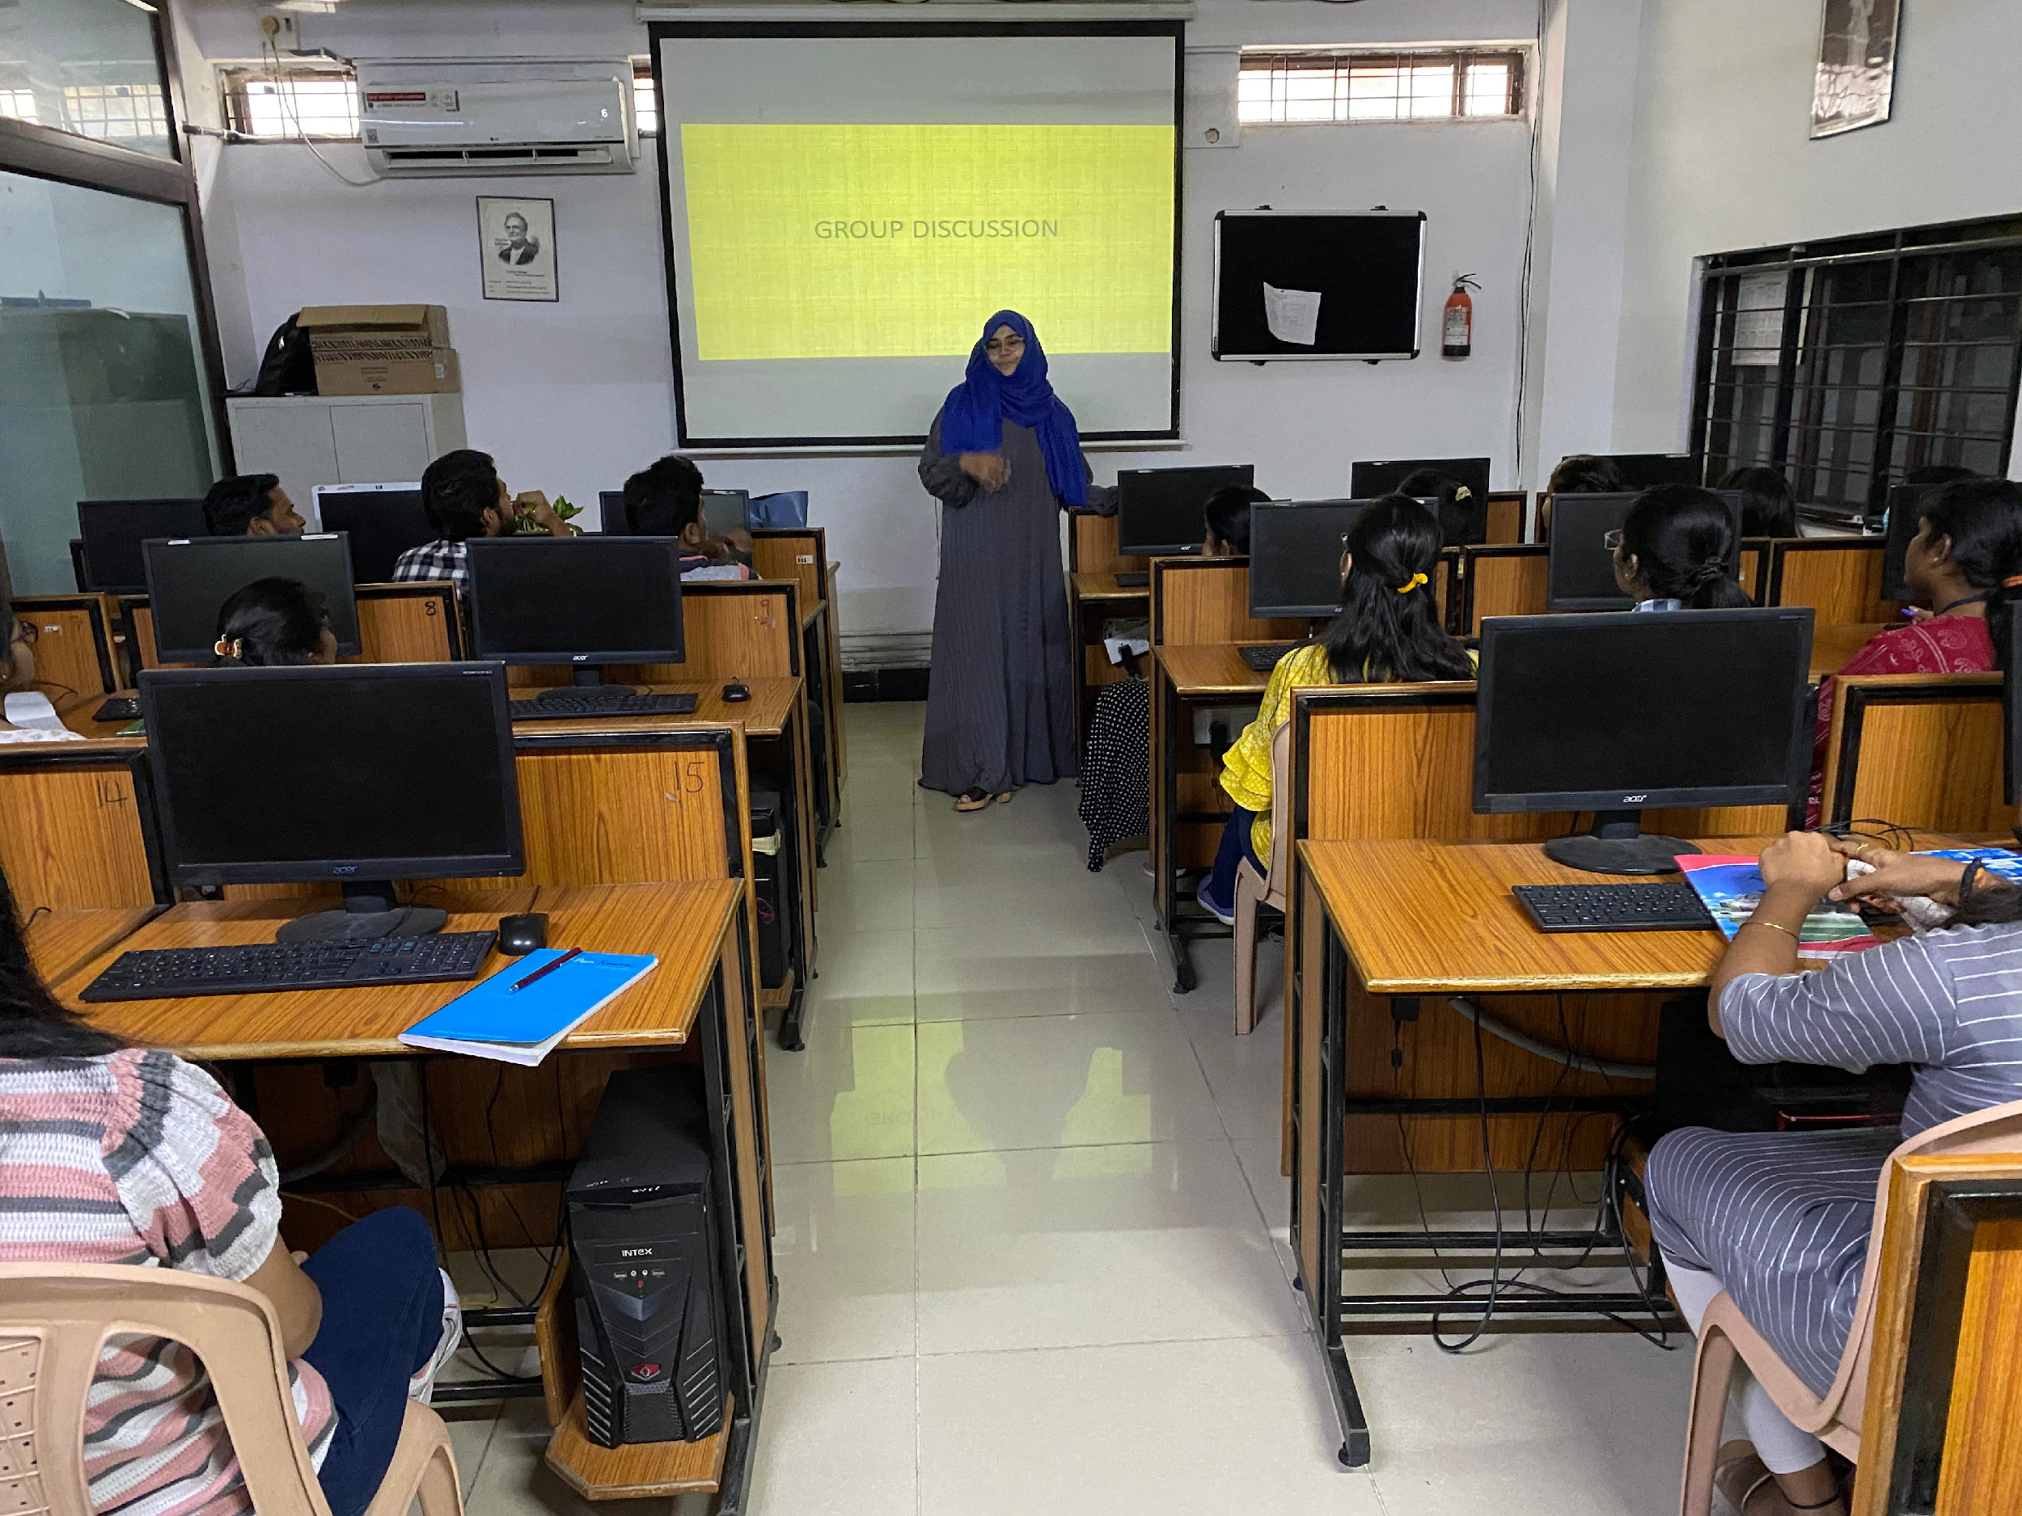

- GUEST PROFILE:
  - Ms.Mirza Shahavar Begum, A&A ADC Senior Analyst, Deloitte
  - Mr.Sudhanshu Vyas, Associate Analyst, Deloitte
  - Mr.Thinderu Sharath Kumar, RADC, Audit Senior Analyst, Deloitte
  - Vaishnavi Nagamalli, RADC, Audit Senior Analyst, Deloitte
  - T V Rithika, FP&A, Senior Accounting Analyst, Optum

- FEED BACK:
https://docs.google.com/spreadsheets/d/1Ih9ghTWTLHYgZ7SpJOoRHPD1VJa6FLOwRyoS5TnJNBU/edit?usp=drive_link

- ATTACHMENTS:
  - Event Proposal
https://drive.google.com/file/d/1RjcN2g3uCWkirrb2qEz4BBdRDok1rCSD/view?usp=drive_link
  - Circular
https://docs.google.com/document/d/10xUCyUBEQJXN9UwoQ_FrUeaLxwoC3uqB/edit?usp=drive_link&ouid=116577731622712087641&rtpof=true&sd=true

