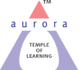
Aurora’s Degree & PG College
(ACCREDITED BY NAAC WITH 'B++' GRADE)
Chikkadpally, Hyderabad 500020

DETAILED REPORT

NAME OF THE EVENT / ACTIVITY | Guest Lecture
TYPE OR TITLE OF EVENT / ACTIVITY | Campus to Corporate
FACULTY INCHARGE | G. Nikitha, Unnaamalai
DEPARTMENT/CELL/COMMITTEE/CLUB | Commerce
DATE | 09-11-2023
VENUE | Aurora’s Degree and PG College
GUEST SPEAKER | Dr. Manoj Gour Chintaluri
TARGET AUDIENCE | Commerce - Final Year Students

- PROGRAM SCHEDULE:
10:00 AM TO 11:30 AM | LECTURE & PPT PRESENTATION
11:30AM TO 12:00PM | QUESTIONS & ANSWERS

- LIST OF FACULTY COORDINATORS (DEPARTMENT) :
S.No. | Name | Designation | Deportment
1. | G.Nikitha | Assistant Professor | Commerce
2. | Unnaamalai | Sr. Assistant Professor | Commerce

- LIST OF THE STUDENT COORDINATORS (NAME , ROLL NO, CLASS & SECTION) :
- LIST OF THE PARTICIPANTS ( NAME , ROLL NO, CLASS & SECTION, NO OF GIRLS, BOYS)
- PARAGRAPH ABOUT THE PROCEEDINGS (TILL THE END OF THE EVENT)
A Guest Lecture was conducted by Dept. of Commerce, Aurora’s Degree and PG College on Campus to Corporate. The event was started by welcome speech by Ms. Unnamalai and also read the profile of the Guest. The Guest speaker Dr. Manoj Gour Chintaluri spoke on, how to navigate the shift from college student to real world professional and also has given some tips and reminders to help them to navigate the big changes up ahead and even to love them.
The presentation was aimed at students who are taking up their first job. The transformation from a student life to a work life has many challenges. Unless a student understands the challenges and learns how to manage the same, he / she is likely to fail in becoming successful at work and is likely to quit the job soon. The presentation emphasized the significance of professional behaviour, workplace ethics, and appropriate dressing in the corporate world. Students learned about the do’s and don’ts of corporate etiquette, The session was highly interactive, with participants actively engaging with the speaker and asking relevant questions.
Dr. Manoj Gour Chintaluri patiently answered most of the queries and provided valuable insights based on his own experiences in the corporate world. Students have actively participated in the session and they have clarified their doubts. At the end of the session few questions the speaker has asked and few students have responded. The session concluded with a vote of thanks given by Dr. Padmini, expressing gratitude to the speaker for his valuable guidance.

- INCOME AND EXPENDITURE: Nil
- EVENT PHOTOS (MIN 2 MAX 4)

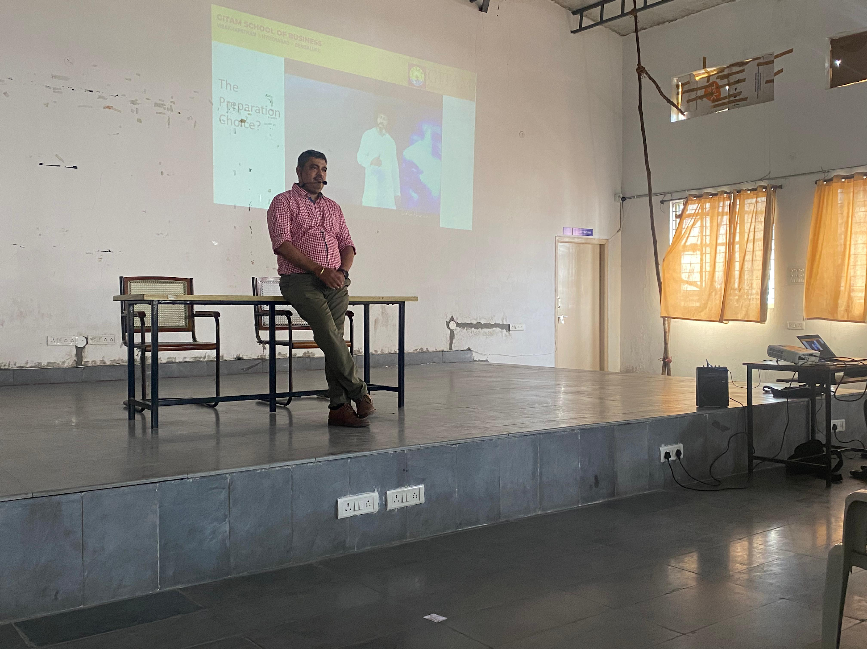

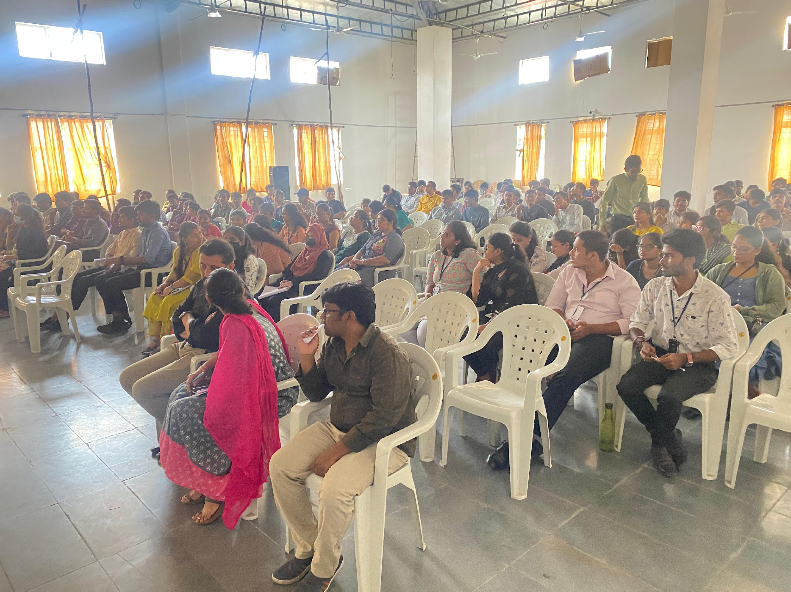
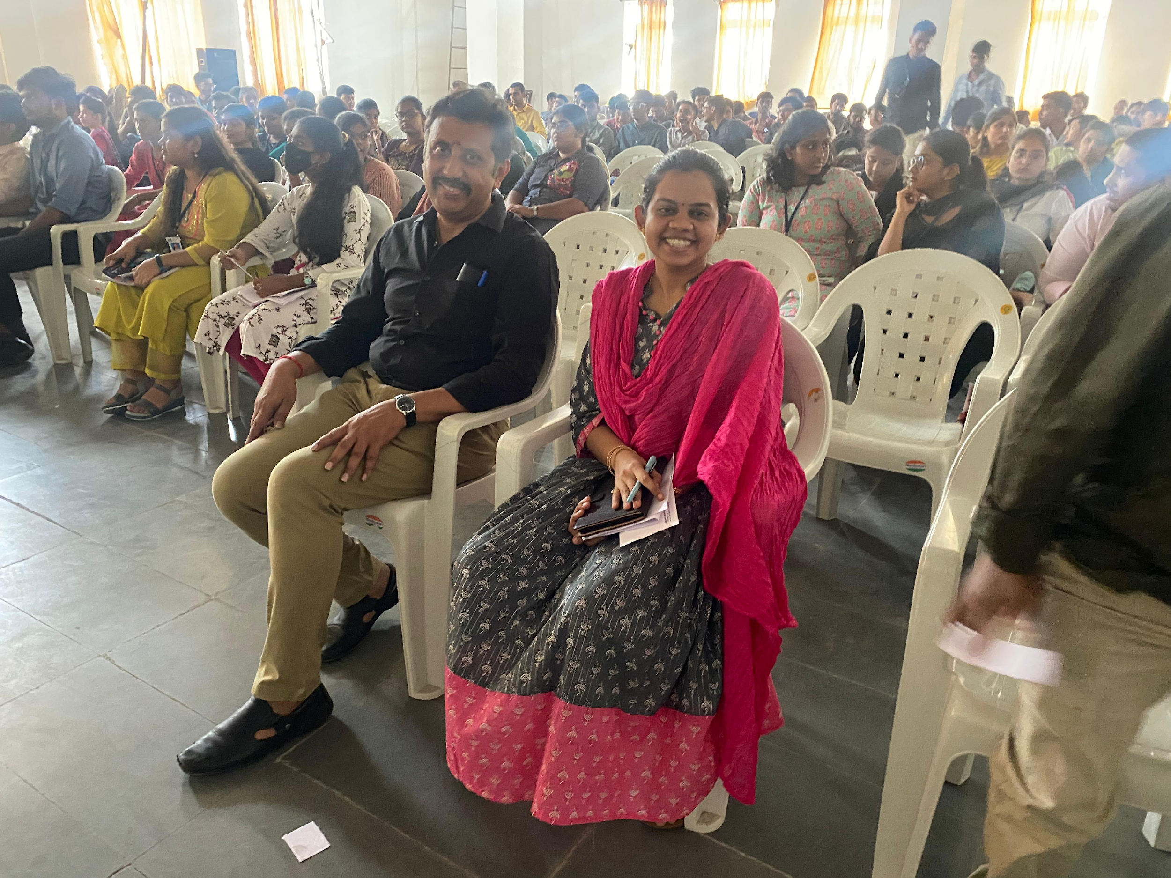

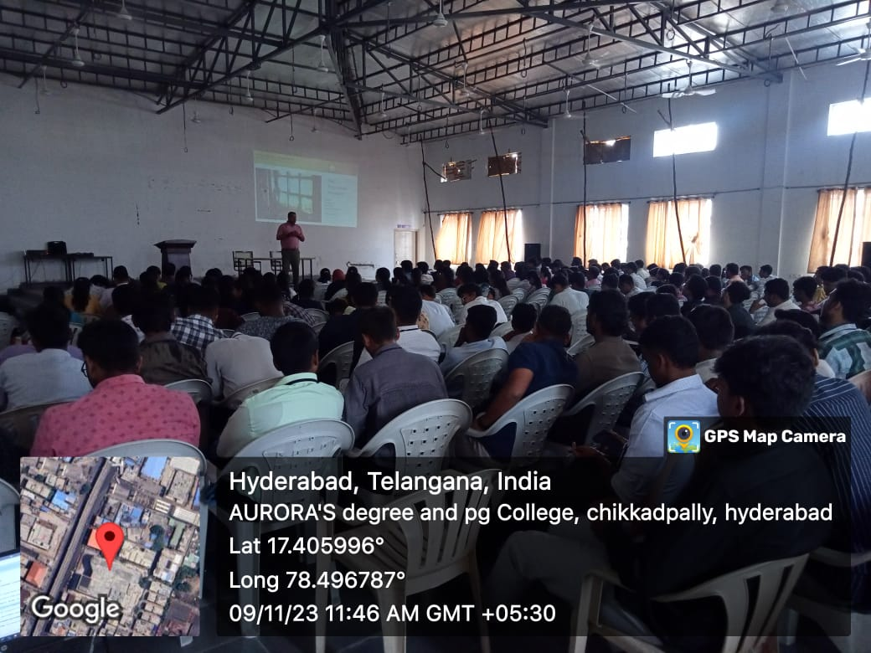
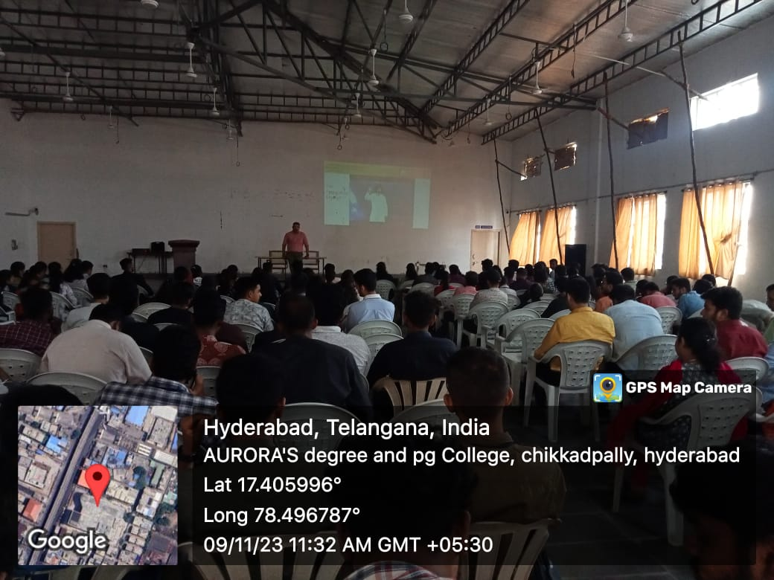

GUEST PROFILE (IF ANY) :
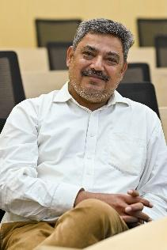
Dr Manoj Gour Chintaluri
https://www.linkedin.com/in/manoj-gour-chintaluri-b8bb88/

I am a management professional with over 27 years of experience at different leadership levels, oriented towards P&L in India and MNCs of repute. My interest as a facilitator of knowledge has its foundations during my graduate days when I would tutor students in Mathematics.
The corporate journey took me to places across India and a stint in the Middle-east. The exposure helped me straddle across Telecom, FMCG, Alcobev, Consumer durables, and Decorative paints, handling turnovers up to 500 cr with roles of a front line to leading the functional leadership.
I started preparing to transition into a teaching/facilitating profession by leveraging the experience. In this attempt enrolled in a Ph.D. program at Gitam Inst of Management, Visakhapatnam, and was awarded in the year 2020.
After a stint of 25 years in the industry, I have transitioned to the world of academics, training, and consulting. Currently a full-time Associate faculty in the area of marketing. The work I have been doing for the past two years.
- Full-time Faculty role (@ MDI, Murshidabad & @ Gitam University)
  - Sales & Dist Mgt
  - Customer Relationship Mgt
  - Product Mgt
  - Rural Marketing and Management
  - Brand Management
  - Mktg Planning and Implementation
  - Negotiation & Conflict mgt
- Executive education
  - Product & Brand Management (12-week program) MDI -Uptop) -2 batches
  - Sales and Distribution Mgt (2-day program), MDI -Program Director
  - Power of Negotiation (2-day program), MDI- Co-Program Director.
  - Program on General Mgt (12-week program)- Resource in the area of Marketing-2 days
  - Middle-level Mgt program (Continous-12 weeks)- Resource in Time management and leading others- 4 sessions of 8 hours each – Customized program for a corporate.
- Consulting
  - Associated with Ti Cycles (Murugappa) on an 8-month assignment in the role of Business Coach and consultant. Built a 5-year strategic plan that included an RTM strategy that incorporated components of a KAM template and structure.
  - Currently a Sales coach and mentor for a Bangalore-based ten years old startup working in the area of channel loyalty.
- Education
  - Ph.D.- Gitam University - 2020
  - PGDM- NMIMS, Batch of 1998
  - BSc – Osmania University-1992

Roles and Positions held in Industry- for detail refer to my LinkedIn profile

Name of the Organization- Industry | Position Held | Geography
National Heaters-Consumer durable | Head Sales & Mktg – MENA region | Based out of Oman, Handling GCC and exploring North Africa
Ariston Thermo-Small appliances | VP-Sales & Service | Based out of Pune, Handling India, Srilanka and Bangladesh
Akzo Nobel-Decorative paints | Regional Manager | Based out of Chennai-South India
Tata Docomo- Mobile Services | Ops head, Inbound Sales head | Based out of Visakapatnam, Rest of AP
Bharti Airtel -2 stints- Fixed line and Mobile services | Head -Customer service  Zonal Business Mgr  Head Distribution  SME Segment head | Karnataka, Andhra Pradesh and MPCG circle
SAB Miller/ McDowell - Alcobev | Regional Head Sales | Maharashtra, Andhra Pradesh
Unilever | Area Sales Manager | Tamilnadu and Kerala

While I am currently undertaking coaching assignments, I am also on the journey for a level 1 (ACC) assignment and I am a certified DiSC assessor.

Coordinates
manojgour93@gmail.com
8096884570

- FEED BACK IF ANY

- ATTACHMENTS:
EVENT/ACTIVITY PROPOSAL
Aurora’s Degree and PG College
(ACCREDITED BY NAAC WITH ‘B++’ GRADE)
Chikkadpally, Hyderabad 500020

EVENT PROPOSAL

Event/Activity Name: GUEST LECTURE

Event/Activity Title: Campus to Corporate
Cell / Committee/Club Convener/facilitator: DEPT-OF-COMMERCE
Faculty coordinators: G. Nikitha, Unnaamalai
Date: 09-11-2023
Venue: Aurora’s Degree and PG College
Target audience: Students
Platform: Off line
Level: College
Student Volunteer’s:
Objective: To create awareness among students about the significance of Transition From Student Life To Work Life
Proposed activities:
- Lecture
Guest/Speaker details: Dr. Manoj Gour Chintaluri
Budget: Nil

Faculty Coordinator IQAC Coordinator Principal
G. Nikitha, Unnaamalai Dr. Meera Joshi Dr. Viswanadham Bulusu

EVENT / ACTIVITY NOTICE
RECEIPTS (IF ANY)
CERTIFICATES (IF ANY)
LETTERS OF COMMUNICATION (IF ANY)

