Aurora’s Degree & PG College
(ACCREDITED BY NAAC WITH 'B++' GRADE)
Chikkadpally, Hyderabad 500020

EVENT / ACTIVITY DETAILED REPORT

NAME OF THE EVENT / ACTIVITY | Alumni Placement Training
TYPE OR TITLE OF EVENT / ACTIVITY | Mock interviews
FACULTY INCHARGE | S.Krishna Priya & Dr.Padmini S
DEPARTMENT | Commerce
DATE | 16th and 18th NOV 2023
VENUE | Block VI, Near :- RTC X Roads, Hyd.
TARGET AUDIENCE | All Final Year Students of B.Com Computer Applications & B.Com Business Analytics

- PROGRAM SCHEDULE

Date | ROOM NO. | TIME | ALUMNI MOCK INTERVIEWER
16th Nov 2023 | 307 | 10AM- 1PM | K Tarun & Sharath
16th Nov 2023 | 308 | 10AM- 1PM | Hari G & Pujitha
16th Nov 2023 | 309 | 10AM- 1PM | V Vaishnavi & M Tarun
18th Nov 2023 | 307 | 10am- 12 pm | Shubham Joshi

- Proposed activity : Mock Interviews

- LIST OF FACULTY COORDINATORS (DEPARTMENT)
Ms.S. Krishna Priya - HOD-Commerce- Computer Applications
Dr.Padmini S - Associate Professor - Commerce - Computer Applications
- LIST OF THE STUDENT COORDINATORS
NAME | ROLL NO | CLASS & SECTION
D.Sai Vamshi Varma | 1051-21-405-024 | BCOM 3 COMPUTER APPLICATIONS A
B.Poojitha | 1051-21-405-073 | BCOM 3 COMPUTER APPLICATIONS B
D.Lokesh | 1051-21-538-017 | BCOM 3 BUSINESS ANALYTICS

LIST OF THE PARTICIPANTS
All students of B.Com Computer Applications Final Year .

S.No | ROLL Number |  | Name of the Student
1 | 1051-21-405-001 |  | Naam Neha
2 | 1051-21-405-002 |  | Pittala Shalem Raju
3 | 1051-21-405-003 |  | Dumpala Shravani
4 | 1051-21-405-004 |  | Shakamuri Karthik Sai
5 | 1051-21-405-005 |  | Gangadhari Shiva Prasad
6 | 1051-21-405-006 |  | Praveen Kumar Dadige
7 | 1051-21-405-007 |  | Mothkuri Laxmi Narsa Goud
8 | 1051-21-405-008 |  | Busapur Rathan Prasad Reddy
9 | 1051-21-405-009 |  | Kasarla Abhinav
10 | 1051-21-405-010 |  | Dodla Vinay Kumar Reddy
11 | 1051-21-405-011 |  | Bandigari Sairam
12 | 1051-21-405-012 |  | Badge Sai Vardhan
13 | 1051-21-405-013 |  | Nandigama Vishal
14 | 1051-21-405-014 |  | Mosali Neha Reddy
15 | 1051-21-405-015 |  | Yelugani Richith Goud
16 | 1051-21-405-016 |  | Guggilla Vamshi Krishna
17 | 1051-21-405-017 |  | Gudekar Prem Kumar
18 | 1051-21-405-018 |  | Paka Samyuth
19 | 1051-21-405-019 |  | Muktha Sneha
20 | 1051-21-405-020 |  | Kondaru Vijay
21 | 1051-21-405-021 |  | Chilakala Shiva Sai Manikanta
22 | 1051-21-405-022 |  | K Swathi
23 | 1051-21-405-023 |  | Lanka Sailatha
24 | 1051-21-405-024 |  | Sai Vamshi Varma Dubba
25 | 1051-21-405-025 |  | Gawkree Rohit Raj
26 | 1051-21-405-026 |  | Gangapuram Karthik
27 | 1051-21-405-027 |  | Thadagoni Jayanth Goud
28 | 1051-21-405-028 |  | Kurmilla Sharathnath Goud
29 | 1051-21-405-029 |  | Nune Harika
30 | 1051-21-405-030 |  | Peddabomma Abhilash
31 | 1051-21-405-031 |  | Sreesha Deshpande
32 | 1051-21-405-032 |  | E Harshitha
33 | 1051-21-405-033 |  | N Ramakanth Raju
34 | 1051-21-405-034 |  | Dhatrika Sharanya
35 | 1051-21-405-035 |  | Atla Laxma Reddy
36 | 1051-21-405-036 |  | M Naga Shashidhar Goud
37 | 1051-21-405-037 |  | Manchala Anil Kumar
38 | 1051-21-405-038 |  | M Pavan
39 | 1051-21-405-039 |  | Beesam Sai Teja
40 | 1051-21-405-040 |  | Gaddam Lokesh Yadav
41 | 1051-21-405-041 |  | Vennakuchi Nandagopal
42 | 1051-21-405-042 |  | Dyappa Achuth Reddy
43 | 1051-21-405-043 |  | Mathapati Keertan Swamy
44 | 1051-21-405-044 |  | Badri Kalyan Kumar
45 | 1051-21-405-045 |  | Palakollu Sri Devi
46 | 1051-21-405-046 |  | Ratanpalke Pradeep
47 | 1051-21-405-047 |  | Om Prakash Sharma
48 | 1051-21-405-048 |  | Babburi Charankumar
49 | 1051-21-405-049 |  | Addagulla Pavan Kumar
50 | 1051-21-405-050 |  | Kurmagadda Pandu Vibhas
51 | 1051-21-405-052 |  | Lingampally Sai Sneha
52 | 1051-21-405-053 |  | Somesh Pimpale
53 | 1051-21-405-054 |  | Gunna Venkatesh
54 | 1051-21-405-055 |  | Saddi Rohit Reddy
55 | 1051-21-405-056 |  | Pandi Venkat
56 | 1051-21-405-057 |  | Mamidi Teja
57 | 1051-21-405-058 |  | Thirumani Manikanta
58 | 1051-21-405-059 |  | Kenche Ramya
59 | 1051-21-405-060 |  | Shanigarapu Nehasri
60 |  | 1051-21-405-061 | Karanam Aashrith Sai Pawan
61 |  | 1051-21-405-062 | Mansi B Khurdale
62 |  | 1051-21-405-064 | Kuchana Devi Prasanna
63 |  | 1051-21-405-065 | Mandalam Harini
64 |  | 1051-21-405-066 | Devarajan Akhila Dev
65 |  | 1051-21-405-067 | N Sahithi
66 |  | 1051-21-405-068 | Rechintala Pavan Kumar
67 |  | 1051-21-405-069 | Erukulla Sravani
68 |  | 1051-21-405-071 | Thamatham Eshwar Kumar
69 |  | 1051-21-405-072 | H Shabana Asmeen
70 |  | 1051-21-405-073 | Boda Poojitha
71 |  | 1051-21-405-074 | Kundavarapu Rithika Reddy
72 |  | 1051-21-405-075 | Sarosia Krithika Jaiswal
73 |  | 1051-21-405-076 | Kasala Shreya
74 |  | 1051-21-405-077 | Udutha Bhavana
75 |  | 1051-21-405-078 | C Manisha
76 |  | 1051-21-405-079 | Gundagula Nikhitha
77 |  | 1051-21-405-080 | Kamandalam Harpitha
78 |  | 1051-21-405-081 | T Vaishali
79 |  | 1051-21-405-082 | Bathula Pranav
80 |  | 1051-21-405-083 | Varkala Tejaswini
81 |  | 1051-21-405-084 | Gonda Manish
82 |  | 1051-21-405-086 | Jonnalagadda Madhu Lohit
83 |  | 1051-21-405-087 | Pawar Tejaswi
84 |  | 1051-21-405-088 | Paridhi
85 |  | 1051-21-405-089 | Ajmeera Ankitha
86 |  | 1051-21-405-090 | Kamlesh Khatri
87 |  | 1051-21-405-091 | Kartick Shee
88 |  | 1051-21-405-092 | Das Aditya
89 |  | 1051-21-405-093 | K Ronit Jaiswal
90 |  | 1051-21-405-094 | D Nandini
91 |  | 1051-21-405-095 | Vadlamani Sriman Narayana
92 |  | 1051-21-405-096 | Arjun Venkatesh
93 |  | 1051-21-405-097 | Akash Dileep
94 |  | 1051-21-405-098 | Himanshu Agarwal
95 |  | 1051-21-405-099 | Nehal Saha
96 |  | 1051-21-405-100 | Salla Anirudh
97 |  | 1051-21-405-101 | Shubham Mishra
98 |  | 1051-21-405-102 | Krishna Pandey
99 |  | 1051-21-405-103 | Gurumitkal Sai Chandra
100 |  | 1051-21-405-104 | Easuraj John Paul
101 |  | 1051-21-405-105 | Pratham Goel
102 |  | 1051-21-405-106 | Gadhgay Yogesh
103 |  | 1051-21-405-107 | Kotagiri Vishal
104 |  | 1051-21-405-108 | Pawan Yadav
105 |  | 1051-21-405-109 | Yalamaly Shivani
106 |  | 1051-21-405-110 | Hemanth Kumar Bansiwal
107 |  | 1051-21-405-111 | Karthik Joshi
108 |  | 1051-21-405-112 | Prashant Khatri
109 |  | 1051-21-405-113 | T Yash Singh
110 |  | 1051-21-405-114 | Ashish Singh
111 |  | 1051-21-405-115 | Thote Mahesh Shivaji
112 |  | 1051-21-405-116 | Harsh Thakur
113 |  | 1051-21-405-117 | Krishi Agarwal
114 |  | 1051-21-405-118 | Anusri Durga Prasad
115 |  | 1051-21-405-119 | Pandiya Premchand
116 |  | 1051-21-405-120 | Gorav Kumar Bardia
117 |  | 1051-20-405-101 | M. Pavan Kumar
118 |  | 1051-21-405-121 | Konapuram Rahul
119 |  | 1051-21-405-122 | Ramjus Yuvraj Kumar
120 |  | 1051-21-405-123 | Mohammed Abdul Raheem
121 |  | 1051-21-405-124 | Jammula Vijay Ramchandra Reddy
122 |  | 1051-21-405-125 | Pawan Singh
123 |  | 1051-21-405-126 | Kanduluri Jai Sri Datta
124 |  | 1051-21-405-127 | Shivarathri Aakanksha
125 |  | 1051-21-405-128 | Dodla Shivani
126 |  | 1051-21-405-129 | Sricharan Aureshi
127 |  | 1051-21-405-130 | Palleti Mohan Kumar
128 |  | 1051-21-405-131 | Mopati Venkata Bhanusri Vedavyas
129 |  | 1051-21-405-132 | Yatham Pavan Yadav
130 |  | 1051-21-405-133 | Charuguntla Ajay Jayadhar
131 |  | 1051-21-405-134 | Kodam Balanikitha
132 |  | 1051-21-405-135 | Aluri Suhas Raj
133 |  | 1051-21-405-136 | Pasupunoori Poojitha
134 |  | 1051-21-405-137 | Basani Uday
135 |  | 1051-21-405-138 | Naradla Jeshwanth Reddy
136 |  | 1051-21-405-139 | Chippalaturthi Pranay
137 |  | 1051-21-405-140 | Bandari Pravalika
138 |  | 1051-21-405-141 | Gumpalli Vinod
139 |  | 1051-21-405-142 | Suguru Sai Priya
140 |  | 1051-21-538-001 | Ashwini Krishnan Charikallimil
141 |  | 1051-21-538-002 | Sumeet Kumar Jaiswal
142 |  | 1051-21-538-003 | Laxmi
143 |  | 1051-21-538-004 | Dev Joshi
144 |  | 1051-21-538-005 | Ashish Pandiya
145 |  | 1051-21-538-006 | Ramawat Harsh
146 |  | 1051-21-538-009 | Angarkar Shreya
147 |  | 1051-21-538-010 | Eshanth Suri
148 |  | 1051-21-538-011 | Aliya Tabassum
149 |  | 1051-21-538-012 | Manav Singh
150 |  | 1051-21-538-013 | Gangishetty Sheker Suhas
151 |  | 1051-21-538-014 | Jilla Priyanka
152 |  | 1051-21-538-015 | Modepu Yuvaraj Chandra Goud
153 |  | 1051-21-538-016 | Dosala Hrudai Keertan
154 |  | 1051-21-538-017 | Durgam Lokesh
155 |  | 1051-21-538-018 | Pampana Sashikanth
156 |  | 1051-21-538-019 | Ajja Bhuvana
157 |  | 1051-21-538-020 | Govindarajan Hariharan
158 |  | 1051-21-538-021 | Nampally Surya Teja
159 |  | 1051-21-538-022 | M Rakshitha
160 |  | 1051-21-538-023 | Mutukula V S R Akshith Angeerasa
161 |  | 1051-21-538-024 | N Jaivish

- PARAGRAPH ABOUT THE PROCEEDINGS (TILL THE END OF THE EVENT)
Department of Commerce - Computer Applications has organized Mock interviews for B.Com Computer Applications Final year students .On the day of the event students were informed to bring their Resumes for attending the Mock Interview session . Session started at 10:30 in the morning. Before the starting of the session Alumni were introduced to the students by Shashikanth B.Com Business Analytics student .
The following elements were concentrated by the Alumni :
- Self introduction about the candidates like Name , Contact information , Educational qualifications , Goals etc.
- The candidates were evaluated on the basis of Communication skills , Problem - Solving ability etc.
- They have identified the candidate's strengths which were demonstrated during the interview .
Alumni were made to sit in Room NO: 307 , 308 and 309 and students were sent for the mock interviews one after the other. At the end of the session Alumni have addressed the students and they have highlighted the following points .
- Highlighted the SWOT of the candidates .
- They have provided the feedback on the all assessment .
- Suggested new skills for cracking the interviews.
- Encouraged students to maintain a professional attire and motivated them to reach their targets.
After Interviewing all the students , the Alumni Interviewers interacted with all the students and suggested them the areas which they have to work on and how to improve themselves to get placed.

- INCOME AND EXPENDITURE
Nil
- EVENT PHOTOS ( MIN 2 MAX 4)

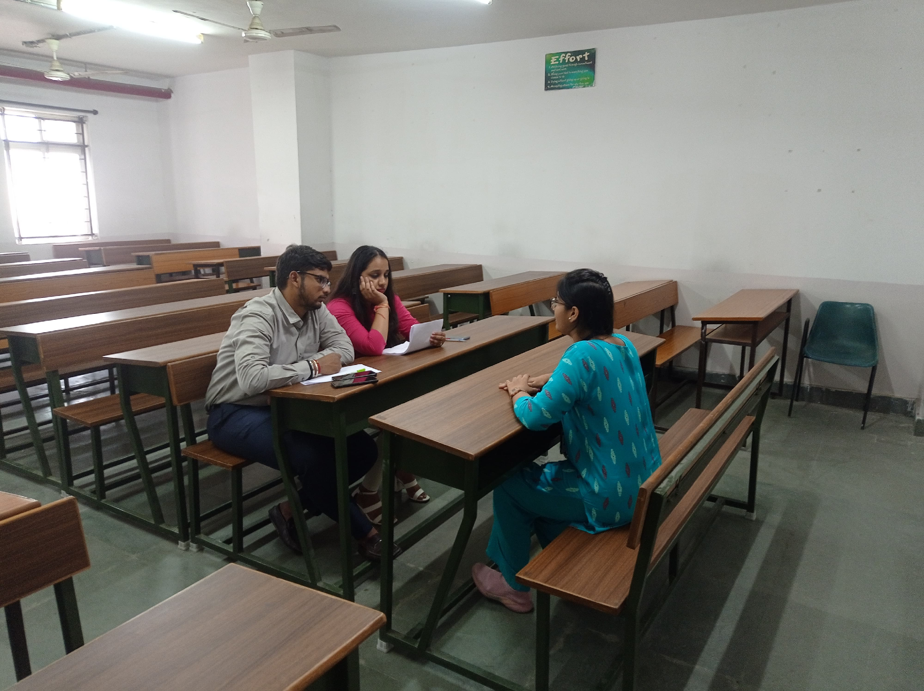
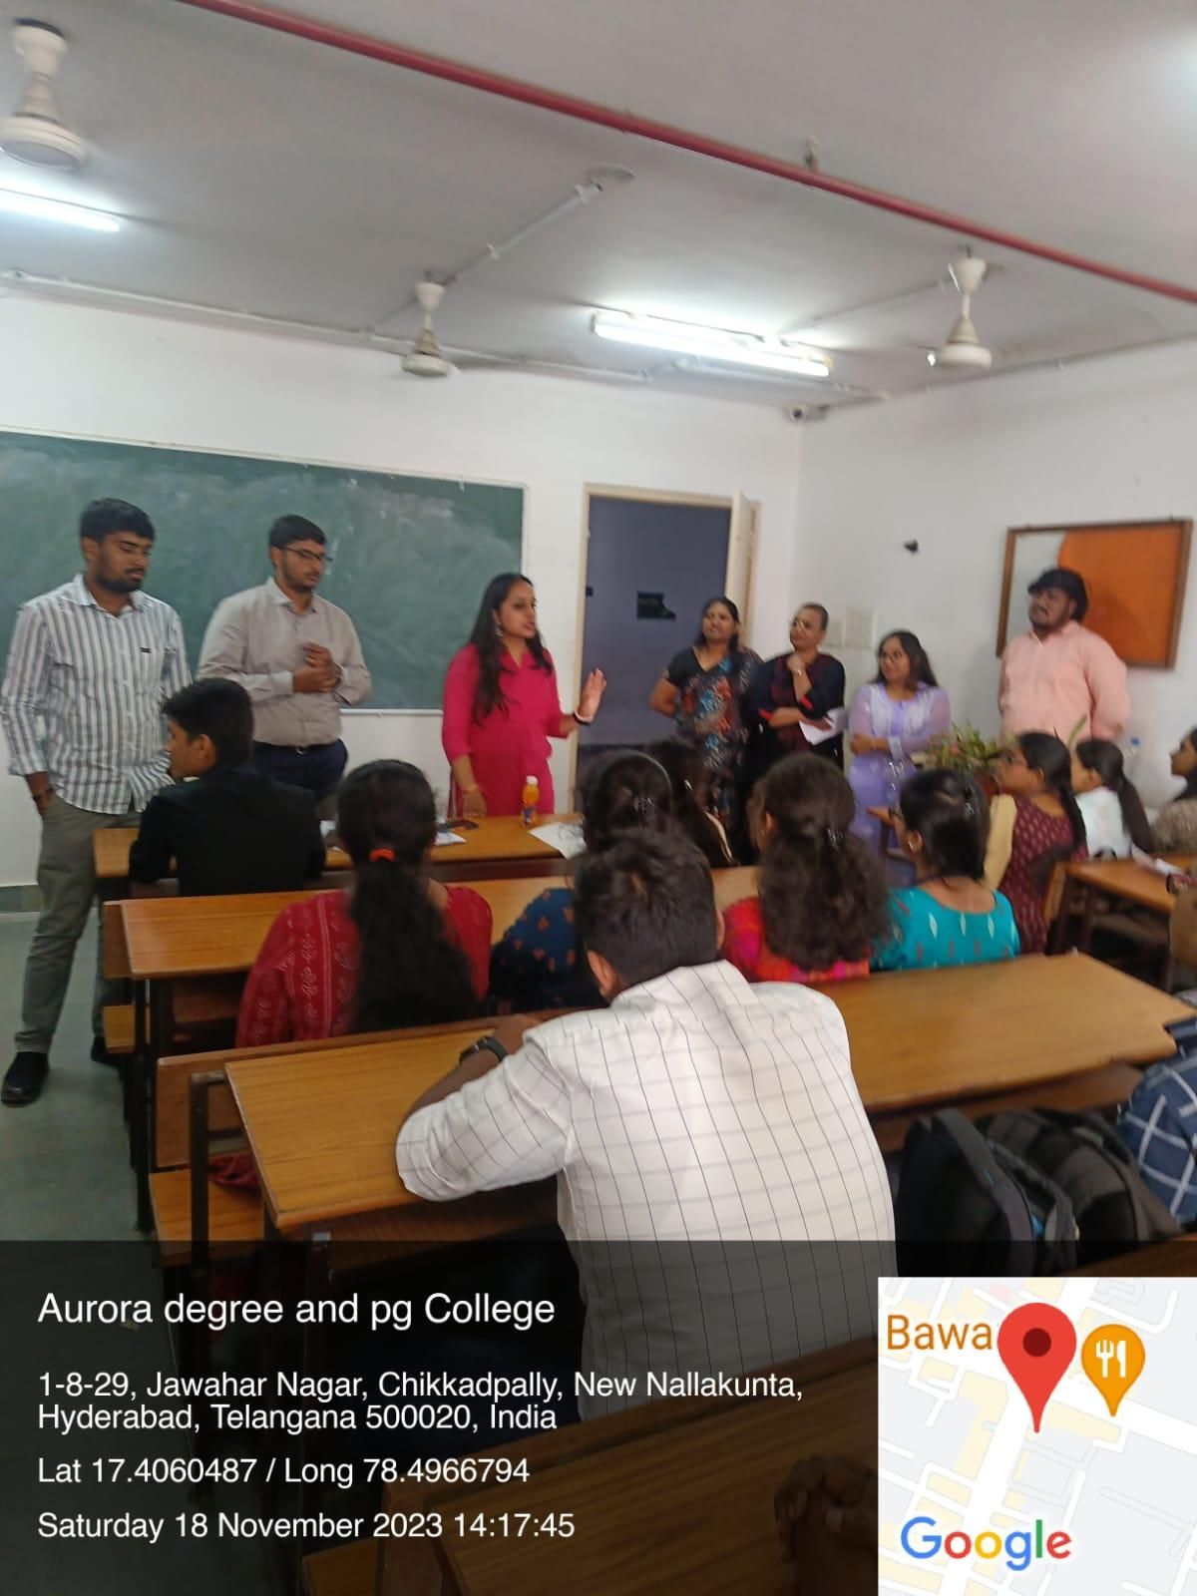
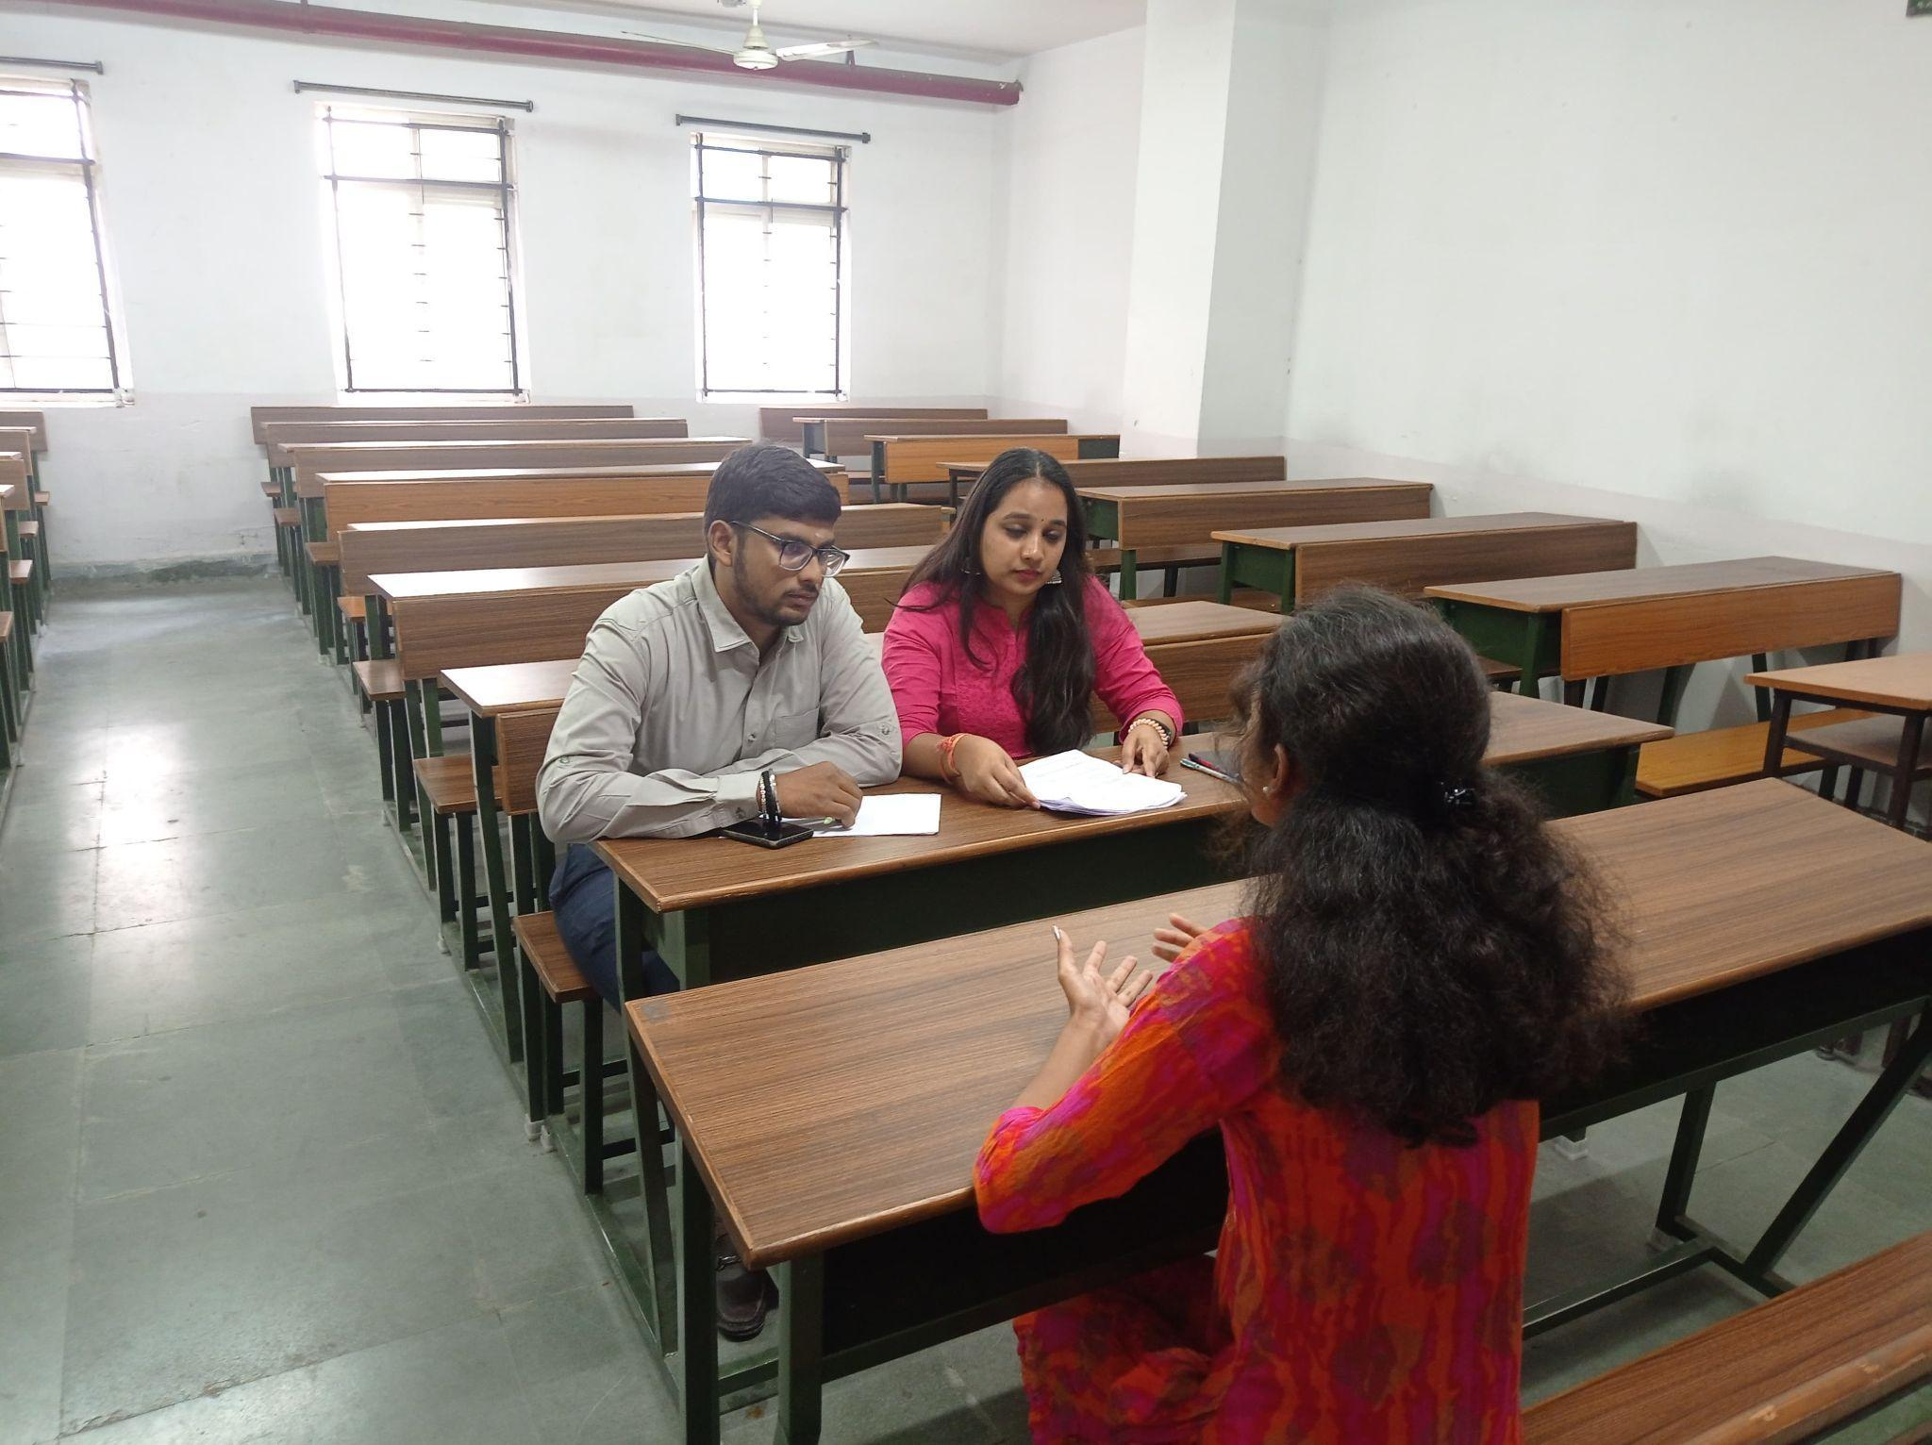

- GUEST PROFILE (IF ANY)
1.Mr. K.Tarun Sai, Tax Consultant 1, Deloitte
2. Mr.Thinderu Sharath Kumar, RADC, Audit Senior Analyst, Deloitte
3. Mr.Hari.G, Tax Consultant, Deloitte
4. Ms. Pujitha CH.V,Financial Analyst, UHG- Optum

5. Mr.Shubham Joshi, Talent Acquisition Specialist, D.E. Shaw Group
6. Tarun Marati, Quality Analyst, Wipro Technologies
7. Vaishnavi V, Human Resource Business Partner, Sutherland

7. ATTACHMENTS:

AURORA’S DEGREE & PG COLLEGE
(Accredited By NAAC with B++ Grade)
Department of Commerce
CIRCULAR
Date :- 10/11/2023

This is to inform all the B.com Computer Applications & B.com Business Analytics final year students that there will be Placement Training Sessions - Mock Interviews will be conducted by our well-placed Alumni Students of our college on 16th & 18th November 2023. Interested students should carry a hardcopy of Resume to the Mock interview.

Venue: Block VI, Room No: 307,308 & 309
Timings: 10am – 1pm
Faculty Coordinator: S Krishna Priya & Dr.Padmini S
Contact : 9100000538

Sd/-

HOD
