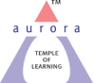
Aurora’s Degree & PG College
(Accredited By Naac With 'B++' Grade)
Chikkadpally, Hyderabad 500020

EVENT / ACTIVITY DETAILED REPORT

NAME OF THE EVENT / ACTIVITY | Guru Purnima
TYPE OR TITLE OF EVENT / ACTIVITY | Guru Purnima – Traditional Event
FACULTY INCHARGE | M. Ramalakshmi Anasuya
DEPARTMENT/CELL/COMMITTEE/CLUB | Languages
DATE | 3rd July 2023
VENUE | Auditorium – PG Students,  Aurora’s Degree & PG College,  RTC Block – VI.
TARGET AUDIENCE | PG Sanskrit Students

1. PROGRAM SCHEDULE:

The program was scheduled on 3rd July 2023.
The program was conducted as follows:
1:00 PM – Started the program with Guru-Sthuti.
1: 15 PM - The program enclosed with Shlokas, Songs and Speeches about Guru and his
Importance in our life.
1:50 PM – Thanking note given by the PG students Ms.Thrupti and Ms. Sahithi
2:00 PM - The session ended with Guru Mantra. And Vote of Thanks by
Ms. Trupthi and Ms. Sahithi.
** During the session only a photo session was conducted.

- LIST OF FACULTY COORDINATORS :
S.no | Faculty Name | Role | Department
1 | M.Ramalakshmi Anasuya | Faculty In-charge | Assistant Professor – Department of Second languages
- LIST OF THE STUDENT COORDINATORS (NAME , ROLL NO, CLASS & SECTION)
S:no | Name of the student | Roll Number | Class/Section
1 | Ms.T. Trupthi Reddy | 1051-22-318-006 | MA(Psychology)
2 | Ms. C. Sahithi | 1051-21-009-021 | MA(English)
3 | Mr. K. Shiva Kumar | 1051-21-009-012 | MA(English)

- LIST OF THE PARTICIPANTS (NAME , ROLL NO, CLASS & SECTION, NO OF GIRLS, BOYS, CASTE )

Total Number of Participants | Number of Girls | Number of Boys
48 | 32 | 16

- PARAGRAPH ABOUT THE PROCEEDINGS (TILL THE END OF THE EVENT)
This traditional event was organized by the Department of Languages, Aurora’s Degree & PG College. This great session was handled by the Sanskrit faculty M.Ramalakshmi Anasuya along with the student coordinators. The target audience and participants of this event were PG students. As part of the celebrations fruits and flowers were offered to all the faculty and staff.

The program began with prayer that evoked the audience with divine feelings. The session laid focus on the role of Gurus and their importance in one’s life. Ms. Trupthi a student of Psychology shared about Guru Dattatreya’s 24 types of Guru. She spoke about the various lessons one can learn from the Gurus in Nature such as Patience from Mother Earth, sense of direction from Air, expansion from Sky, etc. Another student Ms. Sahithi from MA English gave a speech on the role of guru in our life, and she shared shlokas which described Guru and his greatness. Mr. Shiva rendered a special song based on importance of Guru.
The students were enlightened through the speeches, songs and experiences shared by the faculty. The students considered this kind of event as an honor and learnt the important of great Spiritual and Intellectual Gurus to make our lives meaningful.

- INCOME AND EXPENDITURE: NIL

- EVENT PHOTOS ( MIN 2 MAX 4)
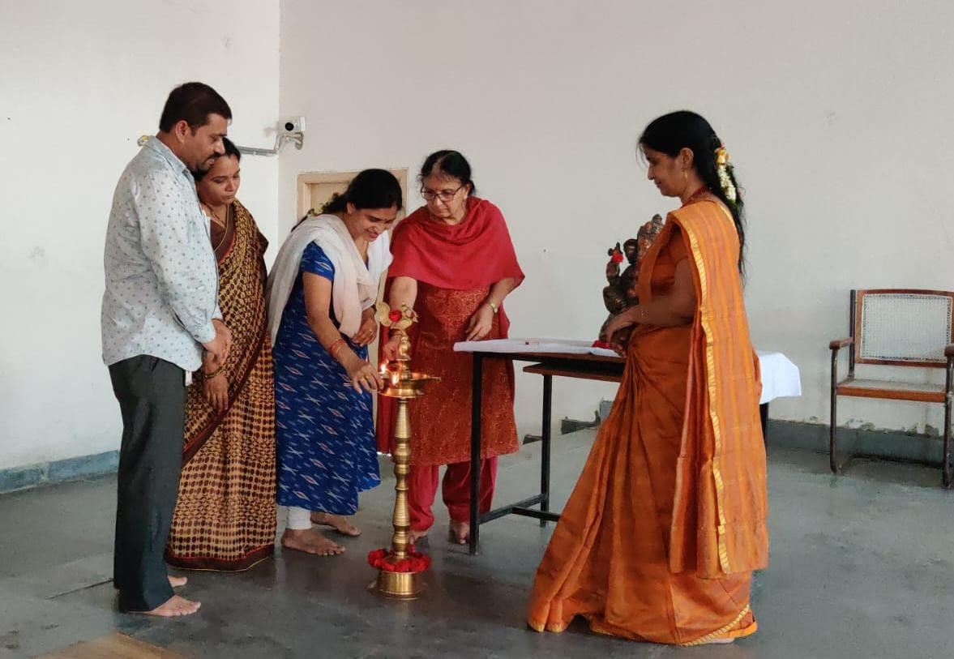

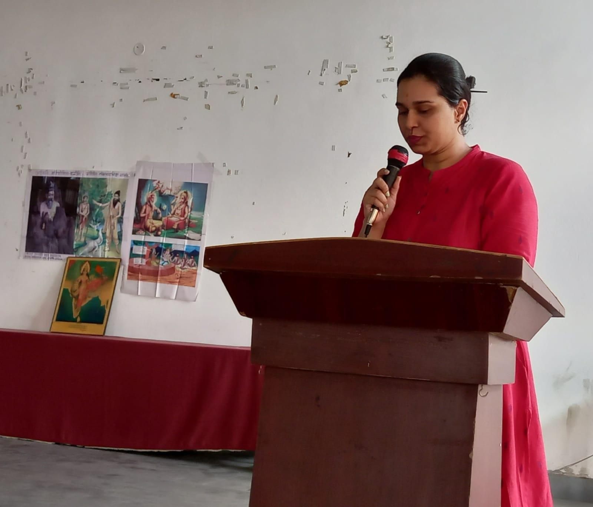

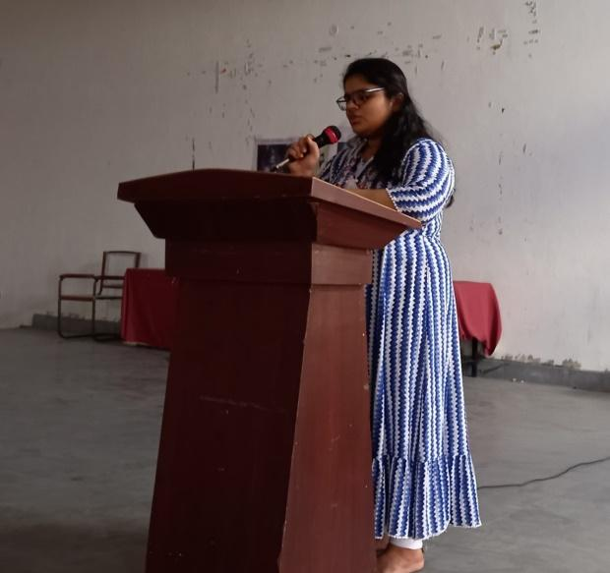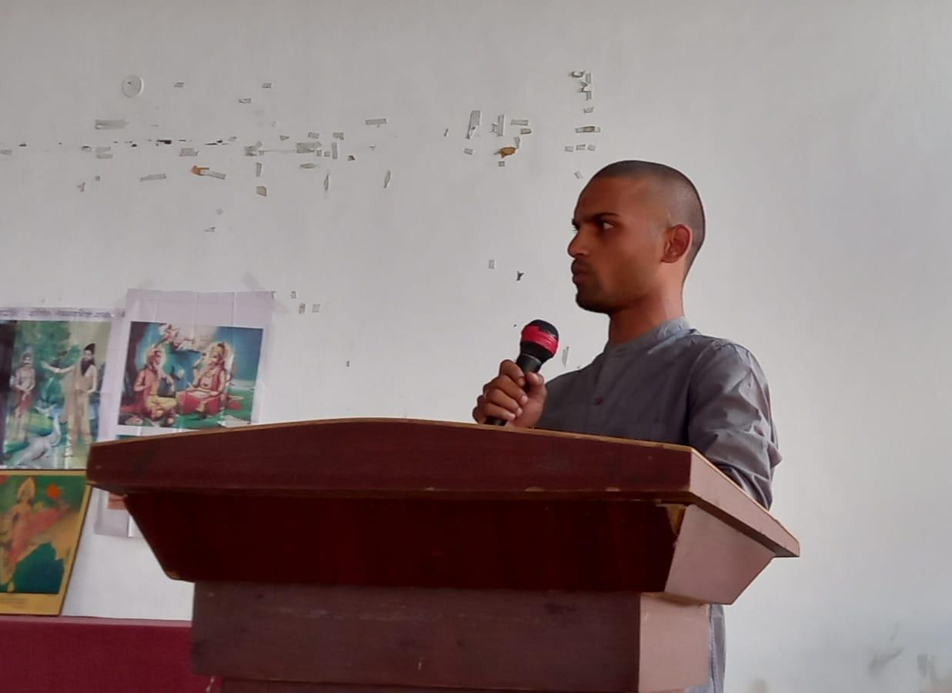

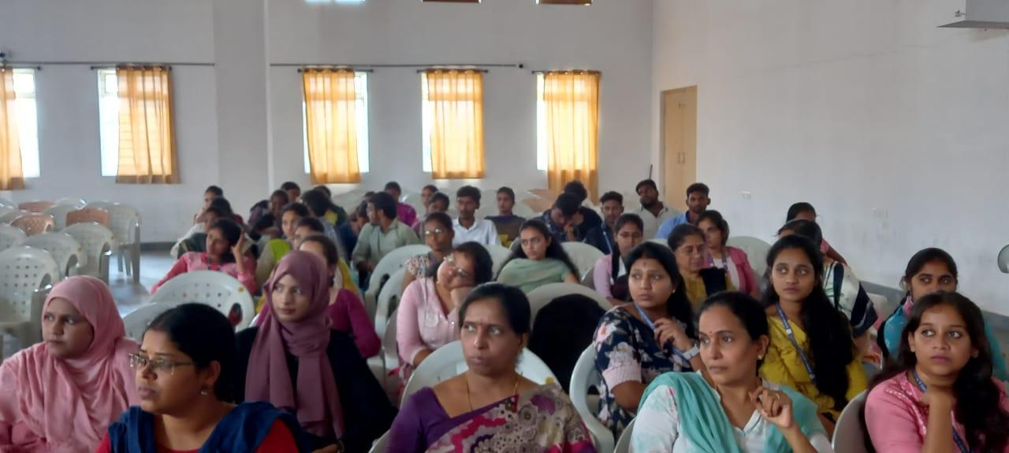
8. GUEST PROFILE (IF ANY) : NA
9. FEEDBACK IF ANY: Yes
This was a great opportunity to know about more information about Guru Dathatreya’s “24 types of Guru”. The main objective of the event is everyone should know that should have a goal. Each and every one need an intellectual and spiritual guide to define their life, and lead their life happily successful. All the students were happy to be a part of this event. It was an interesting and inspirable session for everyone. Everyone expressed their satisfaction and gratitude towards the session.
10. EVENT / ACTIVITY NOTICE:
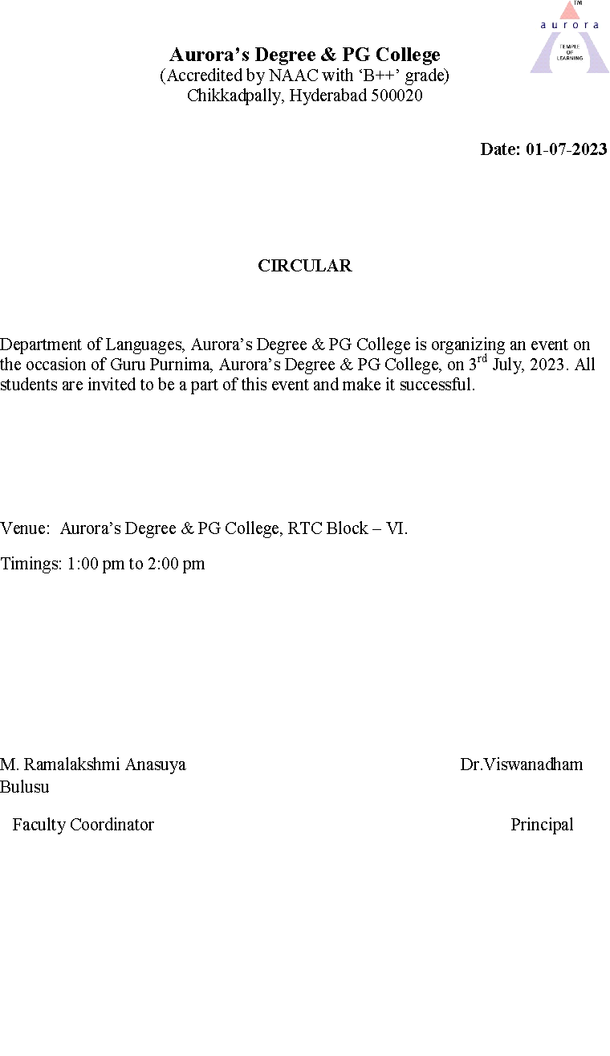
11. EVENT/ACTIVITY PROPOSAL:

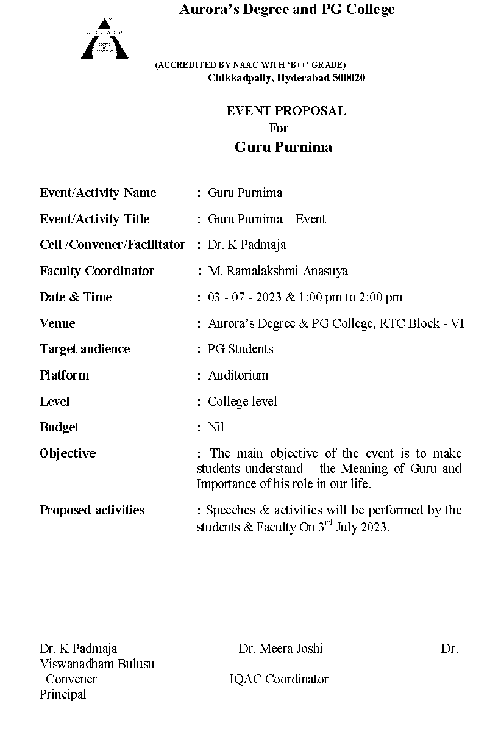

12. ECEIPTS (IF ANY) : NO

13.CERTIFICATES (IF ANY) : NO

14. LETTERS OF COMMUNICATION (IF ANY) : NA

*****

