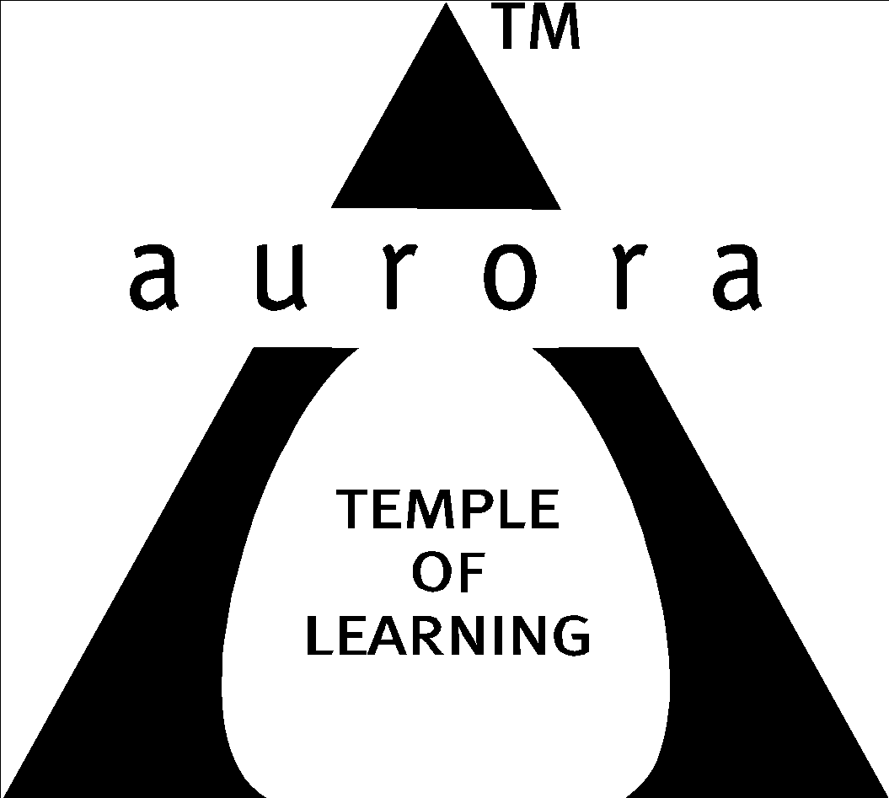

Aurora’s Degree & PG College
(ACCREDITED BY NAAC WITH 'B++' GRADE)
Chikkadpally, Hyderabad 500020

EVENT / ACTIVITY DETAILED REPORT

NAME OF THE EVENT / ACTIVITY | Independence Day
TYPE OR TITLE OF EVENT / ACTIVITY | Independence Day
FACULTY INCHARGE | J Vinita & P Anjanyeulu
DEPARTMENT/CELL/COMMITTEE/CLUB | Statistics
DATE | 15-08-2023
VENUE | Aurora’s Degree and PG College
TARGET AUDIENCE | All Students

- PROGRAM SCHEDULE:
The event scheduled on 15th August 2023, Tuesday at 9:00 a.m .
The following is the schedule.
- Welcome address by the anchor .
- Inviting Principal Sir /Vice Principal Sir /faculty and Students
- Hoisting the flag – by Principal Sir (National anthem)
- Invite Faculty to talk
- Addressing the gathering – by Principal Sir
- Patriotic Song – by Madhavi Madam
- Instrumental – Performance by Rock Band
- Speech in Hindi by student .
- Patriotic Song in Hindi by student .
- Speech in Telugu by student .
- Patriotic Song in Telugu by student .
- Speech in English by student .
- Patriotic Song in English by student .
- Prize Distribution – For the competitions conducted on Aug 8th and Aug 9th 2023 .
- Vote of Thanks – By J. Vinita
- Announcement – for Students and Faculty

- LIST OF FACULTY COORDINATORS (DEPARTMENT): J Vinita& P Anjanyeulu

- LIST OF THE STUDENT COORDINATORS (NAME , ROLL NO, CLASS & SECTION)

Name: Rajput Siddhi
Roll No: 1051-21-467-080
Class: MSCs 3B

Name: Roshan Sharma
Roll No: 1051-21-467-085
Class: MSCs 3B

- LIST OF THE PARTICIPANTS
The participant students:
Painting & Sketching
SNo | Roll No | Name of the Student | Class
1 | 1051-21-467-053 | S.Upasana | MSCS 3B
2 | gurjeetkaur23@adc.edu.in | Gurjeet Kaur | B.Com Hon I
3 |  | B.Kanak Singn | B.Com Comp I
4 |  | L.Ridhima | B.Com General I
5 |  | V.Harshini | B.Com Hon I
6 | katlakarthik23@adc.edu.in | K.Karthik | B.Sc I yr
7 |  | V.Rahul | B.Sc I yr
8 |  | A.Rohit | B.Sc I yr
9 | 1051-21-474-001 | Basavaraj Sajjan | MECS 3
10 |  | C.Suryateja | MSDS I
11 |  | Thakur Kalyan Singh | MSDS I
12 |  | S.Deva Krishna | MSDS I
13 | 1051-21-405-053 | Somesh Pimpale | B.Com Comp App 3
14 |  | Mokshita Tridevi | MSDS I
15 |  | S.Vaishnavi | MSDS I
16 | 1051-21-407-012 | K.Sai Lahari | B.Com Comp 3
17 | 1051-21-407-037 | A.Swetha | B.Com Hon 3
18 | 1051-21-401-077 | M.Hruthik | B.Com General 3
19 | 1051-21-407-019 | Arc. Joshna | B.Com Hon 3

Elocution

SNo | Roll No | Name of the Student | Class
1 | ny417681@gmail.com | A.Nikhil Yadav | B.Sc MSDS 1
2 | durlabhverma@gmail.com | Durlabh Verma | B.Sc MSDS 1
3 | bnrender23@gmail.com | B.Narender | B.Sc MSDS 1
4 | goutham@gmail.com | C.Goutham | B.Sc MSDS 1
5 | satakuridevakrishna23@gmail | S.Deva Krishna | B.Sc MSDS 1
6 | budarajumalikvenkataseshasri@gmail.com | Budaraju Maalik Venkata Sesha Sri | B.Sc MSDS 1
7 | peyyetibpranav@gmail.com | P.Sai Krishna Sai Pranav | B.Sc MSDS 1
8 | 1051-22-468-037 | V.S.Hariharan | B.Sc MPCS 2
9 | 1051-22-468-014 | K.Jaswanth Sai | B.Sc MPCS 2
10 | uradepavan23@gmail.com | Pavan Urade | BCA 1
11 | 1051-21-467-085 | Roshan Sharma | B.Sc MSCS 3B
12 | 1051-22-539-031 | P.Sai Bhavana | MSDS 2
13 | 1051-21-467-080 | Rajput Siddhi | B.Sc MSCS 3B

Documentary

SNo | Roll No./ Email id | Name of the Student | Class
1 | pakalarajkumargoud23@adc.edu.in | P.Raj Kumar | MSDS I
2 | dasarimanideepyadav23@adc.edu.in | D Manideep Yadav | B.Com Comp App - I
3 | vaddetisnigdhamdeekshyadav23@adc.edu.in | Vaddeti Snigdham Deeksh Yadav | B.Com Comp App - I

- PARAGRAPH ABOUT THE PROCEEDINGS (TILL THE END OF THE EVENT):
The event was organized on 15-08-2023. This session was started with the introductory speech by anchors Vedika BCA first year and Sainath BBA 3B . Hoisting of flag was done by Principal Sir and after that addressed the gatherings of faculty and students to enlighten about the importance of the day . Later , patriotic song was played by Madhavi Bulusu mam . Instrumental performance was done by rock band . Followed by speech and songs by students which is as follows :

VS Hariharan from MPCs II year for the speech in Hindi.
Gayathri from BCom computer applications & Goutham from MSCs 3B for the patriotic songs.
Manisha from MPCs III year for the speech in Telugu.
Patriotic Songs by Rock Bond in Telugu.
Ronak Samir from BBA 3B for the speech in English.

The Certificate distribution was done by Vice principal Sai Krishna Sir to the winners of the competitions which is as follows :
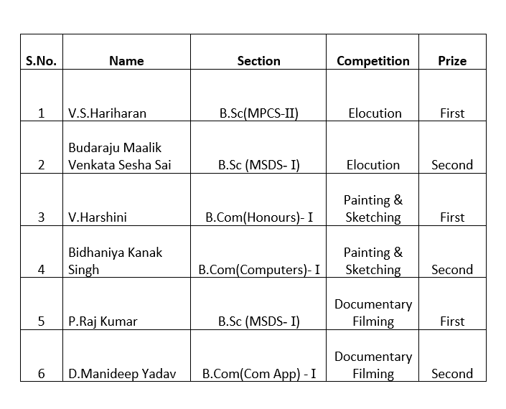

The appreciation letter was given to students by Vice principal Sir who excelled in extracurricular activities by Sai Krishna Sir which is as follows :
SNo | Roll No | Name | Class | NAME OF THE EVENT | Event /Activity | Award/Medal | Month /Year
1 | 1051-22-467-027 | S Abijeeth Kumar | MSCs 2 | Crossbow Shooting | State Crossbow Shooting Championship | Gold-State | 2023
2 | 1051-21-467-010 | K.Charan Kumar Reddy | MSCs 3A | Crossbow Shooting | National Crossbow Shooting Championship | Gold-National | 2023
3 | 1051-21-405-121 | K. RAHUL | B.Com Comp App 2C | POWER LIFTING | SOUTH INDIAN POWERLIFTING CHAMPIONSHIP | 2nd | September 2022
4 | 1051-21-405-121 | K.RAHUL | B.Com Comp App 2C | POWER LIFTING | TELANGANA STATE POWERLIFTING CHAMPIONSHIP | 1ST | 21/08/2022
5 | 1051-21-405-121 | K.RAHUL | B.Com Comp App 2C | DEAD LIFTING | TELANGANA STATE DEADLIFT CHAMPIONSHIP | 1ST | 21/08/2022
6 | 1051-21-467-053 | S Upasana | MSCs 3B | Painting | Telangana Private Teachers ,Lecturers federation | First Prize | March 2023

Finally , thanking everyone’s efforts for coordinating the event , vote of thanks was given by
J. Vinita , Head , Department of Statistics .

- INCOME AND EXPENDITURE:
Flag decoration /
Stage decoration /Tent house – 2000/-
Refreshments&Tea – 8,000/-(400*20)+12,00
Certificates – 100 /-
Total – 11,300/-

- EVENT PHOTOS ( MIN 2 MAX 4):
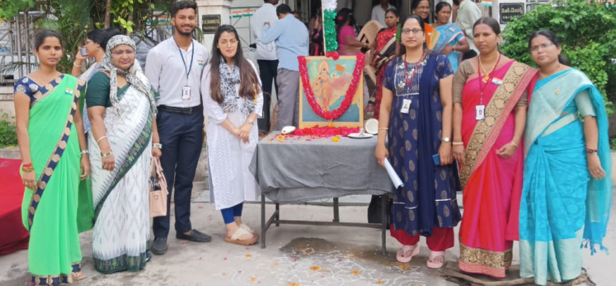
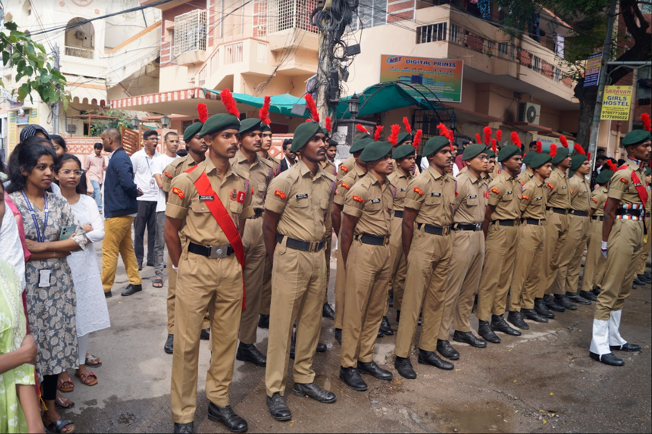
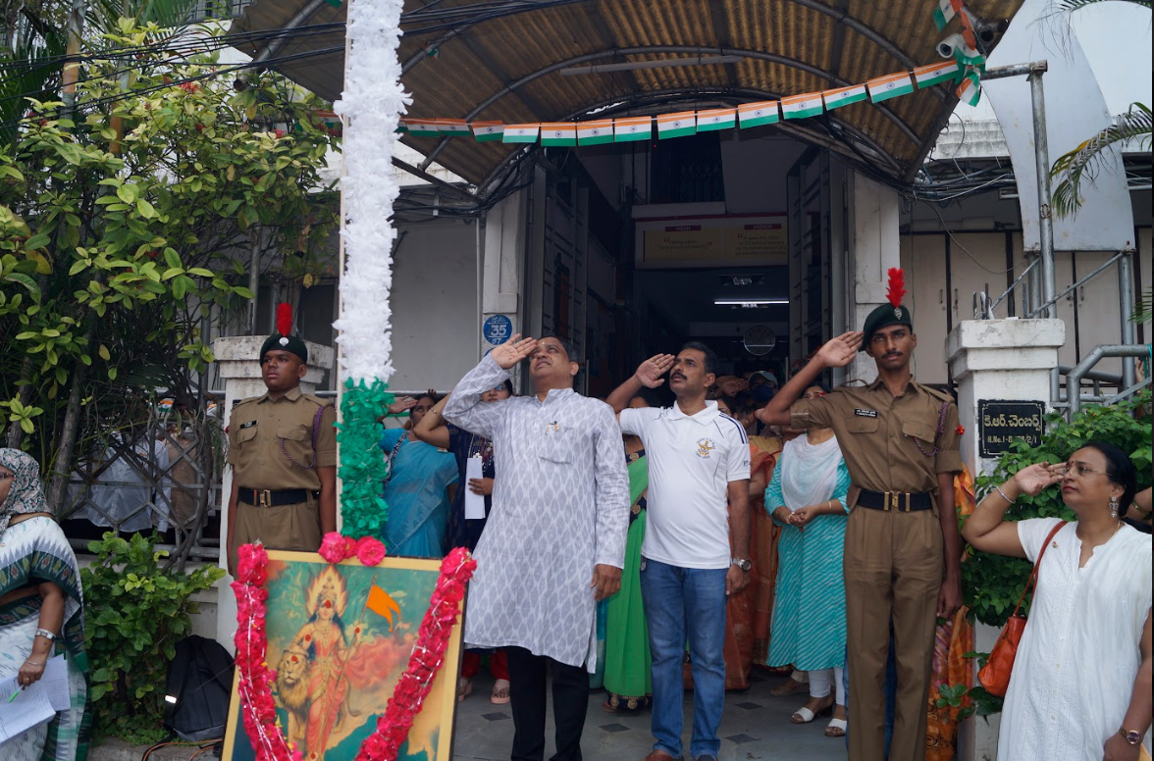
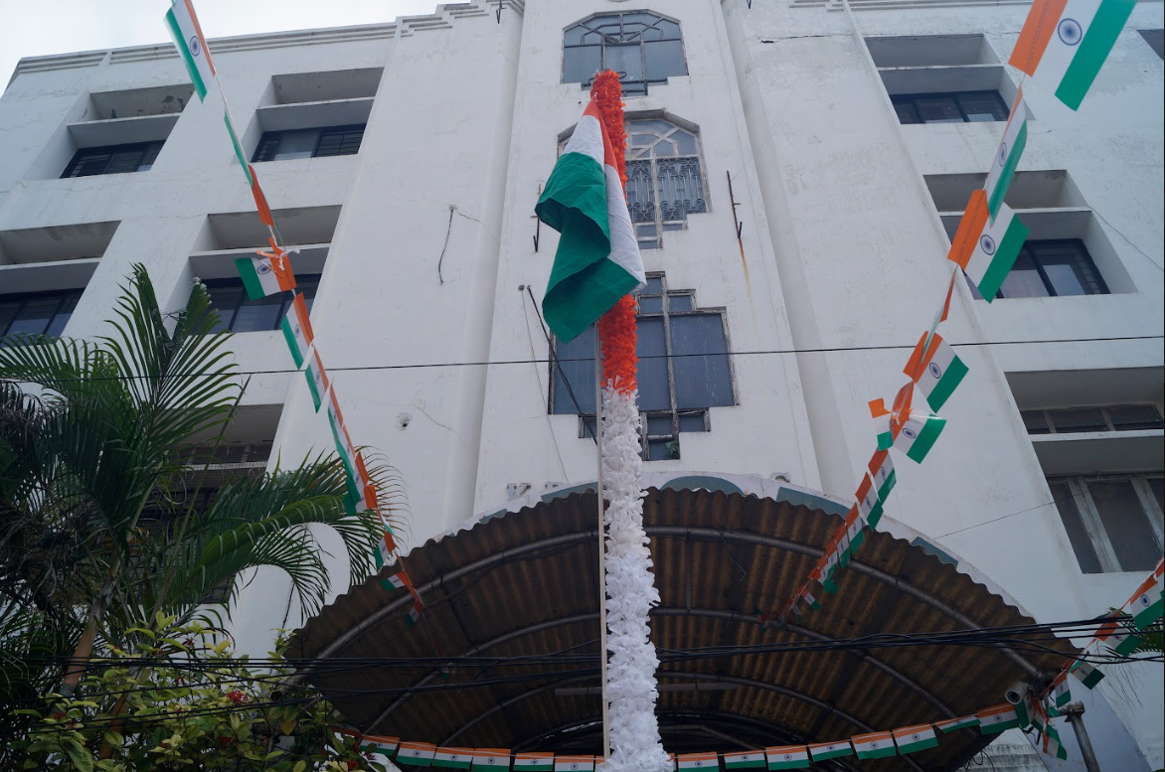
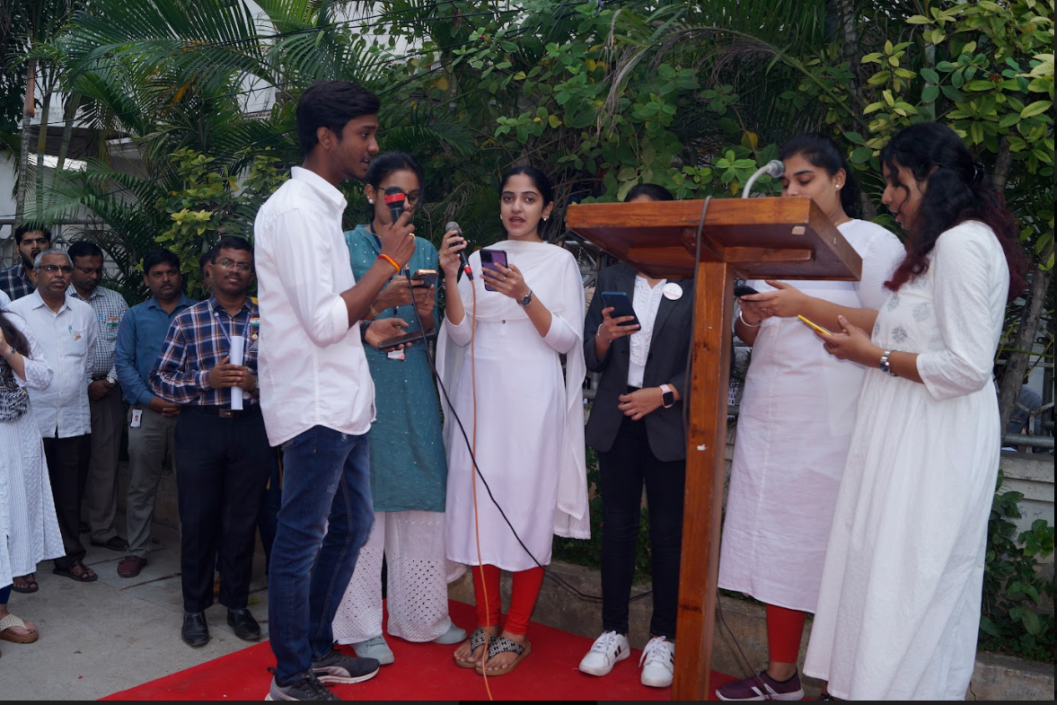
- GUEST PROFILE (IF ANY): NIL
- FEED BACK IF ANY: NIL
- ATTACHMENTS:
EVENT/ACTIVITY PROPOSAL
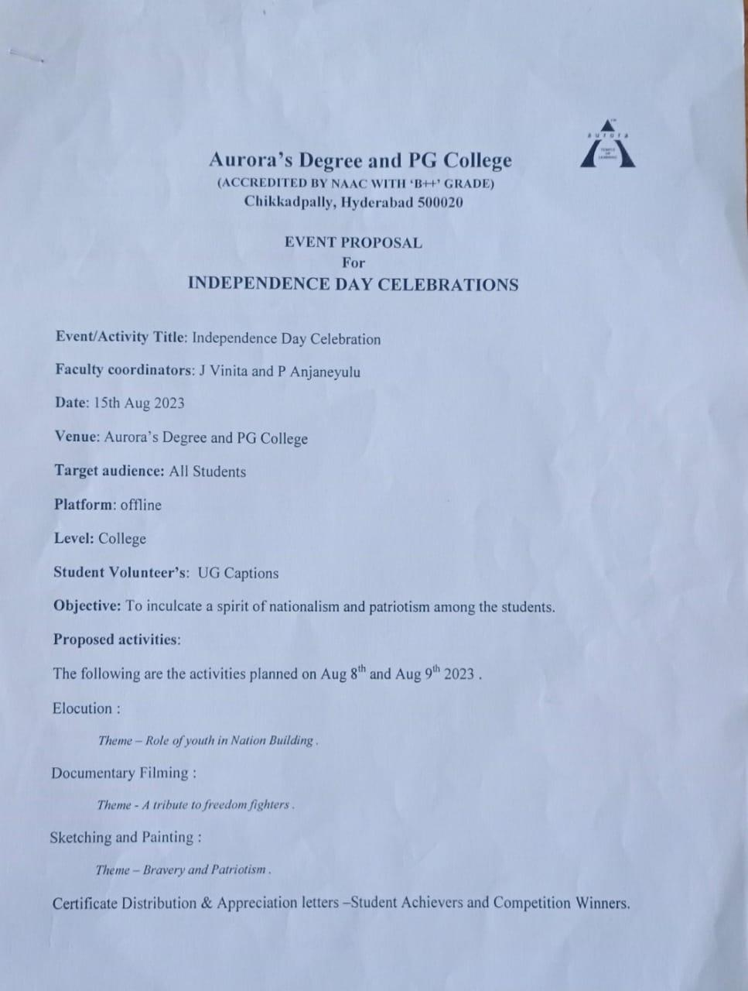
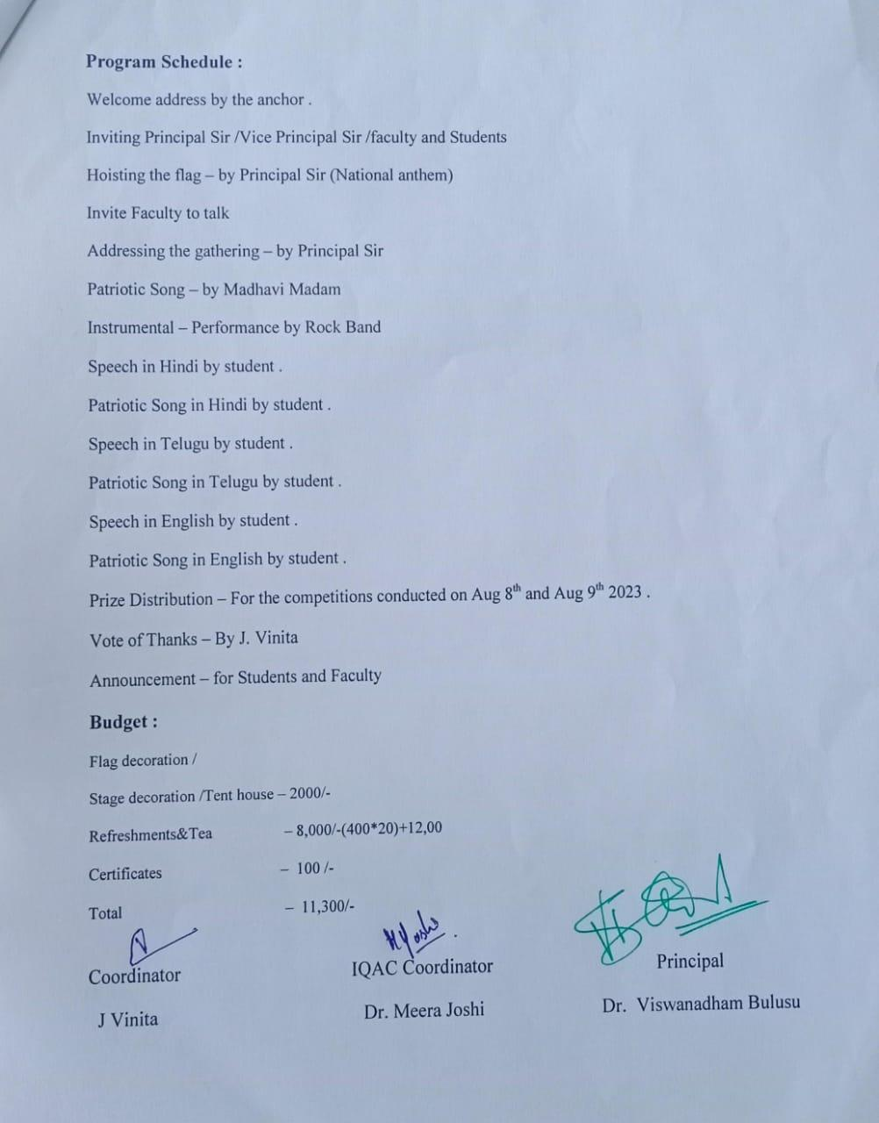

EVENT / ACTIVITY NOTICE
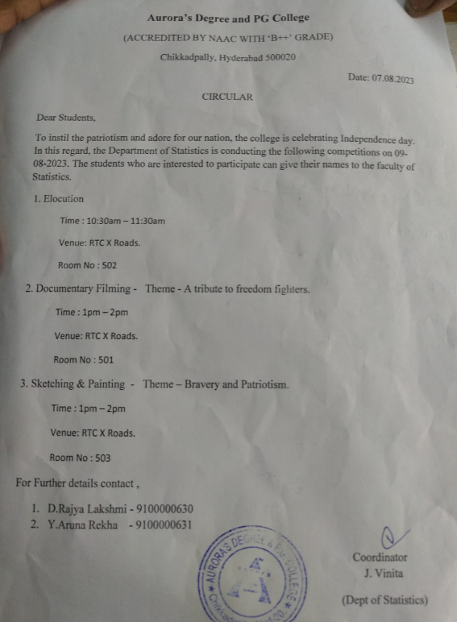

RECEIPTS (IF ANY):
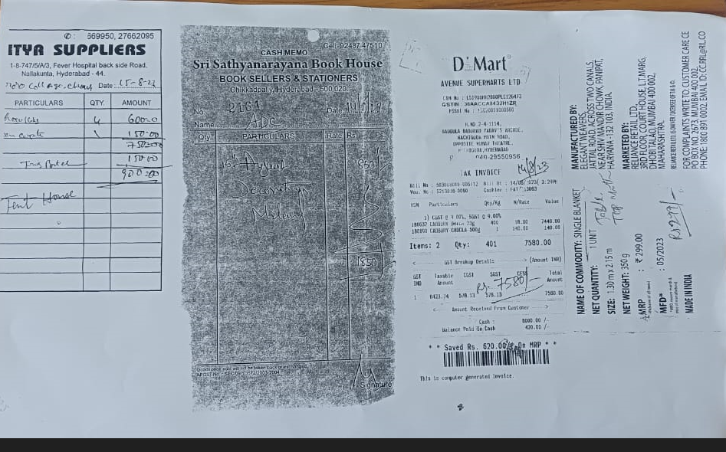
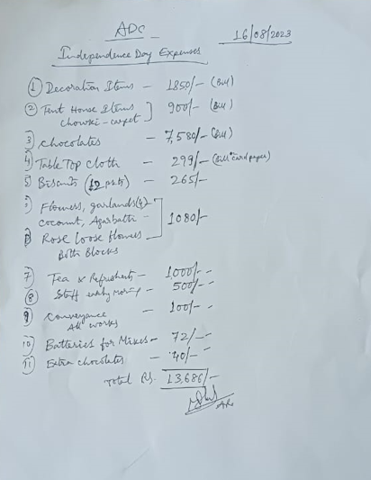
CERTIFICATES (IF ANY):
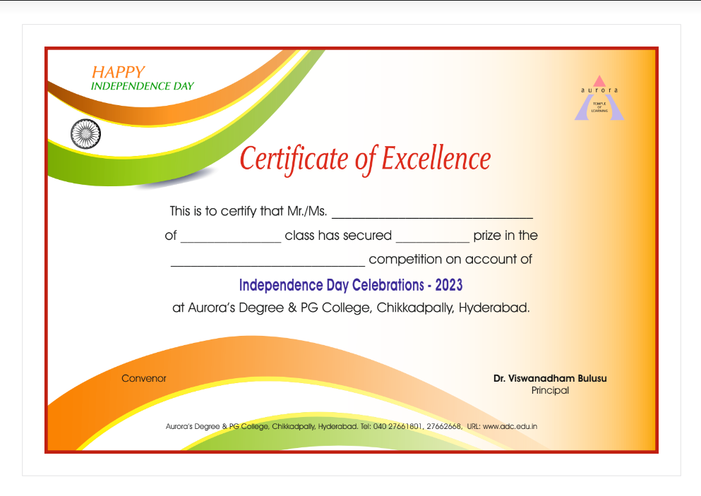

LETTERS OF COMMUNICATION (IF ANY): NIL

