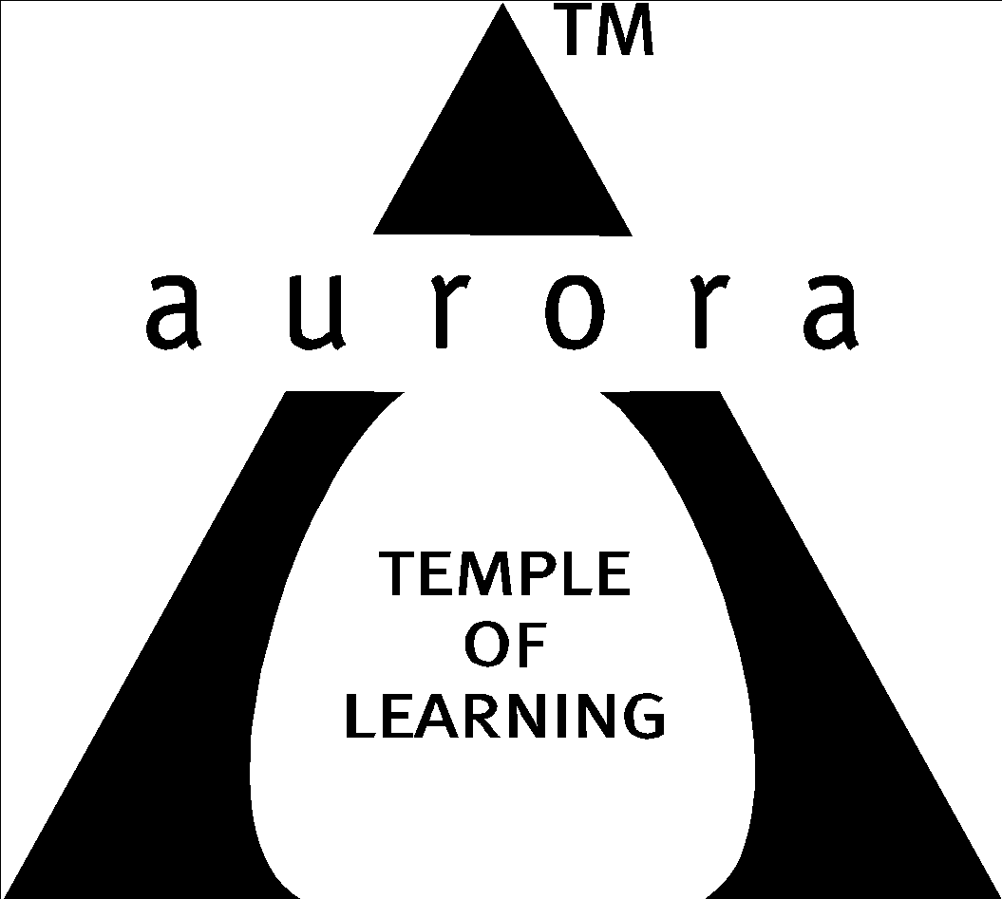

Aurora’s Degree & PG College
(ACCREDITED BY NAAC WITH 'B++' GRADE)
Chikkadpally, Hyderabad 500020

EVENT / ACTIVITY DETAILED REPORT

NAME OF THE EVENT / ACTIVITY | Alumni Lecture
TYPE OR TITLE OF EVENT / ACTIVITY | Placement Talk
FACULTY INCHARGE | Parimala Diana Sudhir. K (Coordinator)
DEPARTMENT/CELL/COMMITTEE/CLUB | Statistics
DATE | 19-08-2023
VENUE | Seminar Hall-Aurora’s Degree and PG College
TARGET AUDIENCE | MSDs/MSCs Final year

- LIST OF FACULTY COORDINATORS (DEPARTMENT): K. Parimala Diana Sudhir (Coordinator)
- LIST OF THE STUDENT COORDINATORS (NAME, ROLL NO, CLASS & SECTION)
- Name: Meher Sai
Roll No: 1051-21 467-001-
Class: MSCS3A
- Name: Siddi Rajput
Roll No: 1051-21 467-001-080
- Name: Mallikarjun.H
Roll No: 1051-21-467-045
Class: MSDS 3

- LIST OF THE PARTICIPANTS
All MSCS & 3rd year students participated.
- PARAGRAPH ABOUT THE PROCEEDINGS (TILL THE END OF THE EVENT):
Day : 19-08-2023
Speaker: 1) Abhishek Mishra, Associate Vice President, Deloitte, Hyderabad.
Th department of statistics organized an Alumni lecture related to placements for final year MSCs & MSDs students. Abhishek Mishra, Associate Vice President, Deloitte, Hyderabad an Alumnus of BSC-MSCs 2006 passes out batch of our college is our speaker. Ms. Parimala Diana Sudhir, coordinator introduced the speaker for the students. Ms. Swapna from the department honored our guest with a bouquet. Abhishek Mishra, emphasized the significance of preparation for placement preparation and improving skills while in the college. He highlighted that securing a job through campus placements’ is easier than off- campus placements, and advised students to be thorough with basic concepts.
Key points in his talk.
- Attend all interviews
- Dedicate 1hr daily to study basic question in Machine Learning (ML) & Artificial Intelligence (AI)
- Follow interview do’s & don’ts
- Regardless of whether a company is service-based or product-based, attend interview
- Research and familiarize yourself with the company profile before interviews
Mr. Abhishek Mishra offered students the opportunity to interact with him via WhatsApp.
Students had the chance to ask questions and clarify their doubts during the session.
The lecture was informative and relevant to final year students, providing valuable insights into the world of placements and career preparation. Ms.Vinita, Hod expressed gratitude on behalf of the department, concluding with vote of thanks.
Overall, this lecture provided students with practical advice and insights to help them succeed in their upcoming placement interviews and career aspirations.
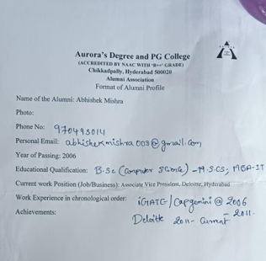

- INCOME : Nil
EXPENDITURE : Rs 240
- EVENT PHOTOS (MIN 2 MAX 4):

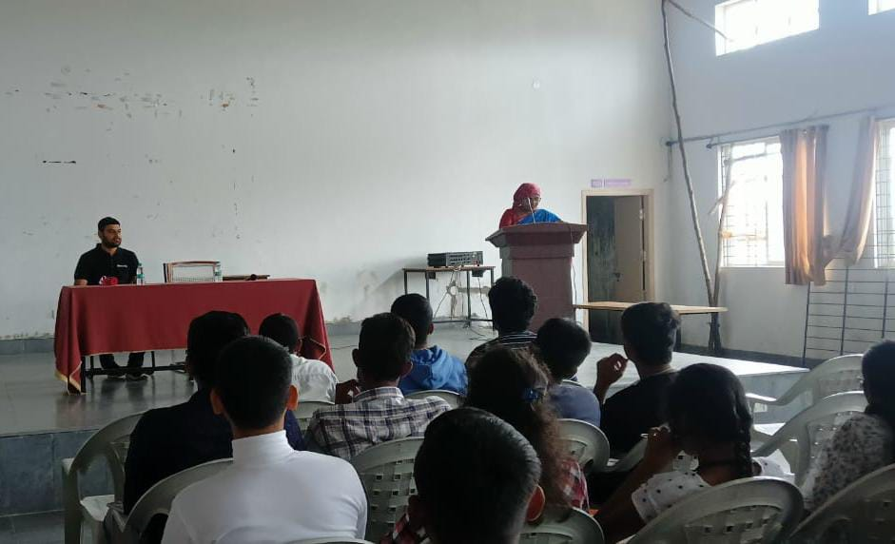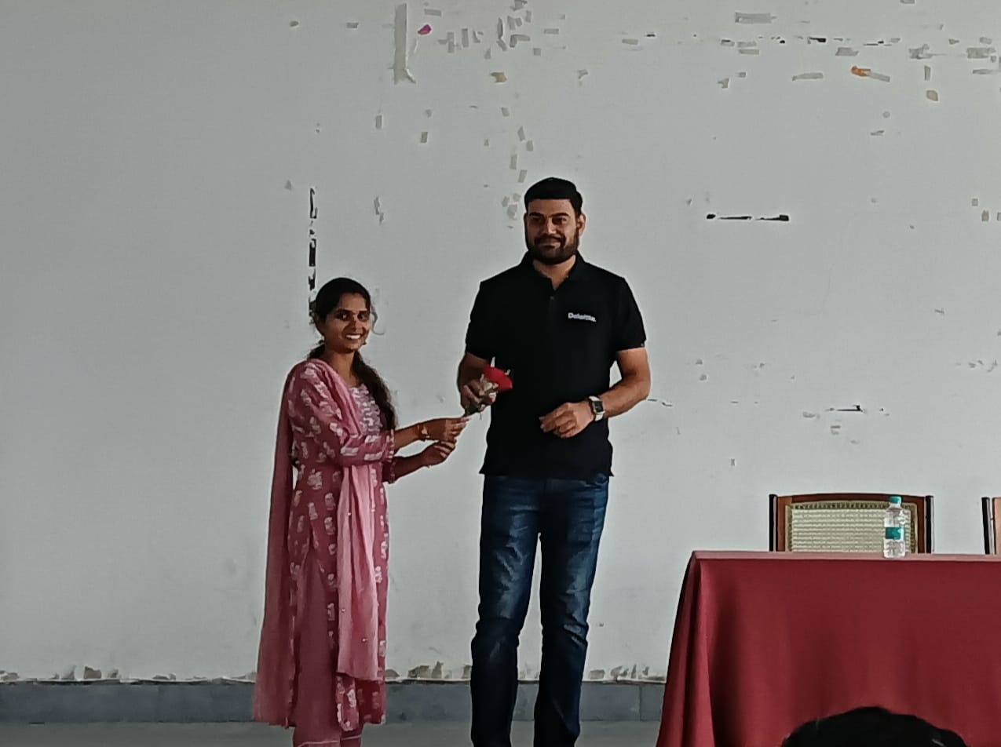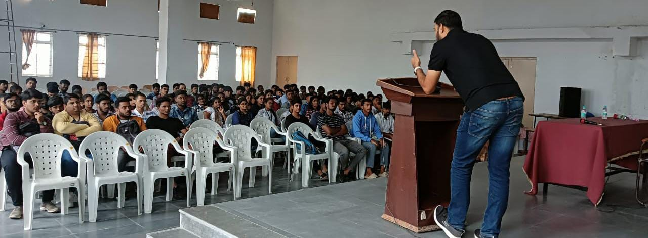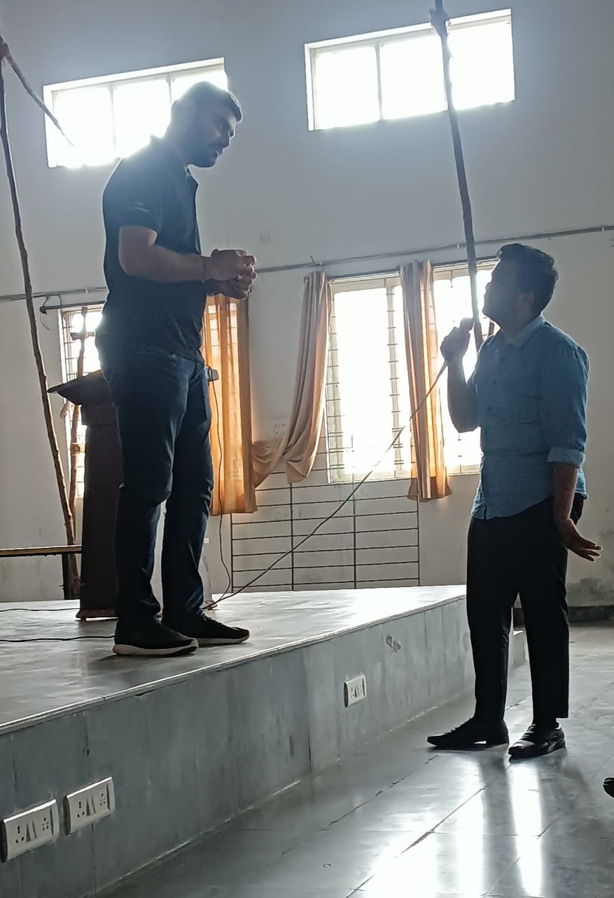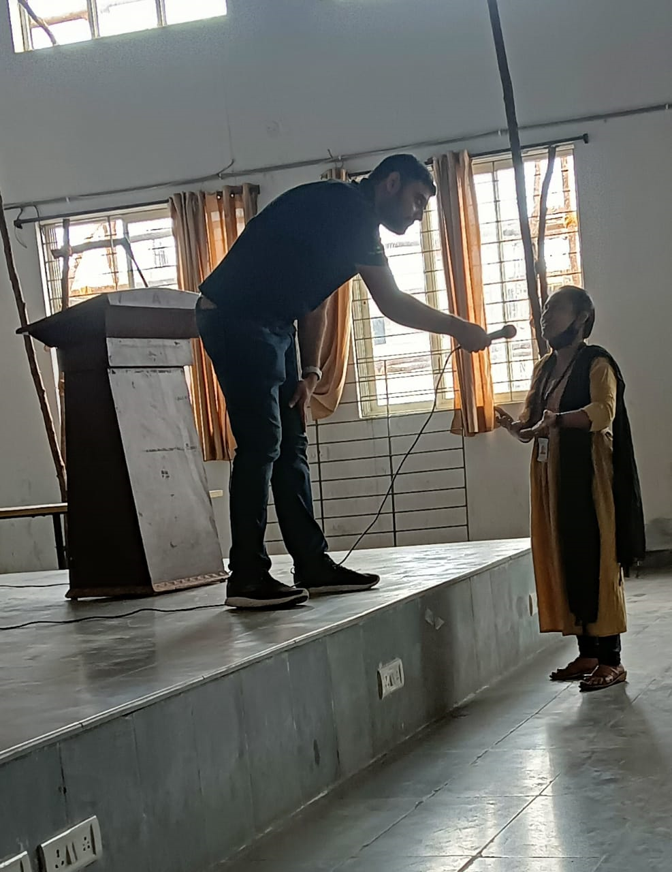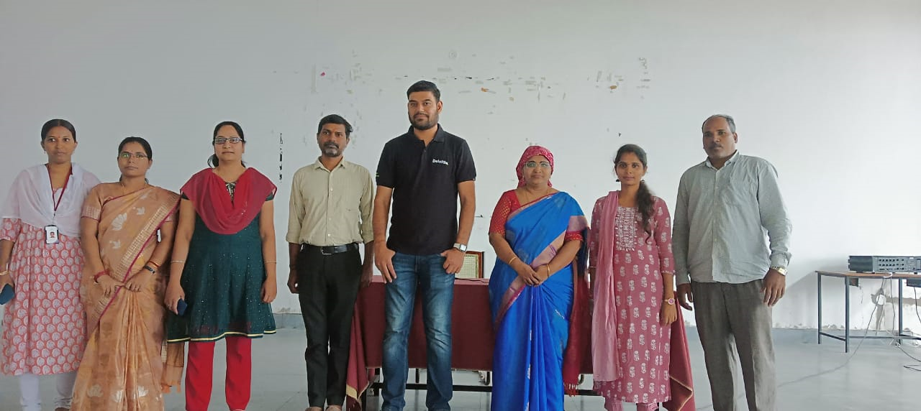

- ATTACHMENTS:
EVENT/ACTIVITY PROPOSAL

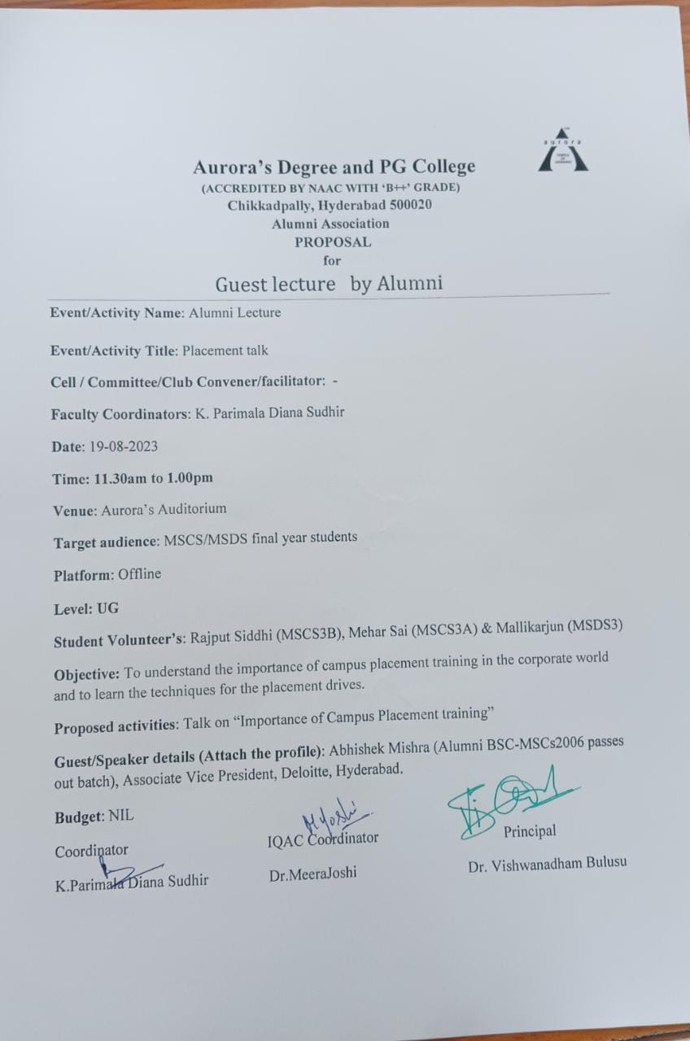

EVENT / ACTIVITY NOTICE
RECEIPTS (IF ANY):
CERTIFICATES (IF ANY):
LETTERS OF COMMUNICATION (IF ANY): (Communicated through WhatsApp.)

