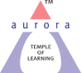
Aurora’s Degree & PG College
(Accredited By Naac With 'B++' Grade)
Chikkadpally, Hyderabad 500020

EVENT / ACTIVITY DETAILED REPORT

NAME OF THE EVENT / ACTIVITY | Sanskrit Day - Guest Lecture
TYPE OR TITLE OF EVENT / ACTIVITY | Importance and Relevance of Sanskrit Language and Literature
FACULTY INCHARGE | D.V. Durga Bhavani
DEPARTMENT/CELL/COMMITTEE/CLUB | Languages
DATE | 31st August 2023
VENUE | RTC Block - 6
TARGET AUDIENCE | UG Students

- PROGRAM SCHEDULE:
- The program was scheduled on 31st August 2023
- The program began at 1.40 pm. At around 1.45 pm D.V. Durga Bhavani welcomed the guest speaker and introduced him to the Class.
- At 2.45 pm the speaker had concluded the Lecture.
- At around 2.45 pm a photo session was conducted.
- At 2.50 pm vote of thanks was given by D.V. Durga Bhavani.

- LIST OF FACULTY COORDINATORS

S.no | Faculty Name | Role | Department
1 | D.V. Durga Bhavani | Faculty In-charge | Assistant Professor – Department of Second languages
- LIST OF THE STUDENT COORDINATORS (NAME , ROLL NO, CLASS & SECTION)
Name | Roll Number | Class & Section
Dhruv Patel | 1051-22-684-020 | BBA 2
Bhagyashree Vyas | 1051-22-401-006 | B.Com

- LIST OF THE PARTICIPANTS (NAME , ROLL NO, CLASS & SECTION )

S.No | Roll Number | Name | Class & Section
1 | 1051-22-684-016 | Chimman War Vishnuvardhan | BBA 2
2 | 1051-22-684-017 | Chitla Vishnu Vardhan Reddy | BBA 2
3 | 1051-22-684-018 | Chittedi Ruthik Reddy | BBA 2
4 | 1051-22-684-019 | Deshavali Sai Praneeth | BBA 2
5 | 1051-22-684-020 | Dhruv Patel | BBA 2
6 | 1051-22-684-021 | Dubbaka Akshita | BBA 2
7 | 1051-22-684-022 | Durgamwar Srija Shankar | BBA 2
8 | 1051-22-684-029 | Gujjula Tharun | BBA 2
9 | 1051-22-684-031 | Hemanth Sharma Tiwari | BBA 2
10 | 1051-22-684-034 | Joy Maity | BBA 2
11 | 1051-22-684-035 | Kadthala Sailatha | BBA 2
12 | 1051-22-684-039 | Koganti Yashwanth | BBA 2
13 | 1051-22-684-045 | Mantri Kushal | BBA 2
14 | 1051-22-684-047 | Naitik S Mehta | BBA 2
15 | 1051-22-684-048 | Nikhil Upadya | BBA 2
16 | 1051-22-684-049 | Nukala Mahesh | BBA 2
17 | 1051-22-684-051 | Pedeker Shilpa Rani | BBA 2
18 | 1051-22-684-053 | Pratham Modi | BBA 2
19 | 1051-22-684-065 | Uppara Lumini Kapil Sagar | BBA 2
20 | 1051-22-684-073 | Vivek Jain | BBA 2
21 | 1051-22-684-074 | Vivek Sitlani | BBA 2
22 | 1051-22-401-001 | Amar Bhalke | B.com (Reg) - 2
23 | 1051-22-401-006 | Bhagyashree Vyas | B.com (Reg) - 2
24 | 1051-22-401-009 | Deepak Kumar Joshi | B.com (Reg) - 2
25 | 1051-22-401-010 | Devkatte Sandeep | B.com (Reg) - 2
26 | 1051-22-401-014 | Isha Vyas | B.com (Reg) - 2
27 | 1051-22-401-015 | Jagdish Swamy | B.com (Reg) - 2
28 | 1051-22-401-019 | Laishetty Madhu | B.com (Reg) - 2
29 | 1051-22-401-020 | Ledhoriya VineethKumar | B.com (Reg) - 2
30 | 1051-22-401-021 | Mudavath Vinay Kumar | B.com (Reg) - 2
31 | 1051-22-401-023 | Nadikudi Sanjay Ram | B.com (Reg) - 2
32 | 1051-22-401-024 | Nishant Soni | B.com (Reg) - 2
33 | 1051-22-401-032 | Reema Pallod | B.com (Reg) - 2
34 | 1051-22-401-033 | Ridhyanshika Saxena | B.com (Reg) - 2
35 | 1051-22-401-035 | Sai Ganesh Biradar | B.com (Reg) - 2
36 | 1051-22-401-036 | Shivratan Kadel | B.com (Reg) - 2
37 | 1051-22-401-041 | Vansh Jain | B.com (Reg) - 2
38 | 1051-22-371-003 | Bijamwar Rushikesh | B.com (Reg) - 2

- PARAGRAPH ABOUT THE PROCEEDINGS (TILL THE END OF THE EVENT)
The event began at 1.40 pm by traditional lighting of the lamp by Guest Speaker - Sri Seetarama Somayajulu and Head of Department of Languages – Dr. K. Padmaja. This was followed by a prarthana geetam sung by faculty – M.R. Anasuya. Then faculty coordinator - D.V. Durga Bhavani introduced the guest speaker and invited him to deliver the guest lecture.

The speaker took over the session at 1.50 pm.

The talk continued till 2.45 pm. This was followed by a photo session and a Vote of Thanks by D.V. Durga Bhavani. The event concluded at 2:50 pm.

Synopsis of the lecture:

The guest speaker narrated the Importance and Relevance of Sanskrit through practical examples and also touched upon its contribution into Linguistics and Natural Language Processing. He also mentioned the Literature aspect through the example of Srimad Bhagavad Geeta and its relevance in current world.

- INCOME AND EXPENDITURE: Nil

- EVENT PHOTOS ( MIN 2 MAX 4)
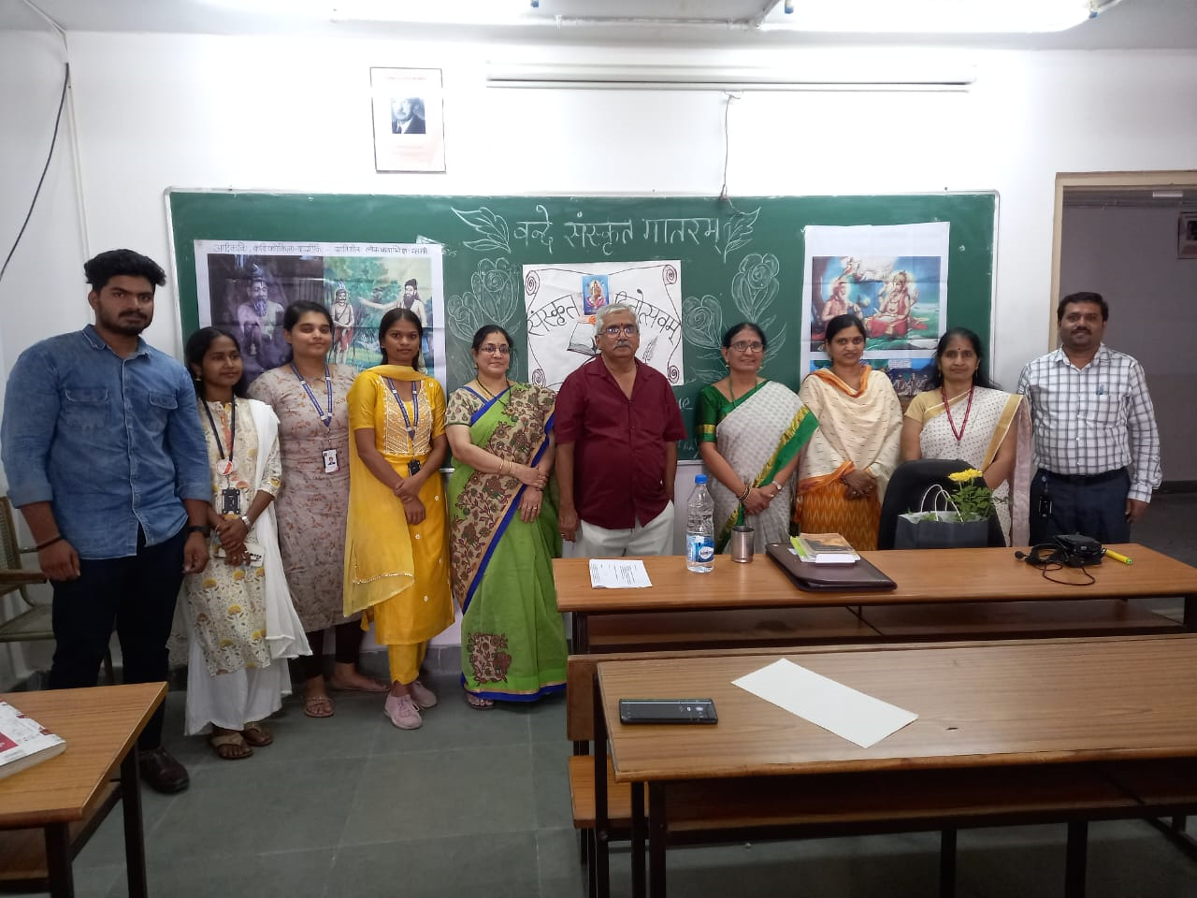

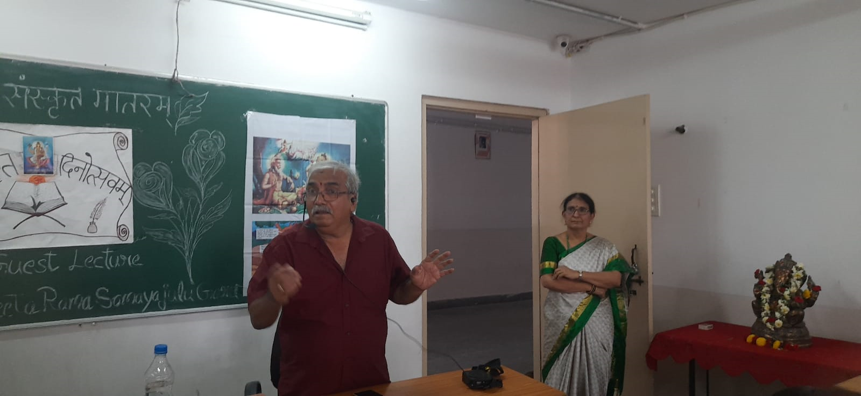

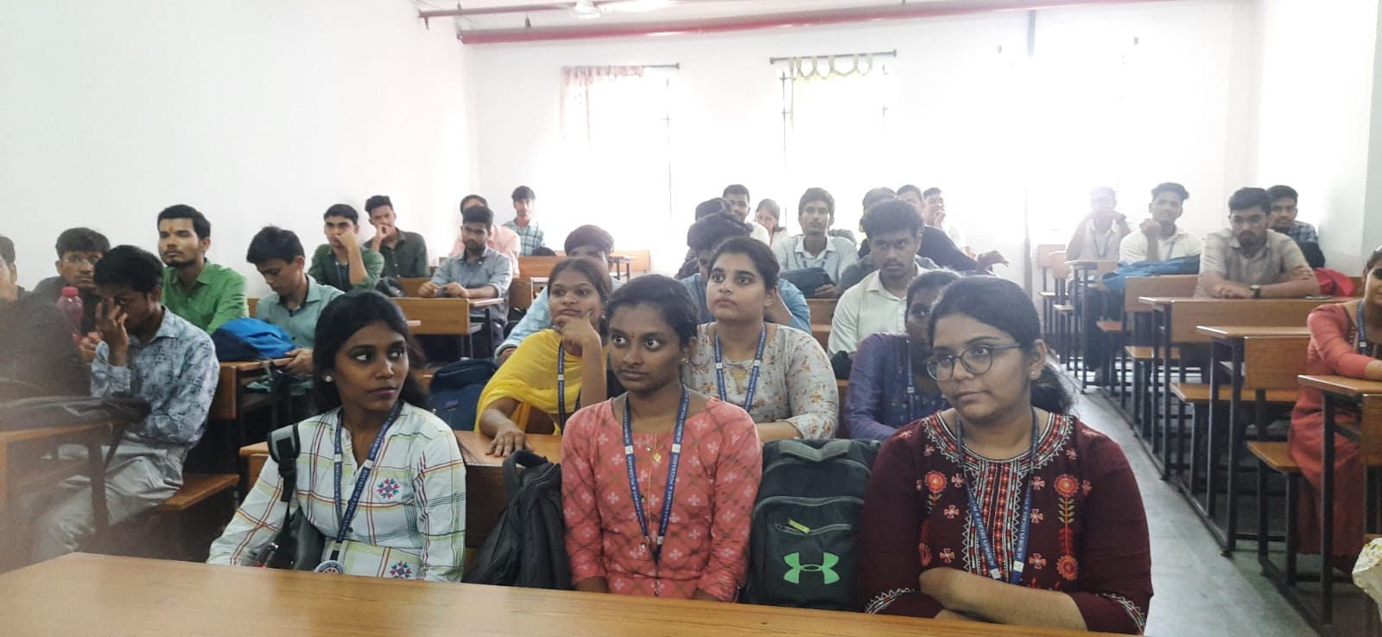
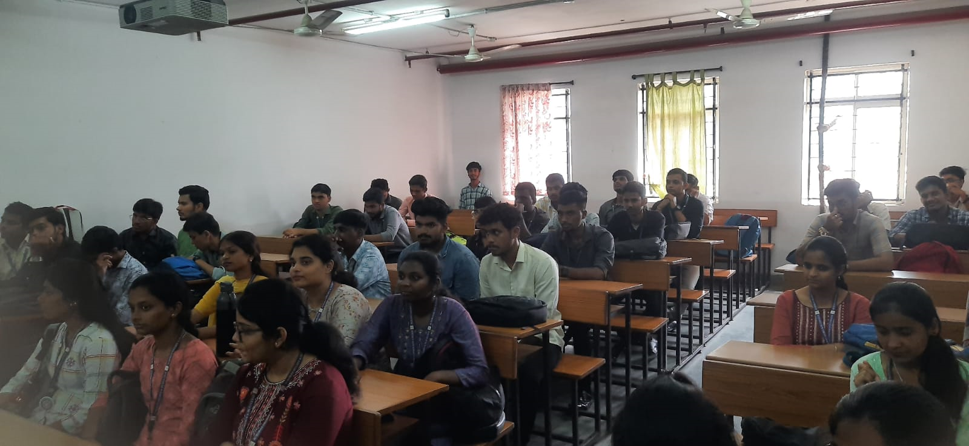
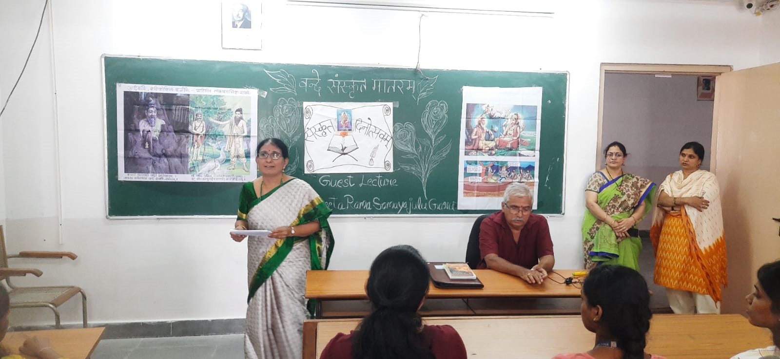

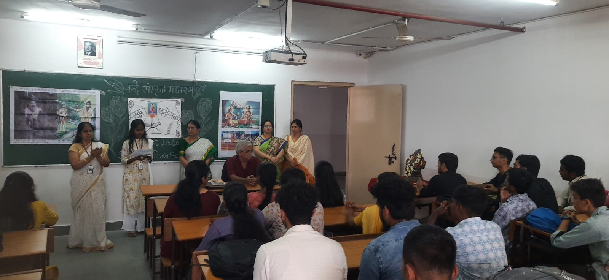
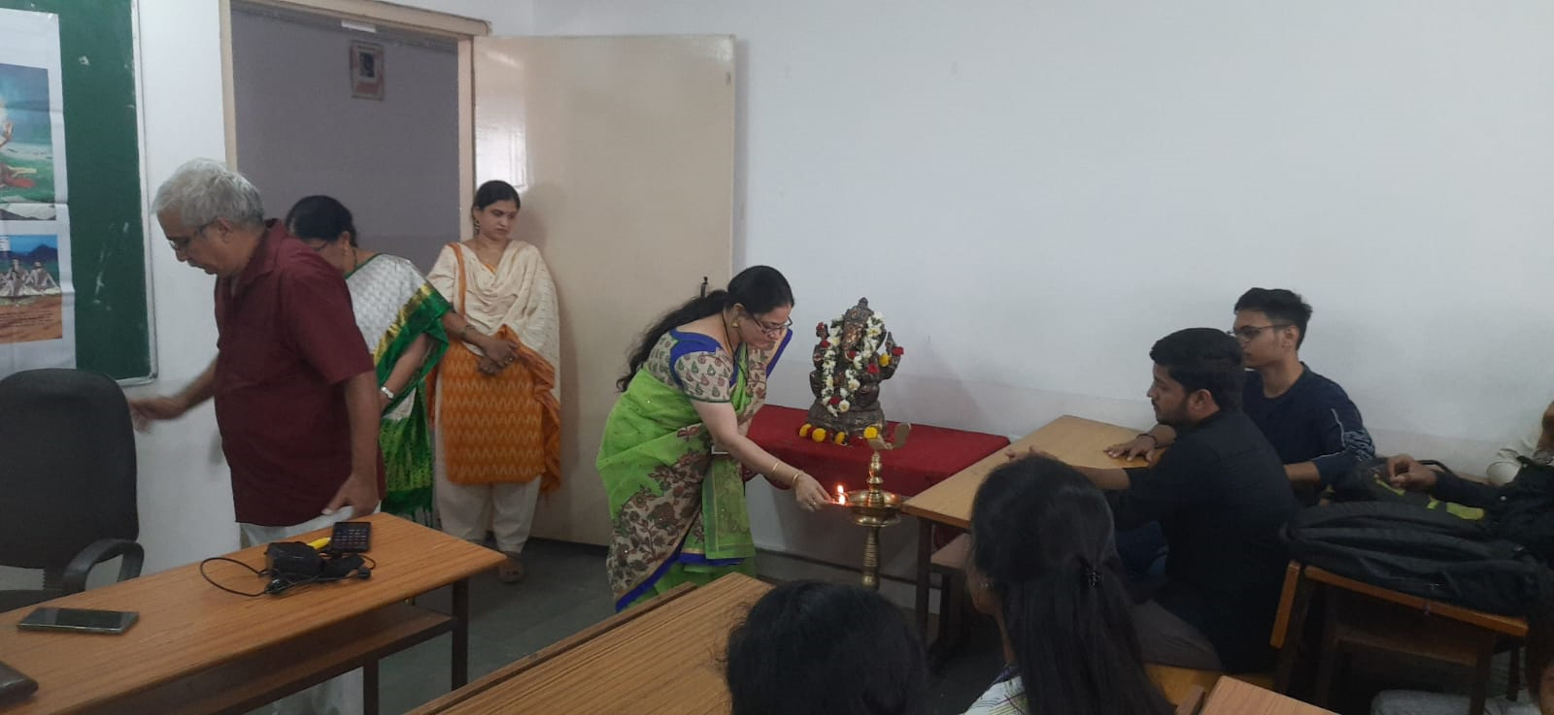

- GUEST PROFILE (IF ANY) :
Sri Seetarama Somayajulu garu has been Adhyaksha of Vidyanagar Branch of Samskrita Bharati, an organization that is devoted to promotion of Sanskrit. They conduct several programs such as Sanskrit promotional certification exams such as Pravesha upto Kovida, Geeta Sopanam, etc., They also conduct sanskrita Sambhashan Shibirams where the talking in Sanskrit is being encouraged.

He has retired as Chief Manager from State Bank of Hyderabad and has been associated with Vivekananda Kendra in Kanyakumari. Ever since retirement, he has been involved in programmes promoting Importance of Matrubhasha, Telugu and Sanskrit. Apart from these, he has also been involved with promotion of vedadhyanam and Carnatic Classical Music. On 2nd Sep, he is going to give a lecture on Sanskrita Kritis.

- FEEDBACK IF ANY: No formal feedback has been taken from participants
EVENT / ACTIVITY NOTICE:

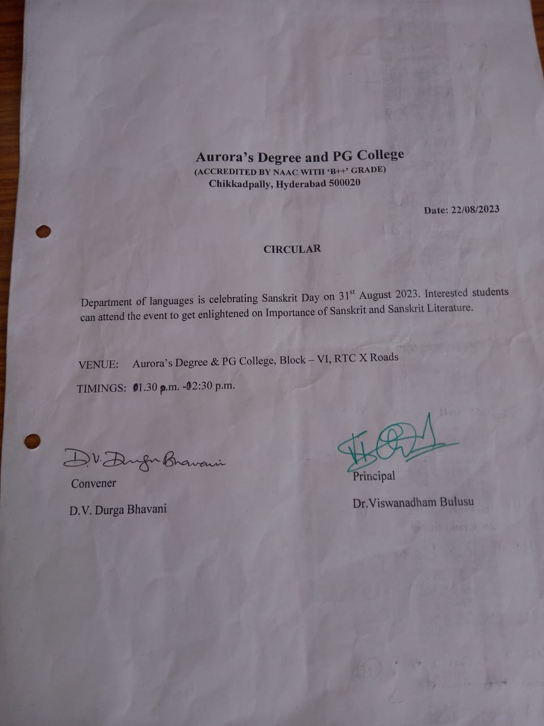

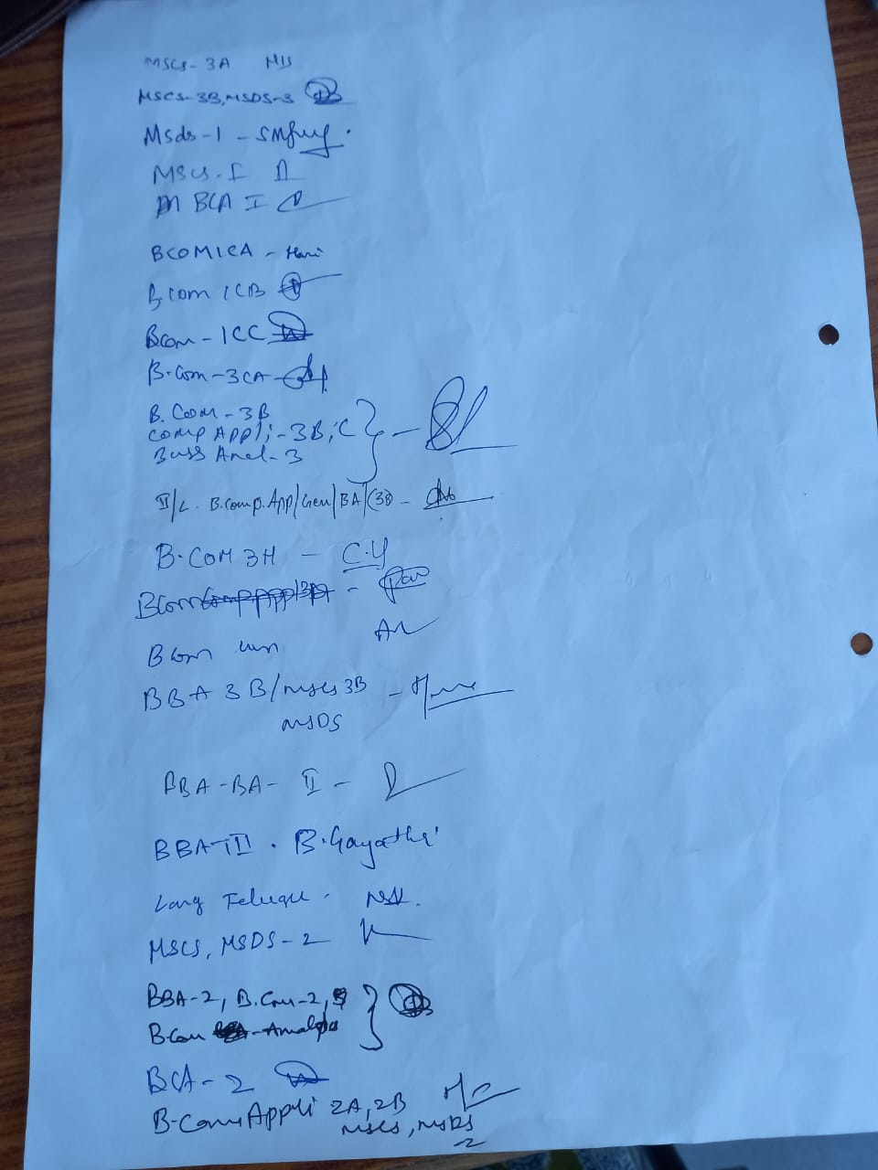
EVENT/ACTIVITY PROPOSAL
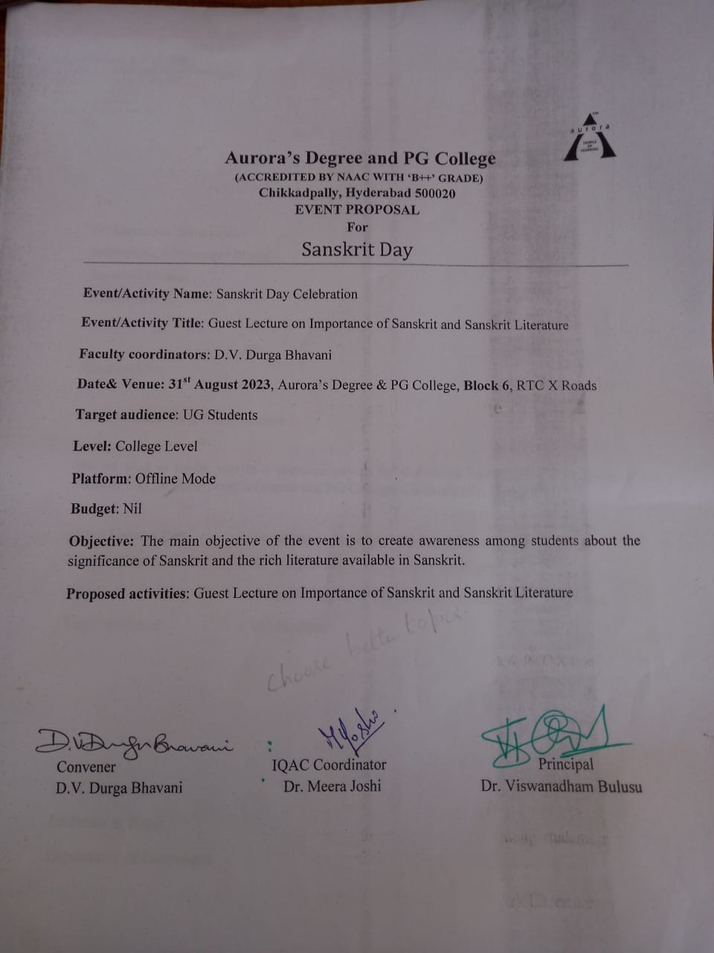

- RECEIPTS (IF ANY)
None
- CERTIFICATES (IF ANY)
None
- LETTERS OF COMMUNICATION (IF ANY)
None

